REPORT ON IOTB TECH HOSPITAL
Medical condition with highest revenue
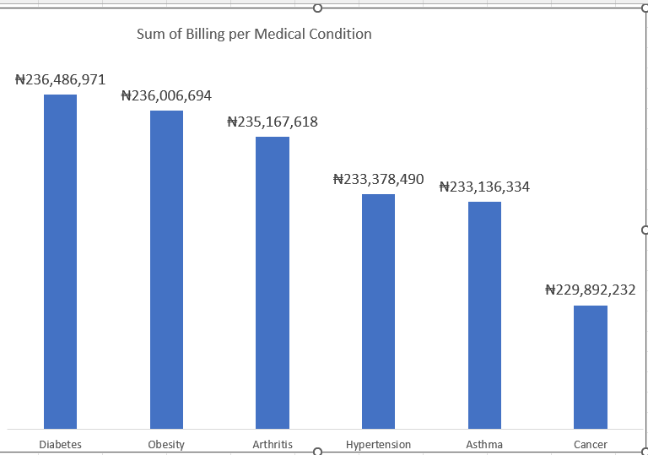
This chart shows that Diabetes Generate the highest revenue of #236,486,971 for IOTB TECH Hospital.

Age with Highest Hospital visit

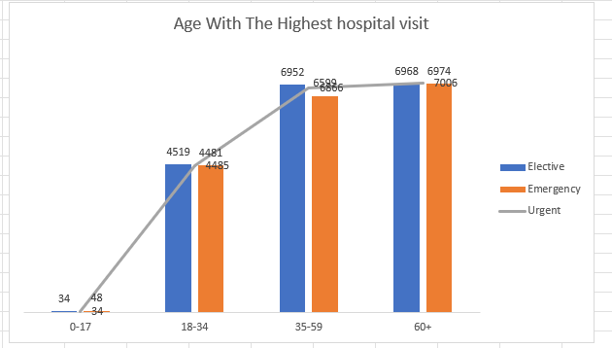

This chart shows that patient that are above 60 years of age visit the hospital the most.

Insurance Per Revenue
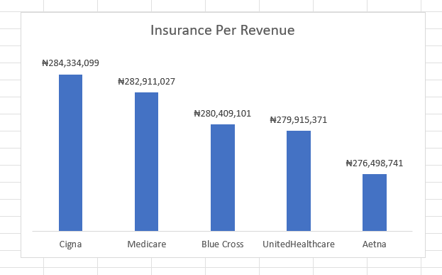

This chart shows that Cigna Insurance generate the highest revenue of #284,334,099 for IOTB TECH Hospital.

Most Common Admission Type
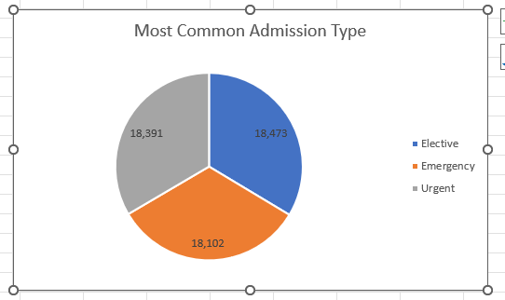

This chart shows that Elective is the most common admission type in IOTB TECH Hospital because it has the highest number of Patients.

Condition with longest hospital stay
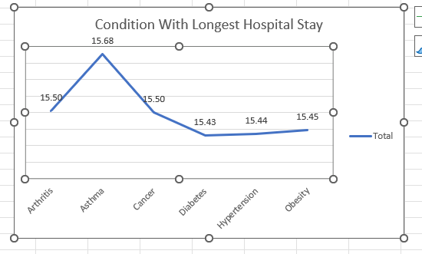
This chart shows that Asthma is the medical condition that have the longest average of 15.68 of hospital stay.

Monthly Revenue Trend
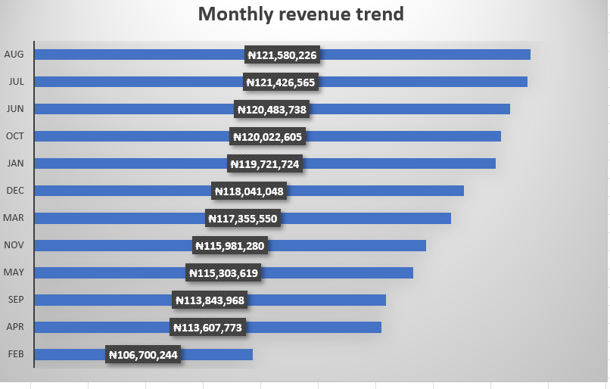
This chart shows that January has the highest monthly revenue of #121,580,226.

Most Common Medical Condition

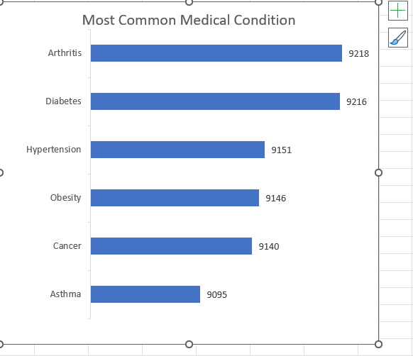
This chart shows that Arthritis is the most common medical condition because it has the highest number in the chart with total number of 9218.

Admission Type Per Revenue

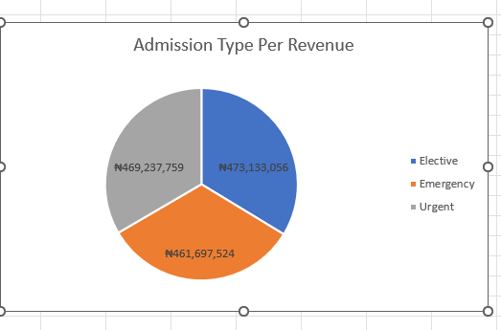
This chart shows that Elective Admission Type generate the highest revenue of #473,133,056 for IOTB TECH Hospital.

Gender distribution per patient
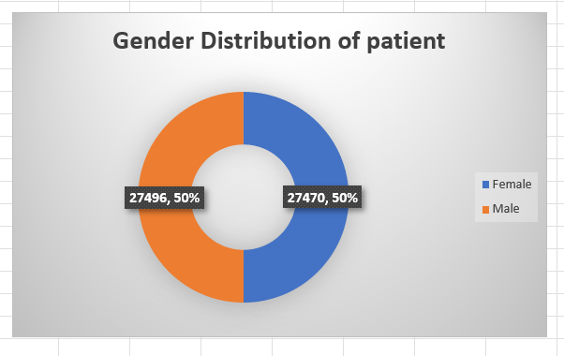
This chart shows that Female has the highest gender distribution in IOTB TECB Hospital.

Medication with highest revenue
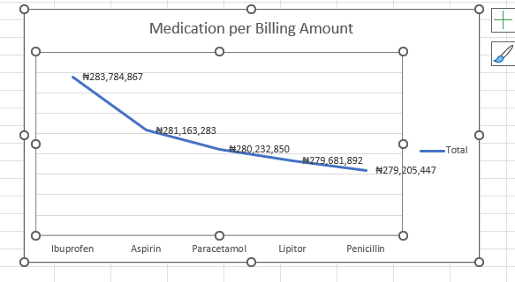
This chart shows that Ibuprofen is the medication that generate the highest revenue For IOTB TECH Hospital

Observation
- Asthma patient has the hospital stay, Arthritis has the highest number of patient while Diabetes generate the highest revenue for IOTB TECH Hospital.
- Cigna and Medicare Insurance generate the highest revenue for IOTB TECH Hospital
- Older people, which are 35 years and above are the main patient while children and young adult barely visit the hospital.
- Ibuprofen is the medication that has the highest revenue for IOTB TECH Hospital.
Business suggestion
- Since asthma has the longest stay in the hospital, it is suggested to set up a program that catches these patients earlier and gets them out faster.
- Cigna and Medicare are paying the bill, so make sure claims aren’t getting stuck or denied. Because faster payment = better cash flow.
Recommendation
- Prioritize Cigna and Medicare for contract renegotiations and faster claims processing.
- Arthritis is the largest patient medical condition. It is recommended that using the most cost effective medication will moderate the case.

