Preliminary Application for the Japanese Government (MEXT) Scholarship
Research Students 2027

Read the instructions carefully before proceeding to fill out the form:
- Please submit your application by email to scholarship-india@nd.mofa.go.jp in MS Word format only. Kindly ensure that the file size does not exceed 1 MB. Please note that applications submitted in any other format or through any other medium may not be considered.
- Please ensure that a photograph is attached to the designated area before submission.
- Applications will be evaluated based on the submitted information and Research Plan. Incomplete applications, including those missing the Field of Study or Research Plan, will not be evaluated. This applies to Master’s course applications as well.
- If your Research Plan exceeds two pages, you may include an additional one or two pages to ensure that your proposal is explained clearly and comprehensively.
- The guidelines available on the Embassy’s website are provided solely for reference and general information up to the preliminary application evaluation stage. The documents specified in the guidelines are required only from candidates who are shortlisted and invited to appear for the written test and interview. Applicants are therefore requested not to attach or submit any additional documents at the preliminary application stage.
- Applicants are encouraged to complete the application form thoughtfully and to the best of their understanding. To help us manage inquiries efficiently, we kindly request that the Embassy be contacted only for important or necessary matters.
- In principle, the university preference mentioned in the application must remain unchanged, and no changes will be permitted at a later stage. Applicants are therefore advised to carefully research Japanese universities and professors before filling in this information. Please note that applicants are not required to contact Japanese university professors at this stage.

Field of Study | (S)Computer Science / Information Technology  [Applicants are advised to select one field of study from the list of 20 fields specified on the Embassy’s website. Selection of a field not included in the list may be subject to disqualification] | (insert a passport size photograph here. The file size should not exceed 20kb)  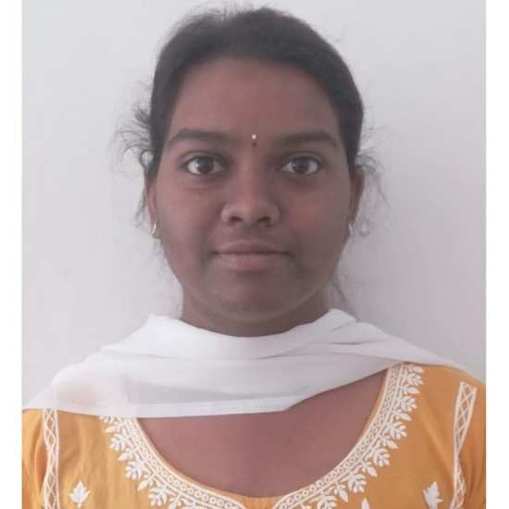
Course Applied | Master  (Choose one and delete the other)
Name | CHILAGANI AISHWARYA
Date of Birth (DD/MM/YYYY) | 05/06/2005
Age (on April 1, 2027) | 21 years
Current Address (Do not omit city name.) | House no:3-134, Road no:4, NSR Nagar colony, Manneguda, Turkayamjal, Abdullapurmet mandal, Rangareddy district, Hyderabad. PIN 501510
Contact No. (write only one, if it is more than one, mention it as alternative no.) | 91+8790451483, Alternative no:91+9346602836
Email id (write only one) | chilaganidharmaraj@gmail.com

Educational Qualification:
 | Name of Institution (School/College/University/Institute) and Place/City | Year of Passing | Score (Percentage only*)
10th Grade | ZPHS, Ragannaguda | 2020 | 97%
12th Grade | Sri Chaitanya Technical Campus, Sheriguda | 2023 | 82.365%
Bachelor Degree  (Computer Science Engineering AI&ML ) | Siddhartha Institute of Engineering and Technology, Ibrahimpatnam | 2026 | 80%
Master Degree  (Please Specify) | N/A
M.Phil./Ph.D. | N/A
Any other national exam like NET/GATE/GPAT etc  (Relevant certificate must be pasted at the end of this form and keep in mind the size of the whole document) | N/A
* Those who have CGPA score must convert grade into percentage according to the respective university’s formula/guidelines.
* If you are currently pursuing a course, please indicate the score obtained up to the most recent completed semester or year.

Employment Record (please begin with your current job and add rows if required)

Name and location of  the organization | Period of Employment | Position | Job profile

* Applicants are requested to list only full-time employment. Research Assistant positions and internships will not be counted as employment experience

Please mention if you have qualified for any of the following along with the respective score and year of qualifying:
1) TOEFL/ IELTS
2) GRE

List of Award/Certificate/Medal, if any (give specific details)
- State level award:
- National level award:
- International level award:

Publication Details (in the given format):
- Research article/Review/book chapter, etc.:
Title:

Journal Name:

Authors (in the same order they appear in publication)
Year/Vol/Page
DOI no. (or direct link to webpage) (mandatory):

Impact factor, if any (only Clarivate Analytics impact factor):

Publisher:
Master’s Thesis details:
Title:

Area of research:

Supervisor’s name:

Abstract:

Name of publication out of master’s thesis, if any:

専攻分野及び研究計画
Field of Study and Research Plan
Name (in alphabet)
(氏名(ｱﾙﾌｧﾍﾞｯﾄ)) _____Chilagani__________________, ________ Aishwarya________________, ________________
(Surname) (Given name) (Middle name)
Nationality
（国 籍）___________________________Indian___________________________________________________

≪Guide for Creating a Field of Study and Research Plan Sheet/作成要領≫
(1) As this sheet is one of the most important references for selection and university placement, outline your field of study and specify your research theme and plan in line with the following items 1 and 2. If plagiarism or fraud is discovered after selection, the selection will be cancelled retroactively.
本様式は選考及び大学配置の重要な参考となるので、下記の項目1 及び2 に沿って専攻分野の概要及び研究計画の詳細を具体的 に記入すること。なお、採用後に不正、盗用等が判明した場合は遡って採用を取り消す。
(2) This sheet must be typewritten or written in block letters. If possible, please write in Japanese.
記入はタイプ又は楷書によるものとする。相当の日本語能力を有する者は日本語により記入すること。
(3) This sheet must be created within two pages. Additional materials may be attached if necessary. Both a single-side and dual-side printing will be acceptable.
本様式は２ページ以内で作成すること。ただし必要な場合は別紙を付してもよい。印刷は片面印刷、両面印刷のどちらも可。

1. Past and present field of study（これまでの専攻分野）

Past field: Bachelor of Technology (B.tech) in Computer science and engineering (Artificial intelligence and machine learning)
Present field of study: Looking for masters

2. Research theme and plan in Japan（渡日後の研究テーマ及び研究計画）
Describe articulately the research theme and plan you wish to carry out in Japan. Specify particularly the ultimate goal(s) of your research in Japan.（日本において希望する研究テーマ及び研究計画を明確に記入すること。特に研究の最終目標を具体的に記入すること。）

- Research theme（研究テーマ）
Artificial Intelligence-Based Cybersecurity System for Secure Smart Infrastructure and Advanced Threat Detection
This research theme focuses on the development of an artificial intelligence-based cybersecurity system to improve the security of modern smart infrastructure and digital communication networks. The proposed research aims to utilize machine learning and deep learning techniques to detect cyber threats, analyze malicious activities, identify abnormal network behavior, and enhance intrusion detection systems in real time. The study will include data prepossessing, threat classification, anomaly detection, and automated response mechanisms to strengthen information security in smart cities, IoT environments, and critical digital systems. The ultimate goal of this research is to contribute to the development of secure and intelligent digital infrastructure in modern society.
(2) Research plan（研究計画）
AI-Driven Intelligent Network Security System for Cyber Threat Prediction and Prevention
This research theme focuses on the development of an AI-driven intelligent network security system for predicting, detecting, and preventing modern cyber threats in digital environments. The proposed research aims to apply machine learning and deep learning algorithms to analyze large-scale network data, identify malicious activities, recognize abnormal traffic patterns, and improve the efficiency of intrusion detection systems. The study will include data preprocessing, predictive threat analysis, malware classification, anomaly detection, and automated response techniques to strengthen cybersecurity in cloud computing, IoT networks, and smart digital infrastructure. The ultimate objective of this research is to enhance secure digital transformation by integrating artificial intelligence technologies with advanced cybersecurity solutions.

Placement Preference Application Form (Preliminary Application Form)

Preference | Name of University | Name of Graduate School | Name of Professor
First choice | Japan Advanced Institute of Science and Technology (JAIST) | School of Information Science | Prof. Eiichiro Fujisaki
Second choice | Nara Institute of Science and Technology (NAIST) | Graduate School of Science and Technology | Prof. Youki Kadobayashi
Third choice | University of Aizu | Graduate School of Computer Science and Engineering | Prof. Akihito Nakamura

