**Boot_sector1:**

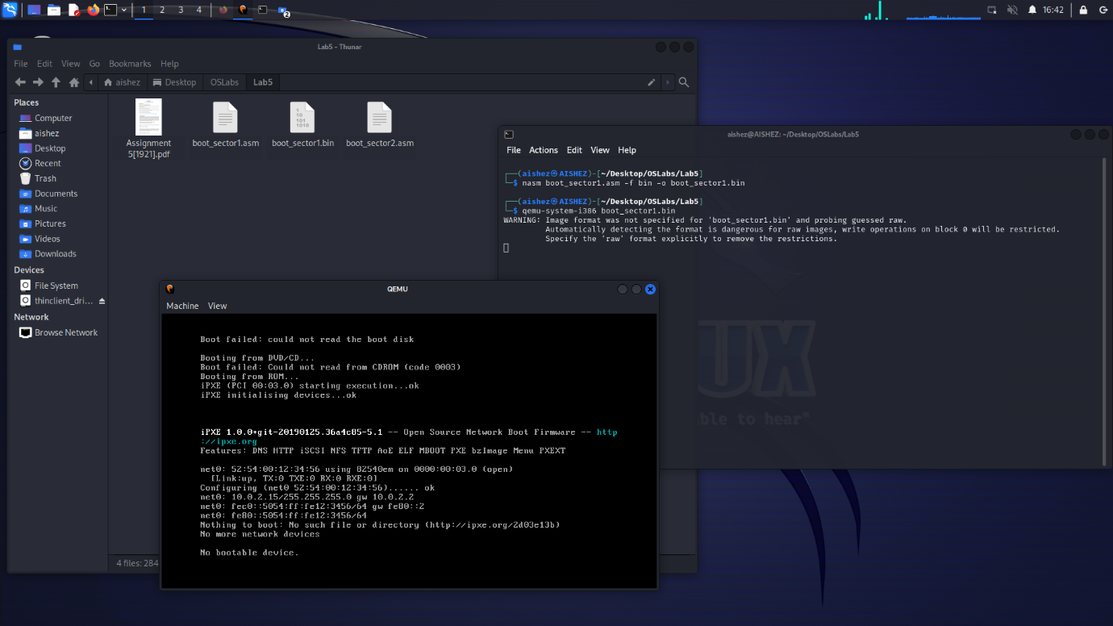

**Boot_Sector2**

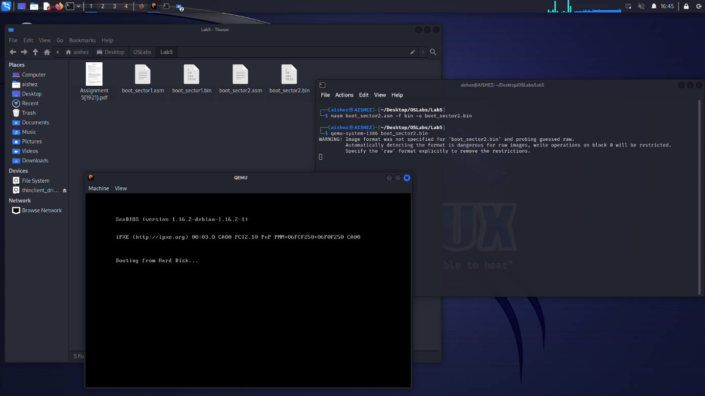

Difference between boot_sector1.asm and boot_sector2.asm is the presence of the magic number (0xaa55). Without this, the BIOS or emulator won't recognize the sector.  
  
that’s why in boot sector 1 emulator is showing no booting failed as it is not able to recognize it as a boot sector  
  
and in boot sector 2 emulator shows booting from hard disk since it was able to recognize boot sector 2 as a boot sector because of the magic number.

