**Name: Aishik Deb**

**SBU ID: 114833138**

I have used top 5 websites from the list available in <https://ahrefs.com/blog/most-visited-websites/> for conducting the experiment in Part C.

The five websites are as follows - **youtube.com, en.wikipedia.org, twitter.com, instagram.com, amazon.com.**

In total 3 experiments were conducted which are as follows –

1. Used self-implemented **Mydig** **tool** to resolve the DNS of the five websites as mentioned above. Conducted this experiment 10 times for each of the 5 websites and at last noted the average of the time taken by each website in milliseconds.
2. Use **Google DNS (8.8.8.8)** to resolve the DNS of the five websites as mentioned above. Conducted this experiment 10 times for each of the 5 websites and at last noted the average of the time taken by each website in milliseconds.
3. Use **Local DNS (192.168.214.243)** to resolve the DNS of the five websites as mentioned above. Conducted this experiment 10 times for each of the 5 websites and at last noted the average of the time taken by each website in milliseconds. Conducted the experiment for Local DNS by

**Experiment 1 Output Data**

**Average DNS Resolution Time for MyDig**

youtube.com - 150.99511 msec

en.wikipedia.org - 660.5979399999999 msec

twitter.com - 403.34652 msec

instagram.com - 135.8164 msec

amazon.com - 346.88766 msec

**Experiment 2 Output Data**

**Average DNS Resolution Time for Google DNS**

youtube.com - 17.76463 msec

en.wikipedia.org - 17.93183 msec

twitter.com - 10.568529999999999 msec

instagram.com - 15.954400000000001 msec

amazon.com - 11.374079999999998 msec

**Experiment 3 Output Data for Local DNS**

**Average DNS Resolution Time**

youtube.com - 18.50693 msec

en.wikipedia.org - 17.734029999999997 msec

twitter.com - 10.29989 msec

instagram.com - 16.29666 msec

amazon.com - 12.30615 msec

**Graph Output**

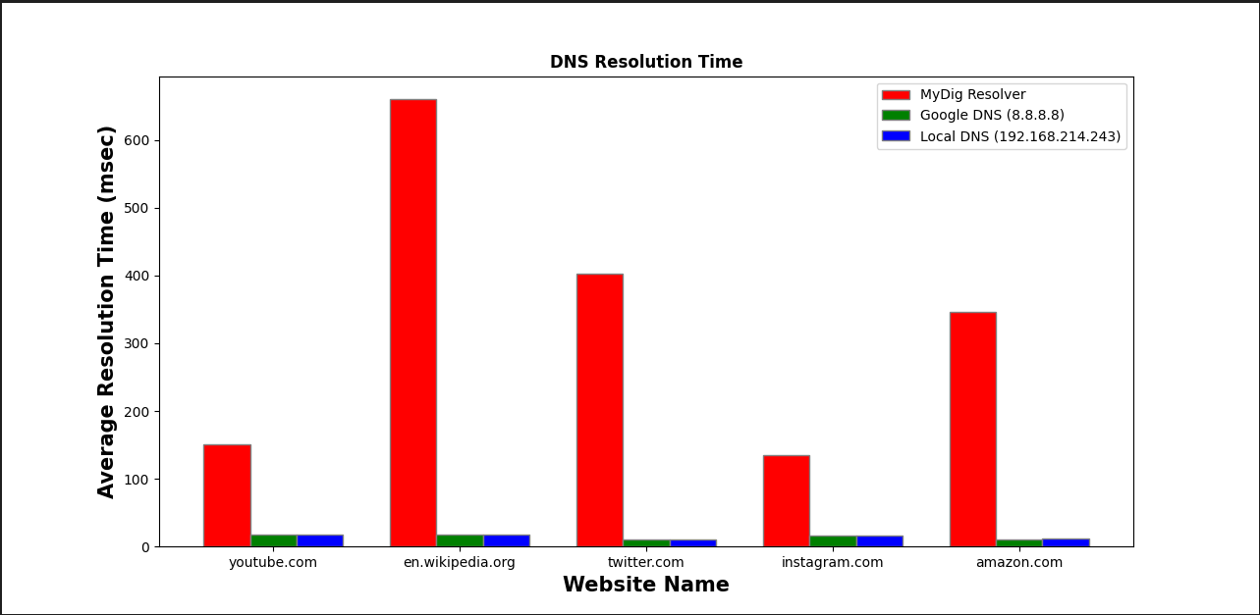

**Observation**

A graph was plotted for **Average Resolution Time (in msec) vs Website Name** for each of the 5 websites mentioned beforehand.

It can be observed from the graph that the Mydig tool takes the most amount of time compared to the Google DNS and the Local DNS. One major factor owing to this output was the absence of caching in the Mydig implementation. Both Google DNS & Local DNS implement caching at all levels thereby drastically reducing the computation time for each DNS resolution.