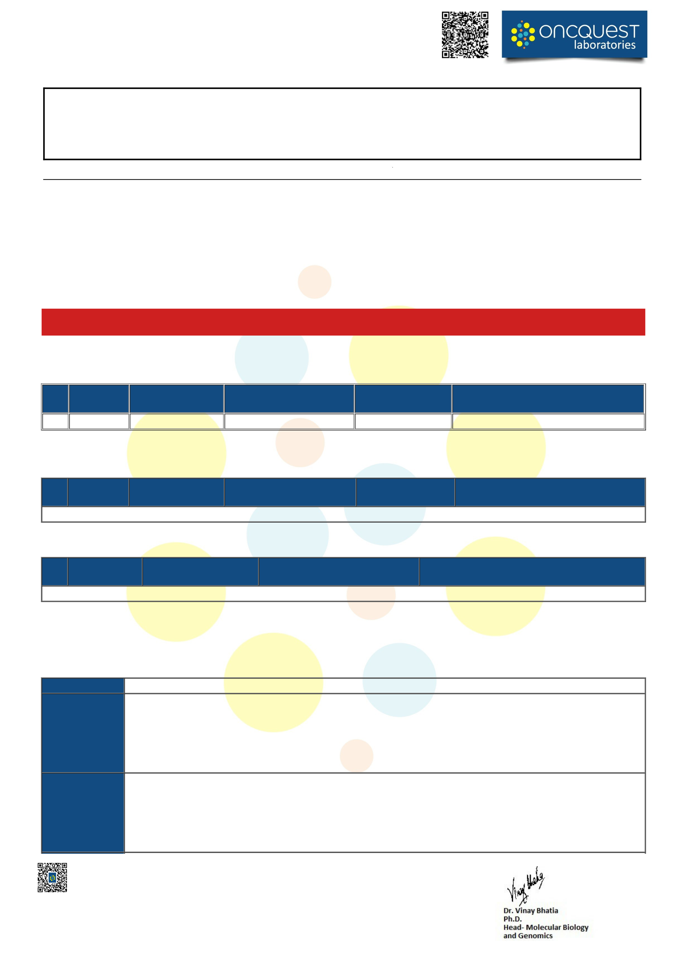
Name | : Mr.PRASANT KUMAR JENA | Centre Details | :AIIMS BHUBNESWAR
Age | : 72 Yrs Sex: Male | Accession.ID | :OQG2607020430
Collection Date | : 01/Jul/2026 12:00AM | Referred By | :DR.SAROJ KUMAR DAS MAJUMDAR
Received Date | : 02/Jul/2026 02:34PM | Report Date | :15/Jul/2026 04:22PM
Registration Date: 02/Jul/2026 02:34PM |  | Ref.No/TRF.No | : /

DEPARTMENT OF MOLECULAR DIAGNOSTICS-II
OncqSol Focus 52 Gene Panel
Next Generation Sequencing
Clinical Indication:Signet ring cell carcinoma. To rule out carcinoma colon Specimen: Slides from FFPE Block: 26106/356
Site: Biopsy from ulceroproliferative growth from hepatic flexure of colon
Test Result Summary
POSITIVE

Clinically relevant actionable variant was detected in KRAS gene
TABLE 1: ALTERATIONS WITH STRONG CLINICAL PROGNOSTIC AND THERAPEUTIC SIGNIFICANCE IN PATIENT TUMOR TYPE *Refer to attachment for Clinical Trials
Gene | CDS variant details | Amino acid  change/ Exon No. | Overall depth/ Mutant Allele Percentage | Function of the gene in cancer | Variant Classification and its relevance in patient tumor type
KRAS | c.35G>T | p.Gly12Val/ Exon 2 | 1537x/ 16.72% | Gain-of-Function | Tier I:A
TABLE 2: NON DRUGGABLE / DRUGGABLE ALTERATIONS WITH POTENTIAL CLINICAL AND THERAPEUTIC SIGNIFICANCE IN OTHER TUMOR TYPES
Gene | CDS variant details | Amino acid change/ Exon No. | Overall depth/ Mutant Allele Percentage | Function of the gene in cancer | Variant Classification and its relevance in other tumor type
None
TABLE 3: VARIANTS OF UNKNOWN SIGNIFICANCE
Gene | CDS variant details | Amino acid change/ Exon No. | Overall depth/ Mutant Allele Percentage | Function of the gene in patient tumor/ Other tumor type
None
*Genetic test results are reported based on the recommendations of AMP-ASCO-CAP guidelines. #Correlation of the genetic findings with the clinical condition of the patient is required to arrive at an accurate diagnosis, prognosis
or therapeutic decisions.
Variant Classification as per AMP-ASCO-CAP Guidelines
Variant | A change in a gene. This could be disease causing (pathogenic) or not disease causing (benign).
Tier I: Variants of Strong Clinical  Significance | Level A, biomarkers that predict response or resistance to US FDA-approved therapies for a specific type of tumor or have been included in professional guidelines as therapeutic, diagnostic, and/or prognostic biomarkers for specific types of tumors;  Level B, biomarkers that predict response or resistance to a therapy based on well- powered studies with consensus from experts in the field or have diagnostic and/or prognostic significance of certain diseases based on well-powered studies with expert consensus.
Tier II: Variants of Potential Clinical Significance | Level C, biomarkers that predict response or resistance to therapies approved by FDA or professional societies for a different tumor type (i.e., off-label use of a drug), serve as inclusion criteria for clinical trials, or have diagnostic and/or prognostic significance based on the results of multiple small studies.  Level D, biomarkers that show plausible therapeutic significance based on preclinical studies or may assist disease diagnosis and/or prognosis themselves or along with other biomarkers based on small studies or multiple case reports with no consensus.
Verify this report by scanning the QR code on top. In case of any discrepancy please report to 01246650000
The sample is processed through Oncquest Laboratories Ltd.; A-17 Infocity, Sector-34, Gurugram | Page 1 of 4

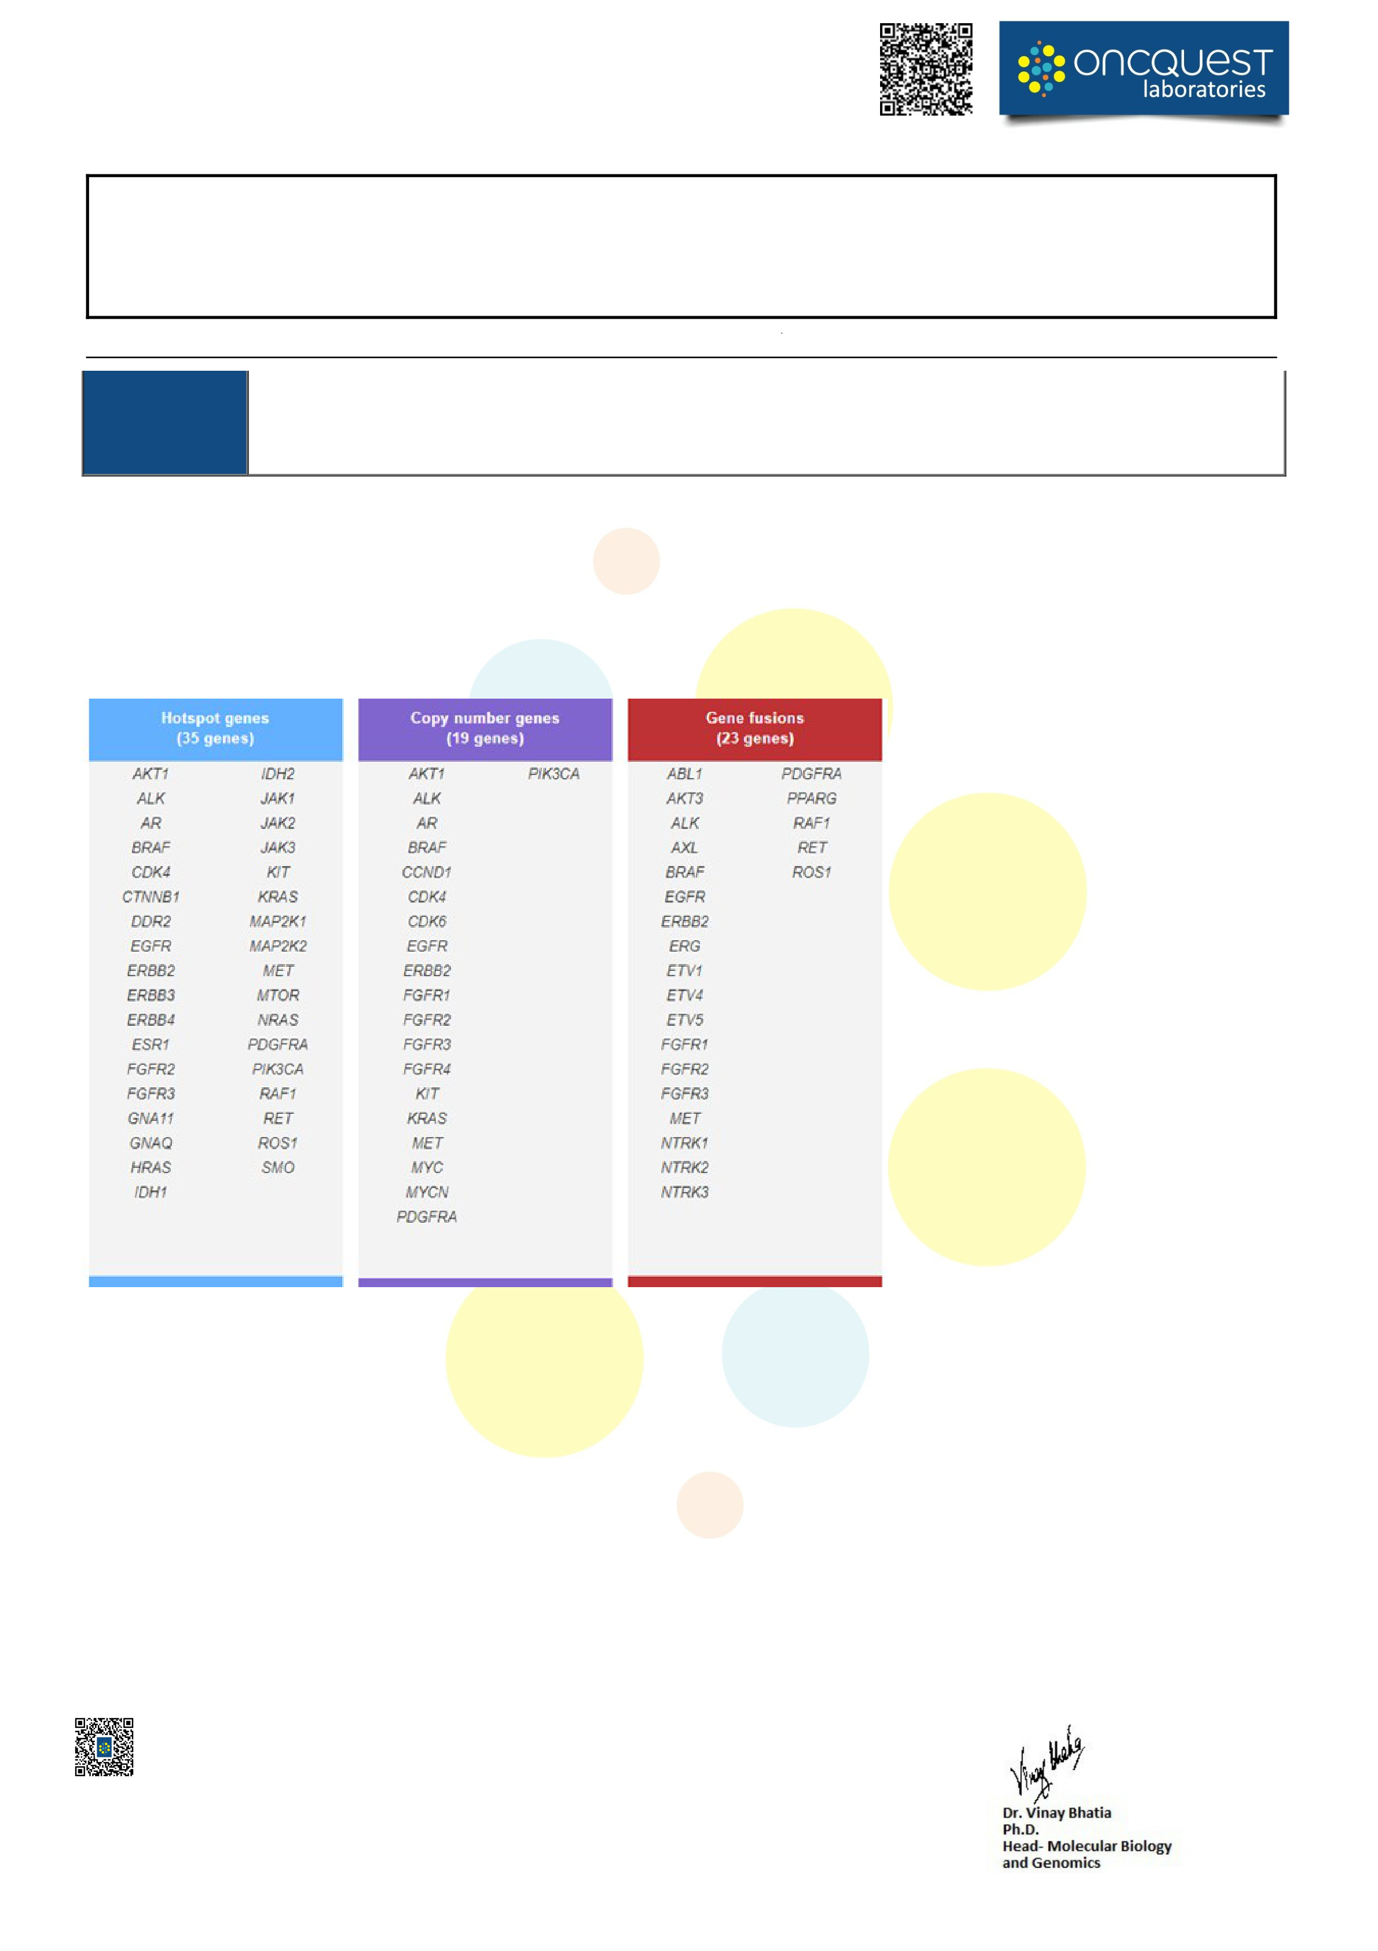
Name | : Mr.PRASANT KUMAR JENA | Centre Details | :AIIMS BHUBNESWAR
Age | : 72 Yrs Sex: Male | Accession.ID | :OQG2607020430
Collection Date | : 01/Jul/2026 12:00AM | Referred By | :DR.SAROJ KUMAR DAS MAJUMDAR
Received Date | : 02/Jul/2026 02:34PM | Report Date | :15/Jul/2026 04:22PM
Registration Date: 02/Jul/2026 02:34PM |  | Ref.No/TRF.No | : /

DEPARTMENT OF MOLECULAR DIAGNOSTICS-II
Tier III:
Variants of Not observed at a significant allele frequency in the general or specific subpopulation or pan cancer or tumor specific unknown clinical variant databases. No convincing published evidence of Cancer Association
significance
Test Attributes, Methodology
OncqSol Focus 52 Gene Panelis a multibiomarker next-generation sequencing (NGS) assay that enables detection of variants in 52 genes relevant to solid tumors. This assay allows concurrent analysis of DNA and RNA to simultaneously detect multiple types of variants, including hotspots, single-nucleotide variants (SNVs), indels, copy number variants (CNVs), and gene fusions, in a single workflow. Some of the alterations detected may provide prognostic/ therapeutic information that may help the Clinician in deciding upon the best line of Targeted/ Chemotherapy options for the patient.
Methodology
FFPE DNA was extracted from tissue using Qiagen Kit and FFPE RNA was extracted from tissue Promega Kit. The DNA and RNA were quantified on Qubit fluorometer. Amplicon based barcoded library was prepared using the extracted DNA and RNA. Libraries were pooled and loaded onto ION Torrent S5 NGS platform to perform massive parallel sequencing. The average Variant Allele Frequency (VAF) for this Test is 5% at 500X coverage. However, it may vary depending on the particular mutation type. Alterations outside of the tested areas of these genes or in other genes will not be detected. This Panel analyzed the following types of mutations- nucleotide substitutions, small insertions, small deletions, indels, CNVs & gene fusions. If the mutation(s) fall in the region of no/ low coverage zone, then they may be missed. Tumor sample must be fixed under appropriate conditions (10% Neutral buffered formalin for 12-72hrs) to ensure preservation of amplifiable quality DNA. PCR is a highly sensitive technique; reasons for apparently contradictory results may be due to improper quality control during sample collection and fixation, high degree of necrosis, mucin content and/or presence of PCR inhibitors. Cytosine deamination has been demonstrated to contribute to background noise for DNA sequencing of ancient and formalin fixed paraffin embedded (FFPE) treated DNA. Deamination can be attributed to multiple factors including biologic (intrinsic to the sample prior to isolation) or an artifact of the molecular biology. It has been observed that formalin induces C:G>T:A transitions during sequencing. These deamination related “apparent mutations” are higher in the FFPE samples than in peripheral blood indicating that the process of specimen
Verify this report by scanning the QR code on top. In case of any discrepancy please report to 01246650000
The sample is processed through Oncquest Laboratories Ltd.; A-17 Infocity, Sector-34, Gurugram | Page 2 of 4

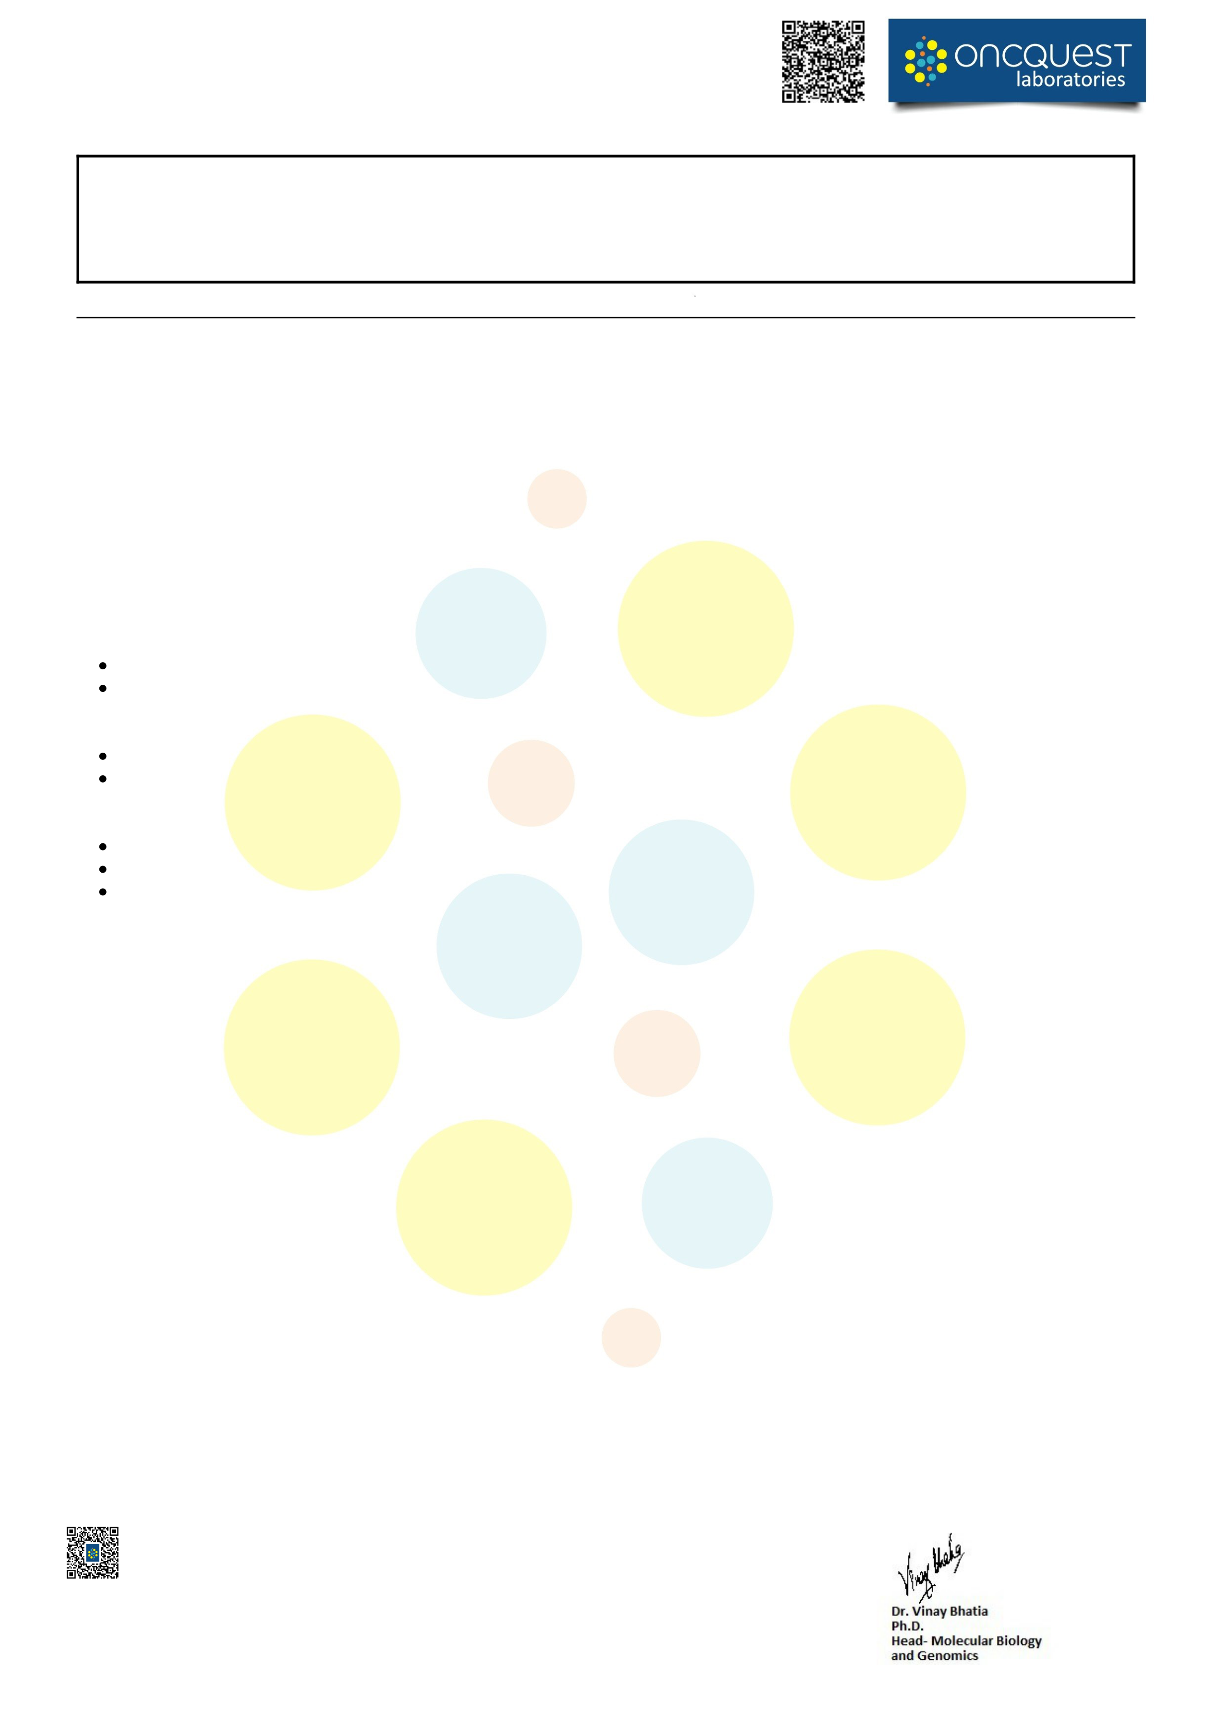
Name | : Mr.PRASANT KUMAR JENA | Centre Details | :AIIMS BHUBNESWAR
Age | : 72 Yrs Sex: Male | Accession.ID | :OQG2607020430
Collection Date | : 01/Jul/2026 12:00AM | Referred By | :DR.SAROJ KUMAR DAS MAJUMDAR
Received Date | : 02/Jul/2026 02:34PM | Report Date | :15/Jul/2026 04:22PM
Registration Date: 02/Jul/2026 02:34PM |  | Ref.No/TRF.No | : /

DEPARTMENT OF MOLECULAR DIAGNOSTICS-II
fixation highly contributes to the noise level.  The FASTQ reads were aligned against the hg19 in the Torrent suite software (v5.12). Variant calling w  The variants were annotated using Oncomine Focus Assay Annotations v1.7 and AMP-ASCO-CAP guidelines were followed for variant classification.  Database versions used  5000Exomes (Source Version:20161108), Canonical RefSeq Transcripts(Source Version:v95), C dbSNP(Source Version:153), DGV(Source Version:20160515), DrugBank(Source Version:201907 Ontology(Source Version:20190930), Named Variants(Source Version:1), Pfam(Source Ve Version:20160919), RefSeq Gene Functional Canonical Transcripts Scores(Source Version:10), RefS CitelineTrialTrove.  Limitation and Disclaimer  Variant with 250X coverage or more are considered for clinical correlation with the disease.  This test is limited to listed genes analysis only, It should be noted that this test does not seque  not all variants have been identified or interpreted, and this report is limited only to variants with evidence for causing or contributing to disease/clinical details.  This assay is not meant to interrogate most promoter regions, deep intronic regions, or other regulatory elements.  Data from this test is based on currently available scientific information. The classification of va  change over time.This data can be re-assessed for the presence of any variants that may be newly linked to be associated with cancer. The physician can request reanalysis of the data.  Certain genes may not be covered completely, and few mutations could be missed.  This NGS test used does not allow definitive differentiation between germline and somatic variants.  TREATMENT DECISIONS BASED ON THESE MUTATIONS MAY BE TAKEN IN CORRELATION WITH OTHER CLINICAL AND PATHOLOGICAL INFORMATION  All investigations have their limitation which is imposed by the limits of sensitivity and specificity of as the quality of the specimen received at laboratory.  Inclusion of variations is dependent upon our assessment of their significance. The quality of seque regions. Many factors such as homopolymers, GC-rich regions etc. influence the quality of sequencin occasional error in sequence reads or lack of detection of a particular genetic lesion.  Analysis  Torrent Variant Caller plugin – A SNP and indel calling analysis module that is part of the Torren through the Torrent Browser. The plugin can either be initiated automatically after sequencing data h or it can be initiated manually to process previously generated datasets.  Ion Reporter™ Software– A cloud-based software service that provides both variant calling and an features that are essential to researchers who perform sequencing assays. It comprises a suite of b and simplifies analysis, reporting, and archiving of semiconductor sequencing data. Ion Reporter™ and integrates comprehensive public annotations to reduce the bioinformatics work needed to unders and to shorten the time to interpret test results.  Oncomine™ Knowledgebase Reporter ‐ The Oncomine™ Reporter software matches genetic varian  relevant data from a curated set of published evidence from public sources. The software is used  sample-specific view of data with each variant matched with relevant data, including labels, guidelines, and clinical trials.  Variants of Unknown Significance (VUS) – These variants may not have been adequately character time this report was issued and/or the genomic context of these alterations makes their significance here in the event that they become clinically meaningful in the future.  Verify this report by scanning the QR code on top. In case of any discrepancy please report to 01246650000 The sample is processed through Oncquest Laboratories Ltd.; A-17 Infocity, Sector-34, Gurugram | as done using Ion Reporter (v5.20). lines were followed for variant  linVar(Source Version:20190909) 23), ExAC(Source Version:1), Gen rsion:32), PhyloP Scores(Sourc eq GeneModel(Source Version:95  nce all bases in a human genome, h evidence for causing or  gulatory elements.  riants of unknown significance can wly linked to be associated with  nts.  OTHER CLINICAL  individual assay procedures as we  ncing and coverage varies betwee g and coverage. This may result in a  t Suite™ Software and is accessibl ave been generated and bases calle  notations, designed with traceabilit ioinformatics tools that streamline Software fast‐tracks variant analysi tand the impact of detected variant  t information from a source file wit to prepare a report that presents s, and clinical trials.  ized in the scientific literature at th unclear. We choose to include the  Page 3 of 4

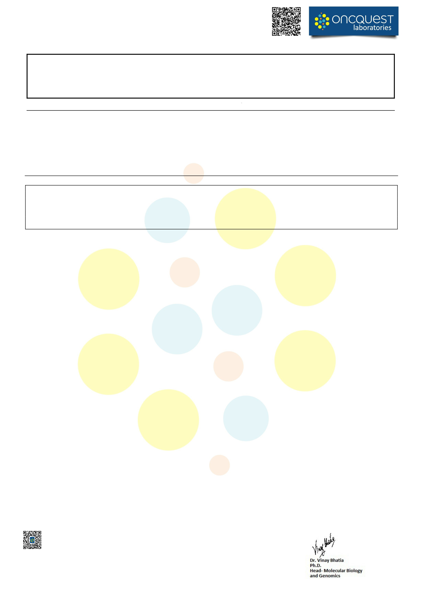
Name | : Mr.PRASANT KUMAR JENA | Centre Details | :AIIMS BHUBNESWAR
Age | : 72 Yrs Sex: Male | Accession.ID | :OQG2607020430
Collection Date | : 01/Jul/2026 12:00AM | Referred By | :DR.SAROJ KUMAR DAS MAJUMDAR
Received Date | : 02/Jul/2026 02:34PM | Report Date | :15/Jul/2026 04:22PM
Registration Date: 02/Jul/2026 02:34PM |  | Ref.No/TRF.No | : /

DEPARTMENT OF MOLECULAR DIAGNOSTICS-II
References:
1. Watson IR, Takahashi K, Futreal PA et al. (2013) Emerging patterns of somatic mutations in cancer. Nat Rev Genet 14(10):703–718 2. Kim TM, Xi R, Luquette LJ et al. (2013) Functional genomic analysis of chromosomal aberrations in a compendium of 8000 cancer genomes. Genome Res 23(2):217–227
Note: The performance of this Test has been evaluated at Oncquest Laboratories Ltd.
*** End Of Report ***
Disclaimer: All Results released pertain to the specimen submitted to the lab
1. Test results are dependent on the quality of the sample received by the lab
2. Tests are performed as per schedule given in the test listing and in any unforeseen circumstances, report delivery may be delayed 3. Test results may show interlaboratory variations
4. All dispute and claims are subjected to local jurisdiction only. Clinical correlation advised.
5. Test results are not valid for medico legal purposes
6. For all queries, feedbacks, suggestions, and complaints, please contact customer care support +0124 665 0000
Verify this report by scanning the QR code on top. In case of any discrepancy please report to 01246650000
The sample is processed through Oncquest Laboratories Ltd.; A-17 Infocity, Sector-34, Gurugram | Page 4 of 4


Case Number: OQG2607020430 | Report Date: 15 Jul 2026 | 1 of 5
Sample Cancer Type: Colon Cancer
Relevant Colon Cancer Findings
Gene | Finding | Gene | Finding
BRAF | None detected | NTRK2 | None detected
ERBB2 | None detected | NTRK3 | None detected
KRAS | KRAS G12V | PIK3CA | None detected
NRAS | None detected | RET | None detected
NTRK1 | None detected
Relevant Biomarkers
Genomic Alteration | Relevant Therapies | Relevant Therapies | Clinical Trials
 | (In this cancer type) | (In other cancer type)
KRAS G12V | bevacizumab + chemotherapy | avutometinib + defactinib 1 | 14
Allele Frequency: 16.72%
* Public data sources included in relevant therapies: NCCN, ESMO, FDA1
Alerts informed by public data sources: Contraindicated,  Resistance,  Breakthrough,  Fast Track
KRAS G12V | cetuximab 1, panitumumab 1
Public data sources included in alerts: NCCN, ESMO, FDA1
Biomarker Descriptions
KRAS G12V
KRAS proto-oncogene, GTPase
Background: The KRAS proto-oncogene encodes a GTPase that functions in signal transduction and is a member of the RAS superfamily which also includes NRAS and HRAS1. RAS proteins mediate the transmission of growth signals from the cell surface to the nucleus via the PI3K/AKT/MTOR and RAS/RAF/MEK/ERK pathways, which regulate cell division, differentiation, and survival2,3,4. Germline mutations in KRAS lead to several genetic disorders known as RASopathies, including Noonan syndrome, which results in heart and congenital defects, growth inhibition, and facial dysmorphic features5. Somatic mutations in KRAS are commonly altered in several cancers including non-small cell lung cancer, pancreatic cancer, and multiple myeloma5.
Alterations and prevalence: The majority of KRAS mutations consist of point mutations occurring at G12, G13, and Q616,7,8. Mutations at A59, K117, and A146 have also been observed but are less frequent9,10. Somatic mutations in KRAS are observed in 66% of pancreatic adenocarcinoma, 41% of colorectal adenocarcinoma, 30% of lung adenocarcinoma, 19% of uterine corpus endometrial carcinoma, 12% of uterine carcinosarcoma, 9% of stomach adenocarcinoma, 8% of testicular germ cell tumors, 6% of cholangiocarcinoma, 5% of cervical squamous cell carcinoma, acute myeloid leukemia, and diffuse large B-cell lymphoma, 4% of bladder urothelial carcinoma, and 2% of skin cutaneous melanoma and kidney renal papillary cell carcinoma6,9. KRAS is amplified in 9% of ovarian serous cystadenocarcinoma and testicular germ cell tumors, 8% of stomach adenocarcinoma , 7% of esophageal adenocarcinoma and uterine carcinosarcoma, 6% of lung adenocarcinoma, 4% of pancreatic adenocarcinoma and bladder urothelial carcinoma, 3% of lung squamous cell carcinoma, and 2% of sarcoma, mesothelioma, brain lower grade glioma, and uterine corpus endometrial carcinoma6,9.
Alterations in KRAS are also observed in pediatric cancers9. Somatic mutations in KRAS are observed in 10% of B-lymphoblastic
Disclaimer: The data presented here are from a curated knowledge base of publicly available information, but may not be exhaustive. The data version is 2026.06(004). The content of this report has not been evaluated or approved by the FDA, EMA or other regulatory agencies.

Case Number: OQG2607020430 | Report Date: 15 Jul 2026 | 2 of 5
Biomarker Descriptions (continued)
leukemia/lymphoma (24 in 252 cases), 8% of leukemia (29 in 354 cases), and in less than 1% of embryonal tumors (2 in 332 cases), glioma (1 in 297 cases), Wilms tumor (1 in 710 cases), and peripheral nervous system cancers (1 in 1158 cases)9. KRAS is amplified in less than 1% of B-lymphoblastic leukemia/lymphoma (1 in 731 cases)9. Structural alterations in KRAS are observed in less than 1% of acute lymphoblastic leukemia (1 in 85 cases)9.
Potential relevance: The FDA has approved the small molecule inhibitors, sotorasib11 (2021) and adagrasib12 (2022), for the treatment of adult patients with KRAS G12C-mutated locally advanced or metastatic non-small cell lung cancer (NSCLC). Sotorasib and adagrasib are also useful in certain circumstances for KRAS G12C-mutated pancreatic adenocarcinoma13. The FDA has approved adagrasib12 in combination with cetuximab (2024), and sotorasib11 in combination with panitumumab14 (2025) for KRAS G12C-mutated colorectal cancer (CRC) after prior fluoropyrimidine-, oxaliplatin-, and irinotecan-based chemotherapy. The EGFR antagonists, cetuximab15 and panitumumab14, are contraindicated for treatment of colorectal cancer patients with KRAS mutations in exon 2 (codons 12 and 13), exon 3 (codons 59 and 61), and exon 4 (codons 117 and 146)10. The FDA has approved the combination of kinase inhibitors, avutometinib and defactinib16 (2025), for the treatment of adult patients with KRAS-mutated recurrent low-grade serous ovarian cancer (LGSOC) after prior systemic therapy. The FDA has granted breakthrough therapy designation (2022) to the KRAS G12C inhibitor, GDC-603617, for KRAS G12C-mutated NSCLC. The KRAS-G12C/NRAS-G12C dual inhibitor, elironrasib18, and the KRAS G12C inhibitor, D3S-00119, were both granted breakthrough therapy designation (2025) for KRAS G12C-mutated locally advanced or metastatic NSCLC in adults previously treated with chemotherapy and immunotherapy, excluding KRAS G12C inhibitors. The KRAS-G12C inhibitor, olomorasib20, was granted breakthrough designation (2025) in combination with pembrolizumab21 for unresectable advanced or metastatic NSCLC with a KRAS G12C mutation and PD-L1 expression ≥ 50%. The RAF/MEK clamp, avutometinib22 was also granted fast track designation (2024) in combination with sotorasib for KRAS G12C-mutated metastatic NSCLC in patients who have received at least one prior systemic therapy and have not been previously treated with a KRAS G12C inhibitor. The KRAS G12C inhibitor, BBO-852023, was granted fast track designation in 2025 for previously treated KRAS G12C-mutated patients with metastatic NSCLC. The RAS(ON) G12D-selective inhibitor, zoldonrasib24, was granted breakthrough designation (2026) for patients with KRAS G12D-mutated locally advanced or metastatic NSCLC who have been previously treated with anti-PD-1/PD-L1 therapy and platinum-based chemotherapy. The RAS inhibitor, daraxonrasib25, was granted breakthrough designation (2025) for previously treated metastatic pancreatic ductal adenocarcinoma (PDAC) with KRAS G12 mutations. The KRAS G12D (ON/OFF) inhibitor, GFH-37526, was also granted fast track designation (2025) for first-line and previously treated KRAS G12D-mutated locally advanced or metastatic PDAC. The pan-KRAS inhibitor, BBO-1181827, was also granted fast track designation (2026) for adult patients with advanced KRAS-mutant PDAC. The KRAS G12C inhibitor, D3S-00128, was granted fast track designation in 2024 for KRAS G12C-mutated patients with advanced unresectable or metastatic CRC. The PLK1 inhibitor, onvansertib29, was granted fast track designation (2020) in combination with bevacizumab and FOLFIRI for second-line treatment of patients with KRAS-mutated metastatic CRC. The immuno-oncolytic virus, pelareorep30, was also granted fast track designation (2026) in combination with bevacizumab and FOLFIRI for second-line treatment of patients with KRAS-mutated microsatellite-stable metastatic CRC. Additionally, KRAS mutations are associated with poor prognosis in NSCLC31. Mutations in the RAS pathway, including KRAS, are ancillary diagnostic markers in pediatric gene fusion-negative rhabdomyosarcoma (RMS)32.
Clinical Trials Summary
KRAS G12V
NCT ID | Title | Phase
 | A Multicenter, Open-Label, Single-Arm, Phase Ib/II Clinical Study of Almonertinib Combined With Palbociclib in the Treatment of Patients With KRAS Mutations-Positive Advanced Solid Tumors | I/II
 | Phase I/II Clinical Study of KRAS Neoantigen Nanovaccine as Adjuvant Therapy for Colorectal Cancer/ Pancreatic Cancer With High Risk of Recurrence | I/II
 | Phase I Clinical Study on the Safety, Tolerance, Pharmacokinetics and Efficacy of YL-15293 in Patients With Advanced Solid Tumor With KRAS Mutation | I/II
 | A Phase I Clinical Study to Evaluate the Safety, Tolerability, Immunogenicity, Pharmacokinetics, Pharmacodynamics and Preliminary Anti-tumor Activity of ABO2102 in Participants With KRAS Mutant Solid Tumors | I
Disclaimer: The data presented here are from a curated knowledge base of publicly available information, but may not be exhaustive. The data version is 2026.06(004).

Case Number: OQG2607020430 | Report Date: 15 Jul 2026 | 3 of 5
Clinical Trials Summary (continued)
KRAS G12V (continued)
NCT ID | Title | Phase
 | A Phase I Study of ASP5834 in Participants With Locally Advanced (Unresectable) or Metastatic Solid Tumor Malignancies With KRAS Mutations or KRAS Amplifications | I  I  I  I  I  I/II  I/II  I  I  II
 | A Clinical Study of IX001 TCR-T In the Treatment of Advanced Pancreatic Cancer and Colorectal Cancer Induced by KRAS Mutations
 | An Open-Label, Dose-Escalation Phase I Clinical Study of T Cell Receptor Gene-Engineered T Cell Therapy Targeting KRAS Mutations in the Treatment of Subjects With Advanced Solid Tumor
No NCT ID | An open-label, multicenter Phase I clinical study to evaluate the safety, tolerability, pharmacokinetic characteristics, and immunogenicity of RGL-232 in patients with malignant solid tumors
 | Safety and Efficacy of KRAS Vaccine in the Treatment of KRAS-mutant Malignancies
 | A Phase I/II Clinical Study Evaluating the Safety, Tolerability, Pharmacokinetics, and Efficacy of BPI-572270 Capsules in Patients with RAS-mutant Advanced Solid Tumors.
A Multi-center, Open-label, Phase I/II Clinical Study to Evaluate the Safety, Tolerability,
Pharmacokinetics, and Antitumor Activity of JYP0015 in Advanced Solid Tumors With RAS Mutation
 | Phase I Study of BPI-442096 in Advanced Solid Tumor Patients
 | Treatment of Solid Tumors Harboring KRAS Mutation With Imatinib and Trametinib
 | Fruquintinib Combined With mFOLFOX6/FOLFIRI in First-line Treatment for Metastatic Colorectal Cancer:HCCSC C02 Trial
Disclaimer: The data presented here are from a curated knowledge base of publicly available information, but may not be exhaustive. The data version is 2026.06(004).

Case Number: OQG2607020430 | Report Date: 15 Jul 2026 | 4 of 5
References
1.  2.  3.  4.  5.  6.  7.  8.  9.  10.  11. 12. 13. 14. 15. 16. 17. 18. 19.  20.  21. 22.  23. 24. 25. 26. 27. 28.  29. 30.  31. | O'Leary et al. Reference sequence (RefSeq) database at NCBI: current status, taxonomic expansion, and functional annotation.  Nucleic Acids Res. 2016 Jan 4;44(D1):D733-45. PMID: 26553804  Pylayeva-Gupta et al. RAS oncogenes: weaving a tumorigenic web. Nat. Rev. Cancer. 2011 Oct 13;11(11):761-74. PMID: 21993244 Karnoub et al. Ras oncogenes: split personalities. Nat. Rev. Mol. Cell Biol. 2008 Jul;9(7):517-31. PMID: 18568040  Scott et al. Therapeutic Approaches to RAS Mutation. Cancer J. 2016 May-Jun;22(3):165-74. doi: 10.1097/  PPO.0000000000000187. PMID: 27341593  Johnson et al. Classification of KRAS-Activating Mutations and the Implications for Therapeutic Intervention. Cancer Discov. 2022 Apr 1;12(4):913-923. PMID: 35373279  Weinstein et al. The Cancer Genome Atlas Pan-Cancer analysis project. Nat. Genet. 2013 Oct;45(10):1113-20. PMID: 24071849 Román et al. KRAS oncogene in non-small cell lung cancer: clinical perspectives on the treatment of an old target. Mol Cancer.  2018 Feb 19;17(1):33. doi: 10.1186/s12943-018-0789-x. PMID: 29455666  Dinu et al. Prognostic significance of KRAS gene mutations in colorectal cancer--preliminary study. J Med Life. 2014 Oct-Dec;7(4):581-7. PMID: 25713627  Cerami et al. The cBio cancer genomics portal: an open platform for exploring multidimensional cancer genomics data. Cancer Discov. 2012 May;2(5):401-4. PMID: 22588877  Allegra et al. Extended RAS Gene Mutation Testing in Metastatic Colorectal Carcinoma to Predict Response to Anti-Epidermal Growth Factor Receptor Monoclonal Antibody Therapy: American Society of Clinical Oncology Provisional Clinical Opinion Update 2015. J. Clin. Oncol. 2016 Jan 10;34(2):179-85. PMID: 26438111  https://www.accessdata.fda.gov/drugsatfda_docs/label/2025/214665Orig1s009correctedlbl.pdf  https://www.accessdata.fda.gov/drugsatfda_docs/label/2026/216340s009lbl.pdf  NCCN Guidelines® - NCCN-Pancreatic Adenocarcinoma [Version 2.2026]  https://www.accessdata.fda.gov/drugsatfda_docs/label/2025/125147s213lbl.pdf  https://www.accessdata.fda.gov/drugsatfda_docs/label/2021/125084s279lbl.pdf  https://www.accessdata.fda.gov/drugsatfda_docs/label/2025/219616s000lbl.pdf  https://assets.cwp.roche.com/f/126832/x/5738a7538b/irp230202.pdf  https://ir.revmed.com/node/11881/pdf  https://www.prnewswire.com/news-releases/d3-bio-inc-announces-fda-breakthrough-therapy-designation-and-orphan-drug-designation-for-d3s-001-for-the-treatment-of-patients-with-kras-g12c-mutated-cancers-302540808.html  https://www.prnewswire.com/news-releases/lillys-olomorasib-receives-us-fdas-breakthrough-therapy-designation-for-the-treatment-of-certain-newly-diagnosed-metastatic-kras-g12c-mutant-lung-cancers-302545643.html  https://www.accessdata.fda.gov/drugsatfda_docs/label/2026/125514s190lbl.pdf  https://investor.verastem.com/news-releases/news-release-details/verastem-oncology-granted-fast-track-designation-combination  https://www.businesswire.com/news/home/20250109170439/en/  https://ir.revmed.com/news-releases/news-release-details/revolution-medicines-announces-fda-breakthrough-therapy-1 https://ir.revmed.com/news-releases/news-release-details/revolution-medicines-announces-fda-breakthrough-therapy https://investor.verastem.com/news-releases/news-release-details/verastem-oncology-granted-fast-track-designation-vs-7375 https://www.targetedonc.com/view/fda-grants-fast-track-designation-to-bbo-11818-in-kras-mutant-pdac  https://www.d3bio.com/press-releases/d3-bios-d3s-001-receives-u-s-fda-fast-track-designation-for-the-treatment-of-colorectal-cancer-with-kras-g12c-mutation  https://cardiffoncology.com/wp-content/uploads/2021/07/Cardiff_Oncology_Investor_Presentation-_July_2021.pdf  https://oncolyticsbiotech.com/press_releases/oncolytics-biotech-receives-fda-fast-track-designation-for-pelareorep-in-2l-kras-mutant-mss-metastatic-colorectal-cancer/  Slebos et al. K-ras oncogene activation as a prognostic marker in adenocarcinoma of the lung. N. Engl. J. Med. 1990 Aug 30;323(9):561-5. PMID: 2199829
Disclaimer: The data presented here are from a curated knowledge base of publicly available information, but may not be exhaustive. The data version is 2026.06(004).

Case Number: OQG2607020430 | Report Date: 15 Jul 2026 | 5 of 5
References (continued)
32. | NCCN Guidelines® - NCCN-Pediatric Soft Tissue Sarcoma [Version 1.2026]
Disclaimer: The data presented here are from a curated knowledge base of publicly available information, but may not be exhaustive. The data version is 2026.06(004).

