Whole exome with Mitochondrial Genome Sequencing
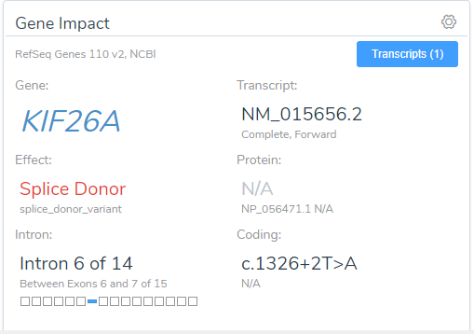 |  | 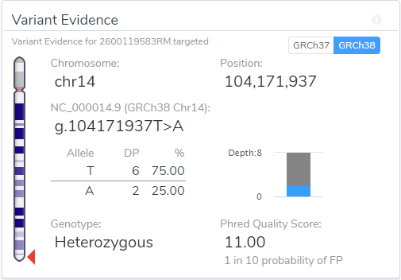
Prepared / Verified By | Reviewing Officer | Authorized Signatory
------------------ End Of Report ------------------

