Student Dropout Analysis for School Education
Using Statistical Aggregation and Random Forest.
Aishwarya Prabhu P
Dept of Computer Science and Engineering
Presidency University
Bengaluru, India
aishwaryaprabhup@gmail.com
Dr Riyazulla Rahman J Assistant Professor Senior Scale,
Dept of Computer Science and Information Science
Presidency University
Bengaluru, India
riyaz@presidencyuniversity.in
Bhargavi N
Dept of Computer Science and Engineering
Presidency University
Bengaluru, India
bhsrgavibhargavi@gmail.com

Bhargavi K
Dept of Computer Science and Engineering
Presidency University
Bengaluru, India
anandanandareddyk@gmail.com

Abstract—Student dropout in the system is a big problem that we still face in an attempt to achieve sustainable development and equal education opportunities. These are caste-based discrimination, poverty, gender inequality, and access to quality education, among other socioeconomic and infrastructural factors that lead to high dropout rates in India, and these are similar to the situation in the state of Karnataka. Our systematic framework allows us to combine machine learning, statistics and interactive visualisation together in the analysis and prediction of dropout trends. We came up with a model which involves Rand Forest classifier to detect high-risk students in terms of their demographic and institutional attributes. We have also designed a dashboard on Streamlit which enables interactive data analysis and presents dropout data on five prominent categories such as: school, area, gender, caste and grade or age level. This framework assists teachers to formulate targeted schemes such as financial aid assistance, midday meal and counselling. The findings indicate that predictive analytics and visualisation tool can be used to enhance the decision-making process based on data and they can be applied successfully when the problem concerns student retention.

Keywords— Student Dropout, Machine Learning, Statistical Aggregation, Streamlit Dashboard, Predictive Analytics, Random Forest.

Introduction

Besides being an essential part of social and economic development, the equal access to education is an urgent problem. A network of problems (family income, caste, gender, access to educational resources) is a complex of factors that has led to the rates of dropouts in the developed world, including India, the state of which Karnataka is. More so, we observe that not only are the early dropouts indicators of personal failure but also stagnation of workforce, community and the national and state development index.

In the past to solve dropout problems, basic solutions such as descriptive analytics and manual data gathering were employed and this at times failed to capture the problem causing drop out in schools. As the data-driven decision-making has expanded, it is now possible to implement predictive systems that can detect dropout trends and offer pre-emptive measures.

In this research study, statistical aggregation, data visualisation, and machine-learning classification algorithms like random forests are combined to know the trends in dropout in Karnataka. Teachers and policymakers can interactively analyze and interpret the trends and detect the at-risk population using a dashboard based on Streamlit.

Related work

The various machine learning models that have been explored in previously conducted dropout prediction studies to classify students at risk of dropping out of school include logistic regression, support vectors, and decision trees. Other studies have also brought out the impact of academic performance and socioeconomic status on dropout.

Regrettably, many of such models overlook interpretability and visualisation which play a vital role in the process of policymaking in favour of a focus on the accuracy measures. In recent educational data mining, to enhance data interpretation, visual analytics tools have been presented. Such tools as Tableau and Power BI have been used to represent dropout trends, though they often do not interact with predictive models. With the help of an interactive dashboard created with Streamlit, as well as a predictive system based on a random forest, this research bridges the gap and enables the analysis of the dropouts in real-time.

Methodology

As shown below, the three main parts of the suggested methodology are the visualisation dashboard, machine learning prediction, and data aggregation.

Data Collection and Preprocessing

The data that was used in the current research entailed student level and school level data that was taken as the secondary education records in Karnataka. The features include grade level, attendance, school infrastructure indicators, and demographics (gender, caste, and locality). To ensure the regularity of the input of machine learning algorithms, data preprocessing steps cover data missing values and categorical variables (through coding) and numerical attribute normalisation.

B. Aggregation of Statistics

Dropout rates and distributions are computed with statistical aggregation in a variety of categories such as gender, caste, age, area type (rural vs. urban) and grade level. This list provides the basic knowledge regarding the factors which have the greatest impact on dropout rates.

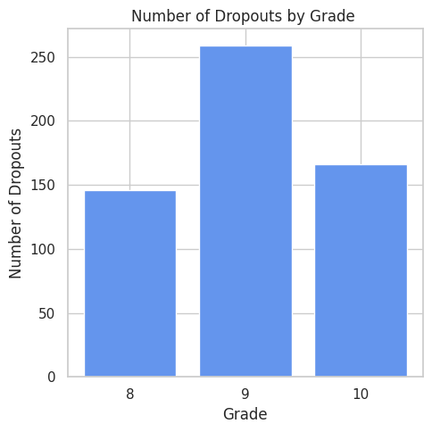

Fig. 1 Dropout Rate by Age and Grade

Fig.1 Students in Grade 9 (age 15) are the most likely to drop out of school, with dropout rates significantly higher than those in Grades 8 (age 14) or 10 (age 16). As a result, dropout prevention programs should strategically target Grade 9 (ages 15 and up).

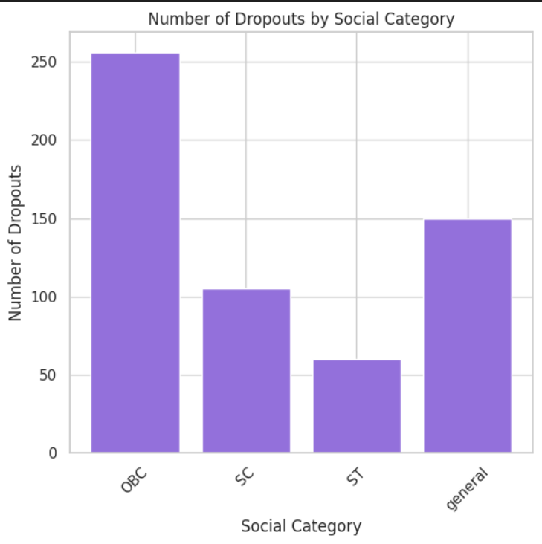

Fig. 2 Dropout Rate by Caste (Social Category)

Fig. 2: Dropout rates are highest among OBC, second among general, third among SC, and lowest among ST.

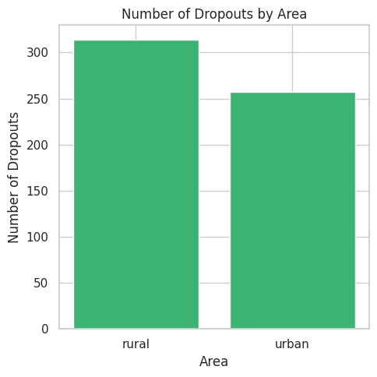

Fig. 3 Dropout Rate by Area (Locality)

Fig. 3 demonstrates that dropout rates are higher in rural areas than in urban areas

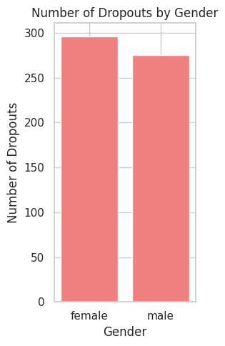

Fig. 4 Dropout Rate by Gender (Male or Female)

Fig. 4 demonstrates unequivocally that the gender-based dropout rate is higher for females than for males.

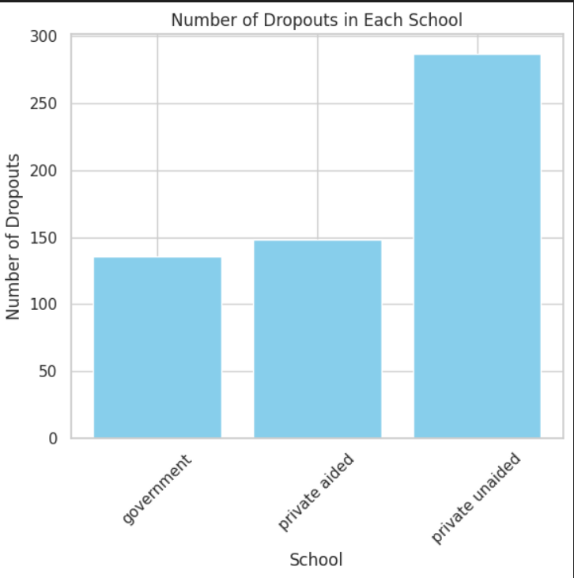
Fig. 5 Dropout Rate by School Type

Fig 5: This suggests that dropout risk is not evenly distributed and disproportionately impacts private unaided institutions, as private unaided schools are expected to have the highest number of dropouts, followed by private aided and government schools.

C. Model of Machine Learning

The predictive component is done using the Random Forest classifier that is a powerful ensemble algorithm known to be effective in handling categorical as well as numerical data. According to the presented features, the model is trained to decide whether a student is in a high or a low risk of dropping out.

The hyperparameter tuning methods are employed in order to optimise the maximum tree depth and the estimators to increase the model generalisation and reliability. The performance of the model is measured by such metrics as accuracy, precision, recall, and F1-score.

To identify the most important dropout predictors, the algorithm of the Random Forest was selected because of its interpretability and the ability to measure the importance of features.

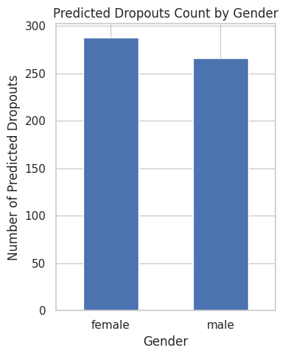

Fig. 6 Predicted Dropout Counts by Gender

Fig 6: The model predicts that females have a higher dropout rate than males.

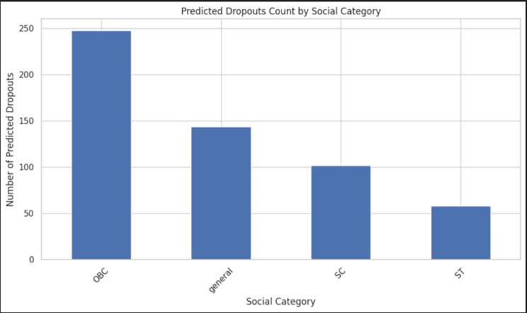

Fig. 7 Predicted Dropout Counts by Caste (Social Categories)

Fig 7: Observing that, OBC students are the most likely to drop out, followed by general, SC, and ST students.

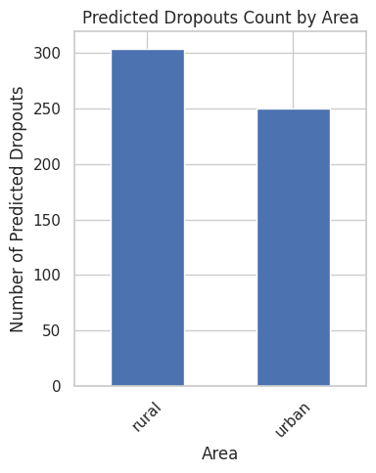

Fig. 8 Predicted Dropout Counts by Area (Locality)

Fig 8: Dropout rates are expected to be higher in rural areas than in urban ones. This indicates that rural students in this dataset might face particular difficulties that raise their risk of dropping out.

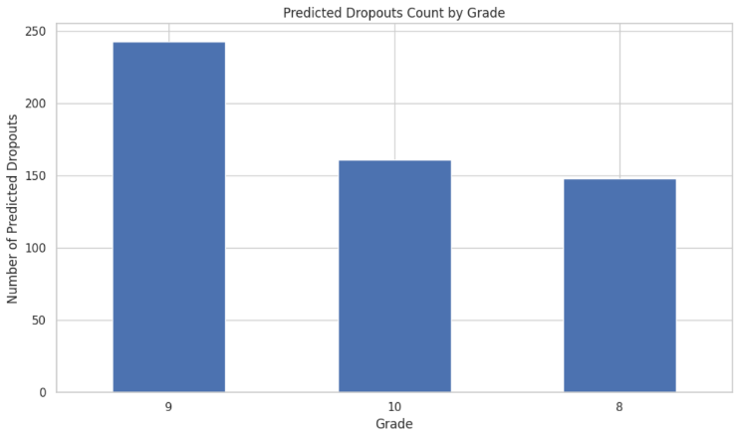

Fig. 9 Predicted Dropout Counts by Grade and Age

Fig 9: Students in Grade 9 (age of 15) are the most likely to drop out of school, with dropout rates higher than those in Grades 8 (age of 14) or 10 (age of 16). Therefore, grade 9 should be the focus of the dropout prevention program.

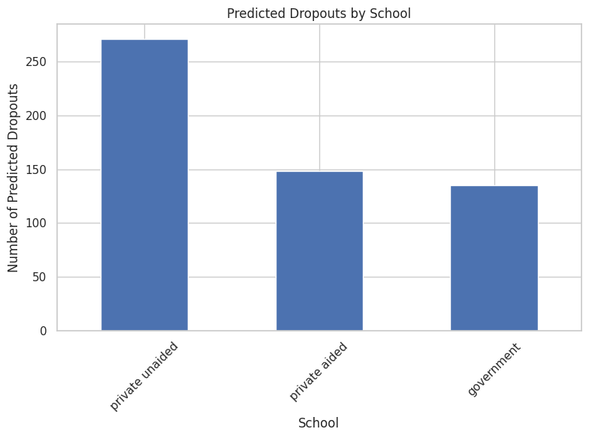

Fig. 10 Predicted Dropout Count by School Type

Fig 10: From the observed data, which shows that private unaided schools have the highest actual dropout rates, compared to private aided and government schools.

D. Streamlit Visualisation

A streamlit-based web dashboard that is utilized to present analytical insights in an interactive manner. The trends of the dropout can be viewed through charts and graphs, and data about the dashboard can be filtered in real time by the gender, caste or the school genre. Moreover, the predictive outcomes of the Random Forest model are presented in real time, which can be used by administrators and policymakers to identify the high-risk regions or groups of the population.

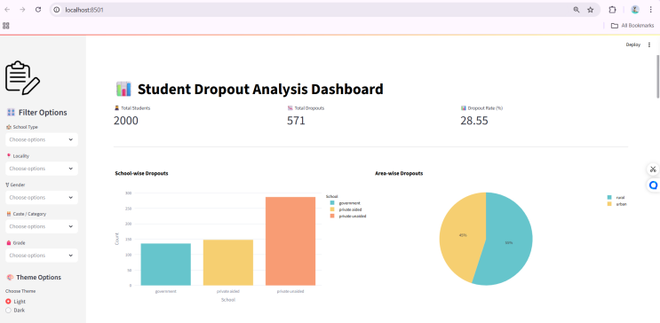

Fig. 11 Student Dropout Analysis Dashboard using Streamlit

Fig. 11: Where the dashboard is created using Streamlit. It is showing the data analysis of the dropouts.

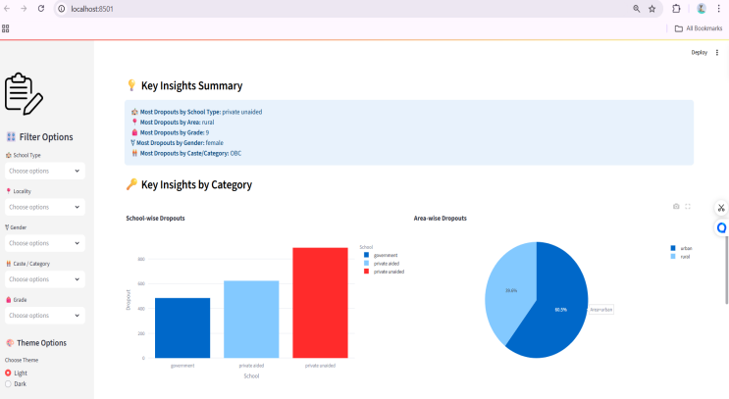

Fig. 12 Key insights by category Dashboard using Streamlit

Fig. 12: Showing the key insight charts for dropout students for 5 key categories.

Implementation and Results

The use of Python and other open-source software like pandas, NumPy, seaborn, and Streamlit are used in the implementation. Streamlit interface combines data aggregation and visualisation processes in a smooth manner to ensure easy exploration and comprehension.

According to the experimental results, the Random Forest model outperformed other baseline algorithms, like Decision Tree and Logistic Regression, which leads to the high-accuracy rate of the model. The importance of features analysis established that such factors as area type, caste category, and attendance rate are rather important in determining the likelihood of dropout. The visual representation of the dashboard allows the users to:

*Compare the dropout rates by geographical area and gender.
* Determine trends of a certain grade or age.
* Visualize the model predictions across sub datasets.

Such visual clarity can help the educational leaders distribute their resources more efficiently and implement timely intervention.

V.Discussion

The integration of machine learning and visualisation can change the manner in which we derive meaning and make decisions. The dashboard offers personalized insights and instant interpretability as opposed to the traditional statistical reports to address the varied stakeholder requirements. As a way of getting practical outcomes in the education sector, the study addresses the need to integrate data analytics and knowledge. Random Forest model is rather stable in its performance and the study points out the limitations of this model which includes quality data. Cloud combines deep learning models and longitudinal datasets to improve predictive capacity and future vision.

Conclusion and Future Work
The proposed research proposes a data-driven model that uses machine learning and data visualisation methods to analyse and forecast student dropout or attrition. The framework offers an in-depth study of dropout behaviour in various perspectives by using statistical aggregation, Random Forest classification, and interactive Streamlit Dashboard.
The findings suggest a possibility of assisting in policy formulation, resource utilization, and specific interventions in the sphere of education.
Future research will centre on automating the updating of the data based on the educational departments, incorporating more socioeconomic variables and using the model as a scalable web-based platform to be used by education institutions and government entitlement.

References

[1] G. Marcolino, J. Junior, and C. Lima, “Student dropout
prediction through machine learning optimisation: insights from
Moodle log data,” Scientific Reports, vol. 15, art. 11234, pp. 1–12,
2025. [Online]. Available: https://www.nature.com/articles/s41598-
025-93918-1
[2] M. A. Hassan, A. H. Muse, and S. Nadarajah, “Predicting
student dropout rates using supervised machine learning: Insights
from the 2022 National Education Accessibility Survey in
Somaliland,” Applied Sciences, vol. 14, no. 17, art. 7593, 2024.
[Online]. Available: https://doi.org/10.3390/app14177593
[3] A. Villar and C. R. Velini de Andrade, “Supervised machine
learning algorithms for predicting student dropout and academic
success: a comparative study,” Discover Artificial Intelligence, vol.
4, art. 2, 2024. [Online]. Available:
https://link.springer.com/article/10.1007/s44163-023-00079-z
[4] S. A. Sulak and N. Koklu, “Predicting student dropout using
machine learning algorithms,” Intelligent Methods in Engineering
Sciences, vol. 3, no. 3, pp. 91–98, 2024. [Online]. Available:
https://doi.org/10.58190/imiens.2024.103
[5] D. Andrade-Girón et al., “Predicting student dropout based on
machine learning and deep learning: A systematic review,” EAI
Endorsed Transactions on Scalable Information Systems, vol. 10,
No. 5, 2023. [Online]. Available: https://doi.org/10.4108/eetsis.3586
[6] “An explainable machine learning approach for student dropout
...,” Expert Systems with Applications, 2023. [Online]
[7] P. Salvou, M. Cowlishaw, or a similar study: “Statistical and
machine learning models for predicting university dropout,” PLOS
ONE, 2024. [Online].
[8] “Predicting student dropouts with machine learning: An
empirical study,” Computers in Human Behaviour Reports, 2024.
[Online].
Private-safe oriented student dropout ...,” PLOS ONE, 2024/2023.
[Online].
[9] A. Kemper, G. Vorhoff, and B. U. Wigger, “Predicting student
dropout: machine learning approach,” European Journal of
Higher Education, vol. 10, no. 1, pp. 28–47, 2020. [Online].
Available: https://doi.org/10.1080/21568235.2020.1718520

