COORPORATE ACTIONS

Company brings change in either

* In terms of number of shares increasing in the hands of the share holder
* Change in face value of the security or receiving shares of a new company

It indicates about the company’s financial affairs and how that action will influence the company’s share price and performance

DIVIDEND

* Returns received by investors in equities come in two forms:

1. Growth in the value of share
2. Dividend

* Dividend is distribution of part of company earnings to share holders , usually twice a year final and intern dividend
* Source of income for share holders
* Directors are head who take care of dividends

DIVIDEND YEILD

* Relationship between the current price of stock and dividend paid by its issuing company during last 12 months
* High dividend yield – under priced
* Low dividend yield – over priced

STOCK SPLIT

* It splits the existing shares of particular face value into smaller denominations

Why?

* Brings the share price down to a more attractive level
* May lead to stocks liquidity

STOCK CONSOLIDATION

* Reverse of stock split
* Present shares are combined to make smaller no of shares

BUY BACK OF SHARES

* Buying shares from other investors in the market
* Reduce number of outstanding shares in the market
* A company is permitted to buy back its share from:

1. Existing shareholders on a proportionate basis through the offer document
2. Open market through stock exchange using book building process
3. Share holder holding odd lot shares

* Company has a disclose pre and post buyback holding of promotes

INDEX

Nifty 50 index:

* 50 stock index, reflecting accurately the market movement of Indian markets
* It is a barometer of Indian markets
* Top 50 companies are present here
* IISL was setup in may 1998 to provide a variety of indices

CLEARING AND SETTLEMENT

Clearing corporation:

It is a part of exchange and separate entity and performs three functions

* Clears and settles the transaction
* Provides financial guarantee for all transactions
* Provides risk management functions

Rolling statement:

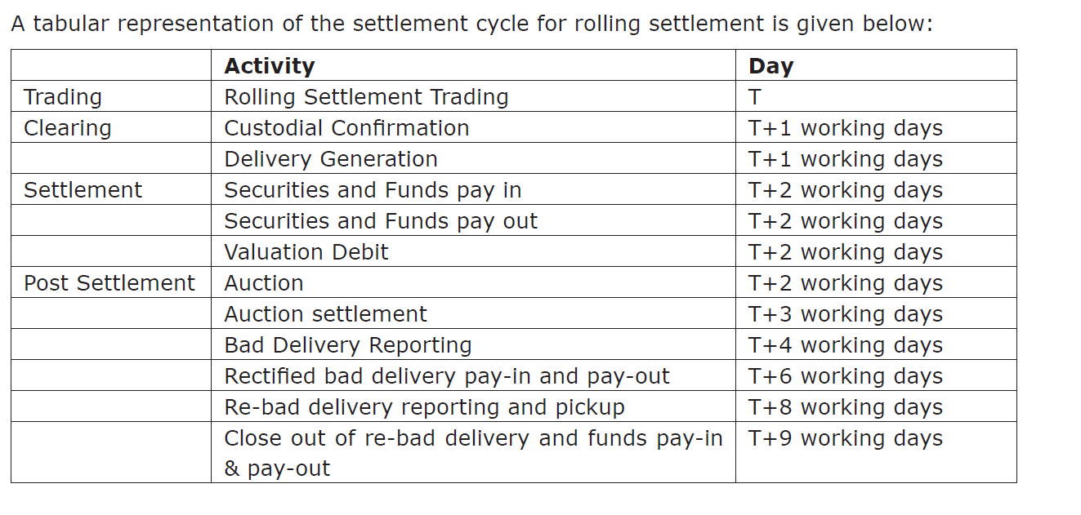

Pay in and pay out:

Pay in day:

Securities sold are delivered to exchange by the sellers and funds for the securities are made available to the exchange of buyers

Pay out day:

Securities purchased are delivered to buyers and funds for securities sold are given to sellers

On second working day

Auction:

On account of non-delivery of securities by the trading member on the pay-in day the securities are put in auction.

Bad Delivery:

Securities given for delivery could be mutilated or damaged or without signature or proper form

BOOK CLOSURE/RECORD DATE:

* Determines the exact share holders
* Closing of the register of the names of investors in the records of company
* The benefits of dividend, bond issue, right issue accrue to investors whose name appears on the company record on given date which is known as record date

Non delivery period:

When the company announces a book closure or record date the exchange sets up a no delivery period

Only trading is permitted

Ex-dividend date:

The date on or after which a security begins trading without dividend included in price

Ex- date:

The first date of the non-delivery period

ARBITRATION

* Resolving disputes

INVESTOR PROTECTION FUND:

IPF is utilised to settle claims of such investors where the trading members through whom the investor has dealt has been declared as defaulters

SEBI SCORES:

To place complaints

* Register
* Unique CN
* Takes issue
* Online complaint and view status

CONCLUSION

This chapter deals will all the miscellaneous things than an investor must keep in mind. Companies announce certain corporate actions like stock split, stock consolidation, bonus issue and buy back of shares which affect the stock holding by quantity and price. These must be kept in mind while trading in shares. Indices are the representative movement of the stock markets, Nifty is the index of NSE which is considered the benchmark of stock markets in India.

All trades in securities are cleared and settled through the rolling settlement in T+2 days. If certain securities are not settled, they are put up for auction. Certain dates like book closure, no record and ex-date become important while trading in securities.

One of the objectives of SEBI is investor protection. There is an investor protection fund of NSE and an arbitration mechanism in place to address the grievances of the investors. Apart from this, SEBI also has an online mechanism – SCORES for investor grievance redressal.