**Assessment-07**

**Assignment: Creating a Virtual Machine, SQL Server Database, and VPN Configuration in Azure Portal**

**Screenshots:**

**Virtual network**

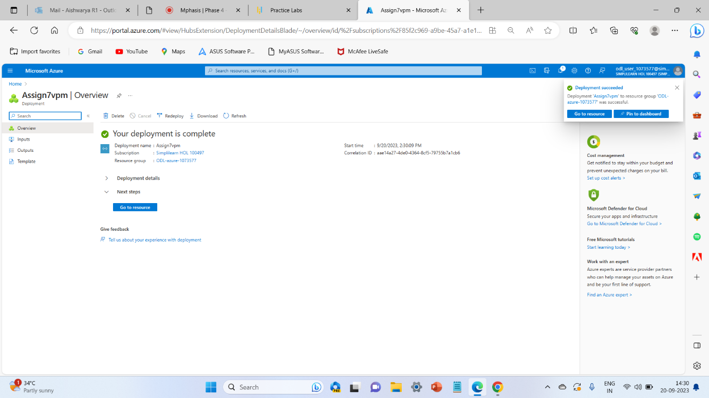

**Sql Database**

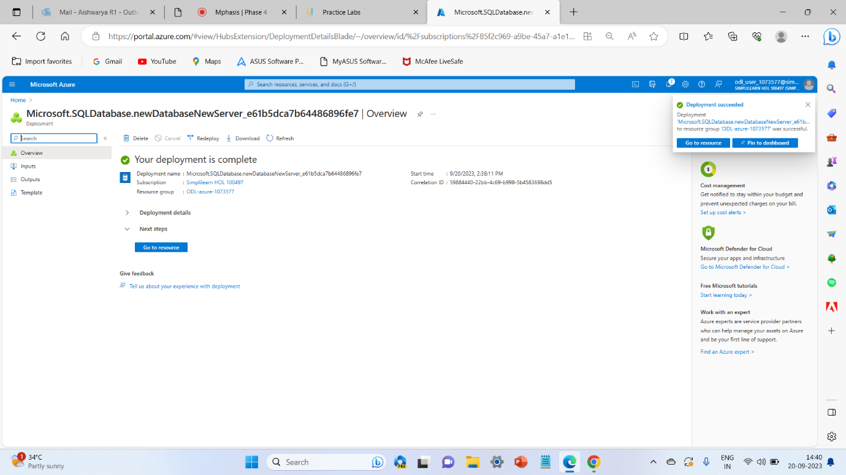

**Virtual Machine**

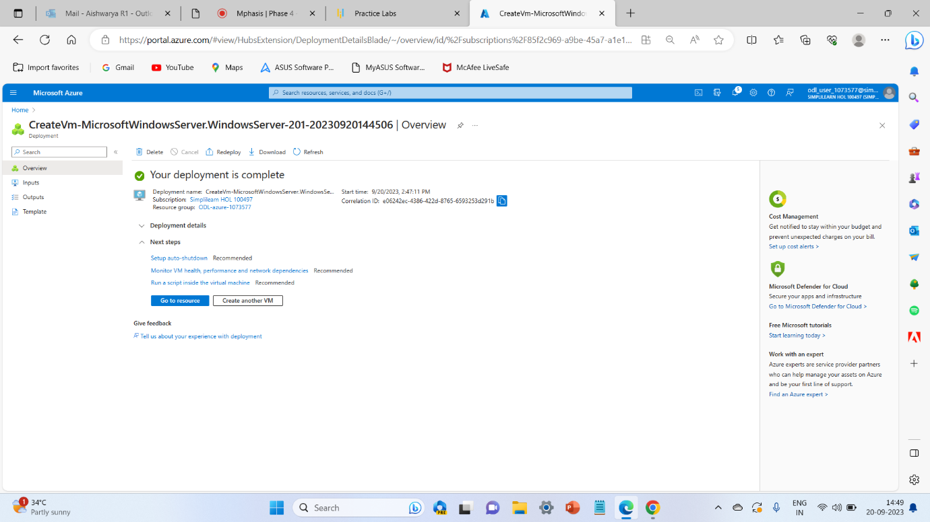

**Connecting VPN with Virtual Machines Outputs:**

