**\*\*\* MCQ questions (AJP & EST) \*\*\***

**A PROJECT REPORT**

**Submitted by**

**71 Priti Yalappa Yemutla**

**72 Aishwarya Ramakant Yemul**

**IN FULFILLMENT OF THE THIRD SEMESTER**

**IN**

**COMPUTER TECHNOLOGY**

***Under The Guidance of***

**Ms Priyanka Channapattan**

** **

**GOVERNMENT POLYTECHNIC , SOLAPUR**

**MAHARASHTRA STATE OF TECHNICAL EDUCATION , MUMBAI**

**CERTIFICATE**

** **

**MAHRASHTRA STATE BOARD OF TECHNICAL EDUCATION MUMBAI**

**GOVERNMENT POLYTECHNIC , SOLAPUR.** *This is to certify that the following students* :

**71 Priti Yalappa Yemutla**

**72 Aishwarya Ramakant Yemul**

*of fifth Semester of Diploma in* ***Computer Technology*** *of* ***Institute Government Polytechnic , Solapur ( Code : 0015 )***  *have complete the micro- project work satisfactorily under my supervision and guidance in subject* ***CGR***  *in topic MCQ questions (AJP & EST) in academic year 2019– 2020 as prescribed in the curriculm.*

Project guide **H.O.D.** principle **( Ms Priyanka Channapattan ) (Mr Arun Taragnge) (Mr Chitlange)**

**ACKNOWLEDGMENT**

We wish to express our profound and sincere gratitude to our guide PROF. Mrs. Priyanka Channapattan MAMa who guided us into the intricacies of this micro- project non-chalantly with matchless magnanimity. We are indebted to her constant encouragement , co-operation and help . It was his enthusiastic support that helped us in overcoming the various obstacles in this project .

We would also like to express our thankfulness to our beloved Principal , H.O.D. , and other faculty members of our Second Year Department for extending their support and motivation .

Thank you …..!!!!

**ABSTRACT**

The Graphical User Interface project , control system met all of the design goals and has been a useful for additional components to an application.

We can make our own applications by using we our pre-defined templates in our projects .This has the ability to manage to Applications in simple and easier way.This project also Validates the user by asking passwords.

Overall this project includes :

1. User name & roll number on registration form.
2. Subject choice i.e AJP & EST to choose user & this subjects has to levels.
3. Then system count scores for each tests.
4. And represent certificate if user excited to watch it.

**INTRODUCTION**

In information technology, the user interface (UI) is everything designed into an information device with which a person may interact. This can include display screens, keyboards, a mouse and the appearance of a desktop. It is also the way through which a user interacts with an application or a website. The growing dependence of many companies on web applications and mobile applications has led many companies to place increased priority on UI in an effort to improve the user's overall experience.

The graphical user interface (GUI) is a type of user interface that allows users to interact with electronic devices through graphical icons and visual indicators such as secondary notation, instead of text-based user interfaces, typed command labels or text navigation. GUIs were introduced in reaction to the perceived steep learning curve of command-line interfaces which require commands to be typed on a computer keyboard.

The project is the MCQ questions of AJP & EST to improve the study.

**AIMS and Scope OF THE Project**

The aim of project is the MCQ questions of AJP & EST to improve the study. This project provide mcq questions to student / user then user have four options to choose options.

Once this page is tested unit and integrationally the major defects from this code will be solved here. So in case if any error/defect occurs then we can refer the test cases did in past & fault identification will be easier also the location of fault will be found easily. So it is beneficial to save the time and cost. It will avoid the future defects so it is prevention of defects.

**Screenshots:**

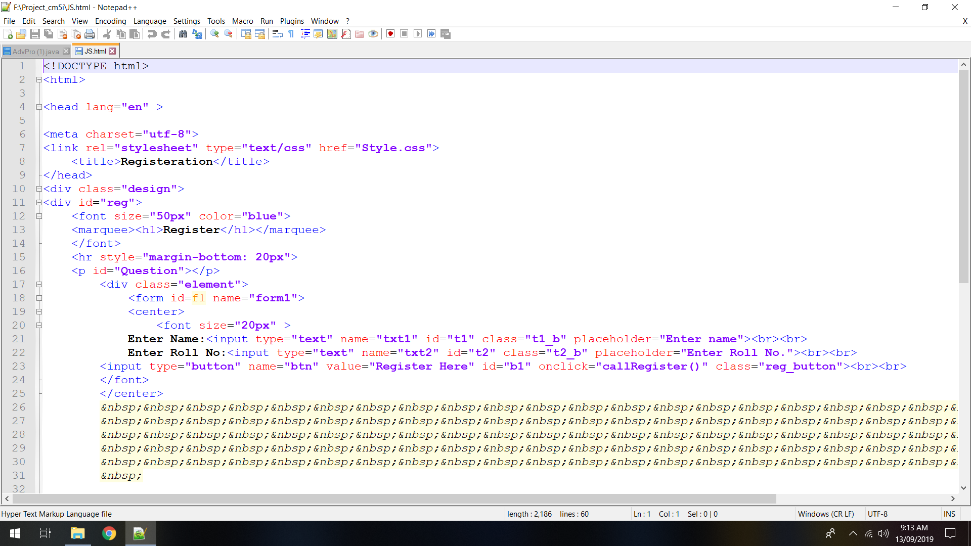

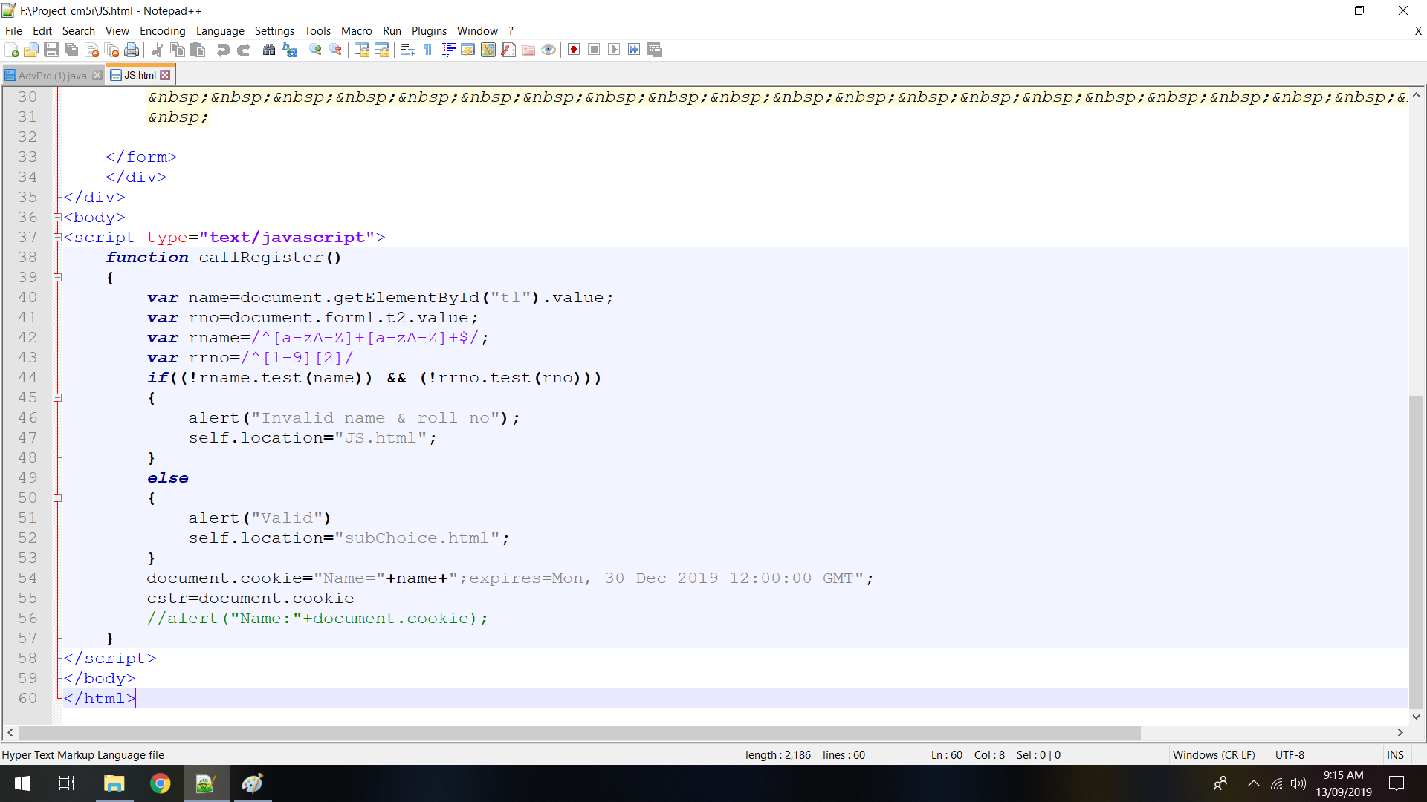

**Outputs**

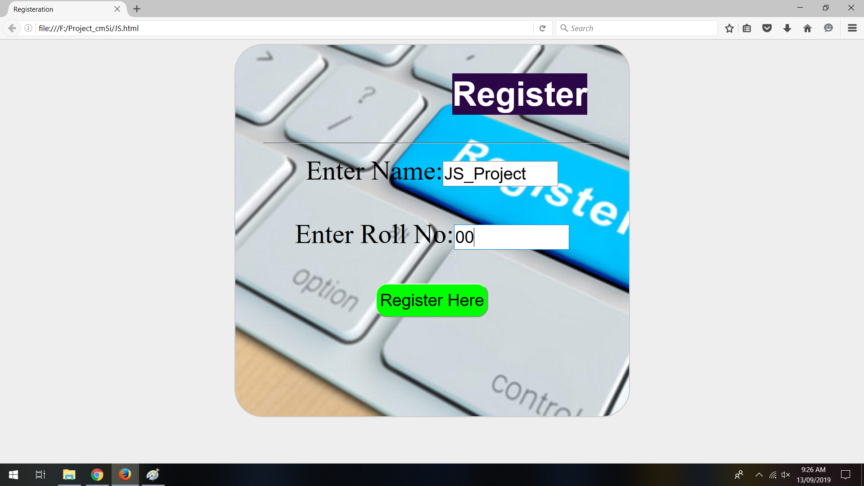

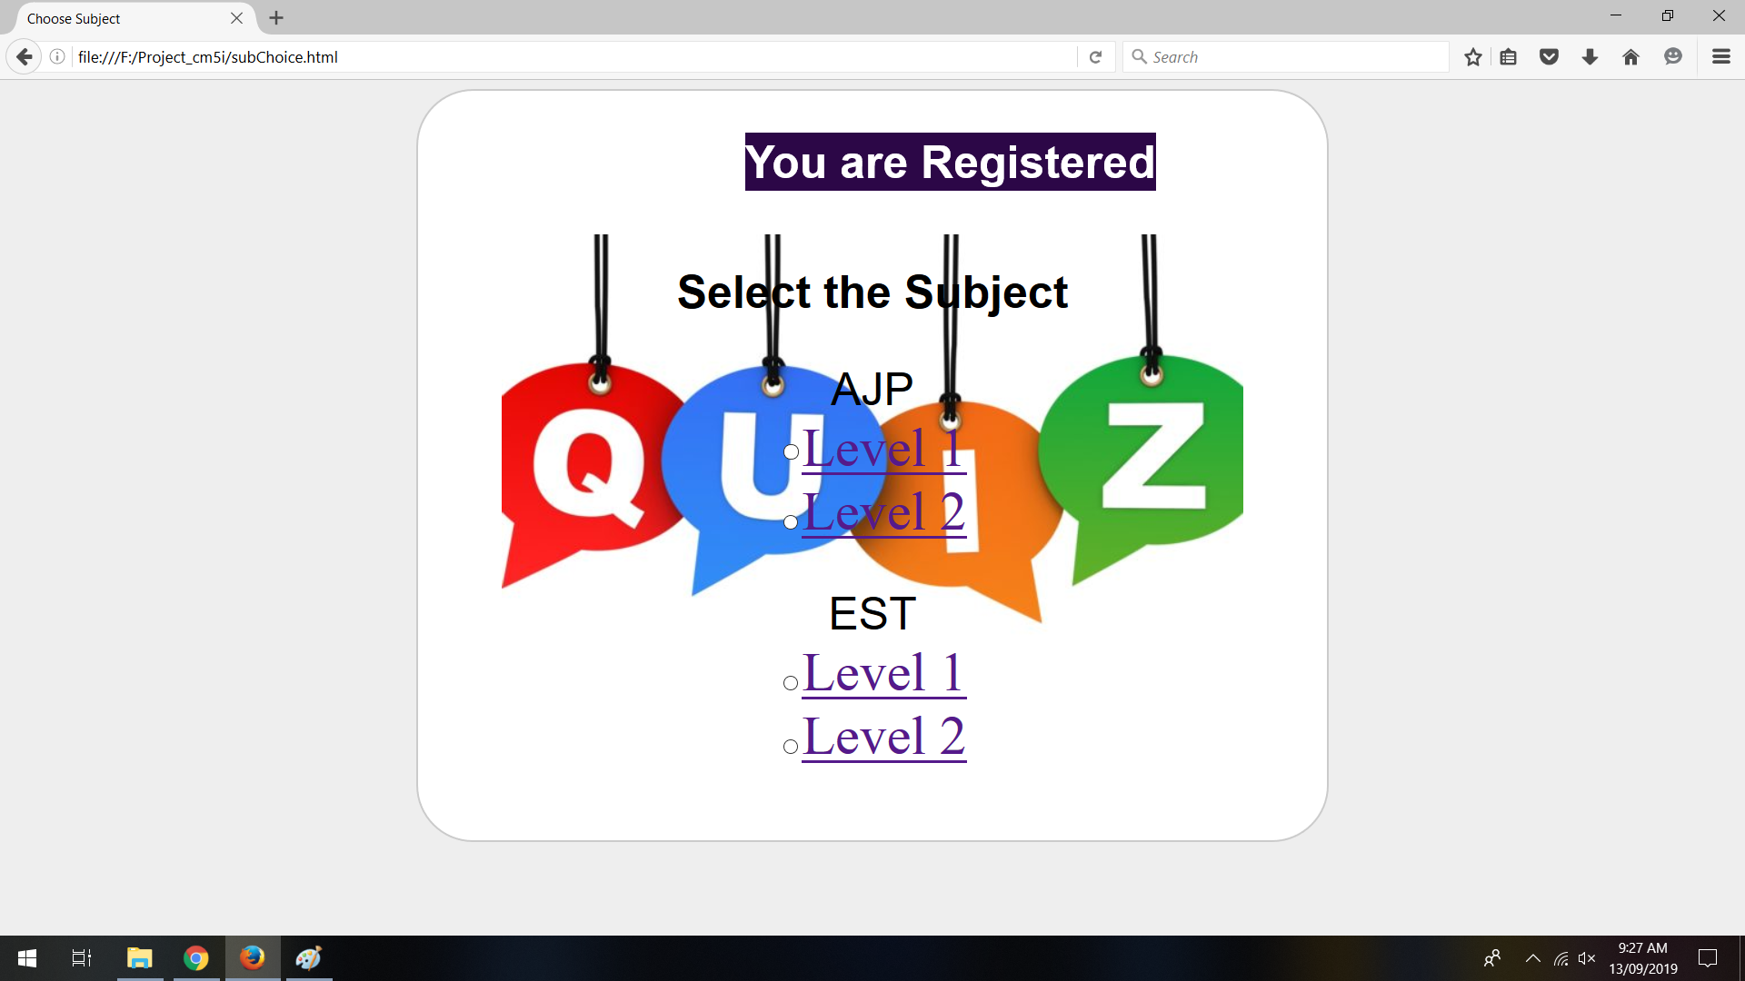

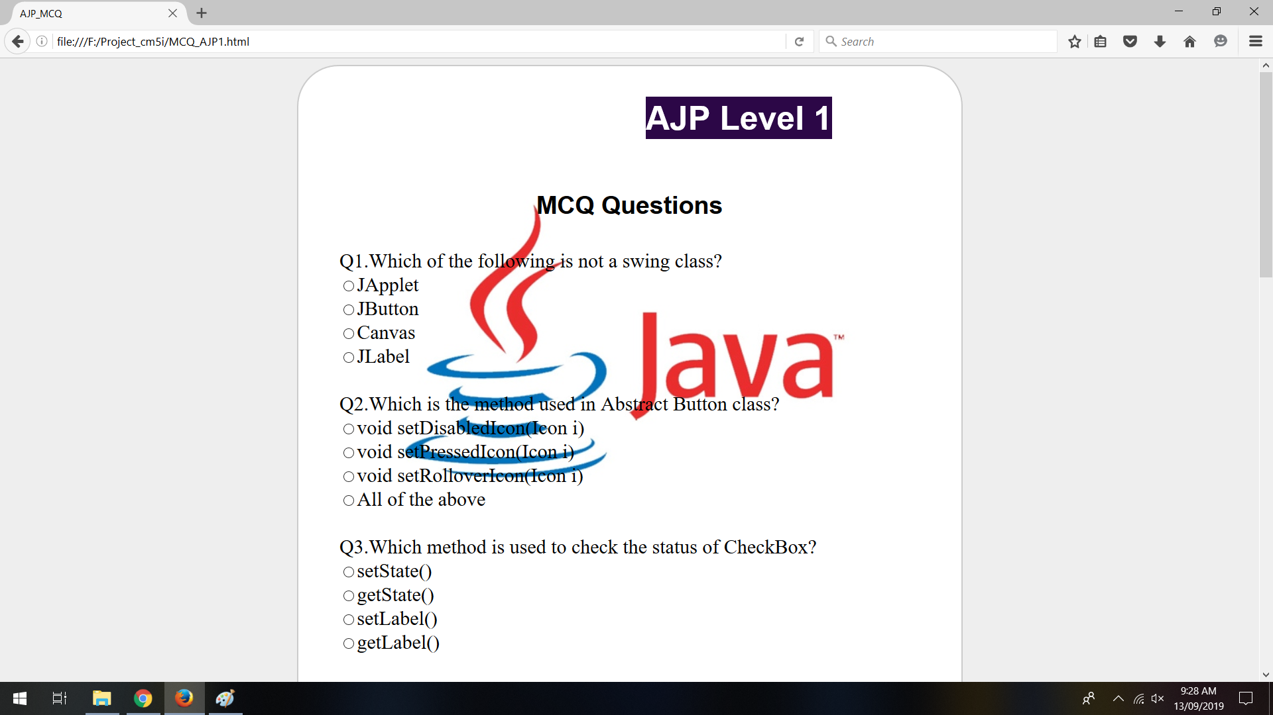

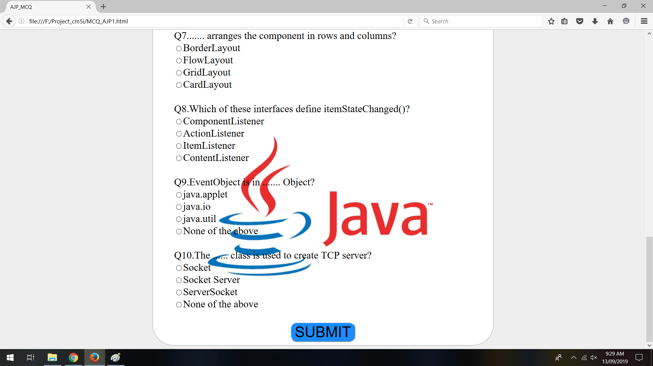

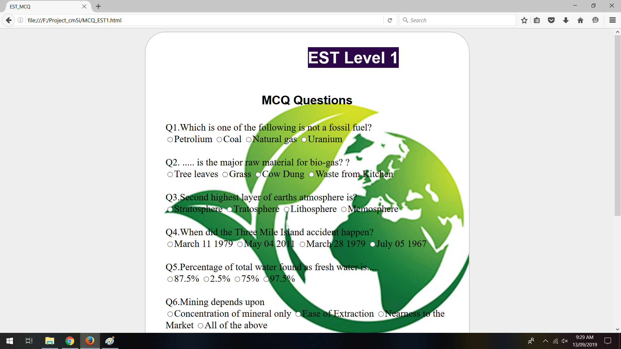

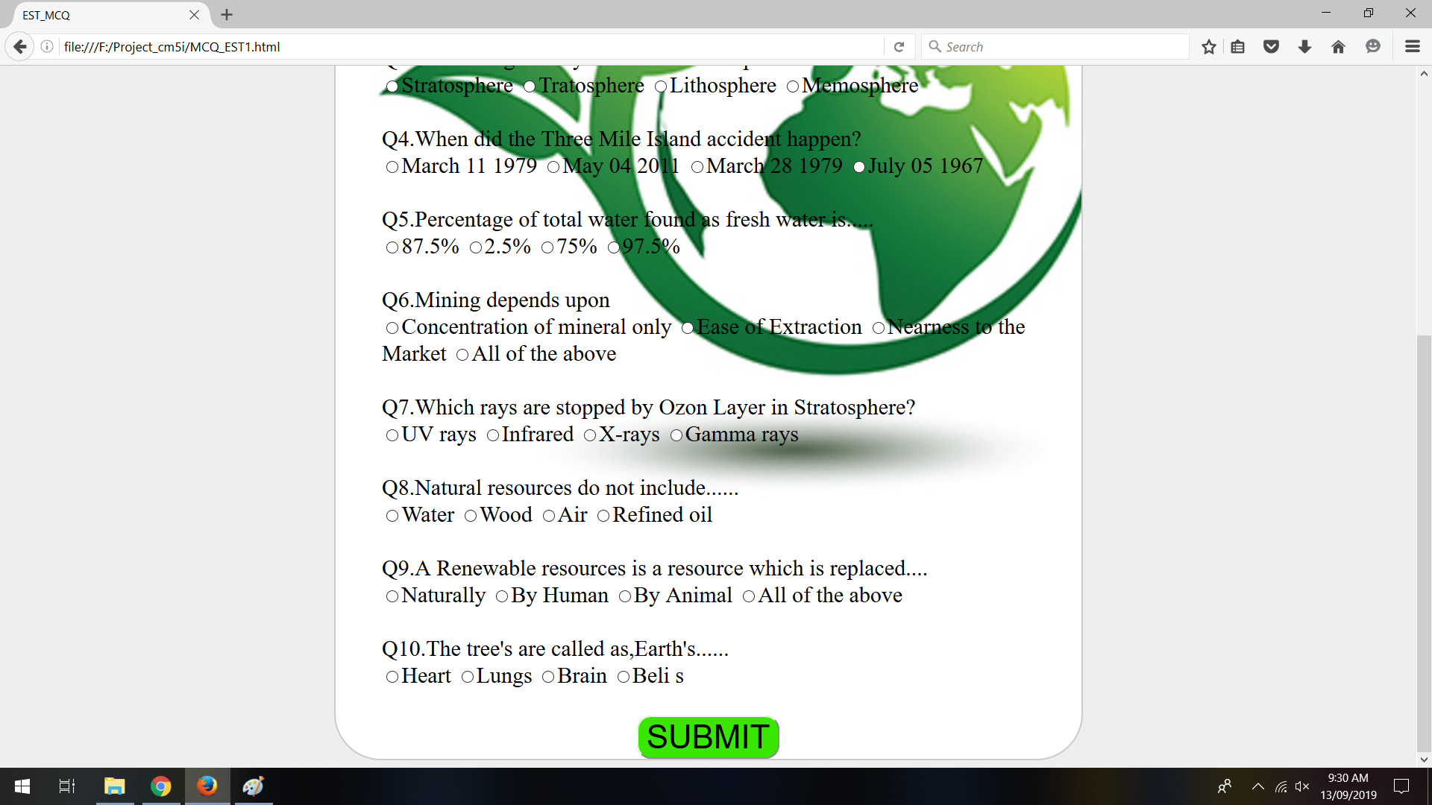

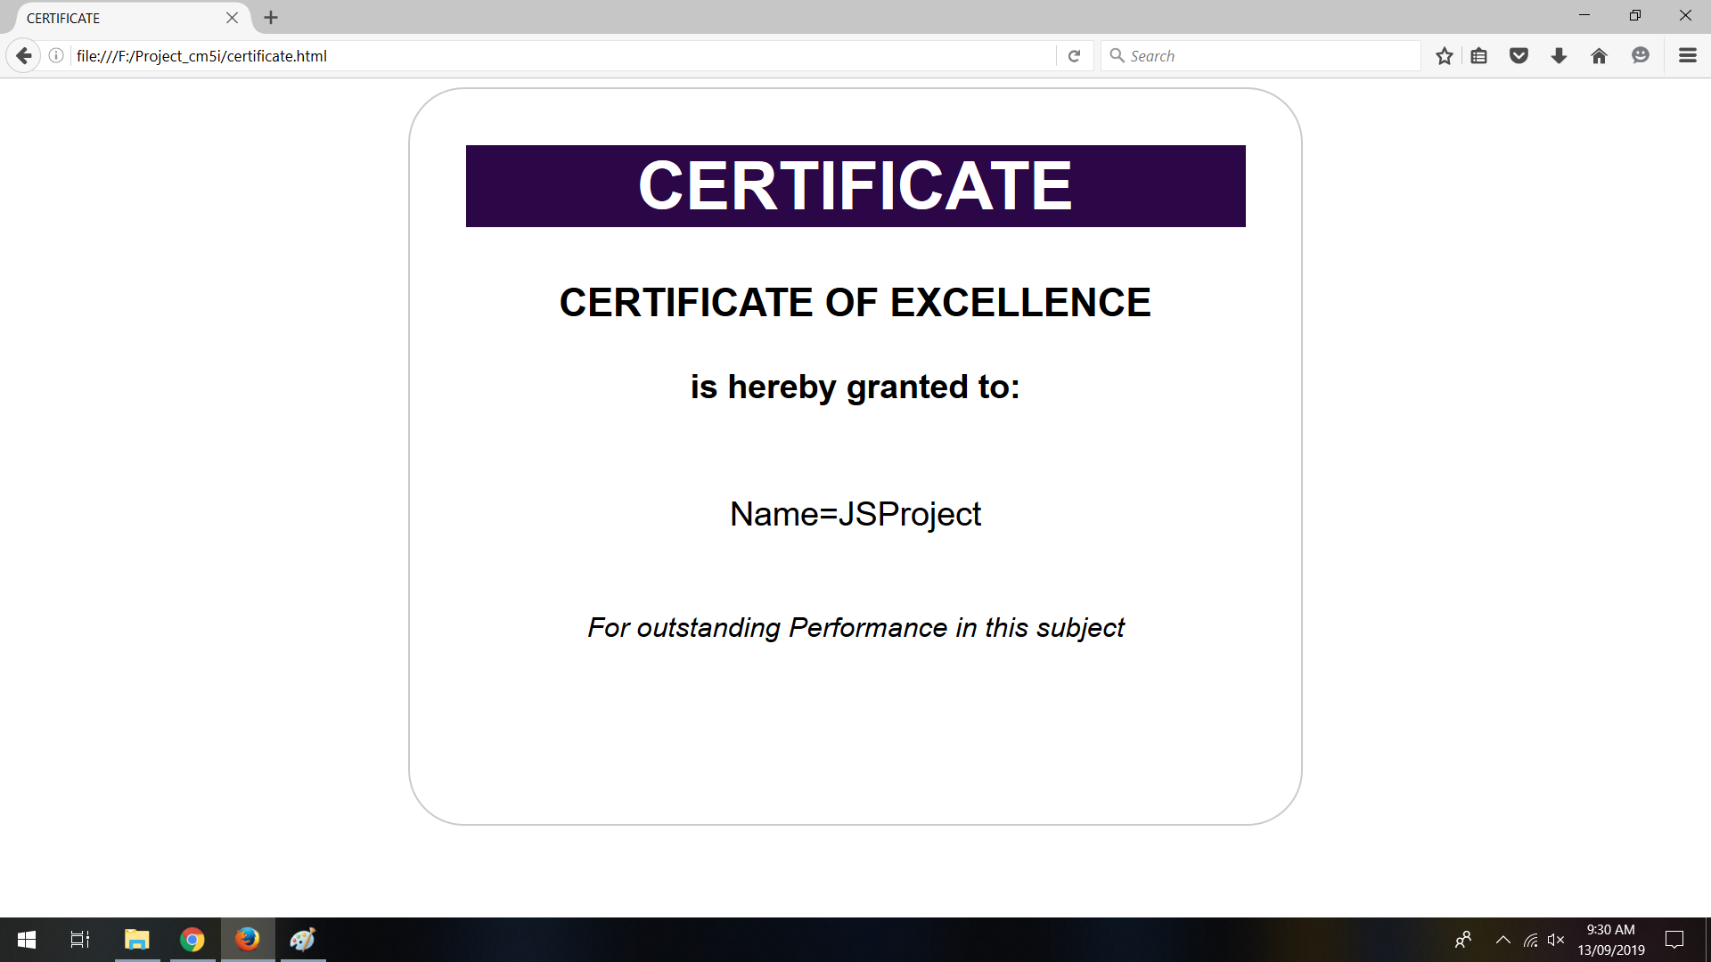

**SOFTWARE REQUIREMENTS USED**

1.operating system-windows 10

2.software-Subline & chrome / firefox

3.ram-4GB

**HARDWARE REQUIREMENTS**

1.laptop

2.ram-4GB

**CONCLUSION**

By doing this project ,we can make entire new application have great graphical user interface and experience.And we can develop a website with such a great design.

**REFERENCE**

* www.guru99.com
* www.softwarefundamentalstesting.com
* www.softwaretestinghelp.com