**Automated Travel Insurance Chatbot**

**PROBLEM STATEMENT:**

1. The Automated Travel Insurance Chatbot is designed to engage customers in a dynamic conversation, which will enable customers with a good level of interaction with the Travel insurance system.
2. This is automated to choose multiple travel plans as like in webpage, based on the interactive and personalized customer engagement.
3. It helps customers to choose the right plan for them.
4. We create specific travel insurance plans for students, senior citizens and for a family or a group of people, individuals.
5. All plans offer combined insurance and services, such as coverage for accident and illness medical expenses, transportation expenses associated with medical evacuation and in event of accidental death or dismemberment and medical assistance services. Depending on the plan selected, other features and options are available.

**REQUIREMENTS:**

* Dialogflow
* An active network

**Dialogflow:**

The chatbot is built using Dialog flow. It is a Google service that runs on the Google Cloud Platform. It also incorporates Google's machine learning expertise and products such as Google Cloud Speech-to-Text. The Dialog flow is user-friendly, intuitive, and just makes sense. Its natural language processing (NLP) is the best we've tried. It gives users new ways to interact with your product by building engaging voice and text-based conversational interfaces, such as voice apps and chatbots, powered by AI. Connect with users on your website, mobile app, the Google Assistant, Amazon Alexa, Facebook Messenger, and other popular platforms and devices. The chatbot is trained in such a way that it answers the user’s queries correctly. By using the integration option in the Dialog flow the chatbot can be connected to many applications.

**Website:**

We created a website were the user to login with an valid email id and password and these data is stored in the database so that is the user has an existing insurance plan it can be identified.

**EXSISTING SYSTEM**

* Chatbot was designed to simulate conversations with human users, especially over the Internet. The first Chatbot, **Eliza**, was built in 1966. Most Chatbots are either accessed via virtual assistants such as Google Assistant and Amazon Alexa or via messaging apps such as Facebook Messenger or Wechat.
* There are various Chatbots available in many fields to answer simple questions and increase the customer engagement and to offer additional ways for them.
* The top companies such as Reliance, Bajaj Allianz, HDFC ERGO has created many travel insurance policies which has more suitable plans.
* But there is no Chatbot with automatically answers the queries. The existing system has chatting facility were the user will be connected to an customer service agent.

**PROPOSED SYSTEM**

1. Automated Travel Insurance Chatbot provides information about the available policies in the system.
2. It helps user to select the appropriate plan

**ADVANTAGES OVER EXISTING SYSTEM**

* Offers 24/7 support
* Immediate answers
* They can simultaneously have conversations with thousands of people
* Easier Approach for users
* Covers Emergency medical and dental expenses

**DRAWBACKS OF EXISTING SYSTEM**

1. Contains only the necessary detailed information
2. Inability to understand unknown queries
3. Poor memory

**OUTPUT**

**SCREENSHOTS**

**Dialogflow training page:**

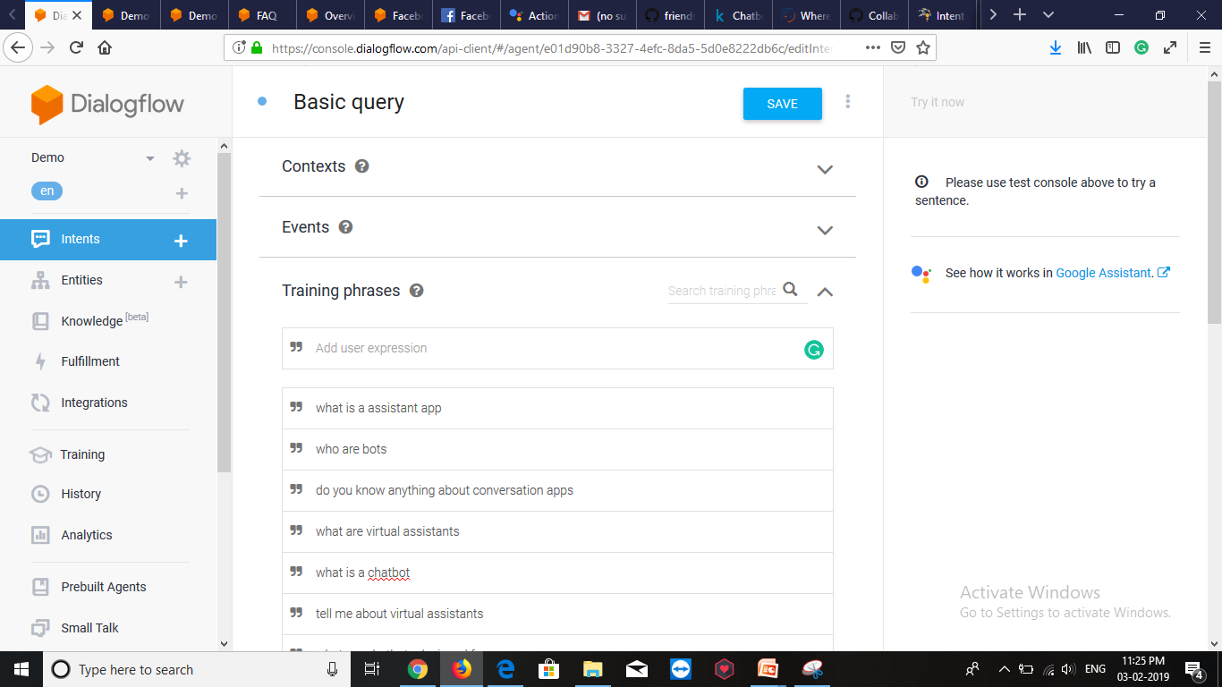

**Running the chatbot in web:**

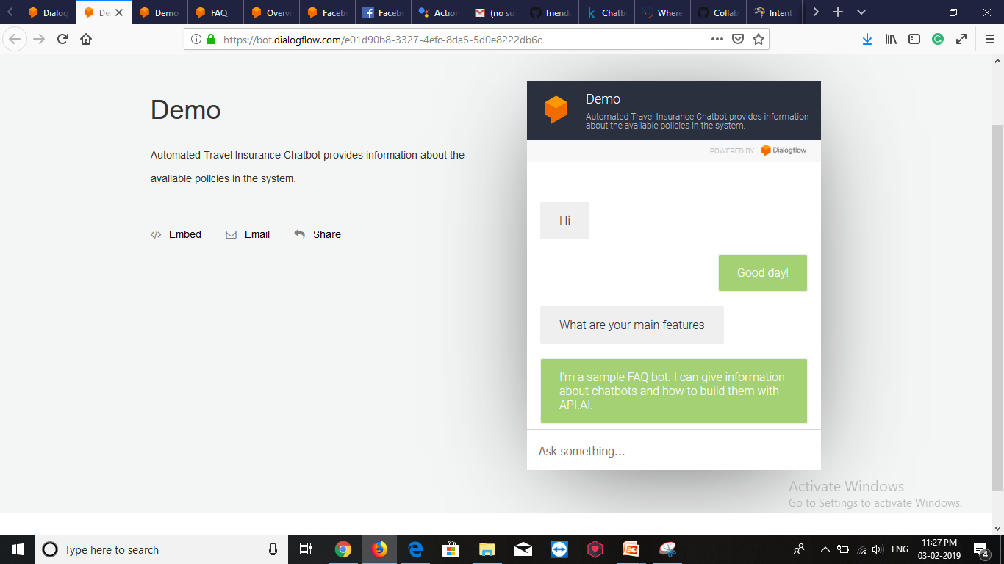

**Login page of the website:**

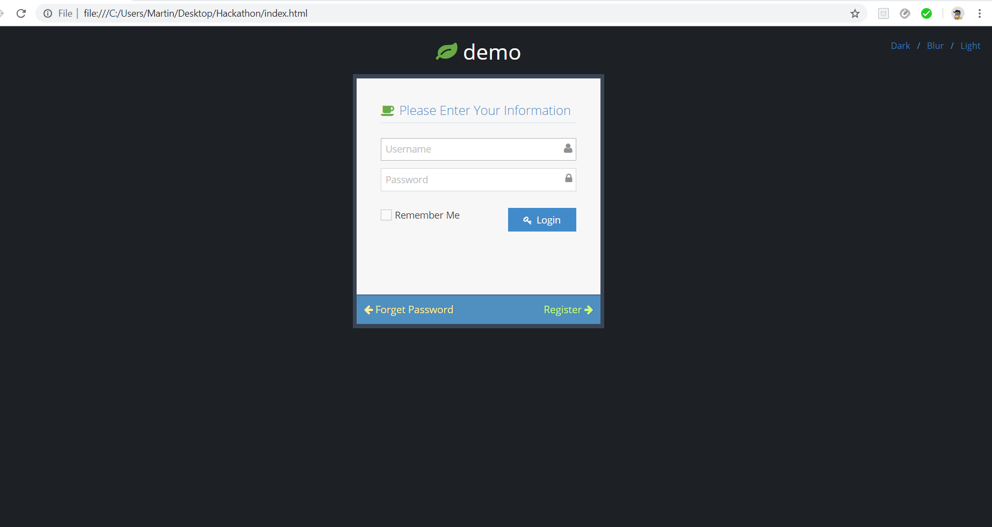

**Website first page:**

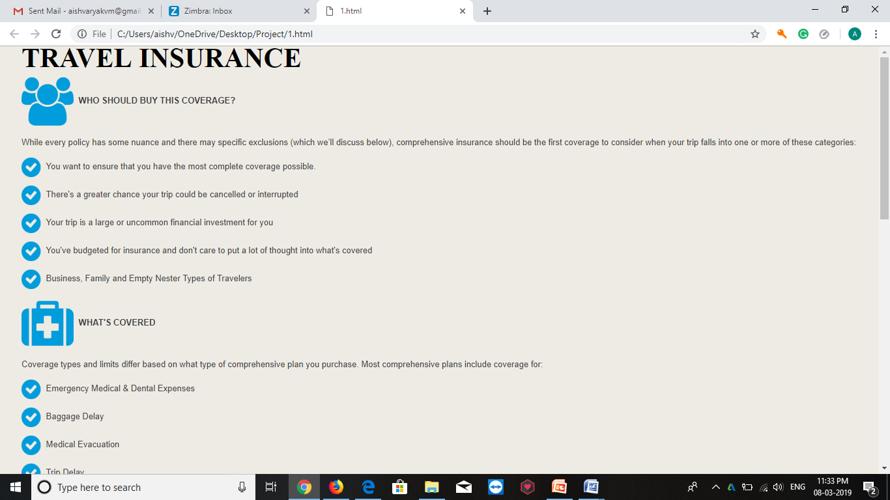

**Second page:**

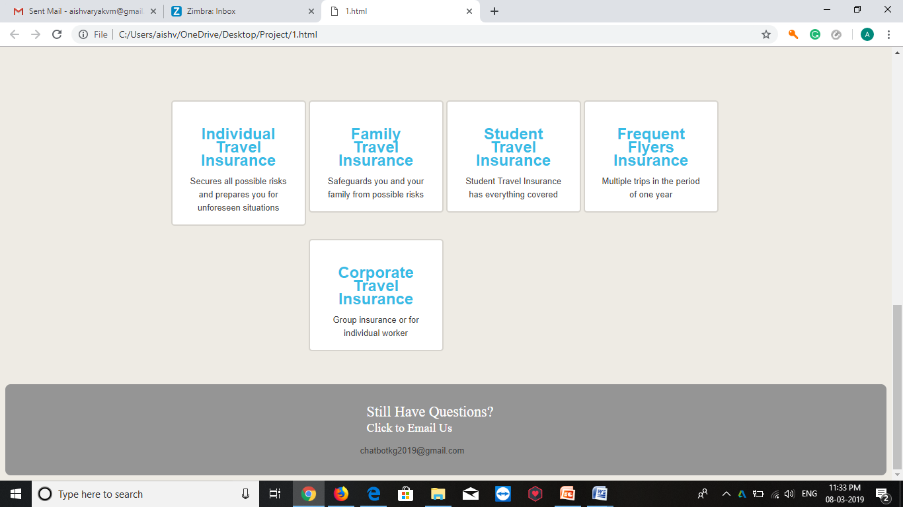

**Chatbot:**

