**ASSIGNMENT 3**

**AISHWARIYA TALATHI**

**CSULB ID: 016131932**

**PROGRAM GRAPHS: 1)specProcess**

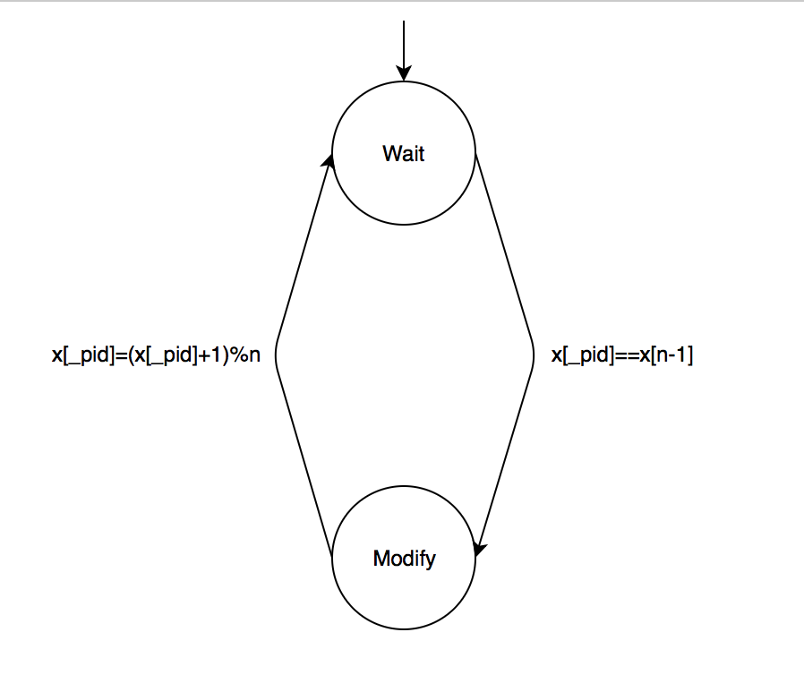

**2)process**

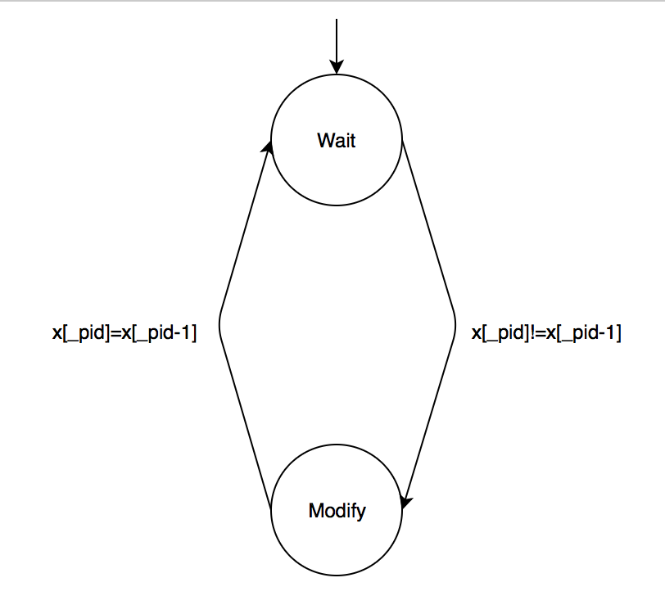

**PARALLEL COMPOSITION FOR ALL 3 PROCESSES:**

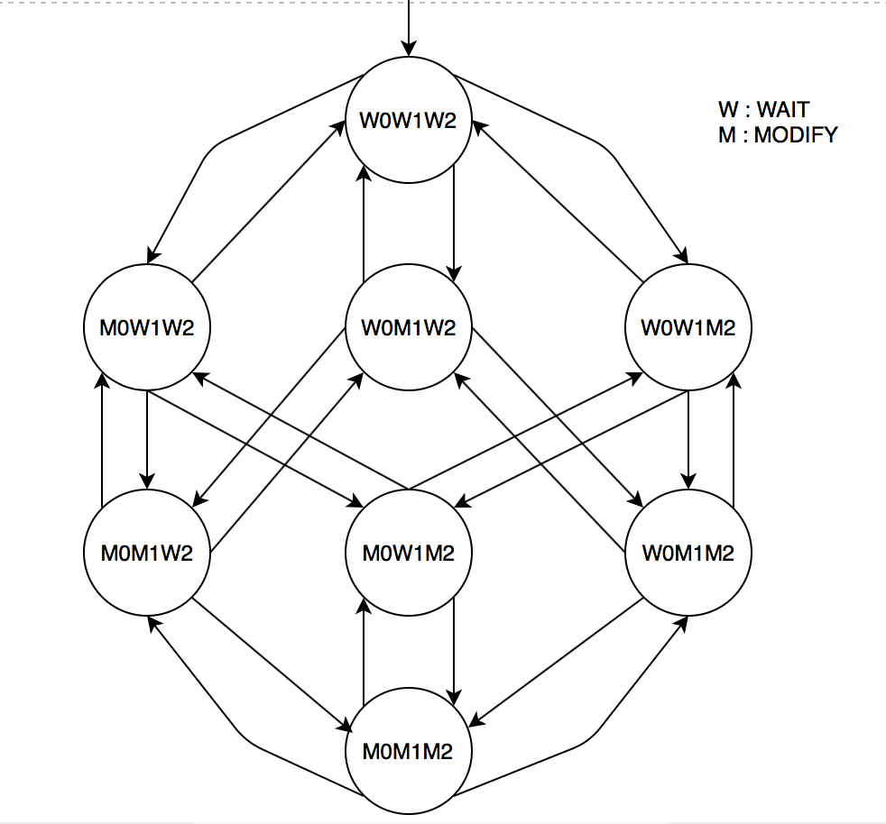

**MODEL IMPLEMENTATION IN SPIN FOR Dijkstra.cpp:**

#define n 3

int x[n];

active proctype specProcess()

{

x[_pid]= 0;

label1: if :: x[_pid]==x[n-1] -> x[_pid]=(x[_pid]+1)%n;

printf("Process ID := %d\n", _pid);

fi;

goto label1;

}

active[2] proctype process()

{

x[_pid] = 0;

label2: if :: x[_pid]!=x[_pid-1] -> x[_pid]=x[_pid-1];

printf("Process ID := %d\n", _pid);

fi;

goto label2;

}

**TERMINAL OUTPUT FOR 100 STEPS:**

Aishwariyas-MacBook-Pro:Exercises aishwariyatalathi$ spin -u30 -p -l ass3.pml

  0: proc  - (:root:) creates proc  0 (specProcess)

  0: proc  - (:root:) creates proc  1 (process)

  0: proc  - (:root:) creates proc  2 (process)

  1: proc  1 (process:1) ass3.pml:15 (state 1) [x[_pid] = 0]

  2: proc  2 (process:1) ass3.pml:15 (state 1) [x[_pid] = 0]

  3: proc  0 (specProcess:1) ass3.pml:6 (state 1) [x[_pid] = 0]

  4: proc  0 (specProcess:1) ass3.pml:7 (state 2) [((x[_pid]==x[(3-1)]))]

  5: proc  0 (specProcess:1) ass3.pml:7 (state 3) [x[_pid] = ((x[_pid]+1)%3)]

      Process ID := 0

  6: proc  0 (specProcess:1) ass3.pml:8 (state 4) [printf('Process ID := %d\\n',_pid)]

  7: proc  1 (process:1) ass3.pml:16 (state 2) [((x[_pid]!=x[(_pid-1)]))]

  8: proc  1 (process:1) ass3.pml:16 (state 3) [x[_pid] = x[(_pid-1)]]

  9: proc  2 (process:1) ass3.pml:16 (state 2) [((x[_pid]!=x[(_pid-1)]))]

          Process ID := 1

 10: proc  1 (process:1) ass3.pml:17 (state 4) [printf('Process ID := %d\\n',_pid)]

 11: proc  0 (specProcess:1) ass3.pml:10 (state 6) [.(goto)]

 12: proc  2 (process:1) ass3.pml:16 (state 3) [x[_pid] = x[(_pid-1)]]

 13: proc  1 (process:1) ass3.pml:19 (state 6) [.(goto)]

 14: proc  1 (process:1) ass3.pml:19 (state 7) [goto label2]

 15: proc  0 (specProcess:1) ass3.pml:10 (state 7) [goto label1]

 16: proc  0 (specProcess:1) ass3.pml:7 (state 2) [((x[_pid]==x[(3-1)]))]

 17: proc  0 (specProcess:1) ass3.pml:7 (state 3) [x[_pid] = ((x[_pid]+1)%3)]

 18: proc  1 (process:1) ass3.pml:16 (state 2) [((x[_pid]!=x[(_pid-1)]))]

 19: proc  1 (process:1) ass3.pml:16 (state 3) [x[_pid] = x[(_pid-1)]]

          Process ID := 1

 20: proc  1 (process:1) ass3.pml:17 (state 4) [printf('Process ID := %d\\n',_pid)]

              Process ID := 2

 21: proc  2 (process:1) ass3.pml:17 (state 4) [printf('Process ID := %d\\n',_pid)]

 22: proc  1 (process:1) ass3.pml:19 (state 6) [.(goto)]

      Process ID := 0

 23: proc  0 (specProcess:1) ass3.pml:8 (state 4) [printf('Process ID := %d\\n',_pid)]

 24: proc  1 (process:1) ass3.pml:19 (state 7) [goto label2]

 25: proc  2 (process:1) ass3.pml:19 (state 6) [.(goto)]

 26: proc  2 (process:1) ass3.pml:19 (state 7) [goto label2]

 27: proc  0 (specProcess:1) ass3.pml:10 (state 6) [.(goto)]

 28: proc  0 (specProcess:1) ass3.pml:10 (state 7) [goto label1]

 29: proc  2 (process:1) ass3.pml:16 (state 2) [((x[_pid]!=x[(_pid-1)]))]

 30: proc  2 (process:1) ass3.pml:16 (state 3) [x[_pid] = x[(_pid-1)]]

-------------

depth-limit (-u30 steps) reached

#processes: 3

x[0] = 2

x[1] = 2

x[2] = 2

 30: proc  2 (process:1) ass3.pml:17 (state 4)

 30: proc  1 (process:1) ass3.pml:16 (state 5)

 30: proc  0 (specProcess:1) ass3.pml:7 (state 5)

3 processes created

**HENCE, AS SEEN FROM ABOVE, AFTER 30 STEPS, THE VALUE OF X[0] = 2, X[1] = 2 AND X[2] = 2 FOR n=3;**