- Title: Smart Intersection Collision Avoidance System
- Architecture diagram
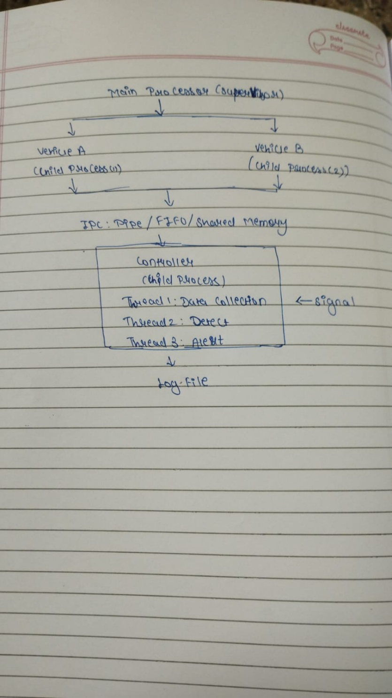
- Run Instruction:
- Run: make
- Run: ./main
- Press Ctrl+C to stop

- Output:
