🔍🚀AI Q&A Chatbot 🤖with LangChain and Groq API

Introduction:
The AI Q&A Chatbot using LangChain and Groq API is an intelligent conversational system designed to interact with users and provide accurate, real-time answers to their queries. This project leverages the power of Large Language Models (LLMs) through Groq’s high-speed inference engine and integrates it with the LangChain framework to build a structured and scalable chatbot.
The chatbot is deployed using Streamlit, providing a clean and interactive web interface for user interaction.

Objectives:
The main objectives of this project are:
- To build a real-time conversational AI chatbot
- To integrate Groq API with LangChain
- To create a user-friendly interface using Streamlit
- To manage chat history dynamically
- To securely handle API keys using environment variables

Technologies & libraries used
- Streamlit → For building the web UI
- LangChain → Framework for LLM application development
- LangChain-Core → Core utilities like prompts and parsers
- LangChain-Groq → Integration with Groq LLM
- OpenAI (optional dependency) → For compatibility/extensions
- Python-dotenv → To securely store API keys

System architecture:
User Input → Streamlit UI → LangChain Prompt Template → Groq LLM → Response → Output Parser → Display in UI
Flow Explanation:
- User enters a query in the chat interface
- Input is passed to LangChain
- Prompt is structured using a template
- Groq LLM processes the request
- Response is parsed into readable text
- Output is displayed back in the chat UI

Project Implementation Steps:
Step 1: Environment Setup
- Install required libraries
- Create .env file
- Store API key securely
Step 2: UI Development
- Use Streamlit to create:
  - Title
  - Chat input box
  - Chat history display
Step 3: API Integration
- Load Groq API key using dotenv
- Initialize ChatGroq model
Step 4: Prompt Engineering
- Define system and user messages using ChatPromptTemplate
Step 5: Chain Creation
- Combine:
  - Prompt Template
  - LLM (Groq)
  - Output Parser
Step 6: Chat Handling
- Store messages in session_state
- Display conversation history dynamically

Steps in building the project (Cmd_prompt)
Written code in google colab, written API key(groq key) in .env file and required libbraries in requirements_1.txt file executed through cmd_prompt
Here is cmd_prompt steps:
- D:
- Cd openai (folder name)
- Python -m venv myvenv
- Myvenv\scripts\activate
- Pip install -r requirements_1.txt
- Streamlit run langchain60_app.py

🖥️ Chatbot Development and Execution(code):
import streamlit as st
import os
from dotenv import load_dotenv

from langchain_groq import ChatGroq
from langchain_core.prompts import ChatPromptTemplate
from langchain_core.output_parsers import StrOutputParser

# Load .env file
load_dotenv()

st.set_page_config(page_title="LangChain Chatbot", page_icon="🤖")

st.title("🔍 AI Q&A Chatbot with LangChain and Groq API")

# Get API key from environment
groq_api_key = os.getenv("GROQ_API_KEY")

# Step 2: Initialize chat history
if "messages" not in st.session_state:
st.session_state.messages = []

# Step 3: Display chat history
for msg in st.session_state.messages:
with st.chat_message(msg["role"]):
st.markdown(msg["content"])

# Step 4: Take user input
if prompt := st.chat_input("Type your message..."):
if not groq_api_key:
st.error("⚠️ GROQ API key not found. Please check your .env file.")
else:
# Save user message
st.session_state.messages.append({"role": "user", "content": prompt})
with st.chat_message("user"):
st.markdown(prompt)

# LangChain setup (Groq)
llm = ChatGroq(
model_name="llama-3.1-8b-instant",
groq_api_key=groq_api_key,
)

prompt_template = ChatPromptTemplate.from_messages([
("system", "You are a helpful assistant."),
("user", "{question}")
])

chain = prompt_template | llm | StrOutputParser()

# Run chain
bot_reply = chain.invoke({"question": prompt})

# Save and display assistant message
st.session_state.messages.append({"role": "assistant", "content": bot_reply})
with st.chat_message("assistant"):
st.markdown(bot_reply)

Key features:
6. Key Features
- 💬 Interactive chat interface
- ⚡ Fast responses using Groq LLM
- 🔐 Secure API key management
- 🧠 Context-aware responses
- 📜 Chat history tracking
- 🖥️ Simple and clean UI

1. Migration from OpenAI to Groq API:
Initially, I was implemented project using the OpenAI API, but due to usage-based billing and cost limitations, it was replaced with the Groq API, which provides faster responses and free access for development, making it more efficient and cost-effective.

2. Errors Faced and How They Were Resolved:
During the development using GroqAI and LangChain, multiple errors were encountered and resolved as follows:
⚠️ a) LangChain Import Errors
- Faced issues like ModuleNotFoundError due to outdated or incorrect package versions
- ✅ Resolved by installing updated libraries: langchain, langchain-core, langchain-community
b) Model Deprecation Errors
- Errors like model not supported / decommissioned occurred
- ✅ Resolved by switching to supported models (e.g., Groq’s llama-3.1-8b-instant)
c) API Key & Authentication Issues
- API key not recognized or missing from environment variables
- ✅ Resolved using .env file with python-dotenv for secure key management

Output:
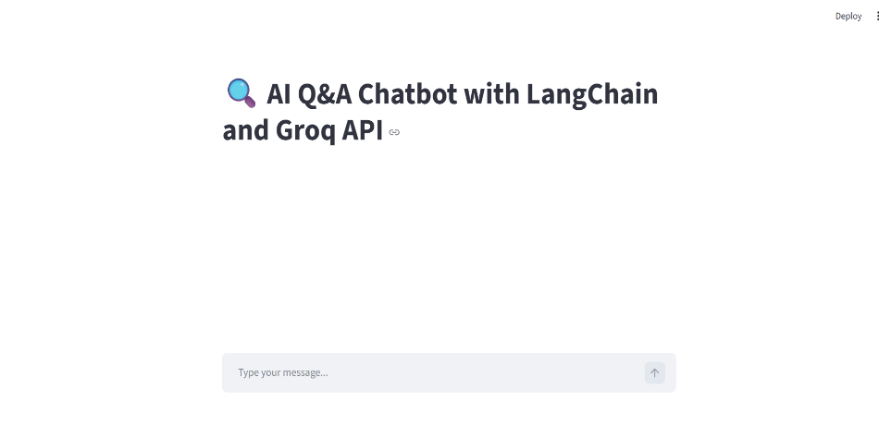

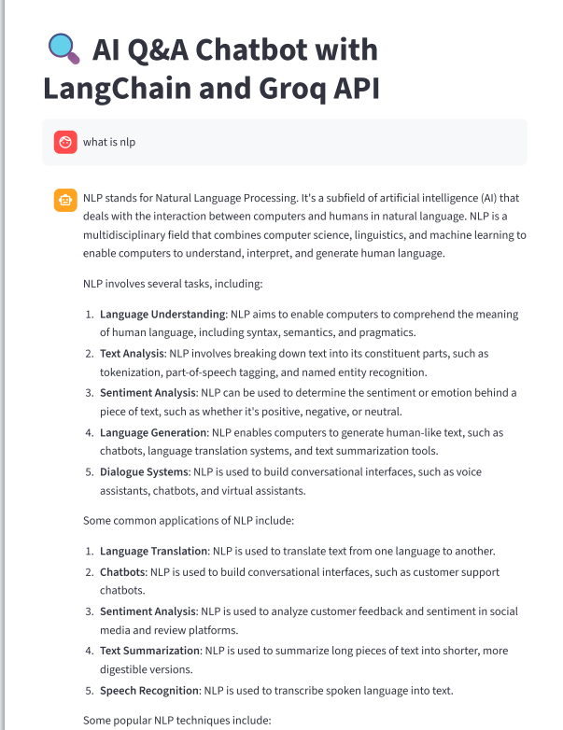
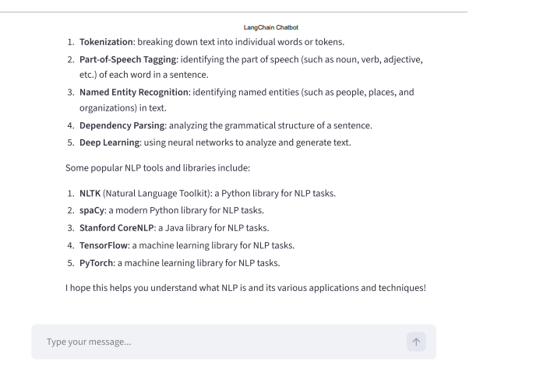

Output Description:
As shown in your output:
- The chatbot successfully answers questions like “What is NLP?”
- It provides:
  - Definition
  - Explanation
  - Applications
  - Techniques
This proves the chatbot is:
- Context-aware
- Informative
- Structured in response generation

