1. **INTRODUCTION**

Computer vision is a scientific discipline that includes methods for acquiring, processing, analyzing and understanding images from the real world in order to produce numerical or symbolic information in the form of decisions. It is being applied to various fields such as agriculture, medical science, biological science, material science and so on. Medical field plays vital role in our day today lives and computer vision is an inseparable part of it. There are thousands of diseases affecting human health that are being dealt with. Related to brain, the most common diseases are epilepsy, stroke, tumor, Parkinson’s, Alzheimer, meningitis, encephalitis etc. The brain stroke is one of deadliest diseases. It is the major cause of death, after coronary heart disease, cancer and accidents.

The human brain is an extremely complex organ, made up of 100 billion neurons that communicate with each other primarily through biochemical signals (neurotransmitters) traveling at speeds, up to 220 miles per hour along a network that involves trillions of synaptic connections. It controls all necessary functions of the body. It receives and interprets all necessary information from the outside world through our five senses: sight, smell, touch, taste and hearing. Intelligence, creativity, emotions, memory are few of the things governed by the brain. The human brain is divided into three parts as cerebrum, cerebellum and brain stem.Cerebrum occupies the larger portion of the brain. It is divided into left and right hemispheres.

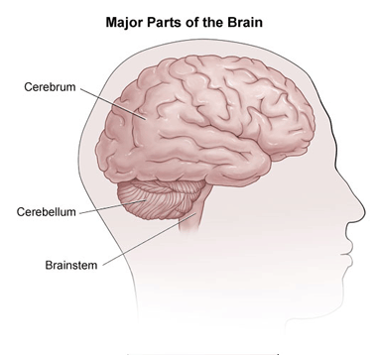

**Figure 1. Major parts of human brain**

**BRAIN STROKE**

Stroke is a brain attack, cutting off vital blood flow and oxygen to the brain. Blood carries essential nutrients and oxygen to your brain, without blood your brain cells can be damaged or die. This damage can have different effects, depending on where it happens in our brain. It can affect the way your body works as well as how you think, feel and communicate. WHO deﬁnes stroke as the clinical syndrome of rapid onset of local (or global, as in subarachnoid hemorrhage) cerebral deﬁcit, lasting more than 24 hours (unless interrupted by surgery or death), with no apparent cause other than a vascular one. Although stroke is often viewed as a disease of the elderly, it sometimes affects younger individuals. The incidence of stroke does increase with age. Because the same factors that caused a first stroke are likely to cause a subsequent one, the risk of stroke for someone who has already had one is increased.

There are three types of stroke: ischemic, hemorrhagic, transient ischemic stroke(TIA). There are two subtypes in ischemic stroke: embolic stroke and thrombotic stroke. In hemorrhagic stroke there are two types: Intercerebral and subarachnoid hemorrhage.

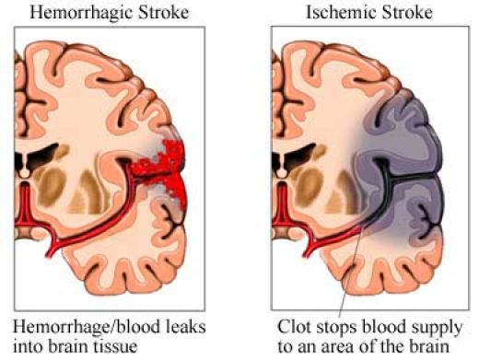

**Figure 2. Hemorrhagic and ischemic brain stroke**

**2. LITERATURE SURVEY**

To know the state of the art of computer applications, we have carried a literature survey. Following is the list of paper cited during the survey.

[Saleh Jomah Said, et. al] have proposed a paper on “imageJ software” which supports unenhanced CT scan. ImageJ is easy to use and can process with CT images. It has the ability to assess the density of each pixel and through recent advances in the ImageJ software package, the density measurements have been calibrated to reflect the true Hounsfield unit values.

[Ryan C. Turner, et. al, 17 January 2013] have proposed a paper on “Translation of neuroprotective agents for ischemic stroke from bench-to-beside” which explains failure to produce improved treatments since the development of tissue plasminogen activator. They also explained about the aged models of ischemic stroke.

[Julien Bogousslavsky, et. al, 2006] have proposed a paper “Diagnosis and classification and risk factors, treatments, management, rehabilitation and secondary prevention” in which they have described about the diagnosis and classification and risk factors, treatments, management, rehabilitation and secondary prevention.

[Susan Tocco, September 2011] has proposed a work “Identifying the vessel which is responsible for stroke, stroke signs and symptoms vary with the affected blood vessel” in which he has explained about identifying the vessel which is responsible for stroke, stroke signs and symptoms vary with the affected blood vessel. It explains about the strokes of the middle cerebral artery(MCA) which is the most common cerebral occlusion site.

[Lawrence M. Brass, M.D.] has proposed a paper “Brain functions” in which he has explained how the brain functions differently from one patient to another when the signs and symptoms of stroke appear.

In the literature survey carried out, it is found that most of the work is carried out on prevention and treatment of brain stroke from x-ray and CT-images. The automation of work connected with, identification of brain stroke, identifying severity from images is found to be minimal.

1. **MOTIVATION AND PROBLEM DEFINITION**

There is need for automation of work related with, identification of brain stroke, identifying severity and so on. The work finds scope in medical field to address the problems faced by patients, society and also the doctors. Hence, the work entitled “C**lassification of Human brain stroke from CT and X-ray images” is proposed**.

**4. OBJECTIVES**

* To classify the brain image into normal and stroke affected.
* To classify the brain stroke images into ischemic and hemorrhagic
* To identify the severity of stroke and the stages of the stroke.

**5. PROPOSED WORK**

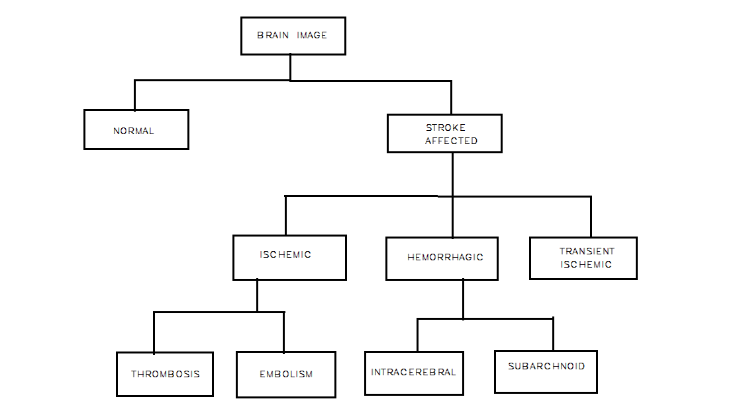

**Figure 3. Tree structure representing classification of brain stroke.**

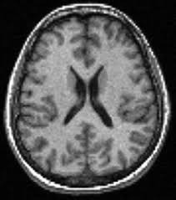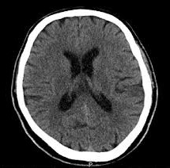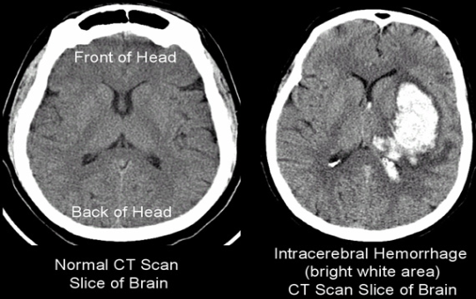

1. 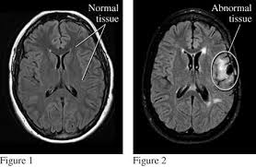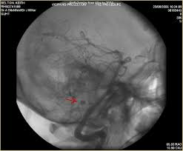**Images of normal brain.**

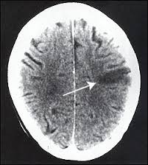

**(b) Images of brain stroke**

**Figure 4. Images of normal human brain and stroke affected brain**

The brain images will be classified into normal and stroke affected as shown in figure 4. As shown in fig 4a the normal human brain has a proper blood supply and therefore functions normally whereas stroke affected brain, shown in figure 4b, is deprived of proper blood supply due to clotting in blood vessels or leakage of blood into the brain. This hinders the normal functioning of brain depending upon which part of the brain is affected.

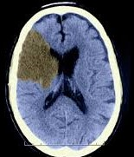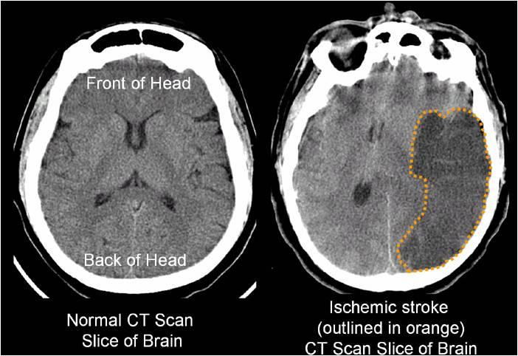

1. **Images of ischemic brain stroke.**

:

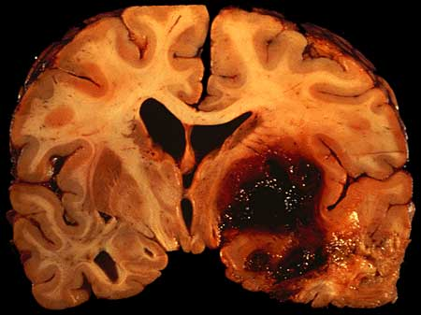Gsdgfdjgajhdjahda22hsJDHGjsd

1. **Images of hemorrhagic brain stroke.**

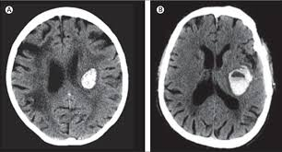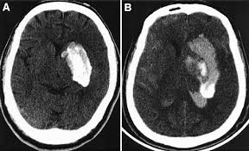

**(c) Images of transient brain stroke.**

**Figure 5. Images of ischemic, hemorrhagic and transient brain stroke.**

The figure 5 shows the images of different types of brain stroke: ischemic, hemorrhagic and transient ischemic. As shown in figure 5a, the occlusion of a cerebral artery causes damage to the brain tissue dependent on blood supply from the affected vessel leads to ischemic stroke. Figure 5b shows the images of stroke caused by leakage of blood into the brain due to rupture of blood vessels carrying blood to the brain called hemorrhagic stroke**.** The transient ischemic stroke, shown in fig 5b, is caused due to temporary blood clot.. When a TIA is over, it usually causes no permanent injury to the brain. Ischemic and hemorrhagic strokes can cause permanent damage to the brain.

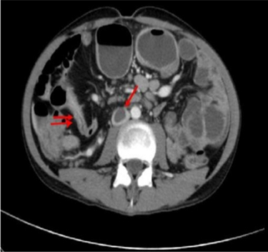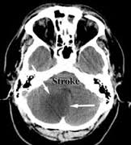

sfhjjfsBfjsHfjheFEcbsbshhskhfjgdwjsajsdjkhdwbscmBfjh

1. **Image of thrombotic brain stroke.**

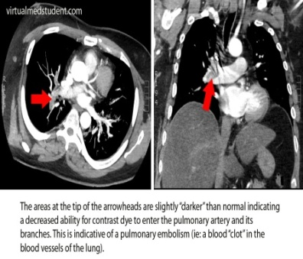

**(b) Image of embolic brain stroke.**

**Figure 6. Images of thrombotic and embolic brain stroke.**

An ischemic stroke can further be classified into thrombotic and embolic stroke. As shown in fig 6b. an **embolic stroke** occurs when a blood clot formed in a blood vessel anywhere in our body eventually reaches our brain. A **thrombotic stroke, shown in figure 6b** is caused by a clot in an artery that supplies blood to our brain, known as thrombosis. Thrombosis can be large vessel or small vessel depending on the size of the artery affected. It can also be caused by a blood clot within one of the small vessels deep inside the brain.

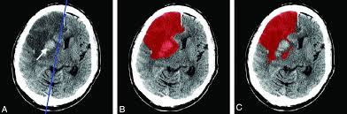

1. **Image of intra-cerebral brain stroke.**

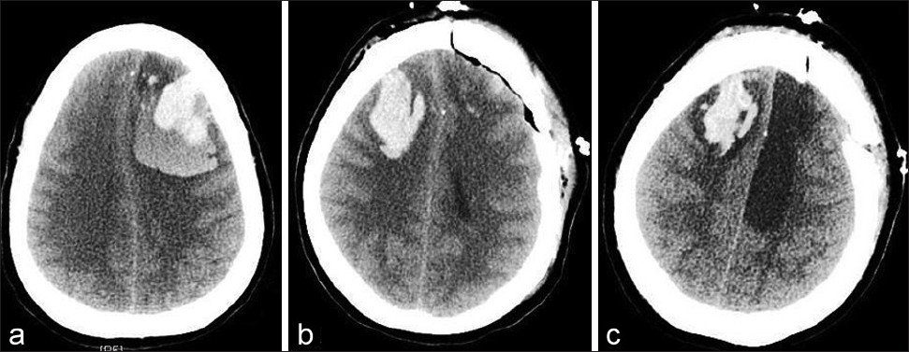

**(b) Image of subarachnoid brain stroke.**

**Figure 7. Images of intra-cerebral and subarachnoid brain stroke**

A hemorrhagic can further be classified into intra-cerebral and subarachnoid As shown in figure 7a, intra-cerebral hemorrhage is occurs when a blood vessel inside the brain bursts and leaks blood into surrounding brain tissue. Whereas subarachnoid hemorrhage, as shown in figure 7b, involves bleeding in the area between the brain and the tissue covering the brain, known as the subarachnoid space.

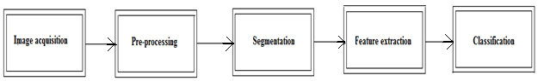

**Figure 8. Major phases used in the envisaged approach.**

**Image acquisition:** It is the process of gathering the CT (computed tomography) and X-ray images that are necessary to answer questions and evaluate outcomes in our proposed model. These images will be collected from the doctors or hospitals by visiting frequently.

**Pre-processing:** Usually the images acquired are not suitable for further processing due to unwanted distortions or degradations such as lighting, intensity variations, poor resolution of images, unwanted background and such. The CT and X-ray images are preprocessed to enhance image clarity for further processing.

**Segmentation:** Image segmentation is the process of partitioning a digital image into multiple segments. In this process, the region of interest is obtained by segmenting X-ray and CT images. For example, in a stroke affected brain image the region of the brain affected by stroke is partitioned for further processing.

**Feature extraction:** Feature extraction is process of extracting the distinct features, which will help to classify one from another. The distinguishable features of normal and stroke affected brain which will be identified in segmentation process are extracted in this phase. The feature such as intensity of pixels, texture features and shape of region of interest can be used in the proposed work. For example, in a stroke affected brain image, the affected region differs in color and pixel density from the normal human brain as shown in figure

**Classification:** The stroke affected images are classified into its different types which include ischemic, hemorrhagic, transient ischemic and their respective subtypes using distinguishable features.

**6. OUTCOMES**

The developed system will be able to

* Classify the input brain images as normal or stroke affected.
* Classify the stroke affected images into ischemic, hemorrhagic and transient ischemic.
* Identify the severity of stroke and the stages of the stroke.

**7. APPLICATIONS**

* Our developed software helps in identifying the minute details in the CT and X-ray images of stroke affected brain that are not visible to the naked eye
* It allows doctors to find the disease earlier and improve patient’s chances.
* By finding the disease early, it reduces the need for invasive procedures facilitating shorter recovery times
* It saves money and improves efficiency in the health care system.

**REFERENCES**

1. Dr. Sudhir V Shah(2008)has written a book on “Diseases of the brain and nervous system” which deals with all the practical problems faced in neurology.
2. Saleh Jomah Said, et. al. “ImageJ software” which supports unenhanced CT scan. ImageJ is easy to use and can process with CT images.
3. Ryan C. Turner, et. al,(17 January 2013) “Translation of neuroprotective agents for ischemic stroke from bench-to-beside” has largely failed to produce improved treatments since the development of tissue plasminogen activator.
4. Julien Bogousslavsky, et.al,(2006) “Diagnosis and classification and risk factors, treatments, management, rehabilitation and secondary prevention”.
5. Susan Tocco(September 2011) “Identifying the vessel which is responsible for stroke, stroke signs and symptoms vary with the affected blood vessel”.
6. Lawrence M. Brass, M.D “How the brain functions differently from one patient to another” when the signs and symptoms of stroke appear.
7. G, Al-Rawi Y, et al. The Desmoteplasein Acute Ischemic Stroke Trial (DIAS):a phase II MRI-based 9-hour window acute strokethrombolysisTaub E, Morris DM. Constraint induced movement therapy to enhance recovery after stroke. Curr Atheroscler Rep.2001;3:279–286.
8. Kolb B. Overview of cortical neuroplasticity and recovery from brain injury. Phys Med Rehabil Clin N Am. 2003;14(1 Suppl):S7–25.
9. Wolf S, Winstein C, Miller J, et al. Effect of constraint-induced movement therapy on upper extremity function 3 to 9 months after stroke: The EXCITE randomized clinical trial. JAMA2006;296(17):2095–2104.
10. Bhogal SK, Teasell R, Speechley M, Albert ML. Intensity of aphasia therapy, impact on recovery. Stroke. 2003;34:987–993.
11. Mesulam M-M. Large-scale neurocognitive networks and distributed processing in attention, language and memory. Ann Neurol.1990;28:597–613.
12. Buccino G, Lui F, Canessa M, et al. Neural circuits involved in the recognition of actions performed by nonconspecifics: An fMRI study. *J* Cogn Neurosci*.* 2004;16(1): 114–126.
13. Ertelt D, Small S, Solodkin A, et al. Action observation has a positive impact on rehabilitation of motor deficits after stroke. Neuroimage2007;36(Suppl 2):T164–T173.
14. Celnik P, Webster B, Glasser D, Cohen L. Effects of action observation on physical training after stroke. Stroke. 2008;39:1814–1820.
15. World Health Organization, 2014. The Atlas of Heart Disease and Stroke.
16. Neurological disorders: public health challenges.,World Health Organization 2006.ISBN 92 4 156336 2 (NLM classification: WL 140)ISBN 978 92 4 156336 9.
17. National Stroke Association’s, 2013. Complete Guide to Stroke.
18. Candelario-Jalil E: Injury and repair mechanisms in ischemic stroke:considerations for the development of novel neurotherapeutics.Curr Opin Investig Drugs 2009, 10:644-654.
19. Durukan A, Tatlisumak T: Acute ischemic stroke: overview of major experimental rodent models, pathophysiology, and therapy of focal cerebral ischemia. Pharmacol Biochem Behav 2007, 87:179-197.
20. Stam J (April 2005). "Thrombosis of the cerebral veins andsinuses". The New England Journal of Medicine 352(17).
21. Ashok Srinivasan, MD. MayankGoyal, MD. Faisal Al Azri, MD., CheemunLum, MD.RadioGraphics 2006; 26:S75–S95. Published online 10.1148/rg.26si065501. State-of-the-Art Imaging of Acute Stroke
22. e. d. seletchi, o. g. duliu.Image Processing and Data Analysis In Computed Tomography.University of Bucharest, Faculty of Physics,Romania,September (2006).
23. Hacke W, Alb trial with intravenous desmoteplase.Stroke .2005;36:66–73.