Case Study Submission Template

- Name : Aishwarya.B

- Employee Id : 399967

- Email Id : b11.a@tcs.com

- Your Git Repository URL :

https://github.com/Aishwarya-Devops/batch10.git

- Attach the screenshot of your Dockerfile.

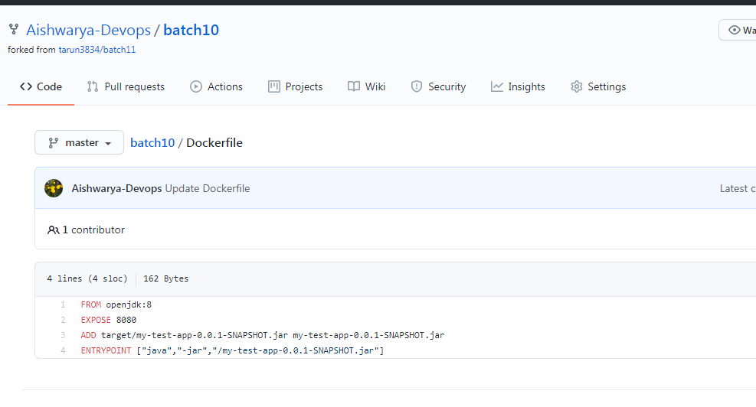

- Attach the screenshot of your Jenkinsfile.
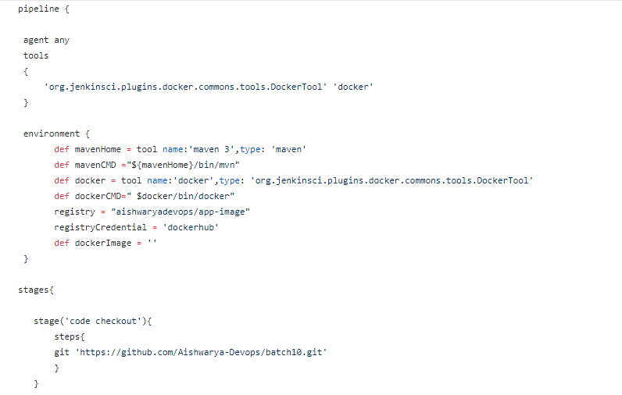
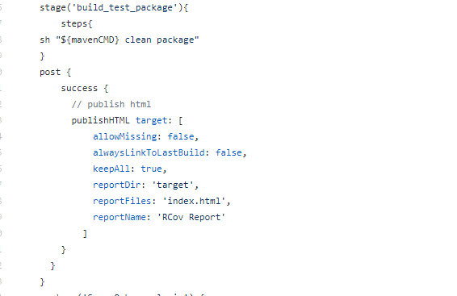
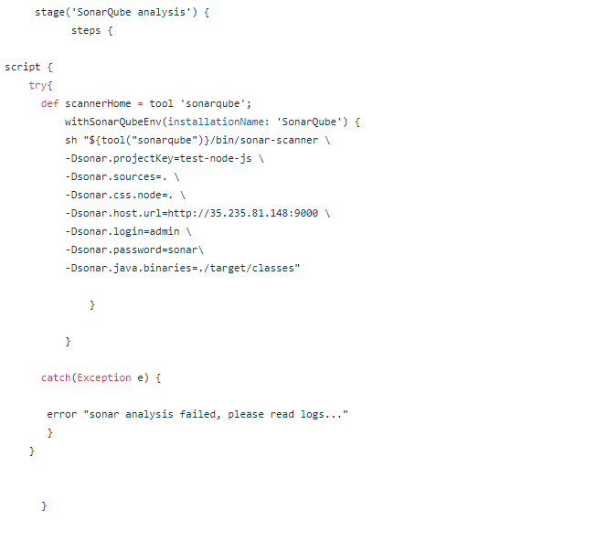
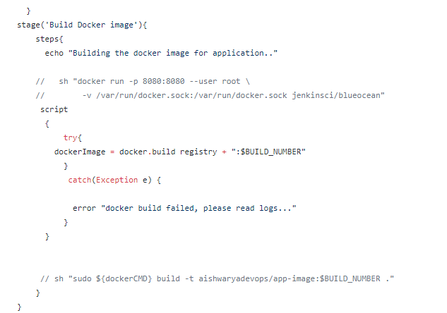
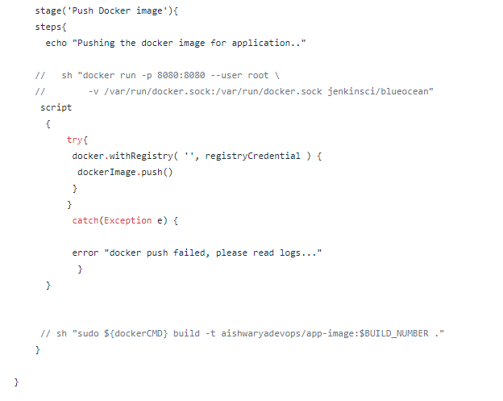
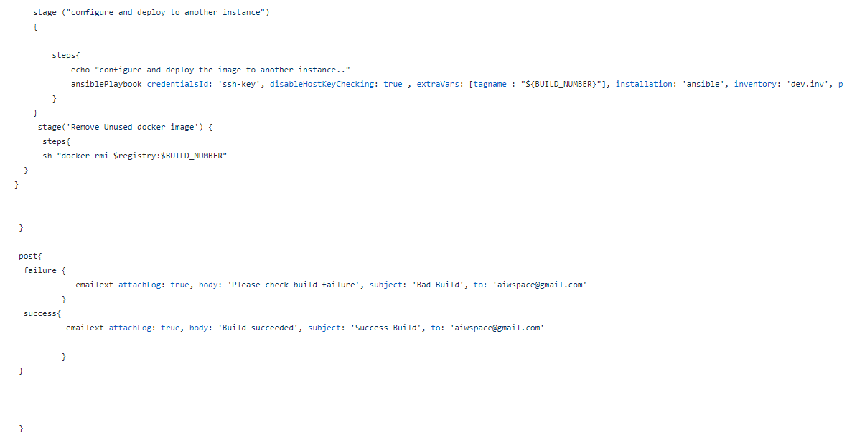

Displaying the below stage again as it is not clear in image above:
stage ("configure and deploy to another instance")
{
steps{
echo "configure and deploy the image to another instance.."
ansiblePlaybook credentialsId: 'ssh-key', disableHostKeyChecking: true , extraVars: [tagname : "${BUILD_NUMBER}"], installation: 'ansible', inventory: 'dev.inv', playbook: 'deploy-playbook.yml'
}
}

- Upload your Jenkins Log file in the Repo.(Complete log file should display your name on top).
Uploaded with file name as : jenkinslog

- Attach the screenshot of Jenkins pipeline job status. (All boxes should be green)

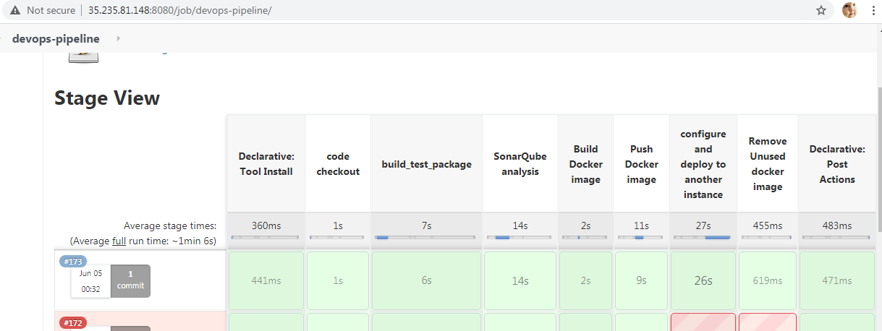

- Attach screenshots of email notification for the Jenkins build.

Added for email in pipeline, but google is blocking the mail to gmail due to security reasons

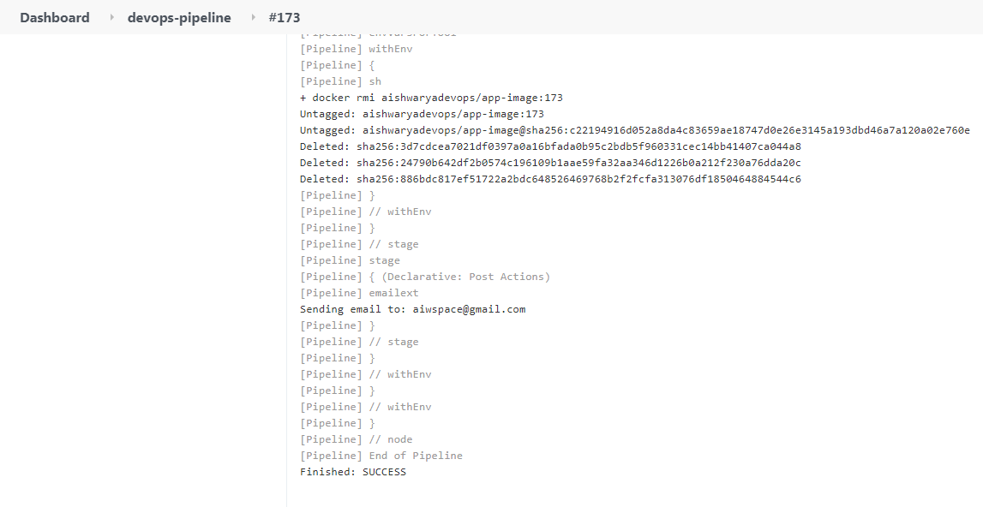
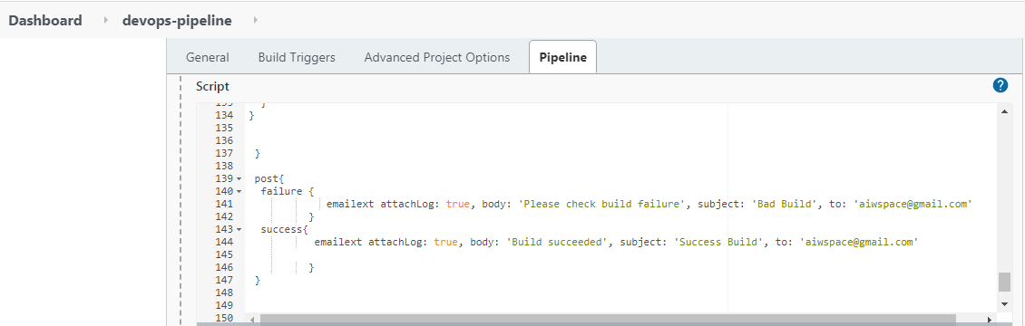
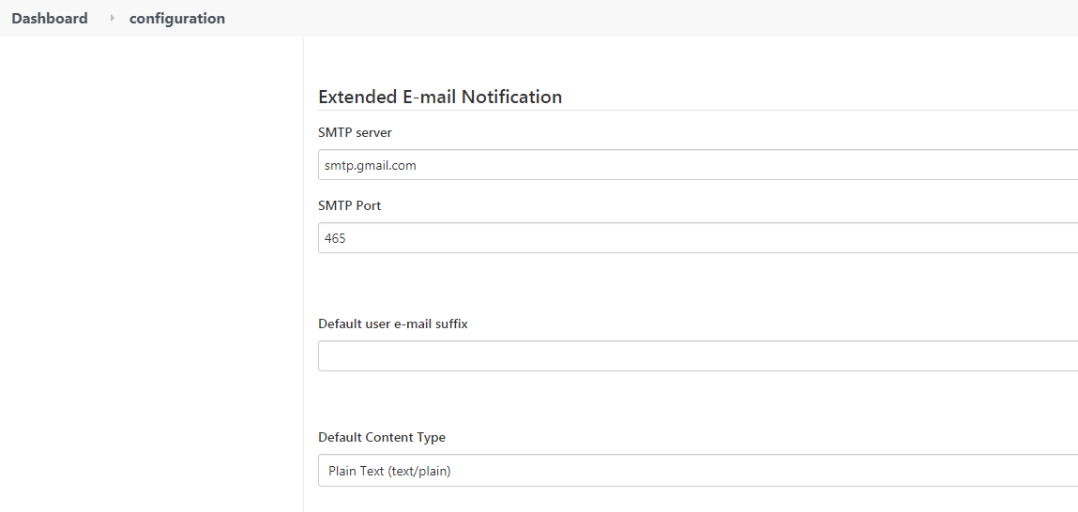

- Attach screenshot of the SonarQube Report.

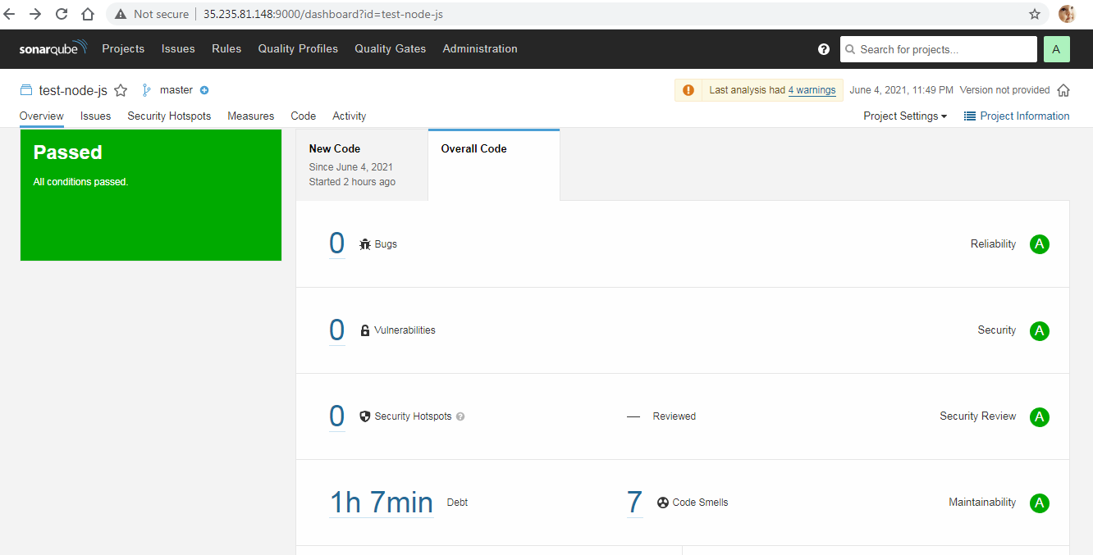

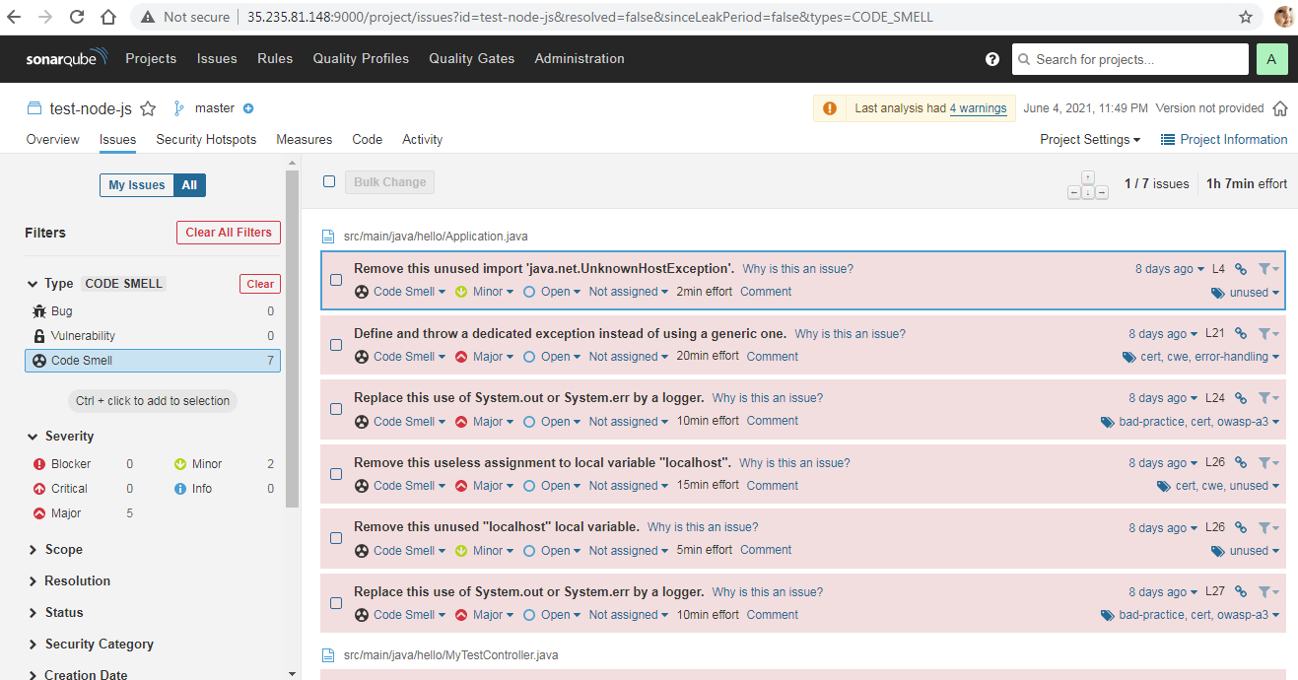

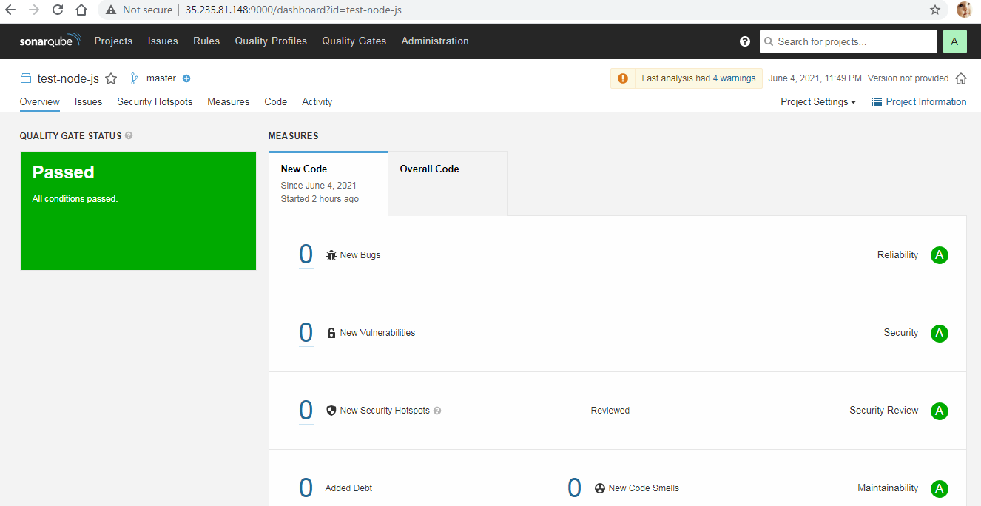

- Attach screenshot of the AppScan Report.

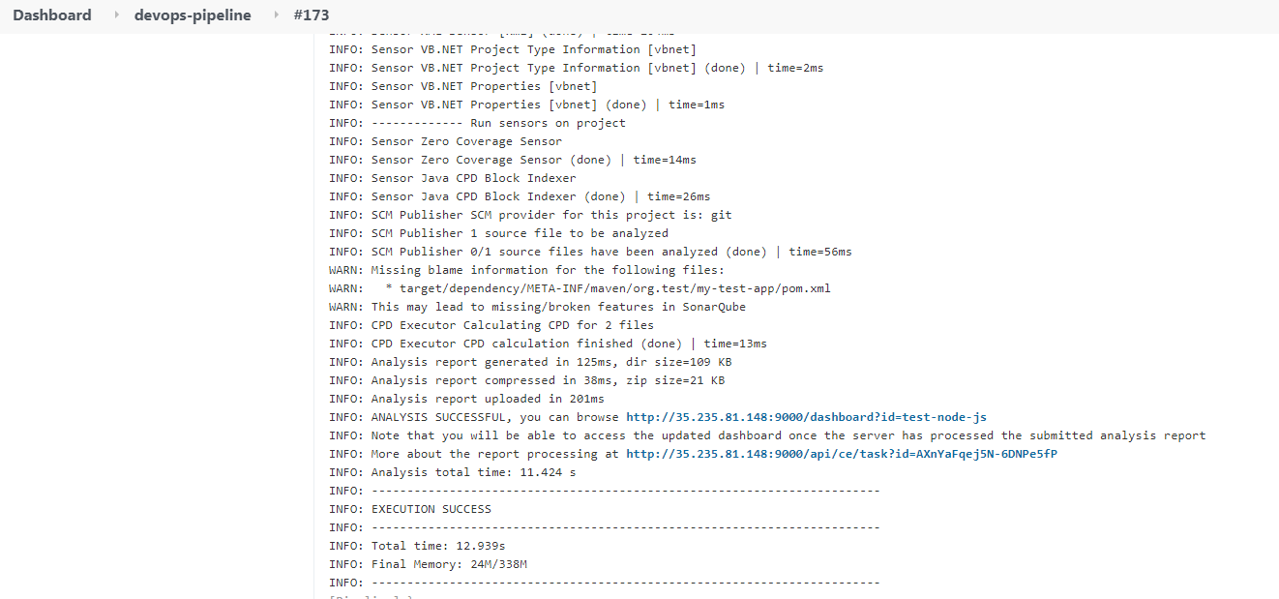

- Attach screenshot of your Ansible Playbook execution logs.
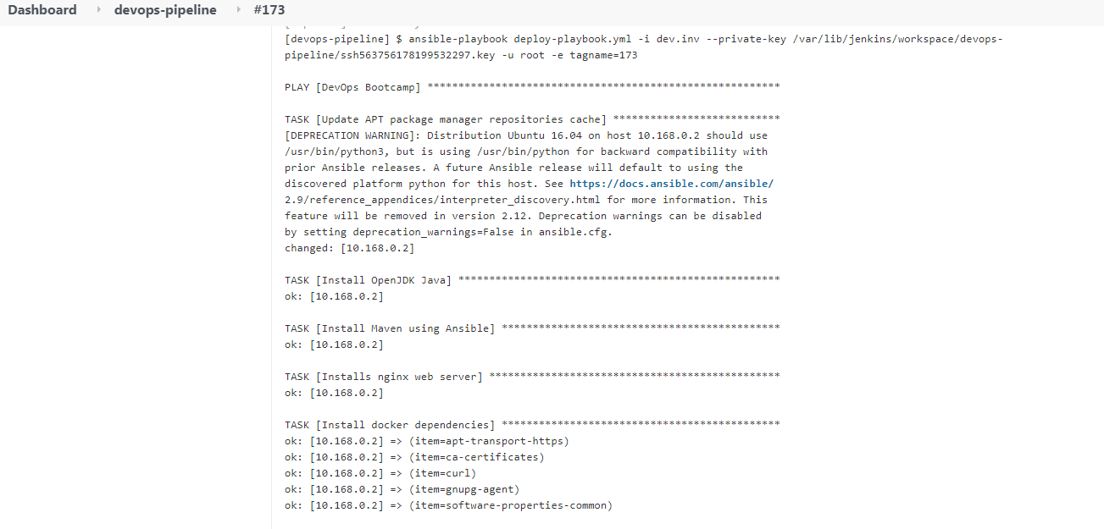
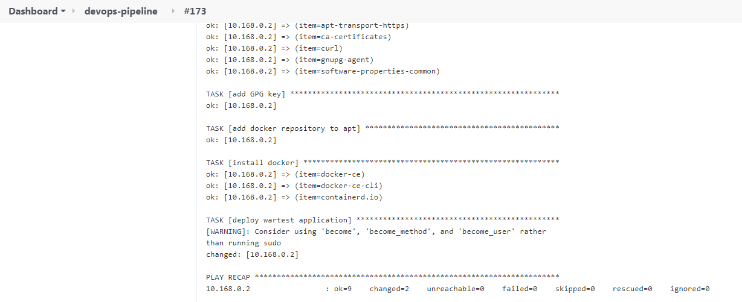

- Attach screenshot of the working application home page on AWS/GCP/Azure.

