Churn Investigation in Hybrid Peer-to-Peer System

Aishwarya GM
Department of Mathematics and Computer Science
The Pennsylvania State University
agm37@psu.edu
Dr Linda Null
Associate Program Chair, Professor in Charge,
The Pennsylvania State University
lmn3@psu.edu

Abstract—Peer-to-peer overlay networks are classified into structured networks and unstructured networks. The structured networks provide accurate and efficient service while the unstructured networks are resilient to churn. To gain advantages of both types of networks the hybrid peer-to-peer system was developed. The hybrid P2P system comprises of super network and every node in this network is attached to an unstructured peer-to-peer network called the subnetwork. The routing algorithms used in the structured component of the network and the unstructured component of the network may vary according to the application requirements. Implementing such networks which try to combine two different topologies is a challenging task by itself. A thorough understanding of the network dynamics is an essential part of implementing the network. In this paper, we investigate the effect of churn in a hybrid peer-to-peer system. We begin with implementing a hybrid network and then study the effect of churn on the network. First, we use the random walk protocol throughout the network and study the effect of churn and then we replace the super network with chord protocol and study the same metrics again. Our simulation results show that the hybrid network with the chord protocol in the super network and the random walk protocol in the sub network performs better in terms of message delivery when compared to the hybrid network with random walk protocol alone. Our results further indicate that such a hybrid network which has the chord protocol in the super network and random walk in the sub network performs significantly better even in the case of large network sizes and is therefore more scalable.
Keywords—Peer-to-peer systems; chord protocol; random walk protocol; churn;

Introduction
Distributed system are computer systems, applications, and clusters which at one level of abstraction or the other act as a single system but are in fact composed of many computers. Architecture is one of the basic aspects of development in distributed systems. Client-server, three-tier, n-tier or peer-to-peer systems are the basic architectures categories that the distributed systems fall into. Client-server systems are built to meet specific needs and there is a single server that provides application-specific services to the clients in the system. The case of client-server architecture where the presentation, application processing, and data management layers are physically separated is the n-tier architecture (n being the number of tiers in the system). Peer-to-peer systems have no concept of a central server. All the participating computers in a peer-to-peer network (called the peers) have equal functionality in that the interaction among the peers is symmetric and this has resulted in its widespread use.
Research has shown that the rapid development of the peer-to-peer systems has led to the contribution of a large portion of the internet traffic [1]. No one peer in the p2p system has control over the network and all the computers within the network have equal responsibilities and functionalities unlike in the case of the client-server architecture where single point failure is a major drawback. The p2p networks comprise of a base physical network upon which a flexible logical overlay network is built [2]. The network topologies in the P2P systems can be broadly classified as structured and unstructured networks. While in structured networks, the nodes are organized following a specific distributed data structure, the unstructured networks access their neighbors in a random fashion. Structured peer-to-peer networks are reliable and provide accurate service. However, structured networks are vulnerable to churn (the dynamics of peer participation, an inherent property of P2P systems) and require a lot of effort in stabilizing the network to bring it back to normal when peers join or leave the system. The costs of maintaining the Distributed Hash Table under no load depend on factors as the number of entries in routing tables, the number of links to other nodes, and the protocols for detecting failures [4]. On the other hand, unstructured networks are resilient to churn and there is no effort put into maintaining the structure of the network. However, unstructured networks are not very accurate in terms of providing service. Thus, we see that neither network alone can give us efficient, accurate lookup and resilience to churn.
Consistent efforts are put into improving the aforementioned metrics. The hybrid peer-to-peer system was proposed to develop a p2p system that uses the efficiency of the structured network and the flexibility of the unstructured network, thus resulting in a more efficient p2p system. It addresses the drawbacks of the structured and unstructured networks. The hybrid network consists of two parts, the structured transit-network (t-network) and the unstructured stub-network (s-network). As proposed in [2], the hybrid system comprises a ring topology that forms the backbone of the system and multiple unstructured s-network nodes are connected to this backbone. Every t-network node is responsible for its own s-network. Different s-network's in the system communicate amongst one another via the backbone. If the service requirements are not met within a given s-network then the t-node of that subnet where the request was raised will route the service query to other s-networks via the t-network ring of the hybrid system. When the response is found in another s-network, the service to the node where the service query was raised is provided by directly communicating with it.
In this paper, we investigate churn in different implementations of the hybrid p2p system. First, we implement chord protocol on a normal network and study the success and failure rate of the system for a given churn rate. Second, the hybrid system is implemented and the same metrics are tested with randomized routing protocol used in the t and the s networks of the system. In the third implementation, the chord protocol replaces the random routing protocol in the t network of the hybrid system. Depending on a system parameter that will be described later we allow the proportion of the peers in the t and the s networks to vary according to the application's need. The hypothesis is, with the introduction of the chord (ab DHT based protocol) in the hybrid system, it performs better compared to the case when random routing is used in locating nodes within the system. The system developed will allow us to tweak the system parameter and analyze the churn rate, thereby helping us determine an optimal network configuration for a given application as necessary.

Literature Review
This section describes work related in the following areas: Peer-to-Peer systems, Hybrid Peer-to-Peer systems, Chord Protocol and network simulators.
A. Peer-to-Peer Systems
Peer-to-peer systems are based mainly on the concept that all participating nodes in the network have equal power in terms of functionality. The use of peer-to-peer (P2P) applications has grown dramatically, particularly for sharing large video/audio files and software, collaborative web caching, for application layer multicast, distributed computing and for providing communication anonymity when sender identity needs to be concealed [1]. The stunning growth and the bandwidth-intensive aspects of such applications suggest that P2P traffic has a significant impact on the underlying network. Therefore, it is necessary that such factors be taken into consideration when developing these systems. This has always prompted researchers and developers into improving P2P systems for efficient performance.
B. Hybrid Peer-to-Peer System
P2P systems can be structured or unstructured. In a structured overlay, each node has a unique identifier in a large numeric key space such as the set of 160-bit integers. Identifiers are chosen in a way that makes them uniformly distributed in that space. The overlay graph has a specific structure; a node’s identifier determines its position within that structure and constrains its set of overlay links [17]. Structured networks are more accurate in providing the lookup service but very expensive and tedious to maintain. In an unstructured
P2P system, there are no constraints on the links between different nodes. Therefore, the overlay graph does not have any particular structure [17]. Unstructured networks are not as expensive and are also resilient to churn but not as reliable as its counterpart in terms of providing accurate service [3]. To gain the advantages offered by both types of network structures different techniques were exploited, one of them being the hybrid network [3]. The hybrid peer-to-peer system forms a two-tier hierarchy of a structured t-network and an unstructured s-network. It utilizes both the efficiency of the structured peer-to-peer network and the flexibility of the unstructured peer-to-peer network, and achieves a good balance between the efficiency and flexibility [1].
C. Chord
Some prominent data sharing protocols include Content Addressable Nodes(CAN) [4], Chord [5], Gnutella [6], BitTorrent [7] and Yappers [8]. The lookup-service provided by each of these protocols plays a significant role in routing network. Chord is one of the first peer-to-peer systems developed in academia that uses the Distributed Hash Table. Chord protocol provides peer nodes insertion, deletion and lookup times low enough to be able to claim it as a Distributed Hash Table. All of the operations take O (log N) on an average which is almost as good as being a constant when we consider real world implementations. Chord uses consistent distributed hash table to provide efficient look up service. Chord arranges nodes in an identifier space ring with wrap-around. It maintains a finger table and a successor list that favor efficient and fast lookup service. The efficiency in Chord comes from the fact that in a steady state and an N-node network, each node maintains routing information of a considerably small number of nodes, O (log N), and resolves lookups via O (log N) messages to other nodes [5]. Chord is valuable component in distributed applications and provides advantage in that the system stabilization is efficient to churn in the network.
D. Random Walk Protocol
Low Latency data delivery is an important consideration when peer to peer systems such as wireless sensor networks are concerned. Random walk protocol has had a significant contribution in the development of efficient routing in such P2P systems. Random walk on a given network is a sequential process, in which a walker moves from one node of the network to another, selected at random among its neighbors, [13]. Membership services, group based communication, query and routing [14].
E. Churn
The dynamics of peer participation, or churn, are an inher- ent property of P2P systems and critical for design and evaluation [15]. The effect of nodes leaving and joining the network has a significant impact on the network’s performance and therefore has been an important area on investigation in peer-to-peer.
F. Simulator
The evaluation of a P2P protocol in realistic environments is very expensive and difficult to reproduce, so simulation is crucial in P2P research [12]. Scalability is one of the most significant features that is supposed to be taken into consideration when a network application such as peer-to-peer needs to be simulated and tested [8]. The participating components in such systems are large in number in the real world and to replicate the real-world scenario as much as possible we will be working with a high-level peer-to-peer specific network simulator, PeerSim. Networks of up to 107 nodes can be simulated in a 4 GB memory [9].

Methodology
The implementation of the project is done in three major phases. First, the standalone chord network followed by the hybrid network with random walk protocol in both super-network and subnetwork and finally hybrid network with chord protocol in super-network and random walk protocol in the subnetwork. The backbone for implementing the protocol is peersim simulator which provides us with basic constructs for a network simulation. i.e. Node - an atomic building block for constructing the network, Control - mechanism enables to modify the simulation, Protocol - the mechanism to send messages over the network with custom flow. Event driven protocol mechanism of peersim is used for all the simulations executed. So, all the communication in the network happens through events/ messages.
This manuscript introduces a hybrid network approach that consists of both structured and unstructured topology.

Network Setup
In hybrid network the whole network is separated mainly into two different sections,
- Super Network also called the t-network
- Subnetwork also called the s-network
Each Node in t-network will maintain a subnetwork. the pictorial representation is depicted in Figure 1. Nodes belonging to the structured topology and the unstructured topology will be distinguished by the way the peer nodes are identified. A subnet having a super peer with the id: ‘xyz’ will have their id’s beginning with the prefix ‘xyz’ followed by their individual id’s.

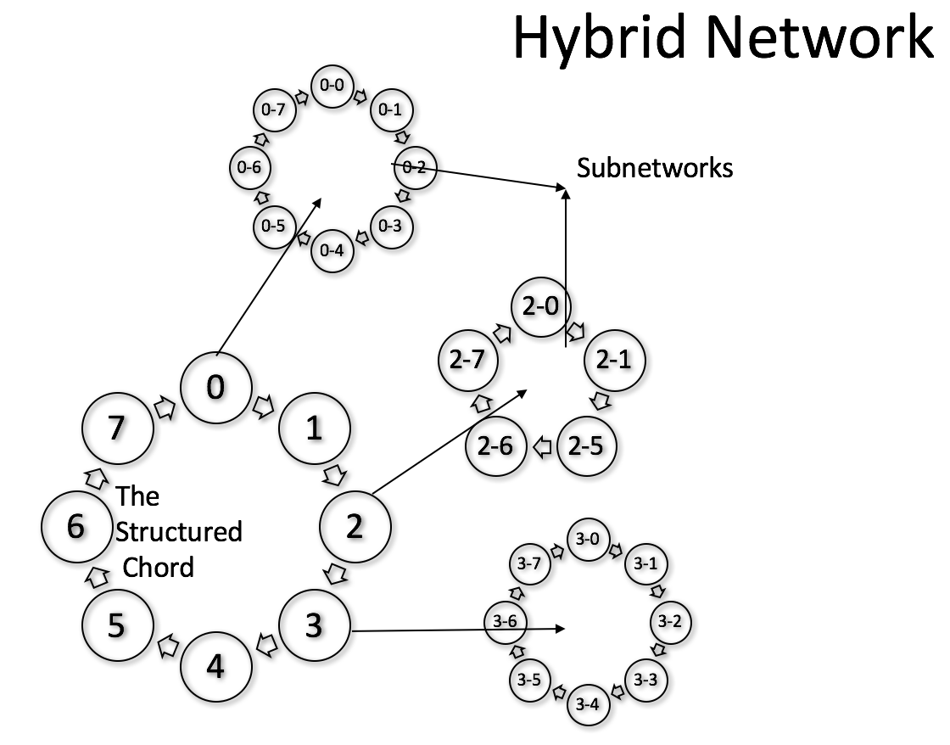

switch(message.type) {
case LOOK_UP :
if(currentNode != destinationNode){
passMessageToRandomNodes(destinationNode);
} else {
SUCCESS++;
return;
}
case LEAVING_NETWORK :
updateDeadNodes();
case ADD_TO_NETWORK:
initialize(node);
addNodeToNetwork(node)
}
Figure 1: The Hybrid Network

Peersim provides the Node - an atomic building block to construct the network and a configuration utility which reads simulation configuration from a file. We specify the total network size and super network size in the configuration file with keys “NETWORK_SIZE” and “SUPER_NETWORK_SIZE” respectively. the subnetwork size is automatically calculated using the following:

SUB_NETWORK_SIZE= NETWORK_SIZE/SUPER_NETWORK_SIZE - 1
All the t-network nodes are initialized at the beginning followed by s-network initialization for each super-node in the t-network. Once the t-network and s-network are initialized, the sub node id will be a composite id which has a super node id prefix in it. All the necessary post-initialization updates like finger table population, successor list population, subnode range calculation (for the super node to keep track of all sub nodes in its subnetwork) etc. will be carried out once the network is populated.

Hybrid Random Walk Network
In this configuration, both t-network and s-network will employ random walk protocol. The basic idea behind random walk protocol is message flooding. There are three main types messages in random walk protocol:

- LOOK_UP
- ADD_TO_NETWORK
- LEAVING_NETWORK

The message type LOOK_UP indicates that a search operation is initiated and the message starts from a source node and reaches a pre-known destination node. Whenever a node receives a message of type LOOK_UP it will forward it to a certain percentage of nodes within its surroundings randomly. The destination node on receiving the message will acknowledge it which accounts for 'successful message delivery' counter increment. Each node maintains a list of dead nodes that it knows about. Initially, the list is empty and is populated gradually whenever it encounters a failed message delivery.
The second main type of message is LEAVING_NETWORK, this message is sent by the node which is leaving the network. Any node which receives the LEAVING_NETWORK message will update its dead node list with the id of leaving node.
Algorithm 1: Random Walk Protocol
The last message type in this configuration of the hybrid network is the ADD_TO_NETWORK message, which is sent when a new node joins the network. When a node receives ADD_TO_NETWORK message, it will initialize the node and adds to the network. the algorithm is depicted in Algorithm 1.

Hybrid Chord Network
In this configuration, the t-network employs chord protocol and s-network employs random walk protocol. There are five main distinct messages in this implementation of the hybrid chord network namely:
- LOOK_UP
- FIND_SUCCESSOR
- LEAVING_NETWORK
- ADD_TO_NETWORK
- STABILIZE
When a node receives a message of type LOOK_UP it will perform the following sanity checks to make a decision on where to route message next:
1) If the node receiving the message is the destination, then acknowledge else go to step b.
2) If the node receiving the message is a subnode and destination is also subnode, it will check if the destination is in same subnetwork. If yes it will pass to all nodes, else routes the message to its super node.
3) If the node receiving the message is super-node and is not the destination node (super-node or a subnode), then it will route the message to nearest Successor node to destination in its finger table, i.e. sends out a FIND_SUCCESSOR message to itself. The high-level algorithm for finding nearest successor is depicted in Algorithm 2
4) If the node receiving the message is super-node and destination is a subnode and is in its subnetwork, the super node will route the message to first subnode in its subnetwork.
These 4 steps of check are crucial in routing the messages to destination in hybrid chord network. when a node receives a LEAVING_NETWORK message, it will update the finger table and successorList with the id of leaving node and also update dead finger nodes list. The leaving node id will be removed from finger table and successor list, added to dead finger node list. When a node receives ADD_TO_NETWORK message it will initialize the new node with appropriate calculated id and add it to the network.
In the case a node receives a STABLIZE message, it will refresh the finger table and successor list and update dead finger nodes list if required. This operation is called the Stabilization in Chord protocol and the algorithm is depicted in Algorithm 3.
if destinationNode in fingerTable:
return destinationNodeAddress
else if destinationNode in successorList:
return destinationNodeAddress
else {
minDistance = 9999
for node in fingerTable {
if (
distance(node, destinationNode) < minDistance
) {
minDistance = distance(node, destinationNode)
nearestNeighbor = node
}
}
return nearestNeighbor
}

Algorithm 2: FindNearestNeighbors (Chord)
switch(message.type) {
case LOOK_UP :
if(currentNode != destinationNode){
sendMessage(currentNode, FIND_SUCCESSOR)
} else {
SUCCESS++;
return;
}
case FIND_SUCCESSOR:
findNearestNeighbour(destinationNode);

case LEAVING_NETWORK :
updateFingerTable(leavingNode);
updateSuccessorList(leavingNode);
updateDeadFingerNodes();
case ADD_TO_NETWORK:
newId = findAppropriatePositionToInsert)
initialize(node, newId)
addNodeToNetwork(node)
case STABILIZE:
stabilize(node)
}

Algorithm 3 :Chord Network
Once the hybrid network is implemented we will run two simulations with two different protocols, random walk and chord protocol. There will two stages of implementation that will be simulated in order to bring out the comparison results.
The success and failure rate of message delivery for different churn rates in the network which uses random walk protocol for both the t-network and the s-network is recorded. The high-level algorithm is depicted in Algorithm 4.

fingerTable = node.getFingerTable
successorList = node.getSuccessorList
deadFingerNodes = node.getDeadFingerNodes
for nodeId in fingerTable:
if getNode(nodeId) == dead:
fingerTable.remove(nodeId)
deadFingerNodes.add(nodeId)
for nodeId in successorList:
if getNode(nodeId) == dead:
successorList.remove(nodeId)
deadFingerNodes.add(nodeId)
node.saveFingerTable(fingerTable)

Algorithm 4: Stabilization in Chord

The second simulation is executed with the chord protocol in the t-network and the random walk in the s-network. The same metrics are recorded for various churn rate. According to our hypothesis, the hybrid network with chord in the t-network and random walk in the s-network should be more resilient to churn with acceptable overhead for maintaining the routing information. The hybrid network with random walk protocol in both the t-network and the s-network is more prone to churn though there is less overhead in maintaining the routing information. In addition, the latter has more overhead on number of messages sent over the network thus consuming more of the network

Simulation Results
In this section, we evaluate the performance of the two different variations of the hybrid peer-to-peer systems through simulation. We have implemented the system on a PeerSim simulator [11].
We have implemented multiple Control interfaces provided by Peersim for creating random message traffic and adding/removal of nodes. Each Control interface expects a step size to be defined which determines how many times that particular Control will be invoked. For example, if the simulation duration is 1000, MessageTrafficGenerator Control has a step size of 5, then every 5th iteration a message will be transmitted over the network, i.e. totally 1000/5=200 random messages will be transmitted over the network. If the Network Control which is responsible for adding/removal nodes has a step size of 20 for node removal, then every 20th iteration a node will be removed from the network i.e. totally 1000/20=50 nodes will be removed from the network. We specify a minSize configuration parameter which enforces a limit on total number of nodes leaving the network, once the limit is reached there will be no more nodes leaving the network. Using this we can calculate the churn rate for any simulation and is given by

churn rate = Network Size * 100.0 / total no. of nodes leaving.

In order to retain the generality of some metrics when different configurations were tested we kept some parameters constant throughout the simulation experiments. The step size, network size, no. of messages sent, simulation duration etc. were kept constant for all the controls within the simulations.
The simulation cycle is run for various churn rates by varying the minSize configuration parameter and resulting message delivery success rate is recorded. The first simulation is run with random walk protocol in both super and subnetworks. As random walk uses flooding for message passing within the network, there were large number messages navigating in the network. Among all the messages the first message that arrives at the destination will cause the success counter to increment and remaining messages will be disregarded. This random flooding accounts for the fast delivery of messages within a subnetwork however it accounted for a large portion of the failed messages.

Figure 2: Comparing the success rates of the hybrid network with random walk protocol and hybrid network with chord protocol.
This has been the reason behind why we studied the success rate of messages against a given churn rate.
The second simulation is run with chord protocol in super-network and random walk protocol in subnetwork. The stabilization rate was kept constant in all the experiments. For every 10 messages sent within the network the stabilization function was initiated to stabilize the network. Since Chord protocol is an efficient look up protocol, the success rate of messages transmitted over the t-network increases considerable as depicted in the test results shown in Figure 2.
T-Test
The t-test is any statistical hypothesis test in which the test statistic follows a Student's t-distribution under the null hypothesis. the t-test value indicates the probability of hypothesis under test being a null hypothesis. The null hypothesis states that there is no significant difference between specified populations, any observed difference being due to sampling or experimental error. The T-test p value calculated proves that our hypothesis holds good and there is very less probability of it being a null hypothesis as shown in the Table 1.

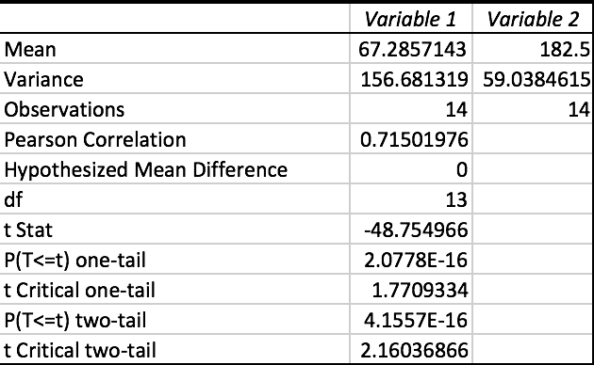
Table 1: T-Test Result

Advantages of the implementation
As a part of the implementation, we built a framework on top of PeerSim to create a heterogeneous network with multiple protocols at a different level of abstraction based on configuration file. This framework provides the user with flexibility to define more levels of abstractions as well, for example, we can define three-level nested networks as well.

CONCLUSIONS AND FUTURE WORK
In this paper, we simulated and analyzed the effect of churn in two different variations of the hybrid peer-to-peer network at the protocol level. The first simulation had the random walk protocol implemented in both the t-network and the s-network of the hybrid network. In the second simulation, random walk protocol in the t-network was replaced with the Chord protocol. In the two simulations, we tested the success rate of messages delivered against the churn rate in the network. Our simulation results indicated that the combination of the chord and the random walk protocols in the hybrid network performed significantly better compared to the network which used only one of the protocols. When the hybrid network with the chord protocol in the t-network and the random walk in the s-network was compared with a structured network which exhibited only the chord protocol, it resulted in more flexibility in the network with respect to churn. On the other hand, the hybrid network with the chord protocol in the t-network and random walk in the s-network resulted in better success delivery rate of messages for a given churn rate. To understand the scalability of the hybrid network with the chord protocol we went on to further test its performance results with larger network sizes. The results indicated that the approach performed equivalently well

Figure 3: Results highlighting the scalability of the hybrid network with chord protocol.
even in the case of larger networks sizes of up to 10⁶ as shown in Figure 3.
Future work includes replacing the chord protocol with even more efficient DHT algorithm and tweaking the network topology of the s-network. The mesh topology of the s-network can be replaced by a tree topology, in which case the network can contribute to achieving faster message delivery and also efficient look up even in the s-networks.

References
- “An efficient hybrid peer-to-peer system for distributed data sharing”,Min Yang and Yuanyuan Yang.
- S. Sen and J. Wang, “Analyzing Peer-to-Peer Traffic Across Large Networks,” Proc. Internet Measurement Workshop, Nov. 2002.
- D. Milojicic, V. Kalogeraki, R. Lukose, K. Nagaraja, J. Pruyne, B. Richard, S. Rollins, and Z. Xu, “Peer-to-Peer Computing,” Technical Report HPL-2002-57, HP Labs, Mar. 2002.
- Miguel Castro, Manuel Costa, and Antony Rowstron. Peer-to-peer overlays: structured, unstructured, or both. Technical Report MSRTR-2004-73, Microsoft Research, Cambridge, 2004.
- S. Ratnasamy, P. Francis, M. Handley, R. Karp, and S. Shenker, “A Scalable Content Addressable Network,” Proc. ACM SIGCOMM ’01, pp. 161-172, 2001.
- I. Stoica, R. Morris, D. Karger, M.F. Kaashoek, and H. Balakrishnan, “Chord: A Scalable Peer-to-Peer Lookup Protocol for Internet Applications,” IEEE/ACM Trans. Networking, vol. 11, no. 1, pp. 17-32, Feb. 2003.
- Gnutella Development Forum, The Gnutella v0.6 Protocol, http:// groups.yahoo.com/group/the gdf/files/, 2009.
- Bittorrent, http://www.bittorrent.com/, 2009.
- TING, Nyik San, DETERS, Ralph. “A Generic Peer-to-Peer Network Simulator”, technical report, Department of Computer Science, University of Saskatchewan, Junho de 2003.
- Peer-to-Peer Systems Rodrigo Rodrigues and Peter Druschel.
- A. Montresor and M. Jelasity. “PeerSim: a scalable P2P simulator.” In Proc. of the 9th Int. Conference on Peer-to-Peer (P2P’09), pp 99–100. Seattle, WA, September 2009. http://peersim.sourceforge.net/
- I. Kazmi and S. F. Y. Bukhari, “Peersim: An efficient & scalable testbed for heterogeneous cluster-based p2p network protocols,”.
- Beraldi R, Baldoni R, Prakash R. Lukewarm potato forwarding: a biased random walk routing protocol for wireless sensor networks.

- L. Lovazs, “Random walks on graphs: A survey”, Combinatorics, Paul
Erdos in Eighty, Vol. 2, 1993, J’anos Bolyai Mathematical Society Budapest.

- Daniel Stutzbach, “Understanding Churn in Peer-to-Peer Networks”.

