**Shri. G. S. Institute of Technology and science**

**Indore(M.P)**

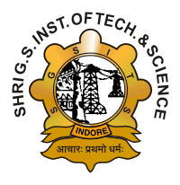

**RECOMMENDATION**

This is to certify that the project report entitled “GESTURE RECOGNITION SYSTEM FOR CONVERTING SIGN LANGUAGE TO TEXT” submitted by Aishwarya Gurjar, Divas Jain, Mansi Agrawal, Romil Jain, Siddhant Gupta students of B.E. final year of this institute in the session 2018-2019, towards the partial fulfillment for the award of degree of **Bachelor of Engineering in Computer Engineering** of Rajiv Gandhi Proudyogiki Vishwavidyalaya, Bhopal is a satisfactory account of their work based on syllabus and is recommended for the award of the degree.

Prof. Urjita Thakar Prof. Urjita Thakar

**Guide Head**

Computer Engg. Department Computer Engg. Department

S.G.S.I.T.S. S.G.S.I.T.S.

Indore Indore

Dean Academic

S.G.S.I.T.S.

Indore