- 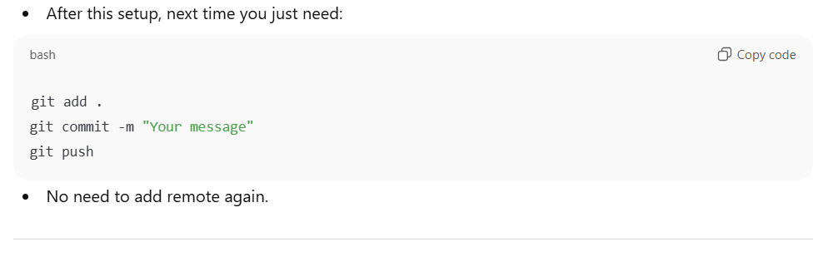
After this setup, next time you just need:
git add .
git commit -m "Your message"
git push
- No need to add remote again.

If you want, I can make a super simple one-command VS Code method to push your repo without even using the terminal. It’s faster for beginners.

