img = imread('img.jpg');

img = rgb2gray(img);

figure(1);

imshow(img);

x1 = input('Enter x1 intensity: ');

y1 = input('Enter y1 intensity: ');

x2 = input('Enter x2 intensity: ');

y2 = input('Enter y2 intensity: ');

l = y1/x1;

m = (y2-y1)/(x2-x1);

n = (255-y2)/(255-x2);

for i=1:size(img,1)

for j=1:size(img,2)

if(img(i,j)<x1)

img(i,j) = l\*img(i,j);

elseif(img(i,j)>=x1 && img(i,j)<x2)

img(i,j) = m\*(img(i,j)-x1) + y1;

else

img(i,j) = n\*(img(i,j)-x2) + y2;

end

end

end

figure(2);

imshow(img);

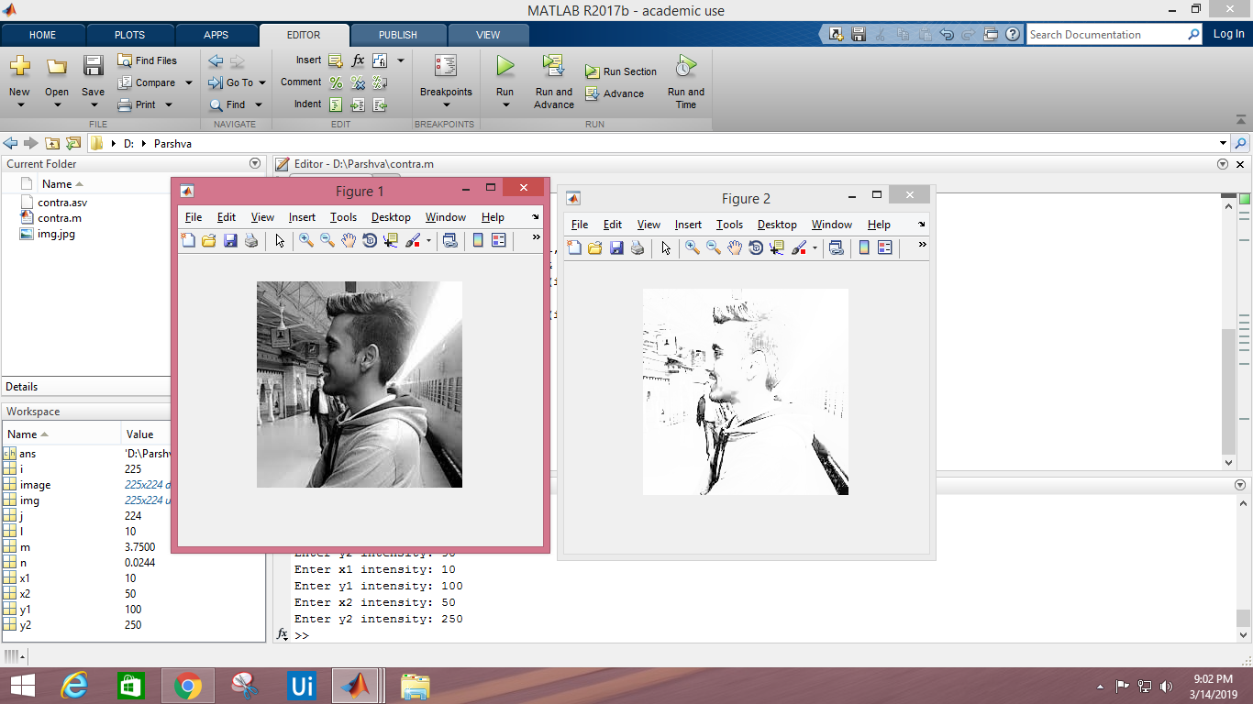

(x1,y1) : (10,100)

(x2,y2) : (50,250)

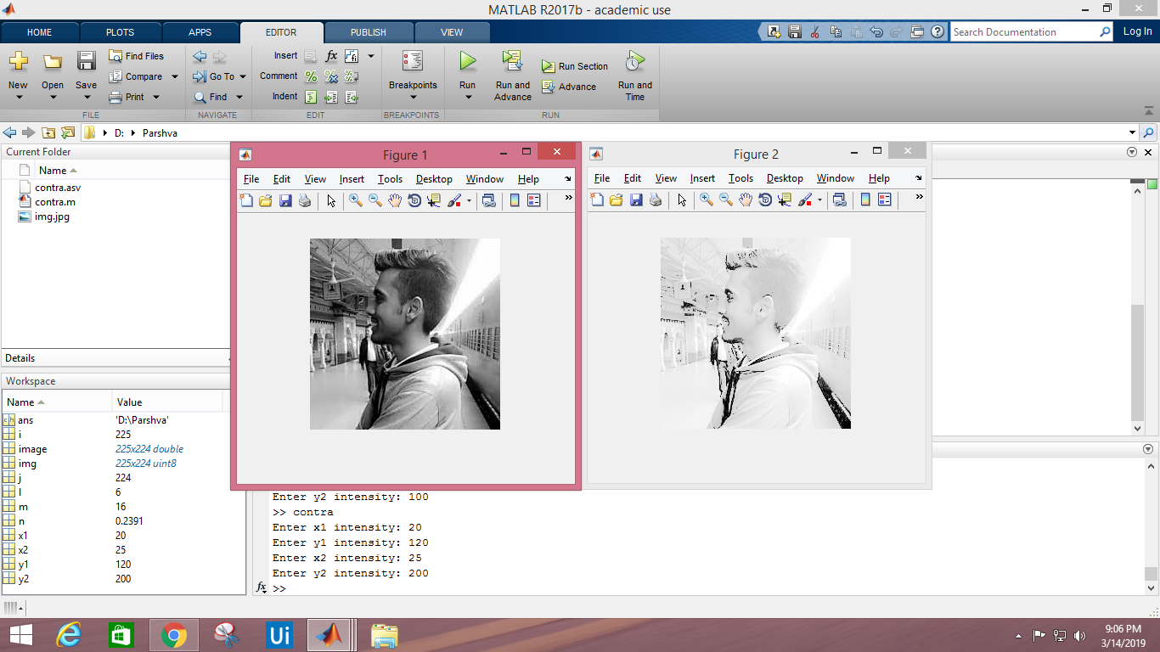

(x1,y1): (20,100)

(x2,y2): (25,200)

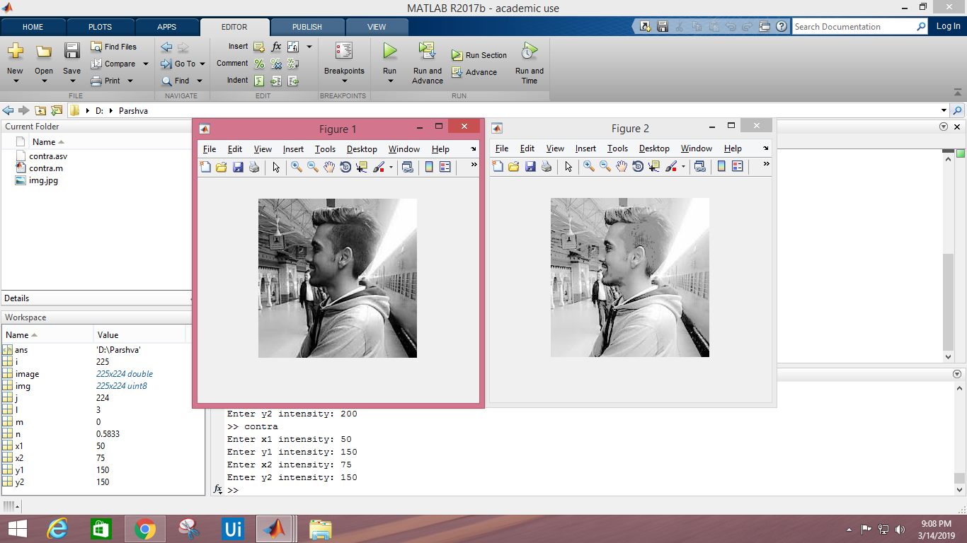

(x1,y1): (50,150)

(x2,y2): (75,150)