## Low pass

%low pass filter

orig = imread('cameraman.jpeg');

img = rgb2gray(orig);

[roworig,colorig] = size(img);

filteredimg = zeros(roworig+2,colorig+2)

for i=1:roworig

for j=1:colorig

filteredimg(i,j) = img(i,j);

end

end

%adding noise

imgnoise = uint8(imnoise(img,'gaussian',0.02));

%filtering

newimage = zeros(roworig,colorig);

for i=2:(roworig+1)

for j = 2:(colorig+1)

newimage(i-1,j-1) = filteredimg(i-1,j-1)+filteredimg(i-1,j)+filteredimg(i,j)+filteredimg(i+1,j)+filteredimg(i+1,j+1)+filteredimg(i+1,j-1)+filteredimg(i,j+1)+filteredimg(i-1,j+1)+filteredimg(i,j-1);

newimage(i-1,j-1) = round(newimage(i-1,j-1)/9);

end

end

newimage = uint8(newimage);

subplot(1,3,1)

imshow(img)

title('Original')

subplot(1,3,2)

imshow(imgnoise)

title('Noisy Image')

subplot(1,3,3)

imshow(newimage)

title('Lowpass filtered')

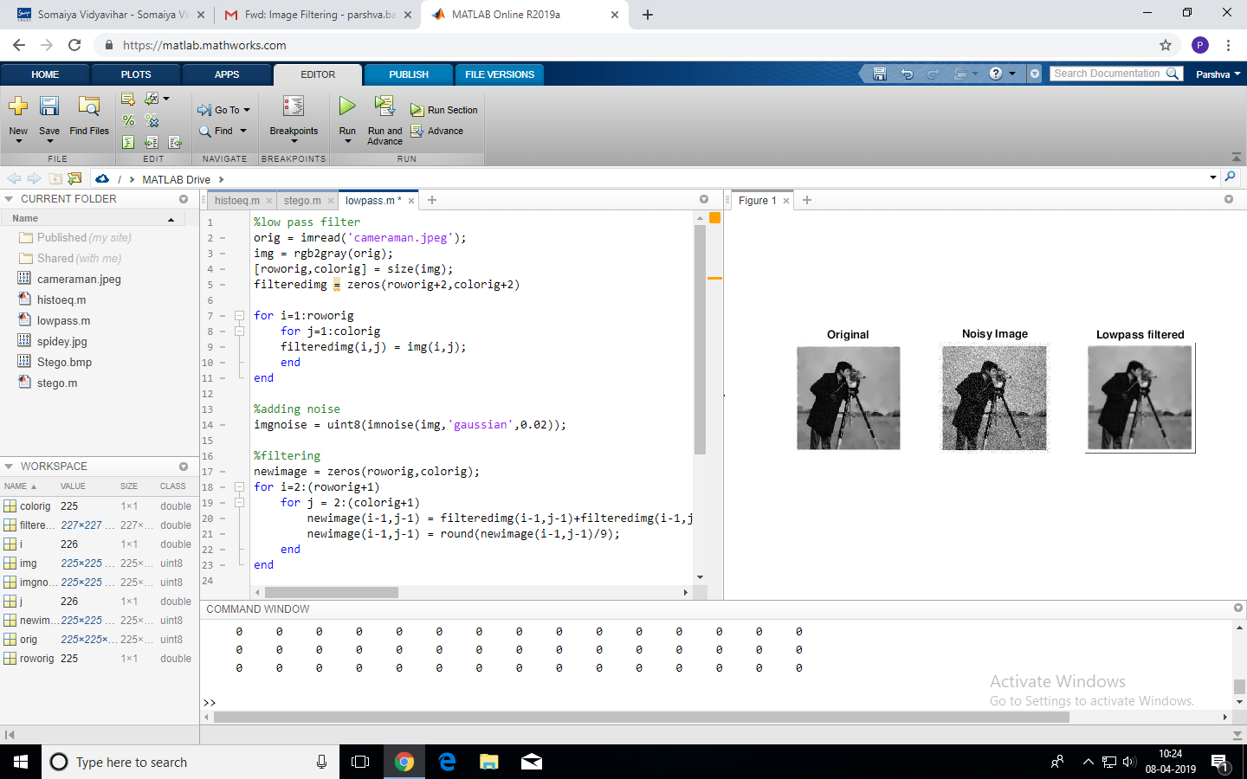

## High pass

orig = imread('cameraman.jpeg');

img = rgb2gray(orig);

[roworig,colorig] = size(img);

filteredimg = zeros(roworig+2,colorig+2);

for i=1:roworig

for j=1:colorig

filteredimg(i,j) = img(i,j);

end

end

%adding noise

imgnoise = uint8(imnoise(img,'gaussian',0.02));

%filtering

newimage = zeros(roworig,colorig);

for i=2:(roworig+1)

for j = 2:(colorig+1)

newimage(i-1,j-1) = -filteredimg(i-1,j-1)-filteredimg(i-1,j)+8*filteredimg(i,j)-filteredimg(i+1,j)-filteredimg(i+1,j+1)-filteredimg(i+1,j-1)-filteredimg(i,j+1)-filteredimg(i-1,j+1)-filteredimg(i,j-1);

newimage(i-1,j-1) = round(newimage(i-1,j-1)/9);

end

end

newimage = uint8(newimage);

subplot(1,2,1)

imshow(img)

title('Original')

subplot(1,2,2)

imshow(newimage)

title('Highpass filtered')

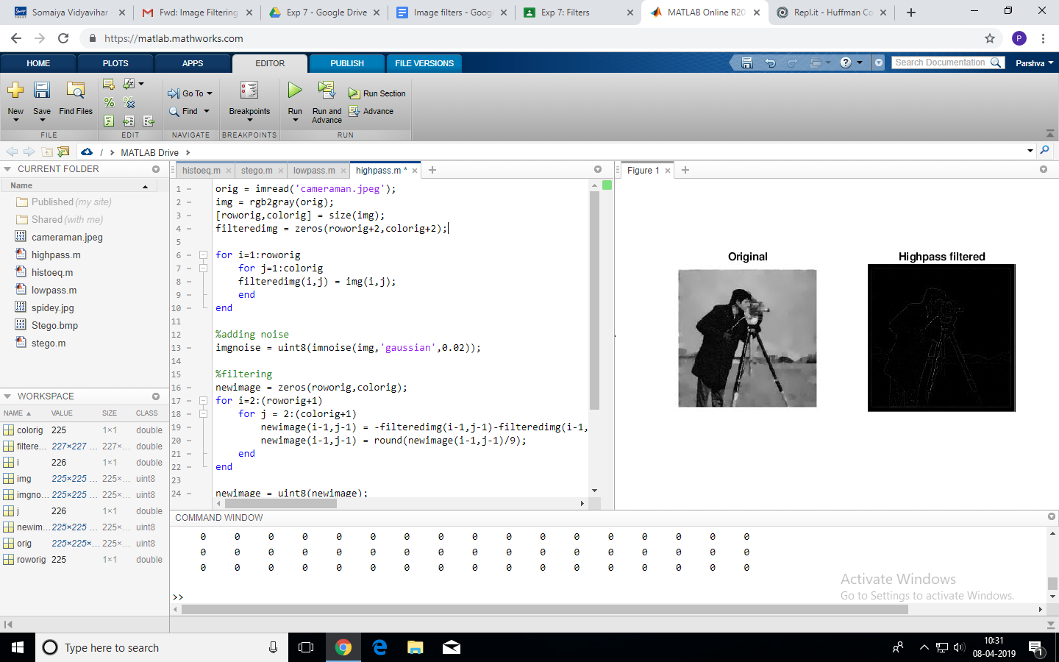

## High boost

orig = imread('cameraman.jpeg');

img = rgb2gray(orig);

[roworig,colorig] = size(img);

filteredimg = zeros(roworig+2,colorig+2);

for i=1:roworig

for j=1:colorig

filteredimg(i,j) = img(i,j);

end

end

%adding noise

imgnoise = uint8(imnoise(img,'gaussian',0.02));

%filtering

newimage = zeros(roworig,colorig);

for i=2:(roworig+1)

for j = 2:(colorig+1)

newimage(i-1,j-1) = -filteredimg(i-1,j-1)-filteredimg(i-1,j)+8.9*filteredimg(i,j)-filteredimg(i+1,j)-filteredimg(i+1,j+1)-filteredimg(i+1,j-1)-filteredimg(i,j+1)-filteredimg(i-1,j+1)-filteredimg(i,j-1);

newimage(i-1,j-1) = round(newimage(i-1,j-1)/9);

end

end

newimage = uint8(newimage);

subplot(1,2,1)

imshow(img)

title('Original')

subplot(1,2,2)

imshow(newimage)

title('Highboost filtered')

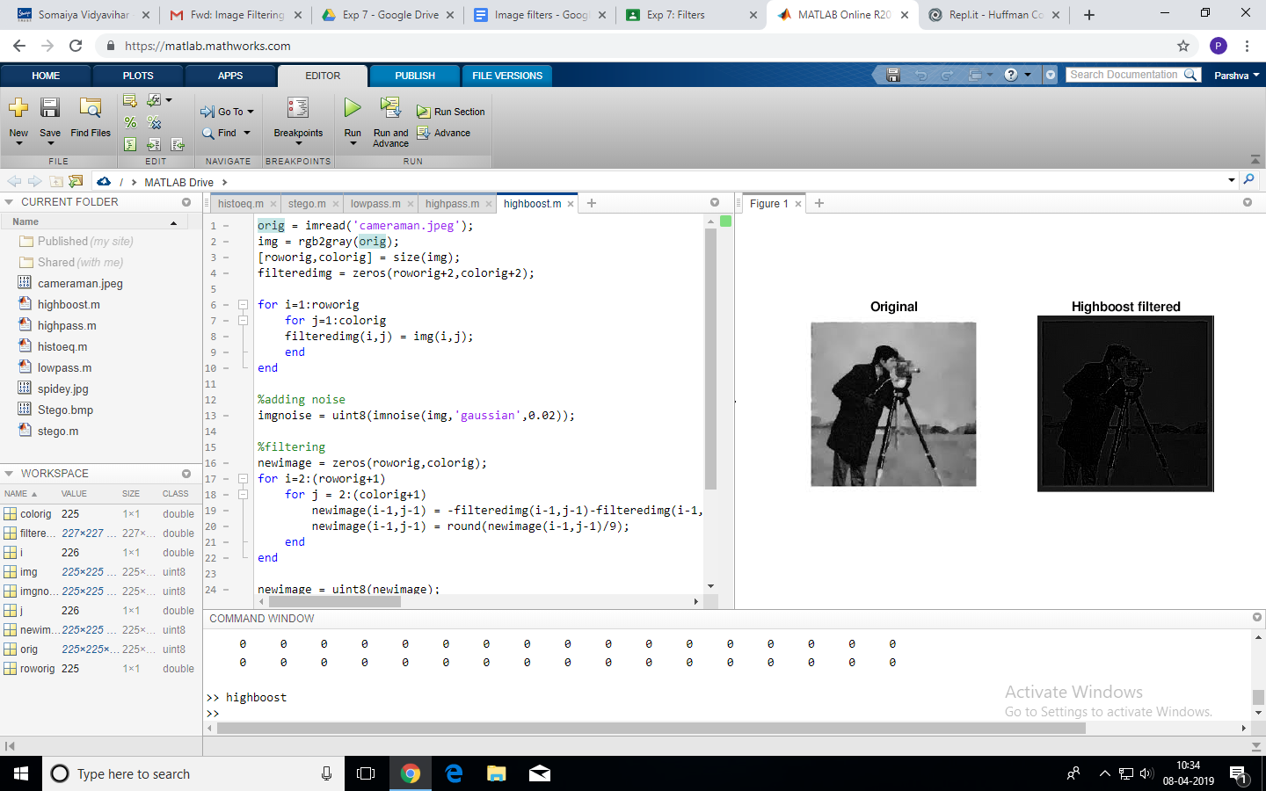

## Median filter

orig = imread('cameraman.jpeg');

img = rgb2gray(orig);

[roworig,colorig] = size(img);

filteredimg = zeros(roworig+2,colorig+2);

for i=1:roworig

for j=1:colorig

filteredimg(i,j) = img(i,j);

end

end

%adding noise

imgnoise = uint8(imnoise(img,'salt & pepper',0.02));

t = zeros(9);

%filtering

newimage = zeros(roworig,colorig);

for i=2:(roworig+1)

for j = 2:(colorig+1)

t(1) = filteredimg(i-1,j-1);

t(2) = filteredimg(i-1,j);

t(3) = filteredimg(i-1,j+1);

t(4) = filteredimg(i,j-1);

t(5) = filteredimg(i,j);

t(6) = filteredimg(i,j+1);

t(7) = filteredimg(i+1,j-1);

t(8) = filteredimg(i+1,j);

t(9) = filteredimg(i+1,j+1);

x = sort(t);

newimage(i-1,j-1) = x(5);

end

end

newimage = uint8(newimage);

subplot(1,2,1)

imshow(img)

title('Original')

subplot(1,2,2)

imshow(newimage)

title('Median filtered')

