ChickenWeight Report-Revised
Aishwarya (Student ID: 20909044)

Data
In ChickWeight data set we have 578 observations about 50 chickens subjected to 4 different diets, for the period of 21 days. [Appendix-1] We have 4 variables as described below:
Chick : ID assigned to each chicken, it may look like numerical, but it is a categorical variable and level of measurement is qualitative, nominal.
Weight : Represents weight on particular day, it is a continuous variable,and level of measurement is quantitative, ratio.The mean weight of chickens across all data is 121.82, the median weight is 103 and the standard deviation was 71.07 [Appendix-2]. Minimum recorded weight is 35gm and maximum recorded weight is 373 gm. (These ranges can be visualized according to diets [Appendix-4] or as given in box-plot)
Time : Represents day of observation, it is a discrete variable and level of measurement is quantitative, ratio. We have observations recorded from 0 to 21 days.[Appendix-3]
Diet : Diet is represented with numbers, however it is a categorical variable and level of measurement is qualitative, nominal.
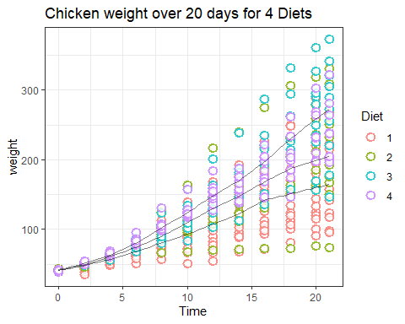
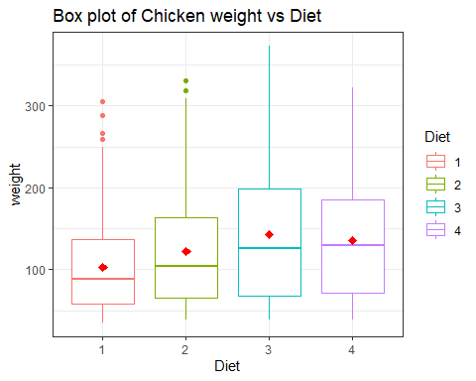 From boxplot of weights across different diet type, weight is right skewed across different Diet types because mean is higher than median. Additionally, for Diet 1 and 2 we can observe some outliers which might have impacted mean and thus skewness of data.Comparatively chickens subjected to diet 3 are heavier than other diets.

Confidence intervals for mean weight at day 0 and 20 for each diet:
We will consider the data in below table as per calculation of the confidence interval.[Appendix-5]
Table for confidence interval provides all the values associated with analysis. We can infer that average weight of chicken subjected to diet 3 is higher than others. From graph we can say that mean weight lies between specific range for each diet and with 95% confidence interval we can say that the mean weight of chicken with Diet 1 lies between 144.06 and 196.76.
We observe that the average chicken weight of Diet 3 is higher than other diets. From the graph for confidence interval at day 20 it has been observed that Diet 1 & Diet 3 interval doesn’t coincide with each other, so we can infer that we are 95% confident that the mean weight of chicken for diet 3 is higher than the mean weight of chicken for diet 1. Also, the Day 20 has highest variability in weights compared to any other day in our population data, so Day 20 cannot be considered as good sample to represent the population mean of chicken weight in 20 days.
day_0 <- ChickWeight %>% filter(Time==0) %>%group_by(Diet)
day_20 <- ChickWeight %>% filter(Time==20) %>%group_by(Diet)
library(Hmisc)
line <- ggplot(day_0, aes(Diet, weight))
line + stat_summary(fun.y = mean,color="red", geom = "point",shape=23,size=2,fill="red") + stat_summary(fun.y = mean, geom = "line", aes(group = 1),colour = "Blue", linetype = "dashed") + stat_summary(aes(color=Diet),fun.data = mean_cl_boot, geom = "errorbar", width = 0.2) + labs(x = "Intervention", y = "Mean Number of weight")+ggtitle("Confidence inteval of each diet at Day 0")+theme_bw()
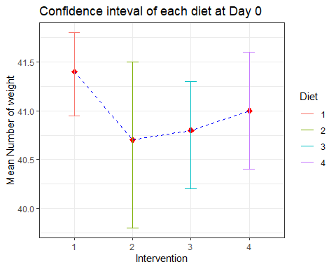
line <- ggplot(day_20, aes(Diet, weight))
line + stat_summary(fun.y = mean,color="red", geom = "point",shape=23,size=2,fill="red") + stat_summary(fun.y = mean, geom = "line", aes(group = 1),colour = "Blue", linetype = "dashed") + stat_summary(aes(color=Diet),fun.data = mean_cl_boot, geom = "errorbar", width = 0.2) + labs(x = "Intervention", y = "Mean Number of weight")+ggtitle("Confidence inteval of each diet at Day 20")+theme_bw()
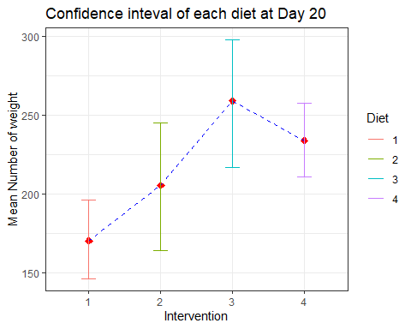
## # A tibble: 4 x 5
## Diet mean sd C1 C2
## <fct> <dbl> <dbl> <dbl> <dbl>
## 1 1 41.4 0.995 41.0 41.8
## 2 2 40.7 1.49 39.8 41.6
## 3 3 40.8 1.03 40.2 41.4
## 4 4 41 1.05 40.3 41.7
## # A tibble: 4 x 5
## Diet mean sd C1 C2
## <fct> <dbl> <dbl> <dbl> <dbl>
## 1 1 170. 55.4 144. 197.
## 2 2 206. 70.3 162. 249.
## 3 3 259. 65.2 218. 299.
## 4 4 234. 37.6 209. 258.

Conclusion for the effect of diets on chickens after 20 days:
We can conclude that there is a linear relationship between weight and time, i.e. weight of chickens is increased with days and hence variablity as well. Additionally, average weight of chicken with Diet 3 is higher than average weights of other diets after 20 days. With 95% confidence we can conclude that average weight for diet 3 is more than diet 1, however we cannot conclude the same for other diets since intervals coincides with each other.

