Assignment2- Partial Correlation -Apendix
Aishwarya (Student ID: 20909044)

Data source:
https://extranet.who.int/tme/generateCSV.asp?ds=estimates

Resources:
Library : https://cran.r-project.org/web/packages/ppcor/
Reference: Discovering statistics Using r-Andy Field (Chapter 5 & 6)
Reference: https://statistics.laerd.com/spss-tutorials/partial-correlation-using-spss-statistics.php

Appendix-1
library(skimr)
library(dplyr)
library(ggplot2)
library(pastecs)
library(psych)
library(grid)
library(gridExtra)
library(GGally)
burdenData = read.csv("TB_burden_countries_2021-03-02.csv", header = TRUE)
df <- as_tibble(burdenData)
new_df<- df%>%select("e_mort_num","c_cdr_lo","e_inc_tbhiv_num_hi" )
new_df<-mutate(new_df, mortality = log(e_mort_num+1),
treatement_coverage = log(c_cdr_lo+1),
cases_tbhiv=log(e_inc_tbhiv_num_hi+1)
)
x <- na.omit(new_df)

Appendix-2
number_of_observations <- count(x)
number_of_variables<- length(df)
number_of_countries<- length(unique(burdenData$country))
data<-x %>% select("mortality","treatement_coverage","cases_tbhiv")

Appendix-3
mortality<- data$mortality
cases<- data$cases_tbhiv
treatment_coverage<-data$treatement_coverage

Appendix-4
##
## Pearson's product-moment correlation
##
## data: mortality and treatment_coverage
## t = -51.924, df = 3589, p-value < 2.2e-16
## alternative hypothesis: true correlation is not equal to 0
## 95 percent confidence interval:
## -0.6732436 -0.6358708
## sample estimates:
## cor
## -0.6549575

Appendix-5
##
## Pearson's product-moment correlation
##
## data: mortality and cases
## t = 132.76, df = 3589, p-value < 2.2e-16
## alternative hypothesis: true correlation is not equal to 0
## 95 percent confidence interval:
## 0.9057900 0.9168672
## sample estimates:
## cor
## 0.9114938

Appendix-6
##
## Pearson's product-moment correlation
##
## data: cases and treatment_coverage
## t = -42.829, df = 3589, p-value < 2.2e-16
## alternative hypothesis: true correlation is not equal to 0
## 95 percent confidence interval:
## -0.6028182 -0.5595109
## sample estimates:
## cor
## -0.5815765

Appendix-7
## mortality treatement_coverage cases_tbhiv
## mortality 100.00000 42.89693 83.08209
## treatement_coverage 42.89693 100.00000 33.82312
## cases_tbhiv 83.08209 33.82312 100.00000

Appendix-8
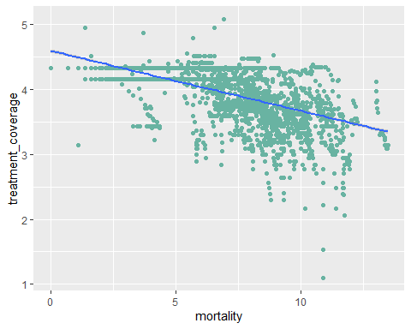

Appendix-9
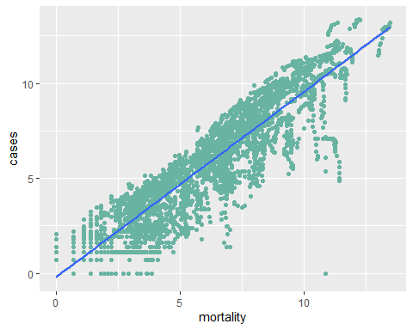

Appendix-10
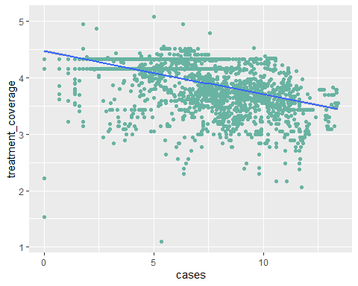

Appendix-11
## [1] -0.373144

Appendix-12
## [1] 0.1392365

Appendix-13
## $tval
## [1] -24.09133
##
## $df
## [1] 3588
##
## $pvalue
## [1] 5.413797e-119

Appendix-14
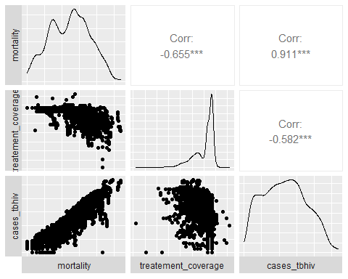

Appendix-18
http://www.sthda.com/english/wiki/scatter-plots-r-base-graphs

