Assignment2- Correlation -Apendix
Aishwarya (Student ID: 20909044)

Data source:
https://extranet.who.int/tme/generateCSV.asp?ds=estimates

Resources:
https://www.statstutor.ac.uk/resources/uploaded/spearmans.pdf
Discovering statistics Using r-Andy Field (Chapter 5 & 6)

Appendix-1
## # A tibble: 1 x 1
## n
## <int>
## 1 4272
## [1] 50

Appendix-2
summary(df$e_pop_num)
## Min. 1st Qu. Median Mean 3rd Qu. Max.
## 1.126e+03 7.363e+05 5.760e+06 3.228e+07 2.050e+07 1.434e+09
#sd(df)

Appendix-3
summary(df$e_inc_num_lo)
## Min. 1st Qu. Median Mean 3rd Qu. Max.
## 0 160 2300 33631 12000 1870000

Appendix-4
In budget data set each column represents unique feature, each row represents unique observation and each cell has unique value so the data provided is already tidy.

Appendix-5
missing_data<- df %>%
select(e_pop_num,e_inc_num_lo) %>%
summarise_all(~ sum(is.na(.)))
This data has several missing values and we may consider the budget to have normal distribution but at the same time this budget depends on several other factors such as economy policies, geography and other medical conditions in vicinity, so due to these uncertainty we are not assuming anything to replace these values with any representative. ggplot will simply ignore missing values.

Appendix-6
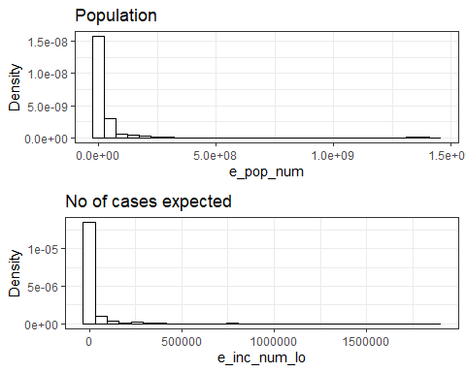

Appendix-7
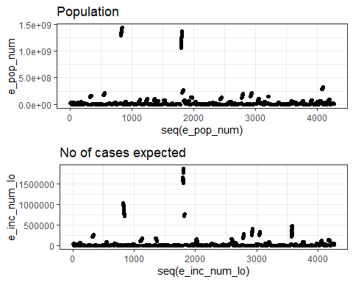

Appendix-8
e_pop_num_desc<-stat.desc(df$e_pop_num, basic=FALSE, norm=TRUE)
e_inc_num_lo_desc<-stat.desc(df$e_inc_num_lo, basic=FALSE, norm=TRUE)
e_pop_num_desc
## median mean SE.mean CI.mean.0.95 var std.dev
## 5.760274e+06 3.227658e+07 1.979156e+06 3.880173e+06 1.673367e+16 1.293587e+08
## coef.var skewness skew.2SE kurtosis kurt.2SE normtest.W
## 4.007818e+00 8.912870e+00 1.189543e+02 8.469490e+01 5.653158e+02 2.098049e-01
## normtest.p
## 2.562658e-86
e_inc_num_lo_desc
## median mean SE.mean CI.mean.0.95 var std.dev
## 2.300000e+03 3.363082e+04 2.226010e+03 4.364136e+03 2.116827e+10 1.454932e+05
## coef.var skewness skew.2SE kurtosis kurt.2SE normtest.W
## 4.326186e+00 8.450104e+00 1.127780e+02 8.293215e+01 5.535499e+02 2.191982e-01
## normtest.p
## 4.739115e-86

Appendix-9
Considering log transformation on budget and log transformation on (no. of cases+1) for handling skewness.
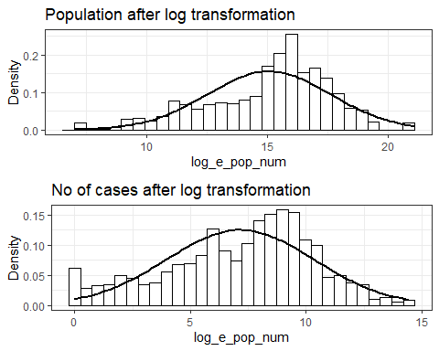

Appendix-10
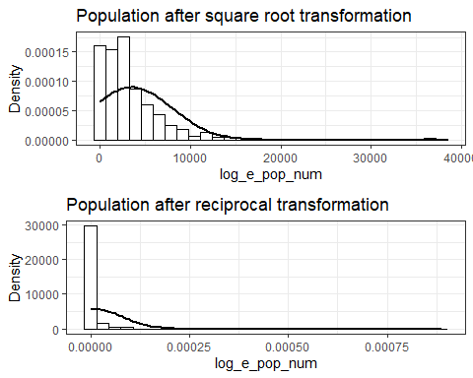

Appendix-11
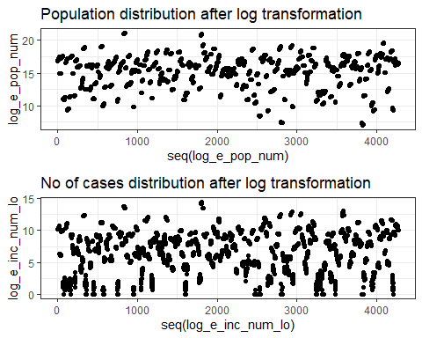
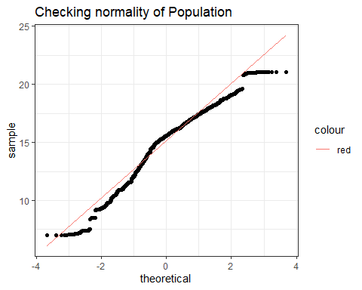
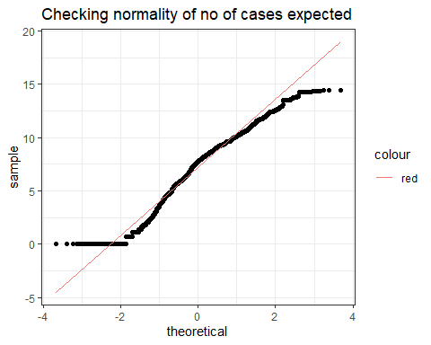
stat.desc(df$log_e_pop_num, basic=FALSE, norm=TRUE)
## median mean SE.mean CI.mean.0.95 var
## 1.556650e+01 1.506601e+01 3.914722e-02 7.674890e-02 6.546861e+00
## std.dev coef.var skewness skew.2SE kurtosis
## 2.558684e+00 1.698315e-01 -6.468572e-01 -8.633181e+00 1.130809e-01
## kurt.2SE normtest.W normtest.p
## 7.547848e-01 9.617908e-01 3.648691e-32
stat.desc(df$log_e_inc_num_lo, basic=FALSE, norm=TRUE)
## median mean SE.mean CI.mean.0.95 var
## 7.741099e+00 7.146174e+00 4.895044e-02 9.596829e-02 1.023633e+01
## std.dev coef.var skewness skew.2SE kurtosis
## 3.199427e+00 4.477119e-01 -4.277316e-01 -5.708654e+00 -4.201397e-01
## kurt.2SE normtest.W normtest.p
## -2.804320e+00 9.716721e-01 2.784738e-28

Appendix-12
skew_e_pop_num<- stat.desc(df$log_e_pop_num, basic=FALSE, norm=TRUE)["skew.2SE"]
skew_e_inc_num_lo<- stat.desc(df$log_e_inc_num_lo, basic=FALSE, norm=TRUE)["skew.2SE"]

Appendix-13
##
## Shapiro-Wilk normality test
##
## data: df$log_e_pop_num
## W = 0.96179, p-value < 2.2e-16
##
## Shapiro-Wilk normality test
##
## data: df$log_e_inc_num_lo
## W = 0.97167, p-value < 2.2e-16

Appendix-14
library(car)
leveneTest(df$log_e_pop_num, df$year, center=mean)
## Levene's Test for Homogeneity of Variance (center = mean)
## Df F value Pr(>F)
## group 19 0.0188 1
## 4252
leveneTest(df$log_e_inc_num_lo, df$year, center=mean)
## Levene's Test for Homogeneity of Variance (center = mean)
## Df F value Pr(>F)
## group 19 0.0406 1
## 4252

Appendix-15
df %>%
select(log_e_pop_num, log_e_inc_num_lo) %>%
cor(use="complete.obs", method = "spearman")
## log_e_pop_num log_e_inc_num_lo
## log_e_pop_num 1.0000000 0.8682392
## log_e_inc_num_lo 0.8682392 1.0000000

Appendix-16
cor.test(df$log_e_pop_num, df$log_e_inc_num_lo, method ="spearman")
##
## Spearman's rank correlation rho
##
## data: df$log_e_pop_num and df$log_e_inc_num_lo
## S = 1712098011, p-value < 2.2e-16
## alternative hypothesis: true rho is not equal to 0
## sample estimates:
## rho
## 0.8682392

Appendix-17
e <- ggplot(budgetData, aes(e_pop_num, e_inc_num_lo))
e+geom_smooth(method = lm)+ggtitle("No of cases Vs Population")+theme_bw()
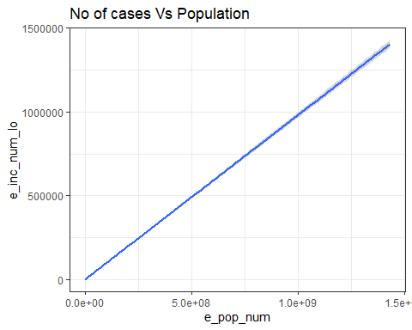

Appendix-18
http://www.sthda.com/english/wiki/scatter-plots-r-base-graphs

