Individual Assignment3 - Appendix

Data source:
https://www.consumerfinance.gov/data-research/consumer-complaints/search/api/v1/?company=BANK%20OF%20AMERICA%2C%20NATIONAL%20ASSOCIATION&date_received_max=2021-03-15&date_received_min=2011-12-01&field=all&format=csv&lens=overview&no_aggs=true&product=Bank%20account%20or%20service&product=Checking%20or%20savings%20account&size=27104&trend_depth=5&trend_interval=month

Reference:
[1] https://www.statisticssolutions.com/assumptions-of-linear-regression
[2] “Discovering Statistics Using R” by Andy Field, Jeremy Miles, Zoe Field.

Appendix -1
library(dplyr)
## Warning: package 'dplyr' was built under R version 4.0.4
##
## Attaching package: 'dplyr'
## The following objects are masked from 'package:stats':
##
## filter, lag
## The following objects are masked from 'package:base':
##
## intersect, setdiff, setequal, union
library(tidyr)
## Warning: package 'tidyr' was built under R version 4.0.4
library(ggplot2)
## Warning: package 'ggplot2' was built under R version 4.0.4
dataset <- read.csv(path)

Appendix -2
dataset<- dataset %>% filter(Company=="BANK OF AMERICA, NATIONAL ASSOCIATION")
dataset <- na.omit(dataset)
dataset<-dataset %>% separate(Date.received, c("Split_Month","Split_Day","Split_Year"),remove=FALSE)
dataset$Split_Year<- as.integer(dataset$Split_Year)
dataset$Split_Month <- as.integer(dataset$Split_Month)
dataset$Split_Year <- (dataset$Split_Year + 2000)
all_years<-c(2011,2012,2013,2014,2015,2016,2017,2018,2019,2020,2021)
all_months<-c(1,2,3,4,5,6,7,8,9,10,11,12)
all_quaters<-c(1,2,3,4)

Appendix -3
## year month time complains
## 1 2012 3 1 183
## 2 2012 4 2 218
## 3 2012 5 3 279
## 4 2012 6 4 217
## 5 2012 7 5 230
## 6 2012 8 6 204
## 7 2012 9 7 167
## 8 2012 10 8 225
## 9 2012 11 9 162
## 10 2012 12 10 152
## 11 2013 1 11 205
## 12 2013 2 12 171
## 13 2013 3 13 173
## 14 2013 4 14 169
## 15 2013 5 15 184
## 16 2013 6 16 175
## 17 2013 7 17 206
## 18 2013 8 18 186
## 19 2013 9 19 200
## 20 2013 10 20 209
## 21 2013 11 21 157
## 22 2013 12 22 160
## 23 2014 1 23 197
## 24 2014 2 24 205
## 25 2014 3 25 203
## 26 2014 4 26 228
## 27 2014 5 27 214
## 28 2014 6 28 195
## 29 2014 7 29 193
## 30 2014 8 30 201
## 31 2014 9 31 190
## 32 2014 10 32 219
## 33 2014 11 33 165
## 34 2014 12 34 217
## 35 2015 1 35 213
## 36 2015 2 36 178
## 37 2015 3 37 211
## 38 2015 4 38 226
## 39 2015 5 39 253
## 40 2015 6 40 283
## 41 2015 7 41 287
## 42 2015 8 42 278
## 43 2015 9 43 262
## 44 2015 10 44 258
## 45 2015 11 45 235
## 46 2015 12 46 241
## 47 2016 1 47 278
## 48 2016 2 48 212
## 49 2016 3 49 270
## 50 2016 4 50 248
## 51 2016 5 51 240
## 52 2016 6 52 255
## 53 2016 7 53 256
## 54 2016 8 54 313
## 55 2016 9 55 326
## 56 2016 10 56 292
## 57 2016 11 57 284
## 58 2016 12 58 270
## 59 2017 1 59 288
## 60 2017 2 60 279
## 61 2017 3 61 316
## 62 2017 4 62 259
## 63 2017 5 63 246
## 64 2017 6 64 268
## 65 2017 7 65 275
## 66 2017 8 66 260
## 67 2017 9 67 259
## 68 2017 10 68 253
## 69 2017 11 69 308
## 70 2017 12 70 270
## 71 2018 1 71 276
## 72 2018 2 72 272
## 73 2018 3 73 313
## 74 2018 4 74 373
## 75 2018 5 75 305
## 76 2018 6 76 291
## 77 2018 7 77 319
## 78 2018 8 78 284
## 79 2018 9 79 292
## 80 2018 10 80 278
## 81 2018 11 81 230
## 82 2018 12 82 190
## 83 2019 1 83 223
## 84 2019 2 84 186
## 85 2019 3 85 245
## 86 2019 4 86 279
## 87 2019 5 87 293
## 88 2019 6 88 287
## 89 2019 7 89 309
## 90 2019 8 90 347
## 91 2019 9 91 294
## 92 2019 10 92 295
## 93 2019 11 93 268
## 94 2019 12 94 294
## 95 2020 1 95 300
## 96 2020 2 96 261
## 97 2020 3 97 273
## 98 2020 4 98 306
## 99 2020 5 99 270
## 100 2020 6 100 290
## 101 2020 7 101 284
## 102 2020 8 102 255
## 103 2020 9 103 289
## 104 2020 10 104 317
## 105 2020 11 105 288
## 106 2020 12 106 369
## 107 2021 1 107 388
## 108 2021 2 108 338
## 109 2021 3 109 24

Appendix -3
## year n
## 1 2012 2037
## 2 2013 2195
## 3 2014 2427
## 4 2015 2925
## 5 2016 3244
## 6 2017 3281
## 7 2018 3423
## 8 2019 3320
## 9 2020 3502
## 10 2021 750

Appendix -4
one important assumption of the linear regression is that the relationship between the outcome and predictor variables is linear and additive. Here quarter and no of complains are strongly & positively related. Correlation can be given as:
cor( df$no_of_quarter,df$complains)*100
## [1] 75.62481

Appendix -5
##
## Call:
## lm(formula = complains ~ no_of_quarter, data = df)
##
## Residuals:
## Min 1Q Median 3Q Max
## -185.647 -61.632 5.355 66.851 158.355
##
## Coefficients:
## Estimate Std. Error t value Pr(>|t|)
## (Intercept) 568.956 30.435 18.69 < 2e-16 ***
## no_of_quarter 9.668 1.434 6.74 9.59e-08 ***
## ---
## Signif. codes: 0 '***' 0.001 '**' 0.01 '*' 0.05 '.' 0.1 ' ' 1
##
## Residual standard error: 89.41 on 34 degrees of freedom
## Multiple R-squared: 0.5719, Adjusted R-squared: 0.5593
## F-statistic: 45.42 on 1 and 34 DF, p-value: 9.589e-08

Appendix -6
## 2.5 % 97.5 %
## (Intercept) 507.105081 630.80603
## no_of_quarter 6.752448 12.58269

Appendix -7
sigma(regressor)*100/mean(df$complains)
## [1] 11.95604

Appendix -8
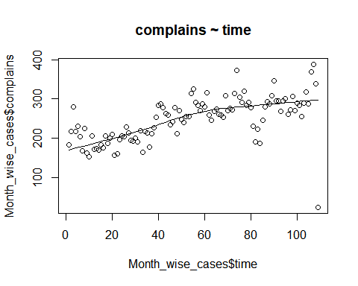

Appendix -9
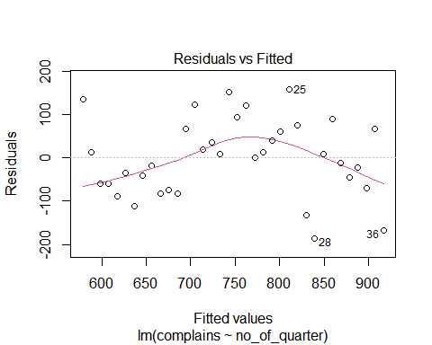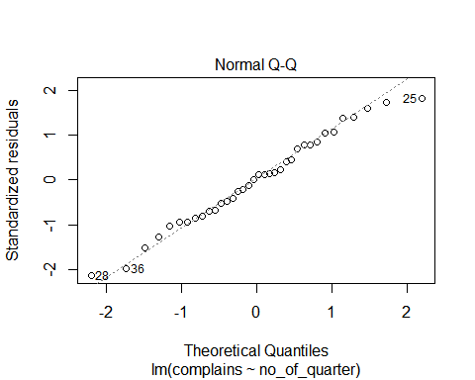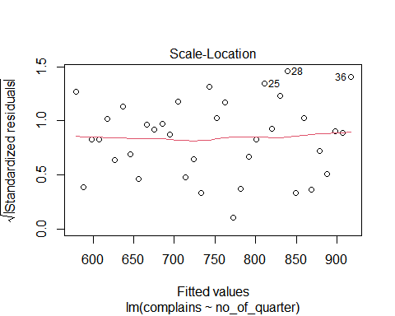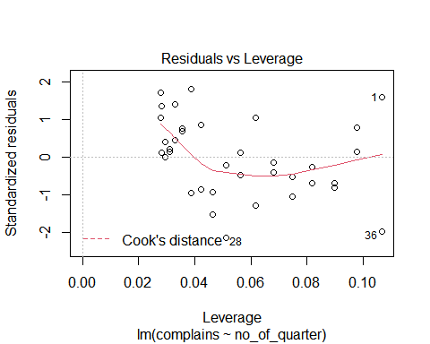

Appendix -10
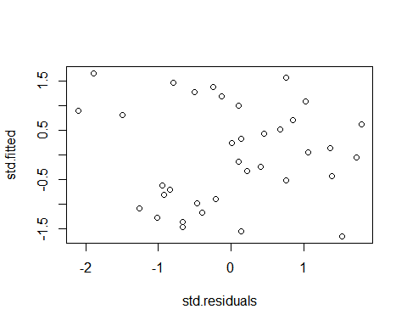

Appendix -11
## [1] 1

Appendix -12
Assumption of normality
## `stat_bin()` using `bins = 30`. Pick better value with `binwidth`.
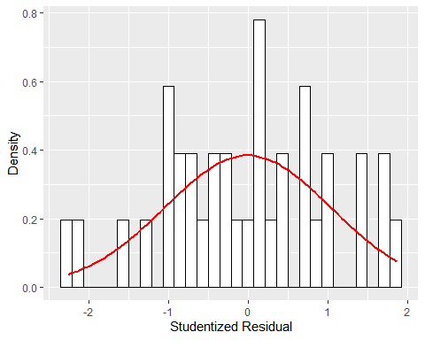 ## Appendix -13
## Warning: `stat` is deprecated
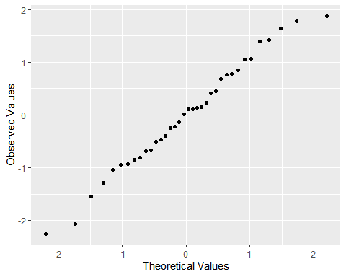 ## Appendix -14
## `geom_smooth()` using formula 'y ~ x'
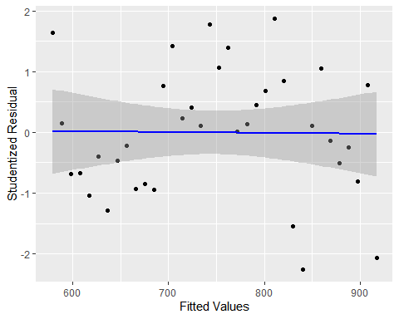

Appendix -15
## 1 2 3 4 5 6 7
## 926.6556 936.3231 945.9907 955.6583 965.3258 974.9934 984.6610

Appendix -16
## [1] 3880.638

Appendix -17
## Warning: package 'car' was built under R version 4.0.4
## Loading required package: carData
##
## Attaching package: 'car'
## The following object is masked from 'package:dplyr':
##
## recode
## lag Autocorrelation D-W Statistic p-value
## 1 0.3428544 1.144262 0.002
## Alternative hypothesis: rho != 0

Appendix -18
## Warning: package 'boot' was built under R version 4.0.4
##
## Attaching package: 'boot'
## The following object is masked from 'package:car':
##
## logit
## BOOTSTRAP CONFIDENCE INTERVAL CALCULATIONS
## Based on 2000 bootstrap replicates
##
## CALL :
## boot.ci(boot.out = results, type = "bca", index = 1)
##
## Intervals :
## Level BCa
## 95% (521.6, 635.2 )
## Calculations and Intervals on Original Scale
## BOOTSTRAP CONFIDENCE INTERVAL CALCULATIONS
## Based on 2000 bootstrap replicates
##
## CALL :
## boot.ci(boot.out = results, type = "bca", index = 2)
##
## Intervals :
## Level BCa
## 95% ( 6.566, 12.433 )
## Calculations and Intervals on Original Scale

