Individual Assignment4- Appendix

Appendix - 1
For latitude between -37.6 and -38.0 there are many houses,which would mean that it’s an ideal residential location.
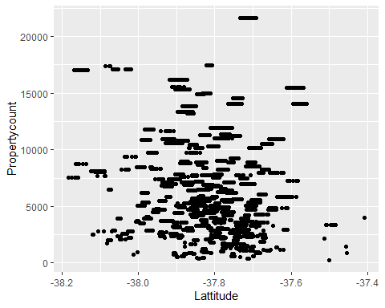
But when we talk about longitude we can see that concentration is high between 144.8 to 145.1 (This is close to the location of CBD) 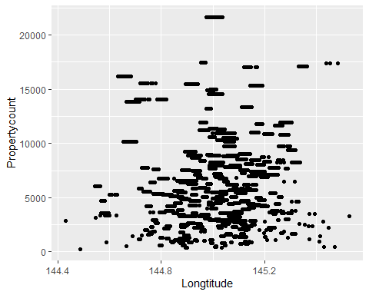
Given number of rooms between 3-5, there seems to be houses in all price ranges. As the number of rooms increases we can find higher price range houses. For 1-2 room houses there are lower price range houses
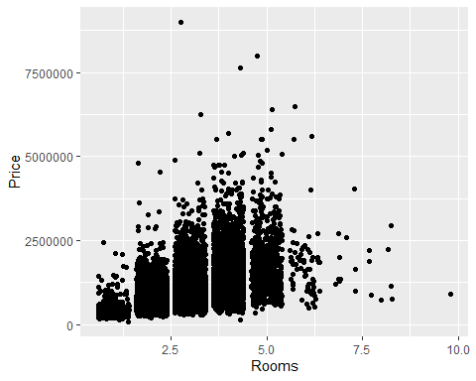
Closer to CBD, there are a number of houses with varying price range Farther away, the number reduces drastically and the price too
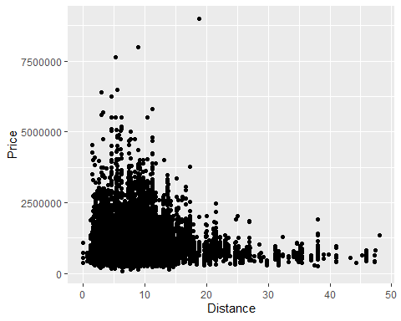
As the number of bathrooms becomes more than 4, the number of houses decreases drastically.
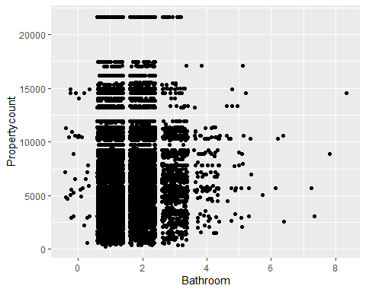
Initially, the price range increases as the number of bathrooms increases.
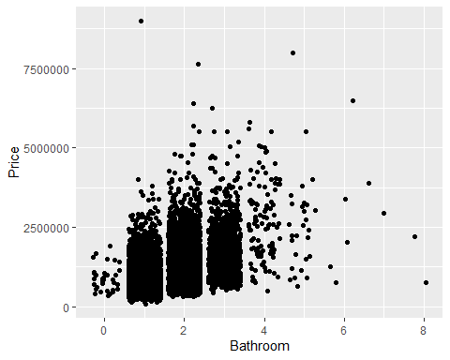
People with 2 or 4 cars have been seen to be buying the costliest of houses As people have more number of houses the price decreases
## Warning: Removed 62 rows containing missing values (geom_point).
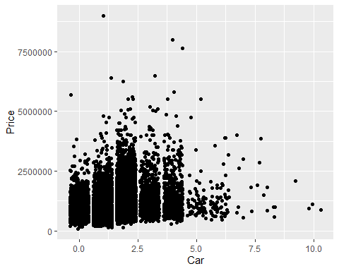
## Warning: Removed 62 rows containing missing values (geom_point).
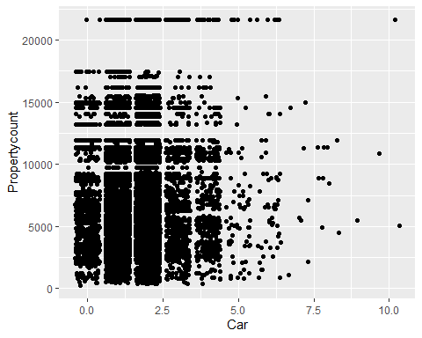
Landsize doesn’t distinctly affect the price of a house
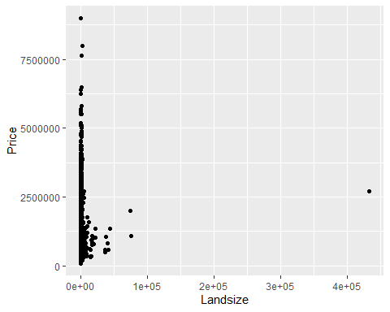
As building area increases we can see a slight shift of the range of the houses available
## Warning: Removed 6450 rows containing missing values (geom_point).
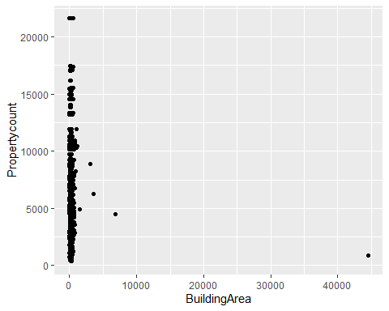

Appendix - 2
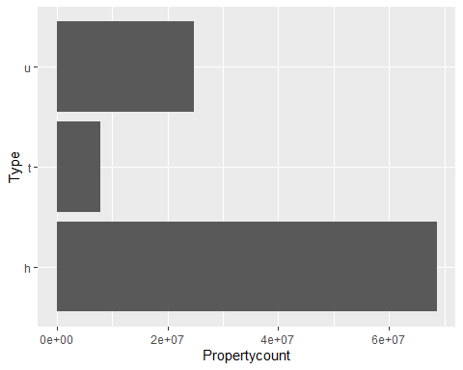 ## Appendix - 3
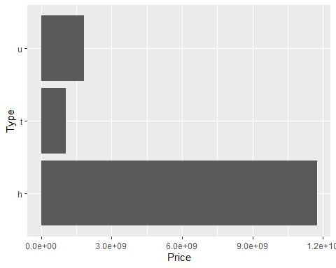

Appendix - 4

Appendix -4b
## Warning: package 'corrplot' was built under R version 4.0.4
## corrplot 0.84 loaded
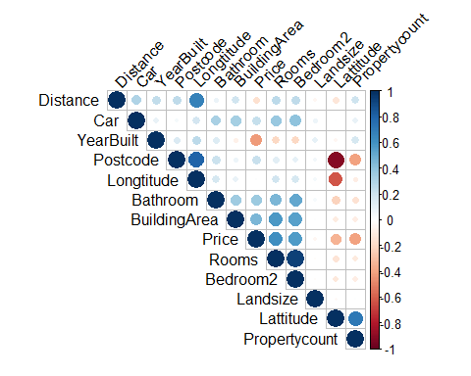

Appendix -5
##
## Call:
## lm(formula = Price ~ BuildingArea + Postcode + Rooms + Bathroom +
## Distance, data = dataset, na.action = na.exclude)
##
## Residuals:
## Min 1Q Median 3Q Max
## -895579 -165361 -9515 149806 1618878
##
## Coefficients:
## Estimate Std. Error t value Pr(>|t|)
## (Intercept) -7536414.8 883638.9 -8.529 < 2e-16 ***
## BuildingArea 1021.7 180.2 5.670 2.15e-08 ***
## Postcode 2553.4 288.3 8.856 < 2e-16 ***
## Rooms 277024.3 15792.7 17.541 < 2e-16 ***
## Bathroom 10256.4 19039.5 0.539 0.59
## Distance -42889.9 2761.4 -15.532 < 2e-16 ***
## ---
## Signif. codes: 0 '***' 0.001 '**' 0.01 '*' 0.05 '.' 0.1 ' ' 1
##
## Residual standard error: 271400 on 652 degrees of freedom
## Multiple R-squared: 0.576, Adjusted R-squared: 0.5727
## F-statistic: 177.1 on 5 and 652 DF, p-value: < 2.2e-16
## Warning: `arrange_()` was deprecated in dplyr 0.7.0.
## Please use `arrange()` instead.
## See vignette('programming') for more help
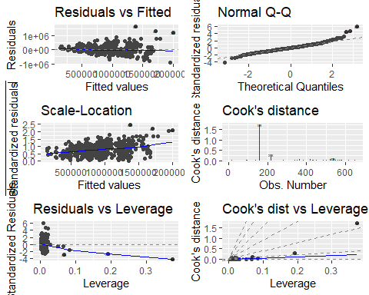
##
## Call:
## lm(formula = Price ~ BuildingArea + Postcode + Rooms + Bathroom +
## Distance + Type, data = dataset, na.action = na.exclude)
##
## Residuals:
## Min 1Q Median 3Q Max
## -853455 -160250 -6818 135489 1544108
##
## Coefficients:
## Estimate Std. Error t value Pr(>|t|)
## (Intercept) -8054081.4 822855.6 -9.788 < 2e-16 ***
## BuildingArea 879.3 168.1 5.232 2.26e-07 ***
## Postcode 2802.1 269.1 10.413 < 2e-16 ***
## Rooms 199133.0 16550.6 12.032 < 2e-16 ***
## Bathroom 47126.9 18062.3 2.609 0.00929 **
## Distance -40944.8 2573.7 -15.909 < 2e-16 ***
## TypeNonHouse -252053.4 24744.3 -10.186 < 2e-16 ***
## ---
## Signif. codes: 0 '***' 0.001 '**' 0.01 '*' 0.05 '.' 0.1 ' ' 1
##
## Residual standard error: 252300 on 651 degrees of freedom
## Multiple R-squared: 0.6343, Adjusted R-squared: 0.6309
## F-statistic: 188.2 on 6 and 651 DF, p-value: < 2.2e-16
autoplot(model.2, which = 1:6, label.size = 1, colour = 'Type')
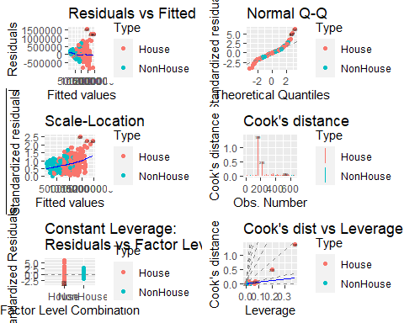

Appendix - 6
summary(model.1)
##
## Call:
## lm(formula = Price ~ BuildingArea + Postcode + Rooms + Bathroom +
## Distance, data = dataset, na.action = na.exclude)
##
## Residuals:
## Min 1Q Median 3Q Max
## -1.12522 -0.19421 0.00462 0.18949 0.96369
##
## Coefficients:
## Estimate Std. Error t value Pr(>|t|)
## (Intercept) -39.27983 7.16820 -5.480 6.09e-08 ***
## BuildingArea 0.19586 0.02490 7.865 1.54e-14 ***
## Postcode 6.46265 0.89243 7.242 1.25e-12 ***
## Rooms 0.78034 0.04084 19.107 < 2e-16 ***
## Bathroom 0.01547 0.03295 0.470 0.639
## Distance -0.33527 0.02148 -15.608 < 2e-16 ***
## ---
## Signif. codes: 0 '***' 0.001 '**' 0.01 '*' 0.05 '.' 0.1 ' ' 1
##
## Residual standard error: 0.2761 on 652 degrees of freedom
## Multiple R-squared: 0.6443, Adjusted R-squared: 0.6415
## F-statistic: 236.2 on 5 and 652 DF, p-value: < 2.2e-16
summary(model.2)
##
## Call:
## lm(formula = Price ~ BuildingArea + Postcode + Rooms + Bathroom +
## Distance + Type, data = dataset, na.action = na.exclude)
##
## Residuals:
## Min 1Q Median 3Q Max
## -1.29296 -0.16896 0.00522 0.17394 0.93493
##
## Coefficients:
## Estimate Std. Error t value Pr(>|t|)
## (Intercept) -46.49184 6.42316 -7.238 1.29e-12 ***
## BuildingArea 0.14669 0.02255 6.504 1.56e-10 ***
## Postcode 7.42083 0.80009 9.275 < 2e-16 ***
## Rooms 0.55974 0.04025 13.906 < 2e-16 ***
## Bathroom 0.09956 0.03012 3.305 0.001 **
## Distance -0.31608 0.01923 -16.435 < 2e-16 ***
## TypeNonHouse -0.31771 0.02457 -12.930 < 2e-16 ***
## ---
## Signif. codes: 0 '***' 0.001 '**' 0.01 '*' 0.05 '.' 0.1 ' ' 1
##
## Residual standard error: 0.2465 on 651 degrees of freedom
## Multiple R-squared: 0.7169, Adjusted R-squared: 0.7143
## F-statistic: 274.8 on 6 and 651 DF, p-value: < 2.2e-16
lm.beta(model.1)
## BuildingArea Postcode Rooms Bathroom Distance
## 0.23865221 0.17512561 0.60317432 0.01271967 -0.38180199
lm.beta(model.2)
## Warning in var(if (is.vector(x) || is.factor(x)) x else as.double(x), na.rm =
## na.rm): NAs introduced by coercion
## BuildingArea Postcode Rooms Bathroom Distance TypeNonHouse
## 0.17874047 0.20109032 0.43266151 0.08183822 -0.35994886 NA

Appendix -7
dataset$residuals<-resid(model.1) #page 323
dataset$standardized.residuals<- rstandard(model.1) #page 324
dataset$studentized.residuals<-rstudent(model.1)
dataset$cooks.distance<-cooks.distance(model.1)
dataset$dfbeta<-dfbeta(model.1)
dataset$dffit<-dffits(model.1)
dataset$leverage<-hatvalues(model.1)
dataset$covariance.ratios<-covratio(model.1)
e <- ggplot(dataset, aes(y=standardized.residuals, x=leverage))
e+geom_point()
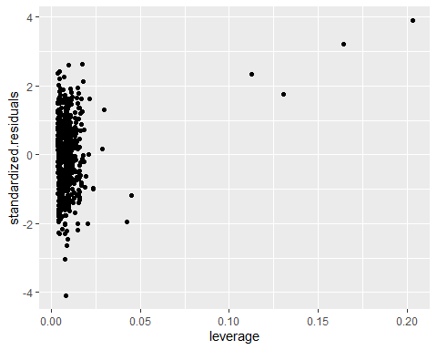
summary(dataset$cooks)
## Min. 1st Qu. Median Mean 3rd Qu. Max.
## 0.0000000 0.0001239 0.0005914 0.0031541 0.0016212 0.6486616
dataset$residuals<-resid(model.2) #page 323
dataset$standardized.residuals<- rstandard(model.2) #page 324
dataset$studentized.residuals<-rstudent(model.2)
dataset$cooks.distance<-cooks.distance(model.2)
dataset$dfbeta<-dfbeta(model.2)
dataset$dffit<-dffits(model.2)
dataset$leverage<-hatvalues(model.2)
dataset$covariance.ratios<-covratio(model.2)
e <- ggplot(dataset, aes(y=standardized.residuals, x=leverage))
e+geom_point()
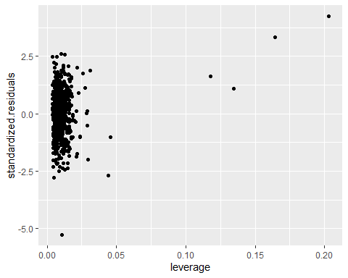
summary(dataset$cooks)
## Min. 1st Qu. Median Mean 3rd Qu. Max.
## 0.0000000 0.0001281 0.0005717 0.0030707 0.0016027 0.6570990

Appendix-8
vif(model.1)
## BuildingArea Postcode Rooms Bathroom Distance
## 1.687631 1.071840 1.826461 1.344159 1.096637
1/vif(model.1)
## BuildingArea Postcode Rooms Bathroom Distance
## 0.5925467 0.9329750 0.5475068 0.7439596 0.9118790
mean(vif(model.1))
## [1] 1.405346
vif(model.2)
## BuildingArea Postcode Rooms Bathroom Distance Type
## 1.737006 1.081114 2.226409 1.409876 1.103206 1.483621
1/vif(model.2)
## BuildingArea Postcode Rooms Bathroom Distance Type
## 0.5757032 0.9249720 0.4491538 0.7092822 0.9064491 0.6740268
mean(vif(model.2))
## [1] 1.506872

Appendix -9
confint(model.2)
## 2.5 % 97.5 %
## (Intercept) -59.10445776 -33.8792250
## BuildingArea 0.10240145 0.1909742
## Postcode 5.84975658 8.9918942
## Rooms 0.48070195 0.6387792
## Bathroom 0.04041596 0.1587085
## Distance -0.35384635 -0.2783171
## TypeNonHouse -0.36595389 -0.2694600
exp(confint(model.2))
## 2.5 % 97.5 %
## (Intercept) 2.144175e-26 1.933925e-15
## BuildingArea 1.107828e+00 1.210428e+00
## Postcode 3.471499e+02 8.037667e+03
## Rooms 1.617209e+00 1.894167e+00
## Bathroom 1.041244e+00 1.171996e+00
## Distance 7.019828e-01 7.570567e-01
## TypeNonHouse 6.935348e-01 7.637918e-01

Appendix -10
anova(model.1,model.2)
## Analysis of Variance Table
##
## Model 1: Price ~ BuildingArea + Postcode + Rooms + Bathroom + Distance
## Model 2: Price ~ BuildingArea + Postcode + Rooms + Bathroom + Distance +
## Type
## Res.Df RSS Df Sum of Sq F Pr(>F)
## 1 652 49.708
## 2 651 39.550 1 10.158 167.2 < 2.2e-16 ***
## ---
## Signif. codes: 0 '***' 0.001 '**' 0.01 '*' 0.05 '.' 0.1 ' ' 1

Appendix -11

Price prediction
## 1
## 13.51889
exp(log_price)
## 1
## 743328.8
log_newdata
## BuildingArea Postcode Rooms Bathroom Distance
## 1 4.60517 8.024862 1.098612 0.6931472 2.484907
log_newdata$Type='House'
log_price=predict(model.2, log_newdata)
exp(log_price)
## 1
## 833423.7
log_newdata$Type='NonHouse'
log_price=predict(model.2, log_newdata)
exp(log_price)
## 1
## 606579.1

