Individual Assignment4- solution

Problem statement:
We are analyzing Melbourne housing dataset, from basic exploratory analysis we have observed that properties of type house are more in number as compare to other types and prices for house are more than that of unit and town-houses. 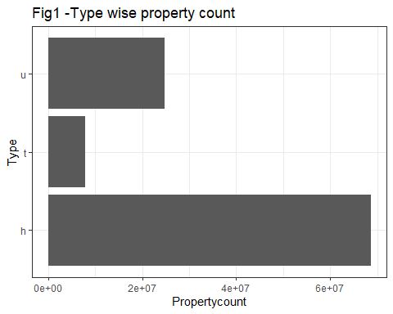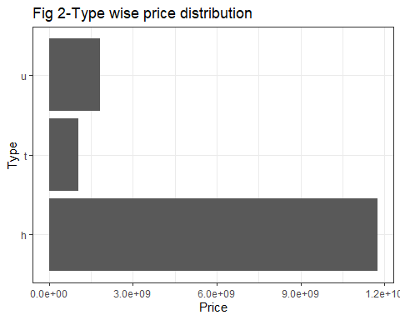
e <- ggplot(dataset, aes(x=Propertycount, y=Price, colour=Type))
e+geom_point()
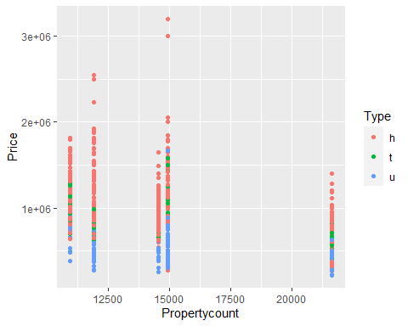
In relation to this, “Does type of house in an area plays important role in determining the price if all other things(like number of rooms,bathroom, locality,area,etc ) are same ?” To answer this question we can propose null hypothesis as type of house has no influence over price and alternative hypothesis as the type is statistically significant while deciding the price. For the sake of analysis we are considering housing data of 658 across 5 popular sub-urban areas (Bentleigh East, Brunswick, Preston, Reservoir, Richmond) and we are considering the housing types to be h, u, t .
- Planning: Plan your analysis based on the problem statement. Include data wrangling, assumption tests, and any other analyses you may need to conduct.
## Warning: package 'ggfortify' was built under R version 4.0.4
- Analysis: Conduct a multiple linear regression, along with any appropriate assumption and accuracy checks. You will need to choose from two or more predictor variables, and compare your final model against other possible options (either through variable selection or to answer a research question).
- Conclusion: Write up your analyses in a report to your manager (who has not taken MSCI 718, and does not understand statistics) and explain your conclusions.

