SNIGDHA

1. **Team Name** – SNIGDHA  
   **Team Leader’ name**– AishwaryaVerma  
   **Team Leader’ email id** – [aishwaryaverma107@gmail.com](mailto:aishwaryaverma107@gmail.com)
2. **Solution Brief Overview**

As we all are fighting against the corona pandemic, difficult situations may arise at any point in time, where the communication crisis is a major and common problem faced by us. At such times our contribution is to help people with correct and basic info about the pandemic and pass the message of being calm and help them mentally to face these

Situations positively.

***How can technology help?***

Now we are in the era of making conversation via texting apps. So, similarly, we have used an AI-enabled Chabot for our solution. These Chabot need a one-time data storage and can handle the multiple numbers of users and their queries within no time. These features make chat-bots user friendly and provide them satisfactory results, without any strain of getting the wrong information.

One such platform is to create a Chabot using IBM Watson Assistant. Which we can build easily and train it as per user convenience. Also, its flexible feature to get integrated with any app or website makes it to be available at a larger space and services.

1. **Working Model**– <https://youtu.be/Uzo_pT6zsSs>
2. **Solution Description**

The main feature is that any person can anonymously put their queries related to COVID-19 and will be answered through the app integrated with Watson assistant Chabot. Through this application, we can control the forward of wrong information and create the right awareness among people. With this concern, people can communicate by passing on the right information to each other which helps them to feel confident to fight these critical situations.

The app mainly concerns about creating awareness among people in India. So, the Watson assistant (Chabot) is trained in a way that it can give answers in a pictorial way and also in Hindi, the mother tongue of India. Few answers are internet-based information which is updated continuously, like the corona case count. For providing such live news information, the Watsonassistant is interfaced with Watson discovery via IBM cloud function API.

The user will be provided with accurate live results and correct information from well-known certified websites like CDC, WHO, MyGov (India), etc. Also, information on lockdown, helpline details, health-related information is provided in brief. Through this solution, our aim is to create confidence and the right awareness among people via the communication platform provided by IBM services, with which the situations can be handled in a smoother way.

1. **Solution Architecture** -   
   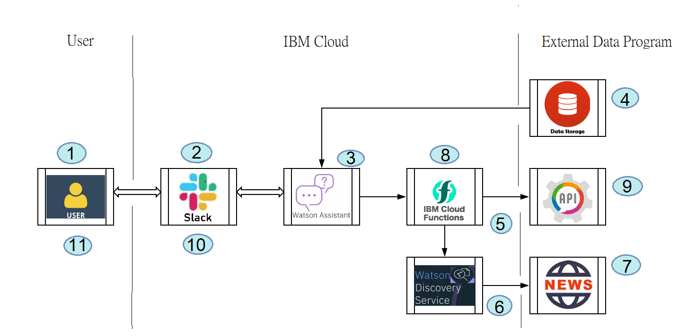
   1. The user will log in to his/her slack account.
   2. In the slack, we integrated our Watson assistant named Co-Help. So the user will ask queries related to COVID-19 to Co-Help.
   3. Co-Help checks if answers to user questions can be given from the data source/ library created by us. If present, it replies to the same answer.
   4. The data source contains the dialog skills made of expected user intents and entities.
   5. If the user asks any live updates related queries then Co-Help will call out IBM cloud function.
   6. Through the IBM cloud function, an action is performed which we can get answers from the Watson discovery service.
   7. The Watson discovery service gets information from trusted resources like the CDC website.
   8. The answer is communicated to the Co-Help Chabot via IBM cloud function through an API.
   9. Then the correct answer is displayed to the user, and further communication is performed.
   10. The Co-Help chat-bot provides answers in pictorial format, in English and Hindi languages. But it can take only English text as input.
2. **IBM Cloud Services/Systems** –

Systems used in the solution are:

* + - 1. Watson Assistant
      2. Watson Discovery
      3. IBM Cloud Function
      4. Slack