Contents

1.0 User Story 2

2.0 Wireframe & UI Requirements 2

3.0 Workflow 3

# 1.0 User Story

|  |  |
| --- | --- |
| **Title:** Consolidate User Accounts | |
| **As a:** | Logged in Lincoln Financial Group customer eligible for account consolidation |
| **I want to:** | Consolidate my Mutual Fund Account into my Legacy Brokerage Account |
| **So that:** | I can have a simpler investing experience where I can view all my assets under one account |
| **Acceptance Criteria:** | 1. For every user eligible for account consolidation, system displays ‘Consolidate Your Account’ hyperlink on the “Accounts Overview” page 2. On click of ‘Consolidate Your Account’ hyperlink, system navigates the user to ‘Consolidate Your Account’ page in the same browser window. 3. ‘Consolidate Your Account’ page shall display all the upgrade eligible Mutual Fund Account(s) and the associated Legacy Brokerage Account(s) with the same registration type. 4. System shall allow the user to select one or more or all the eligible Mutual Fund Accounts available for an upgrade. 5. On Click of ‘Continue’ button, system shall validate that the user has selected one or more eligible Mutual Fund Account(s).    1. In the event of user selecting one or more eligible Mutual Fund Account, system shall navigate the user to ‘Review & Submit’ page.    2. In the event of the user clicking ‘Continue’ button without selecting any eligible Mutual Fund Account, system shall displays the following inline error message: “Please select an eligible Mutual Fund Account to continue.” 6. On click of ‘Cancel’ button, system shall navigate the user to “Accounts Overview” page |

# 2.0 Wireframe & UI Requirements

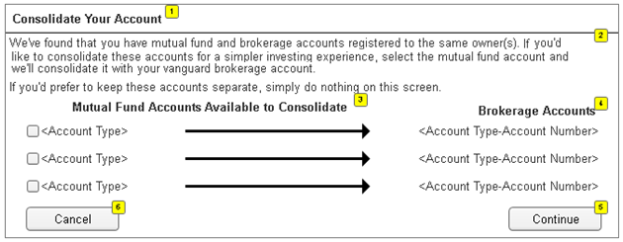

| **ID** | **Field Name** | **Field Type** | **Content** | **Default Selection** |
| --- | --- | --- | --- | --- |
| 1 | <Page Title> | Text | Consolidate Your Account | N/A |
| 2 | <Note> | Text | We've found that you have mutual fund and brokerage accounts registered to the same owner(s). If you you'd like to consolidate these accounts for a simpler investing experience, select the mutual fund account and we'll consolidate it with your brokerage account.  If you'd prefer to keep these accounts separate, simply do nothing on this screen. | N/A |
| 3 | Mutual Fund Accounts Available to Consolidate | Check Box | <Account Type> | Unchecked |
| 4 | Brokerage Accounts | Text | <Account Type-Account Number> | N/A |
| 5 | Continue | Command Button | Continue | N/A |
| 6 | Cancel | Command Button | Cancel | N/A |

# 3.0 Workflow

