Contents

1.0 User Story 2

2.0 Wireframe & UI Requirements 3

Wireframe 1: Recurring Payments Scheduled 3

Wireframe 2: ‘Are you Sure?’ Pop-Up 4

Wireframe 3: Recurring Payments Cancelled 5

# 1.0 User Story

|  |  |
| --- | --- |
| **Title:** Delete Recurring Payment | |
| **As a:** | Group Insurance Administrator |
| **I want to:** | Have an ability to delete a scheduled recurring payment |
| **So that:** | I can have the self-service capability of cancelling a recurring payment and do not have to place a cancellation request via mail or fax. |
| **Acceptance Criteria:** | 1. On the ‘Recurring Payments Scheduled’ page, system shall display an option to ‘Cancel Payment’ {**refer to wireframe 1:Recurring Payments Scheduled}** 2. On selecting the ‘Cancel payment’ command button, system shall display the “Are you Sure?” pop-up window {**refer to wireframe 2: Are you Sure?}**    1. On selecting the ‘No’ command button, system shall close ‘Are You Sure’ pop-up.    2. On selecting ‘Yes’ command button, system shall do the following:       1. Cancel the recurring payment scheduled request and navigate the user to ‘Recurring Payment Cancelled’ page. {**refer to wireframe 3:Recurring Payments Cancelled**}       2. Send out an email to the contact email on file with the following details:   **From Email**: [donotreply@libertyinsurance.com](mailto:donotreply@libertyinsurance.com)  **Subject**: Scheduled Recurring Payment Cancellation Notification  **Email Text**:  Dear <Contact Name>  The following scheduled recurring payment has been successfully cancelled:  Cancellation Date: <Date>  Group Premium Amount: <Total Due>  Pay From: <Pay from Bank Name & Acc #>  Scheduled For: <’Scheduled For’ Day of month since> |

# 2.0 Wireframe & UI Requirements

## Wireframe 1: Recurring Payments Scheduled

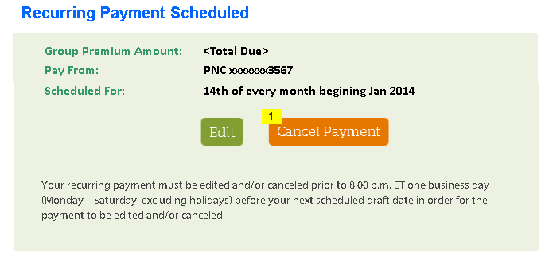

| **ID** | **Field Name** | **Field Type** | **Notes** |
| --- | --- | --- | --- |
| 1 | Cancel Payment | Command Button | On click, launch ‘Are You Sure’ pop-up |

## Wireframe 2: ‘Are you Sure?’ Pop-Up

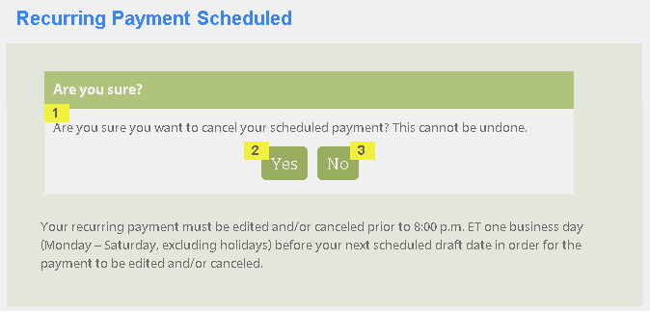

| **ID** | **Field Name** | **Field Type** | **Notes** |
| --- | --- | --- | --- |
| 1 | Are you sure you want to cancel your scheduled payment? This cannot be undone | Read Only Text |  |
| 2 | Yes | Command Button | On click, close the pop-up and navigate the user to ‘Recurring Payment Cancelled’ page |
| 3 | No | Command Button | On click, close the pop-up and remain on ‘Recurring Payment Scheduled’ page |

## Wireframe 3: Recurring Payments Cancelled

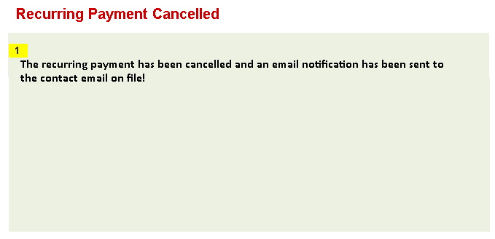

| **ID** | **Field Name** | **Field Type** | **Notes** |
| --- | --- | --- | --- |
| 1 | The recurring payment has been cancelled and an email notification has been sent to the contact email on file! | Read Only Text |  |