|  |  |
| --- | --- |
| **As a** | Registered online user |
| **I want** | To view the following 2 categories in ‘My account Coupons’ section (in desktop & mobile):   * Use Anywhere * Online-Only Coupons |
| **So that** | I can clearly distinguish between coupons that can be used anywhere versus coupons which are online only |
| **Acceptance Criteria** | 1. System shall add the following 2 categories in ‘My account Coupons’ section (in desktop & mobile):    1. Use Anywhere    2. Online-Only Coupons 2. ‘Use Anywhere’ category shall display the following:    1. Coupon Image    2. Coupon Title    3. Coupon Expiry Date    4. Coupon Description    5. Option to:       1. Apply Coupon: On selecting this option, system shall……………<Write the behavior of what happens)       2. Redeem Coupon: On selecting this option ……………<Write the behavior of what happens)       3. Print Coupon: On selecting this option ……………<Write the behavior of what happens) 3. ‘Online-Only Coupon’ category shall display the following:    1. Coupon Image    2. Coupon Title    3. Coupon Expiry Date    4. Coupon Description    5. Option to:       1. Apply Coupon: On selecting this option, system shall……………<Write the behavior of what happens) |

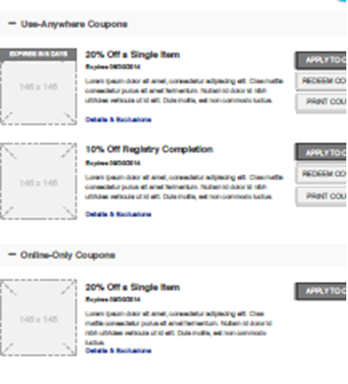

|  |  |  |  |  |  |  |
| --- | --- | --- | --- | --- | --- | --- |
| **Section** | **Field Name** | **Field Type** | **Content** | **Min Char** | **Max Char** | **Notes** |
| Use Anywhere Coupons | <Coupon Image> | Image | n/a | n/a | n/a | Image Size: ?? |
| <Coupon Name> | Read Only | Alpha Numeric | ?? | ?? |  |
| <Coupon Name> | Read Only | Alpha Numeric | ?? | ?? |  |
| Expires <mm/dd/yyyy> | Read Only | Alpha Numeric | ?? | ?? |  |
| <Coupon Description> | Read Only | Alpha Numeric | ?? | ?? |  |
| Apply To Card | Command Button |  |  |  |  |
| Redeem Coupon | Command Button |  |  |  |  |
| Print Coupon | Command Button |  |  |  |  |
| Online-Only Coupons | <Coupon Image> | Image | n/a | n/a | n/a | Image Size: ?? |
| <Coupon Name> | Read Only | Alpha Numeric | ?? | ?? |  |
| <Coupon Name> | Read Only | Alpha Numeric | ?? | ?? |  |
| Expires <mm/dd/yyyy> | Read Only | Alpha Numeric | ?? | ?? |  |
| <Coupon Description> | Read Only | Alpha Numeric | ?? | ?? |  |
| Redeem Coupon | Command Button |  |  |  |  |