Activity 1 – Heatmap (Student Performance Analysis)

1. Construct a Heatmap
The heatmap displays student marks in different subjects using colors. Darker (or warmer) colors represent higher marks, while lighter colors represent lower marks. This makes it easy to compare performance across students and subjects.

2. Highest Overall Performer
Calculate the average marks of each student.
Student | Average Marks
S1 | 88.0
S2 | 74.2
S3 | 81.2
S4 | 70.0
S5 | 92.0
S6 | 63.0
S7 | 84.0
S8 | 73.6
S9 | 94.2
S10 | 79.6
Answer: S9 is the highest overall performer with an average of 94.2 marks.

3. Highest Average Subject
Subject | Average
Mathematics | 79.1
Physics | 79.7
Chemistry | 78.0
Programming | 83.9
English | 79.2
Answer: Programming has the highest average score.

4. Students Needing Support
Students with average marks below 70 need additional support.
Answer: S6 (Average = 63)

5. Advantages of Heatmap
- Easy comparison among many students and subjects.
- Quickly identifies strong and weak performers.
- Reveals performance patterns using colors.
- Suitable for large datasets.
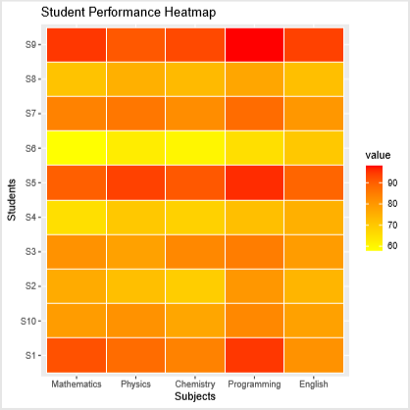

Activity 2 – Violin Plot & Boxplot (Employee Salary Analysis)

1. Draw Violin Plots
A violin plot combines a boxplot with a density plot. It shows salary distribution and where salaries are concentrated.

2. Construct Boxplots
A boxplot summarizes:
- Median
- Quartiles
- Spread
- Outliers

3. Largest Variation
Variation is measured using the spread (standard deviation).
Approximate variation:
Department | Variation
HR | Low
IT | Highest
Finance | Moderate
Marketing | Low
Answer: IT Department has the largest variation in salaries.

4. Highest Median
Approximate medians:
Department | Median
HR | 4.5
IT | 7.45
Finance | 6.25
Marketing | 5.45
Answer: IT Department has the highest median salary.

5. Which Plot Better Represents Distribution?
Violin Plot
- Shows distribution shape.
- Displays multiple peaks if present.
- Better for understanding density.
Boxplot
- Better for comparing medians.
- Clearly identifies outliers.
- Easier to interpret.
Answer: The violin plot better represents the overall distribution, while the boxplot is better for summarizing statistics.

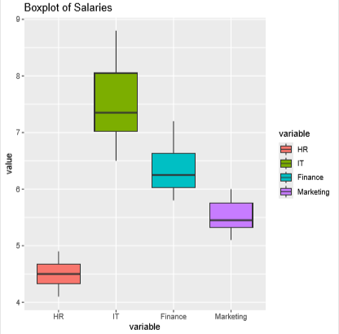

Activity 3 – Histogram & Density Plot (Website Response Time)

1. Draw Histogram
The histogram groups response times into intervals and displays the frequency of observations in each interval.

2. Plot Density
The density plot provides a smooth estimate of the response time distribution.

3. Determine Skewness
Most response times lie between 250 ms and 330 ms, with a few larger values (350–380 ms).
Answer: The distribution is slightly positively (right) skewed.

4. Common Range
Most observations fall between:
250 ms – 330 ms

5. Which Plot Better Represents Distribution?
Histogram
- Shows frequencies.
- Easy to understand.
Density Plot
- Shows the overall shape smoothly.
- Better for identifying skewness and peaks.
Answer: The density plot better represents the overall distribution.
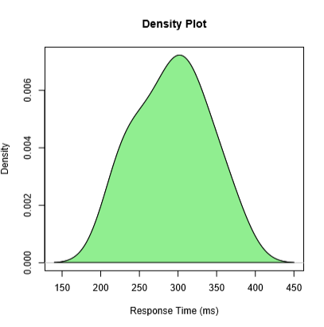

Activity 4 – Ridgeline Plot (Electricity Consumption)

1. Create Ridgeline Plot
The ridgeline plot compares electricity consumption distributions for each month.

2. Highest Average Month
Average consumption:
Month | Average
January | 230.8
February | 239.9
March | 256.5
April | 281.2
May | 300.7
Answer: May has the highest average electricity consumption.

3. Widest Spread
The spread indicates how much consumption varies among houses.
Answer: May has the widest spread because values range approximately from 292 to 310 units.

4. Describe the Trend
- Electricity consumption increases steadily from January to May.
- Houses consume more electricity during warmer months.
- The overall trend is upward.

5. Why Ridgeline Plot?
Advantages:
- Compares multiple distributions simultaneously.
- Displays distribution shape clearly.
- Uses less space than multiple histograms.
- Makes month-to-month comparisons easier.
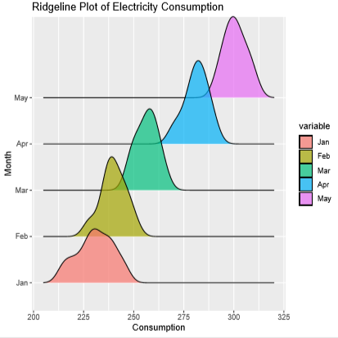

Activity 5 – Histogram, Density & Boxplot (Daily Steps)

1. Draw Histograms
Histograms show how daily step counts are distributed for each age group.

2. Plot Density Curves
Density curves provide a smooth representation of the distribution for each age group.

3. Create Boxplots
Boxplots summarize:
- Median
- Quartiles
- Spread
- Outliers

4. Highest Median Group
Approximate medians:
Age Group | Median Steps
20–30 | 10,150
31–45 | 8,650
46–60 | 6,975
Answer: 20–30 years has the highest median daily step count.

5. Best Visualization and Justification
Plot | Purpose
Histogram | Shows frequency distribution
Density Plot | Shows smooth distribution shape
Boxplot | Compares median, spread, and outliers
Answer: The boxplot is the best visualization because it clearly compares the three age groups, showing their medians, variability, and any potential outliers in a single chart.
