Mall Customers Analysis Report

Mall customers dataset contains information about customers visiting a mall. This analysis focuses on spending score and understanding the each and individual of fields compared with each other

The dataset includes:

• CustomerID
• Gender
• Age
• Annual Income (k$)
• Spending Score (1–100)

STEP 1:

The dataset was loaded using PySpark through the SparkSession interface.

STEP 2:

Clean the data.

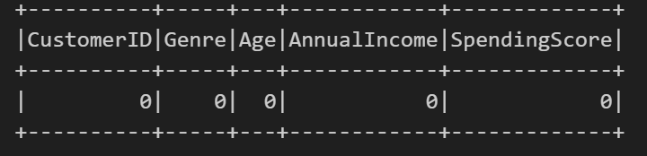

STEP 3:

Analysis Based on Spending Score.

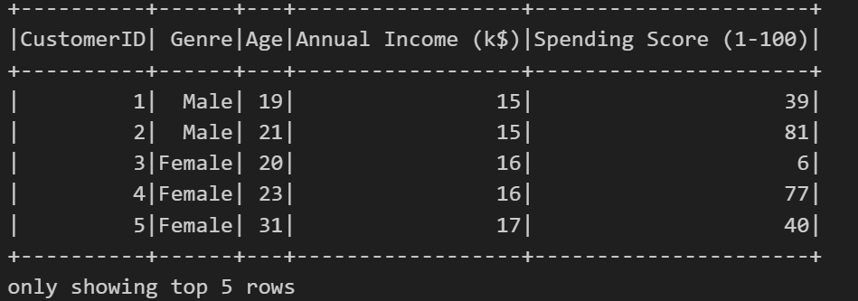
STEP 4:

Analyzing the statistics.

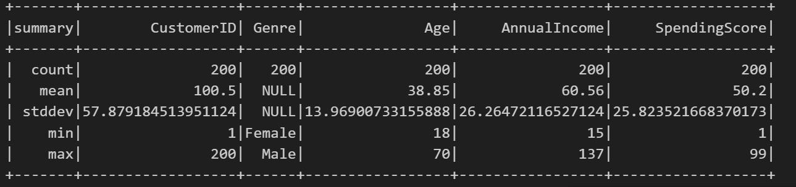

STEP 5:

- Visual Analysis:

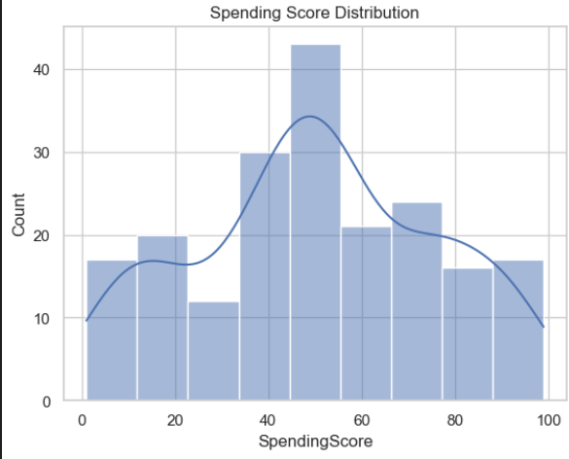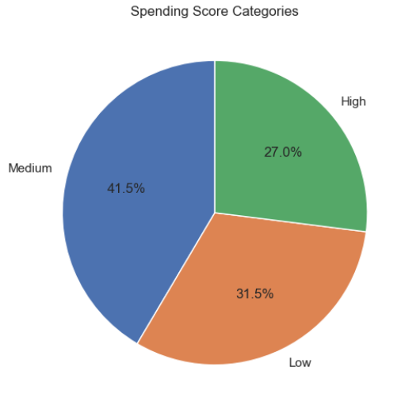

- Comparsions:

