## Exercise 1.

You will use a Jupyter Notebook and Python to do the following:

1. Before you use Jupyter, use the Azure Portal to create a storage account.
2. Download a CSV file and some data objects from a local store.
3. Push the data objects as blobs into the storage account.
4. Create an Azure NoSQL Table
5. For each line in the CSV file create a line in the table with a pointer (URL) to the correspond blob
6. Admire your work with the Azure Storage Explorer.

## Step 1

Go to the azure portal.

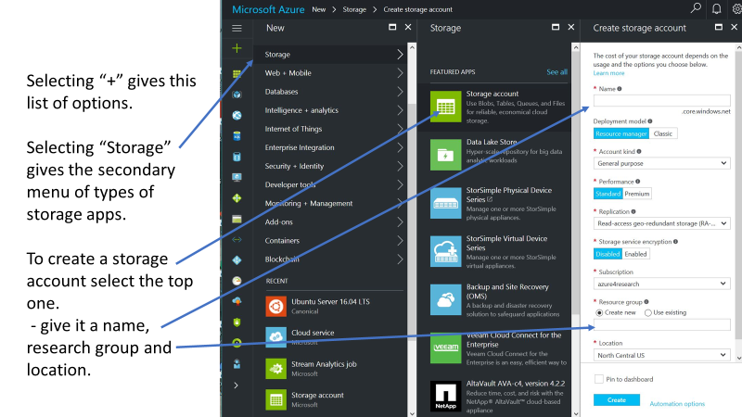

While you are in the Azure portal, you should grab a copy of the access key

Click on blue “Microsoft Azure” in the upper left corner. This take you to your top level view of your resources.

Look for your new storage account and click on that name.

That will give you a view like the following

Click on the “Access key” button. And copy the 2nd access key and save it somewhere like notpad.

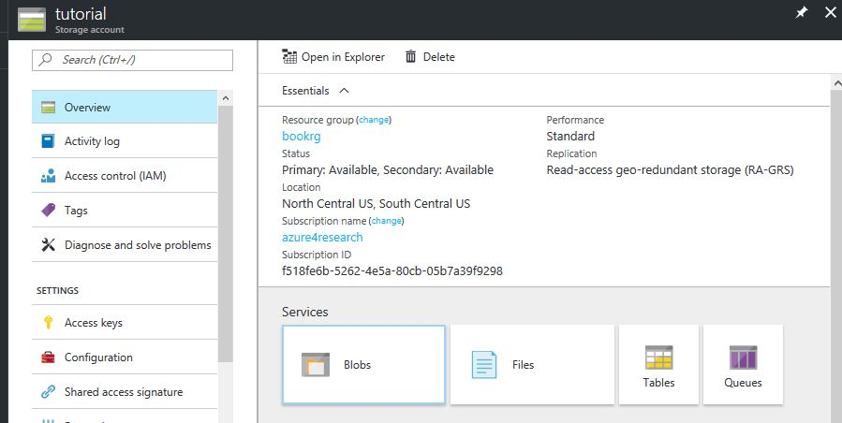

Click here to get the key ->

Make sure you have docker installed on your machine

Download Docker for your pc or mac

<https://docs.docker.com/engine/installation/>

Then do

docker run -i -t -p 8888:8888 dbgannon/tutorial

This will take a while

When it is up go to https://localhost:8888

You will need to add security exceptions in the browser. It is safe.

Password is “tutorial”

Open azure.ipynb in Jupyter

Or, if using a different jupyter, download <https://SciengCloud.github.io/azure.ipynb>

# Steps 2-5.

These steps are in the Jupyter notebook. The first cell is a comment. You probably should remove the # symbol and turn it his to a command. Run it. That will make sure we have the azure python modules installed.

What you are doing is build a structure like the picture below.

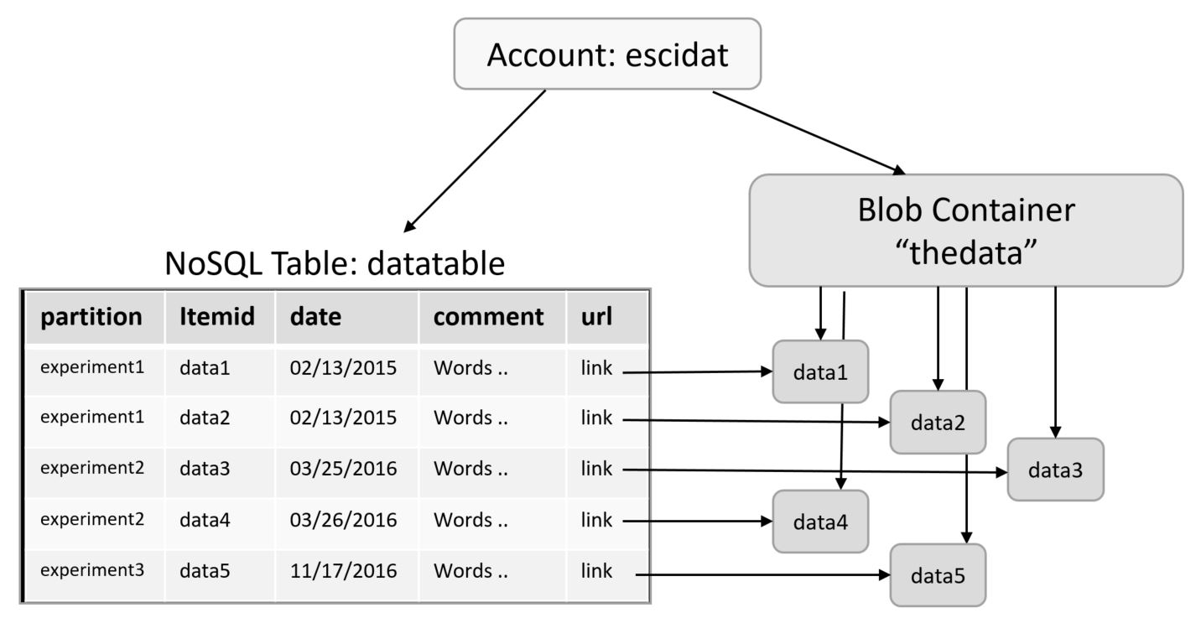

The first steps in the note book create a “container” in your blob storage account.

The next step creates a table called “DataTable” in the same storage account.

In the next step we load the CSV file. If you are using the tutorial container, it is local. If you are not running the tutorial container, you will need to load it. The notebook has two commented commands. Remove thee # mark and execute that box and it should download the needed file.

When you are done working through the notebook look at the table in the Data Explorer.