# Exercise 2. Install the Linux Data Science VM

In this exercise you will

1. Create a password protected private and public key
2. Install and deploy the Linux DS VM using your public key
3. Download X2GO and use it to visit your VM
4. Run Jupyter on the VM through the jupyter hub

## Step 1

You will need a public-private key pair.

### If you have a mac or linux do this

>ssh-keygen

And follow the instruction. This will generate two files. One is you private key and the other has the extension .pub. this is the public key you will upload to your VM.

### If you are on a windows machine do this

Download and Install PuTTY. From [www.putty.org](http://www.putty.org)

This should contain two programs. PuTTY and PuTTYgen. Run PuTTYgen. After a few mouse moves you will see

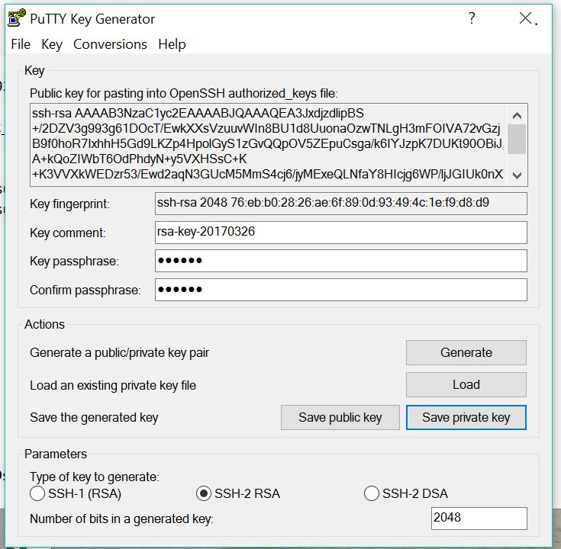

Give it a password (key passphrase) and save the public and private keys.

## Step 2. Install the Linux Data Science VM

Using your Azure account connect to the portal and sign in.

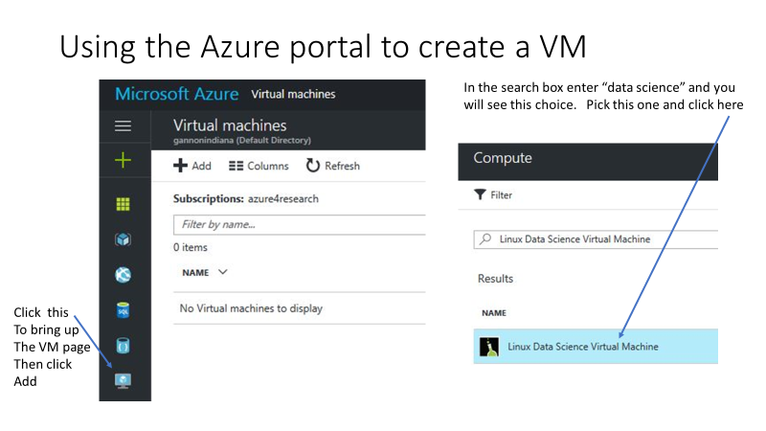

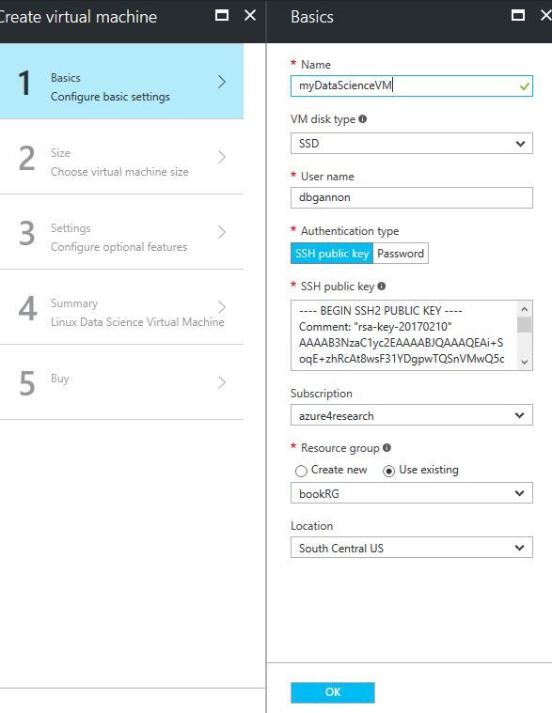Next do the basic configuration

Give your vm a name  
🡨

Give yourself a user ID  
🡨

Copy and paste your public key   
here  
🡨

You probably don’t have a resource group,  
so select “create new”  
🡨   
South Central US works for me. It will tell  
you which regions you are allowed to use.

IF everything has a green check mark then click OK

You next must select a server type for this VM. You will get three choices

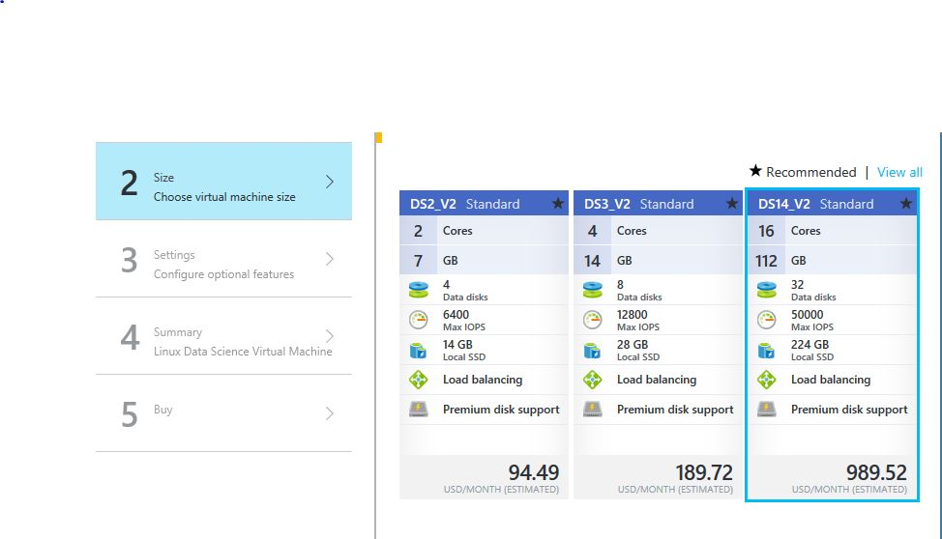

Pick the one you can “afford”. Then go to step 3. Just click OK to accept all the defaults. And finally click “Buy”.

When the VM starts you should be able to see it in the portal on you dashboard (which you get to by clicking on the big Microsoft Azure in the upper left corner. You should see:

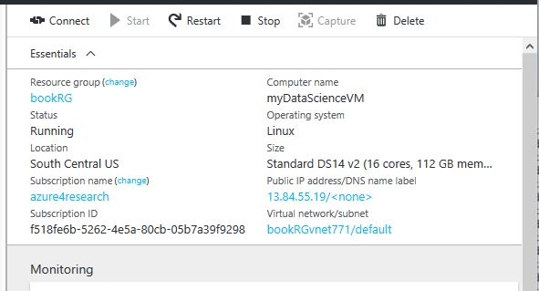

Make note of the IP address. You should be able to log into your VM with your private key as follows.

For the Mac or Linux type  
>ssh –i privatekey youruserid@ipaddress

For Windows run Putty. You will need to upload your private key into the putty client

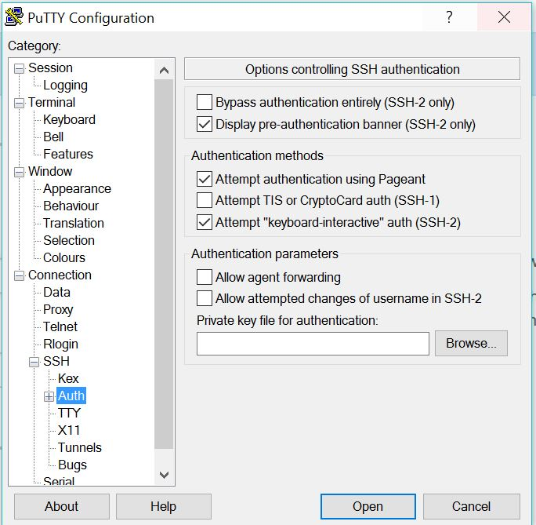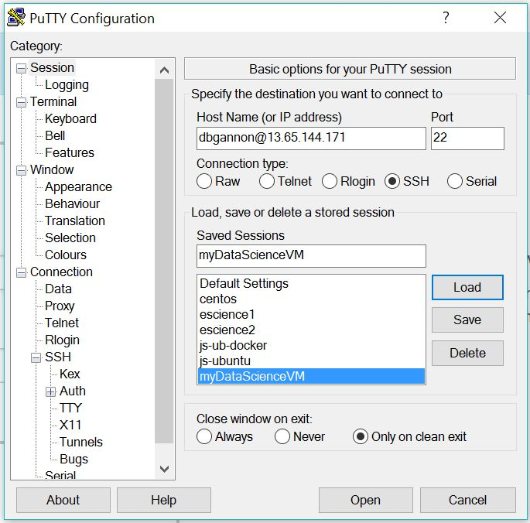

Then return to the session tab and enter your userid@yourVM-IP-address. You can give it a name and select “save”. This will save the configuration for next time. Next select “open”.

While you are logged into the vm, you should also set your local password. Type

> sudo passwd userid

>enter your password twice

We will use this later.

## Step 3. X2Go

Download X2Go. [http://wiki.x2go.org](http://wiki.x2go.org/) install it. Create a new session.

You will need your ip address and login id and the path to your secret key. And set the session type XFCE

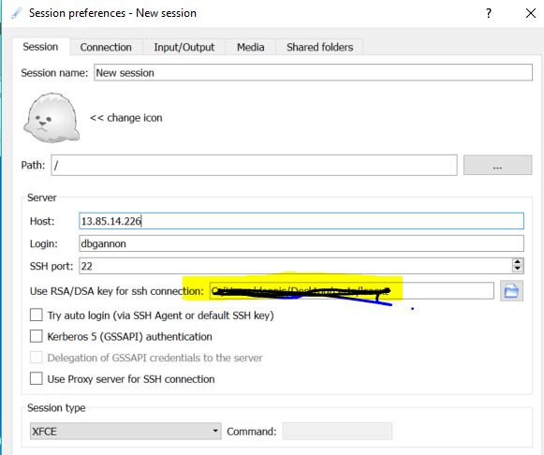

You will need to give it the password to unlock your secret key. If you are running windows it may protest but just wait. It should come up with the desktop.

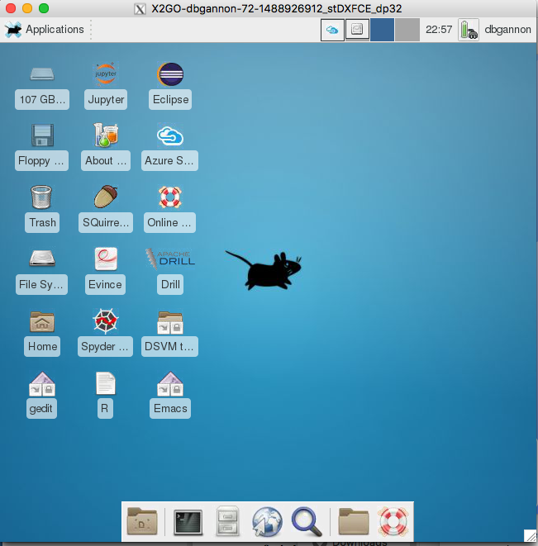

From here you can launch a terminal window, file manage, web browser by looking in the bottom row of icons. There are many other tool.

## Step 4. Run jupyter

The system is already running a tool called jupyter hub that will allow you to log in and start a jupyter session in your browser. Go to <https://youvm-IP:8000>. Login with your userid and password.

There are some great examples here.