- Download jenkins.war file from http://mirrors.jenkins.io/war-stable/latest/jenkins.war
- Copy this jar file in your C: or D: or whatever other drive is available inside “Jenkins” (you need to create this folder manually) folder
- Then go to command prompt and go to “Jenkins” folder (this is the folder where Jenkins gets installed typically it will be C:\Program Files (x86)\Jenkins) and type the following command:
java -jar Jenkins.war (by default it will take port 8080 i.e. the url will be http://localhost:8080)
If you want to use other port as 8080 in use
java -jar jenkins.war --httpPort=9191

- This will start the Jenkins server you should see output similar to the below screenshot
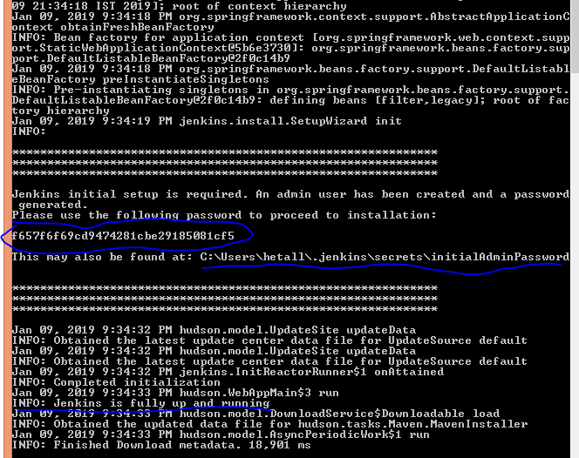
- Copy the secret password either from console using “Mark” command or from the file mentioned above in “initialAdminPassword” file.
- Now go to any browser and type “localhost:8080” as url, you should see the following screen
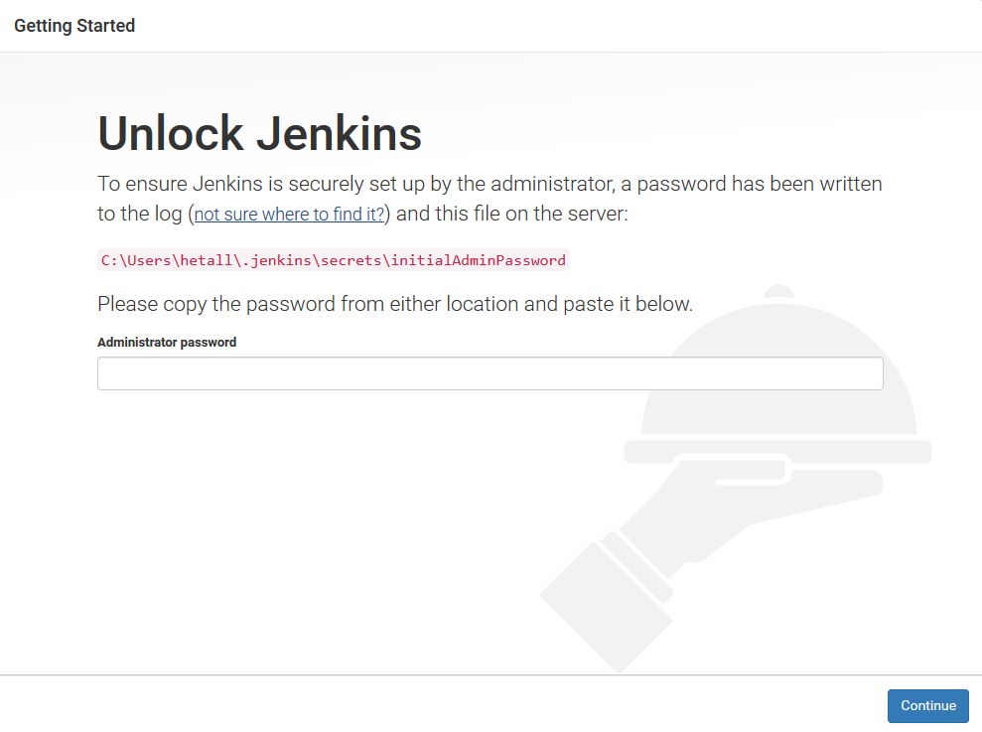
- Enter the secret password under “Administrator password” field and click on Continue. You will see Getting Started – Customize Jenkins window. Click on “Install suggested plugins” option. This will install necessary plugins. It may take few minutes to complete.
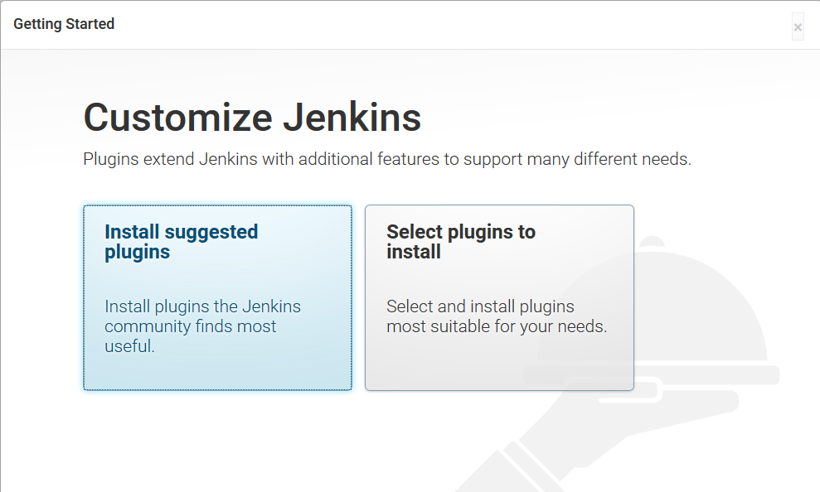
- After installation for plugin the following screen will appear, please make sure you remember your id and password as it will be required every time you want work with Jenkins.
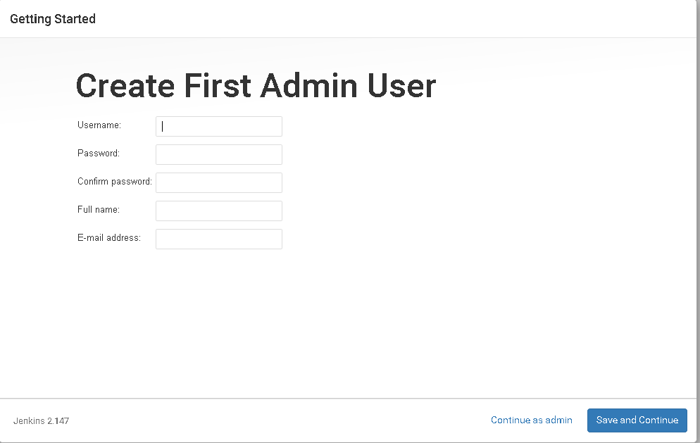

- You will get the following screen.Click on Save and Finish. 