The project is used for removing the comments in a given input C file using JavaScript and PHP regex.

**________________________________________________________________________________________**

## Getting Started

These instructions will get you a copy of the project up and running on your local machine for development and testing purposes. See deployment for notes on how to deploy the project on a live system.

**______________________________________________________________________________**

**Both the programs are running and they remove the valid comments from the cycle.c file and give an error message to the invalid comments.**

**______________________________________________________________________________**

**Instructions to run Node.js file**

The program has been written in NodeJS there is no need to install any independencies.

*Make sure that the cycle.c file is in the same directory as the node.js file

**Run the following command to store output in an output.c file:**

node node1.js > output.c

The node.js program will store the output in the output.c file with all valid comments removed and the invalid comments have been given an error message.

**OR**

**_____________________________________________________________________________**

**Use the following command to run the program to get output on command line:**

node node1.js

The node.js program will open the input file in the command line with all valid comments removed and the invalid comments have been given an error message.

**Following is the screenshot of the program in NodeJS I have also attached the output.c file in which all the comments have been removed and the invalid comments have been given an error message.**

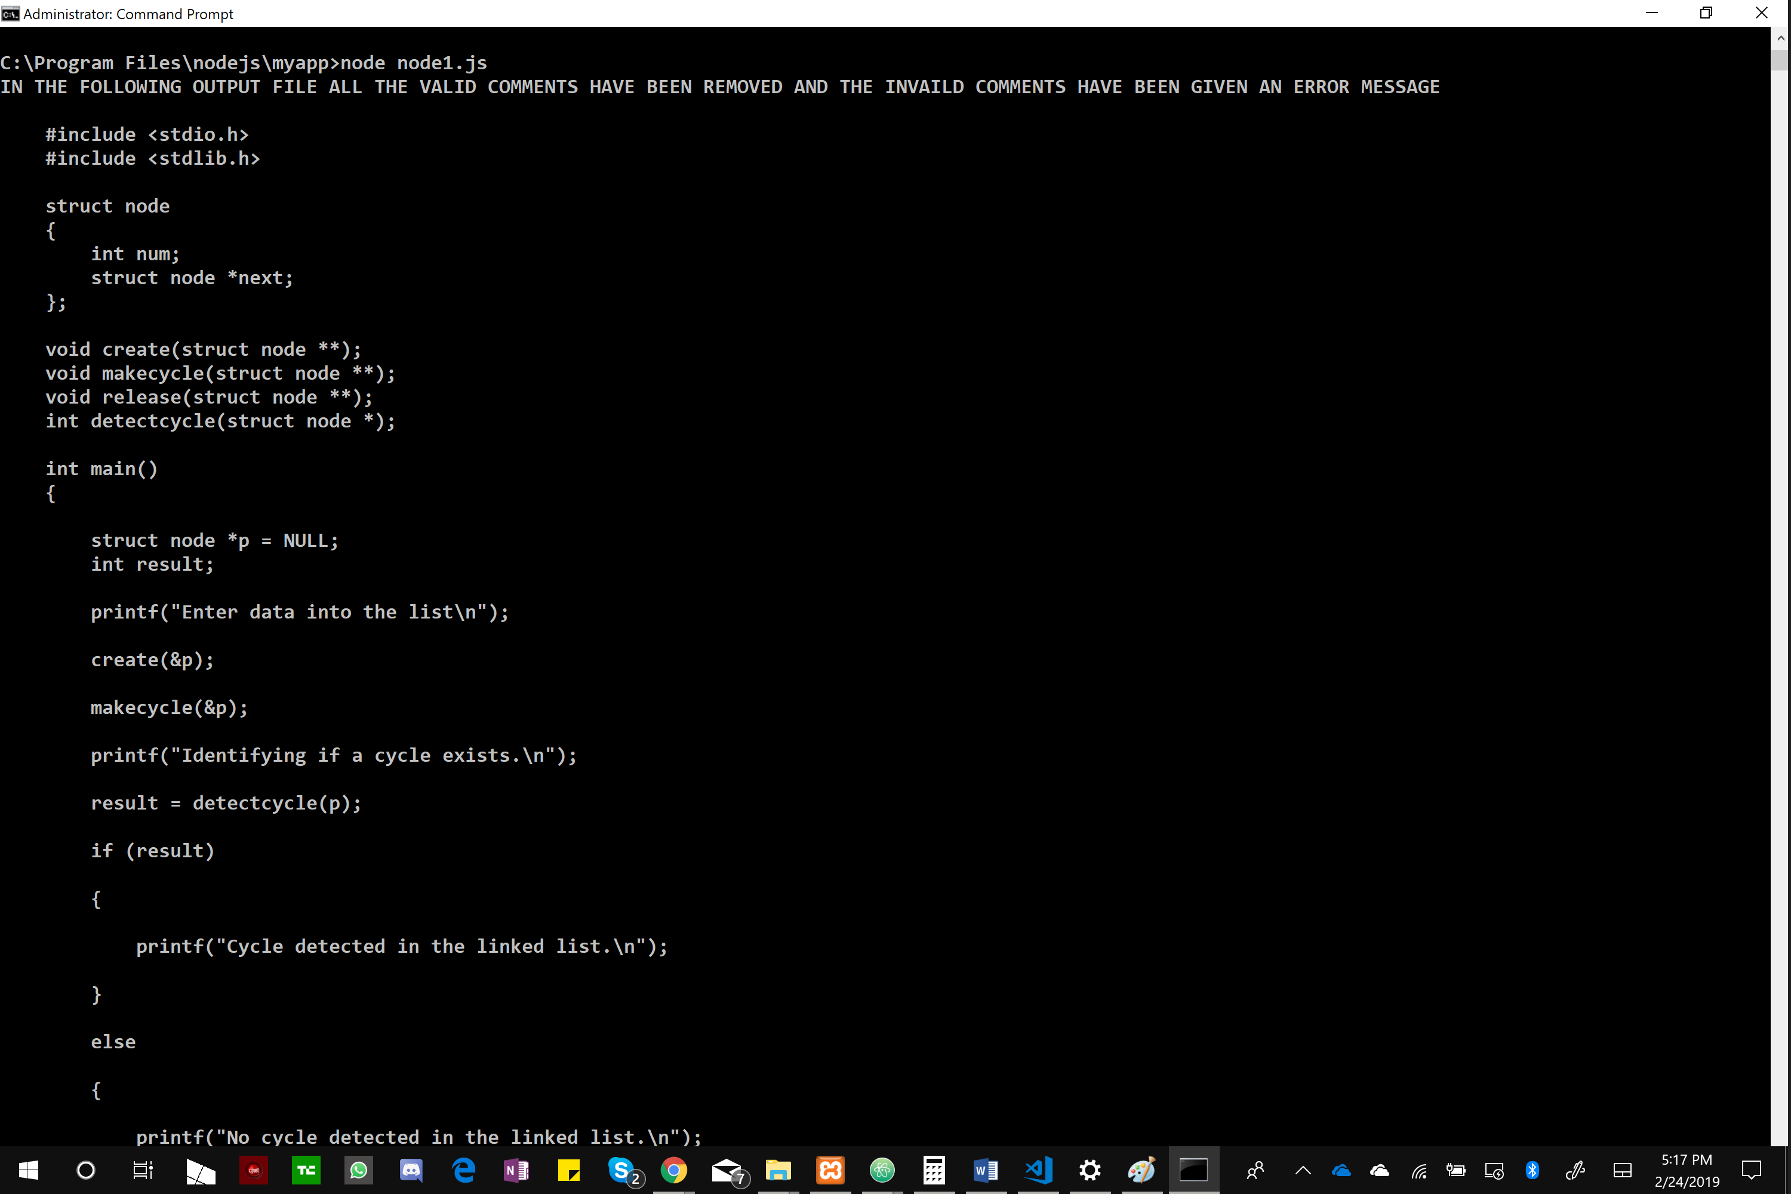

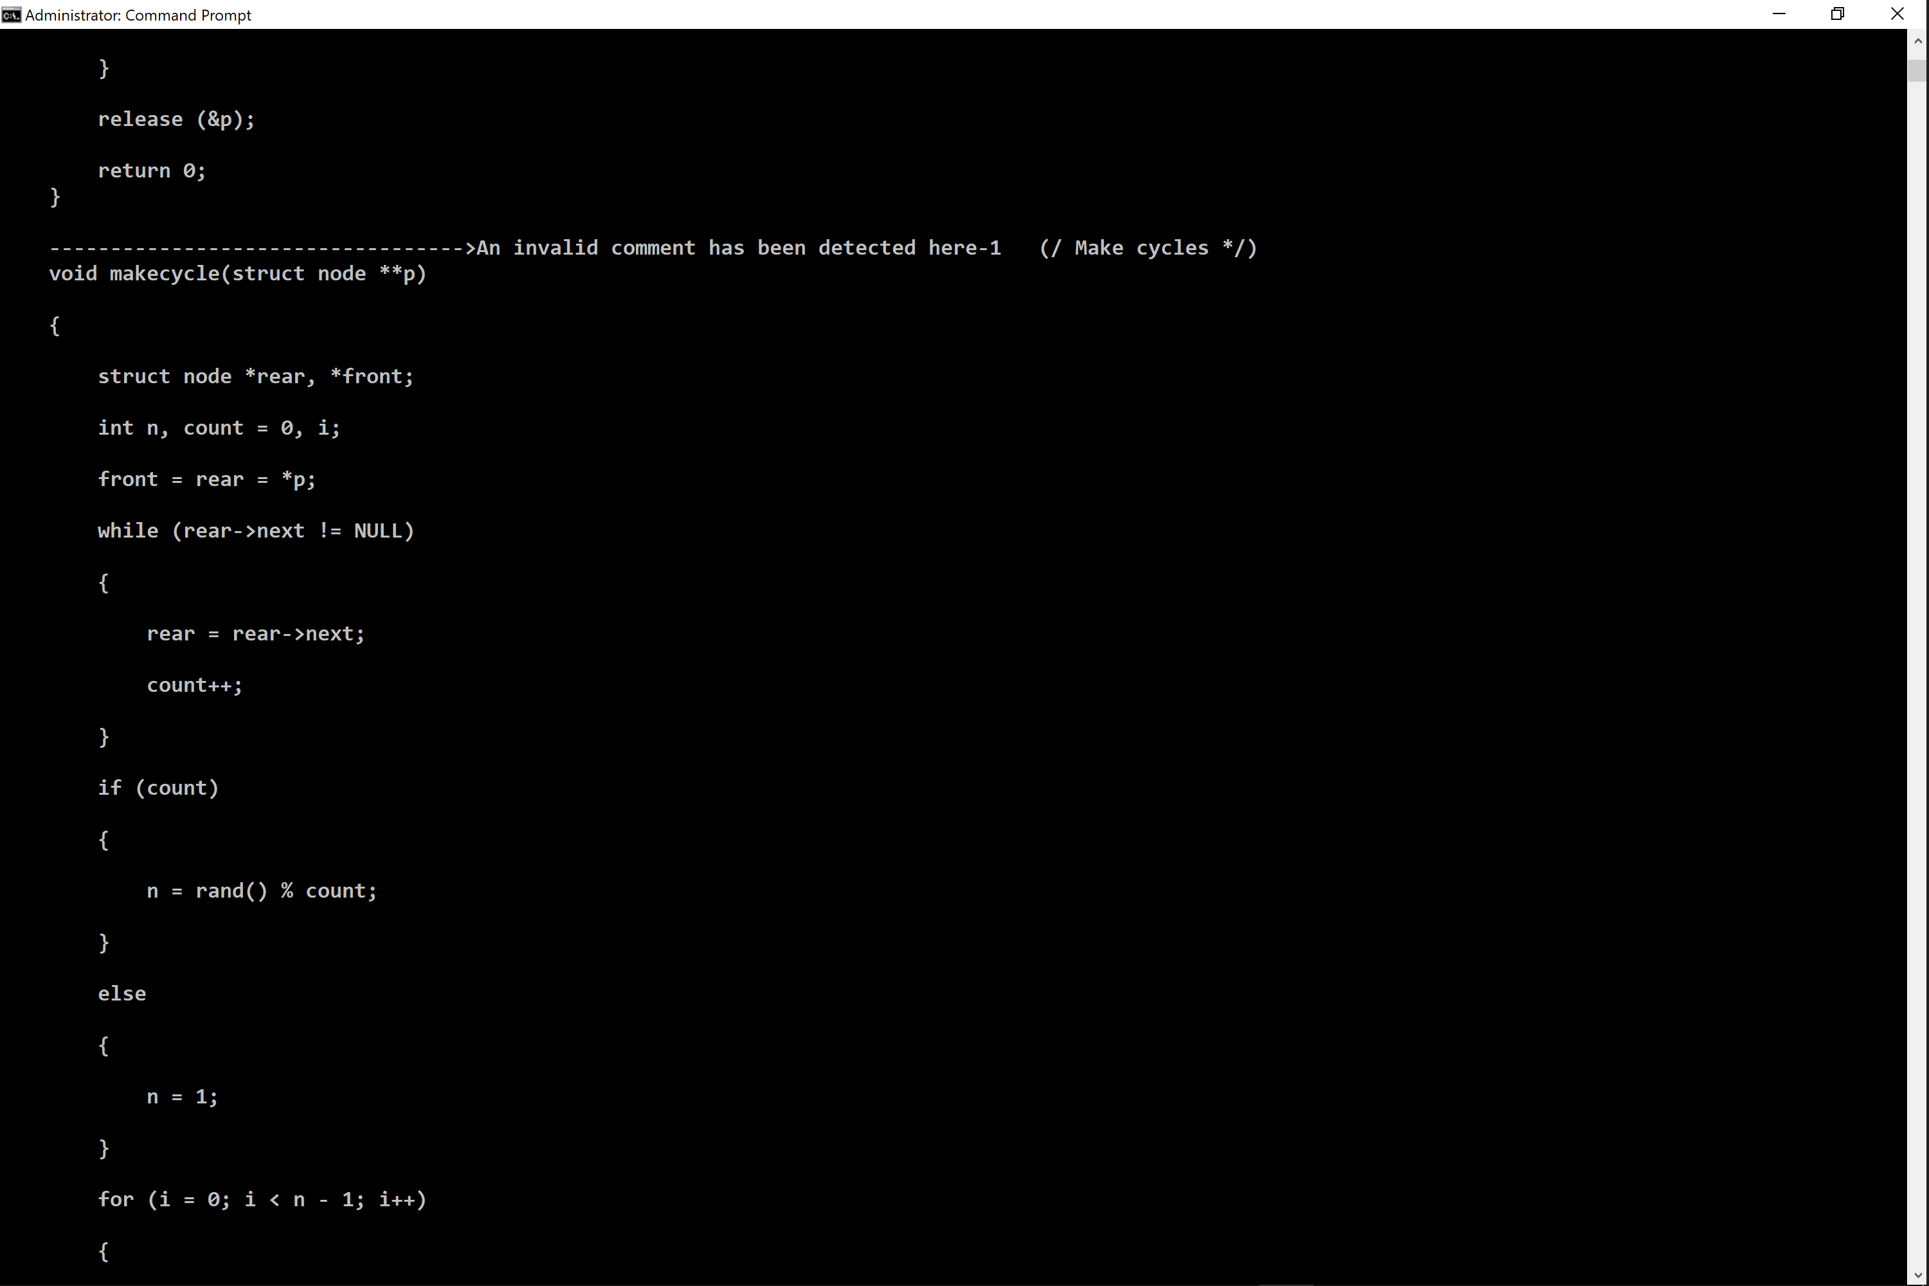

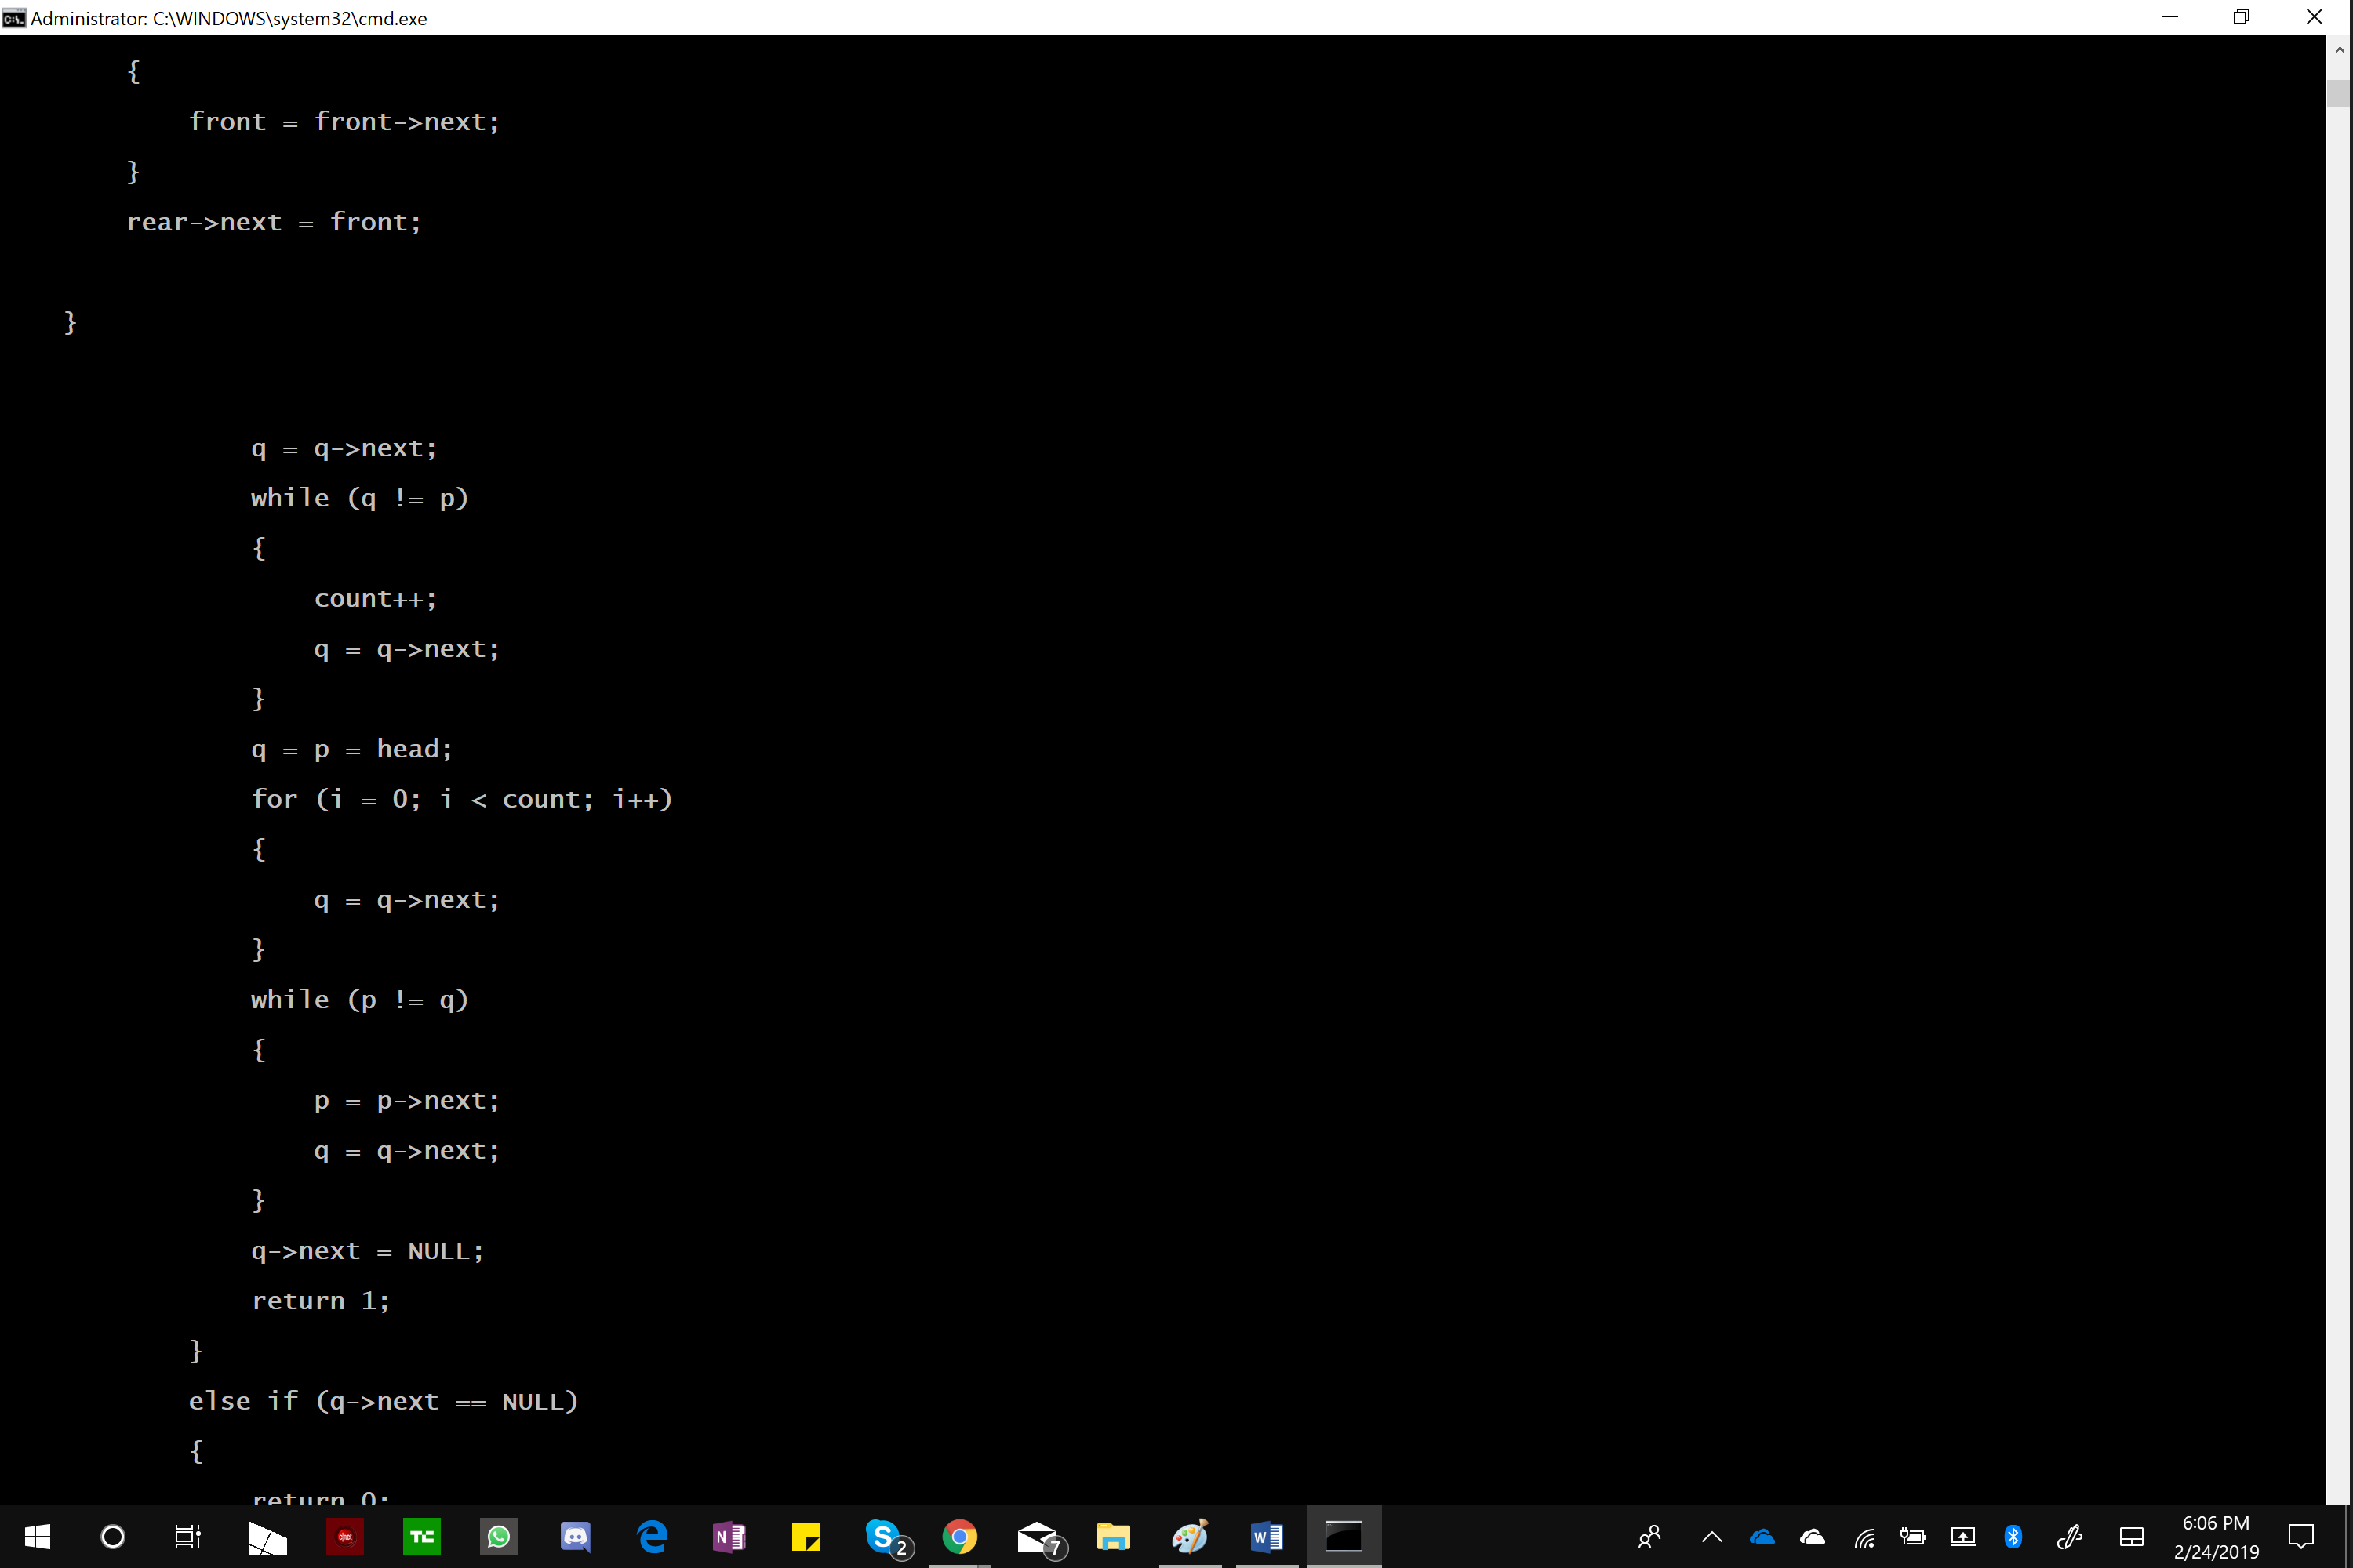

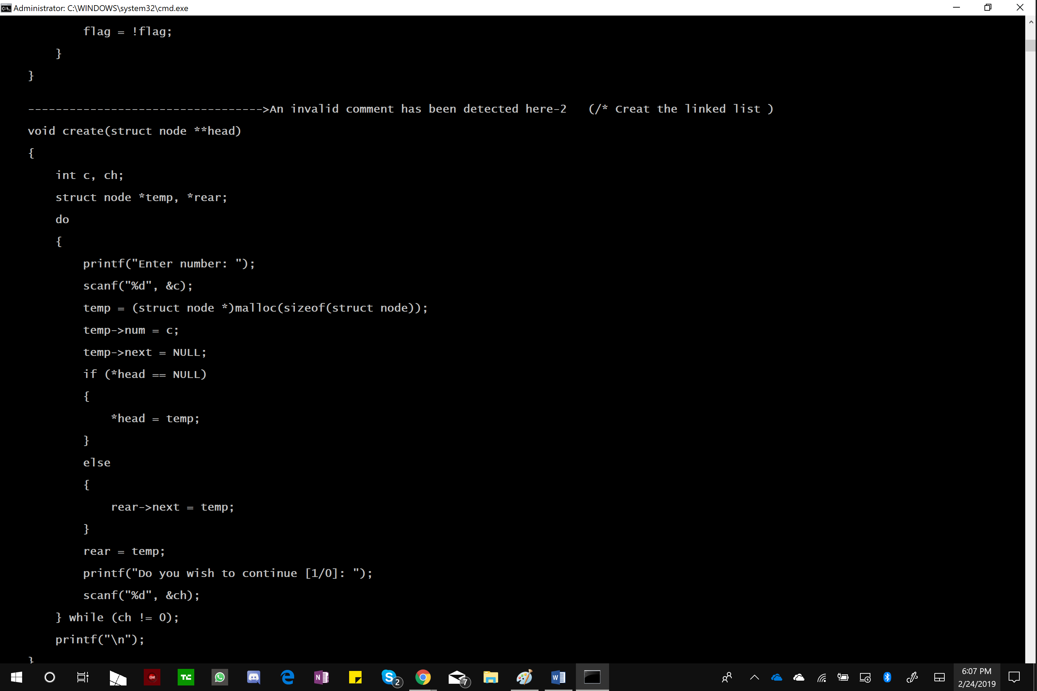

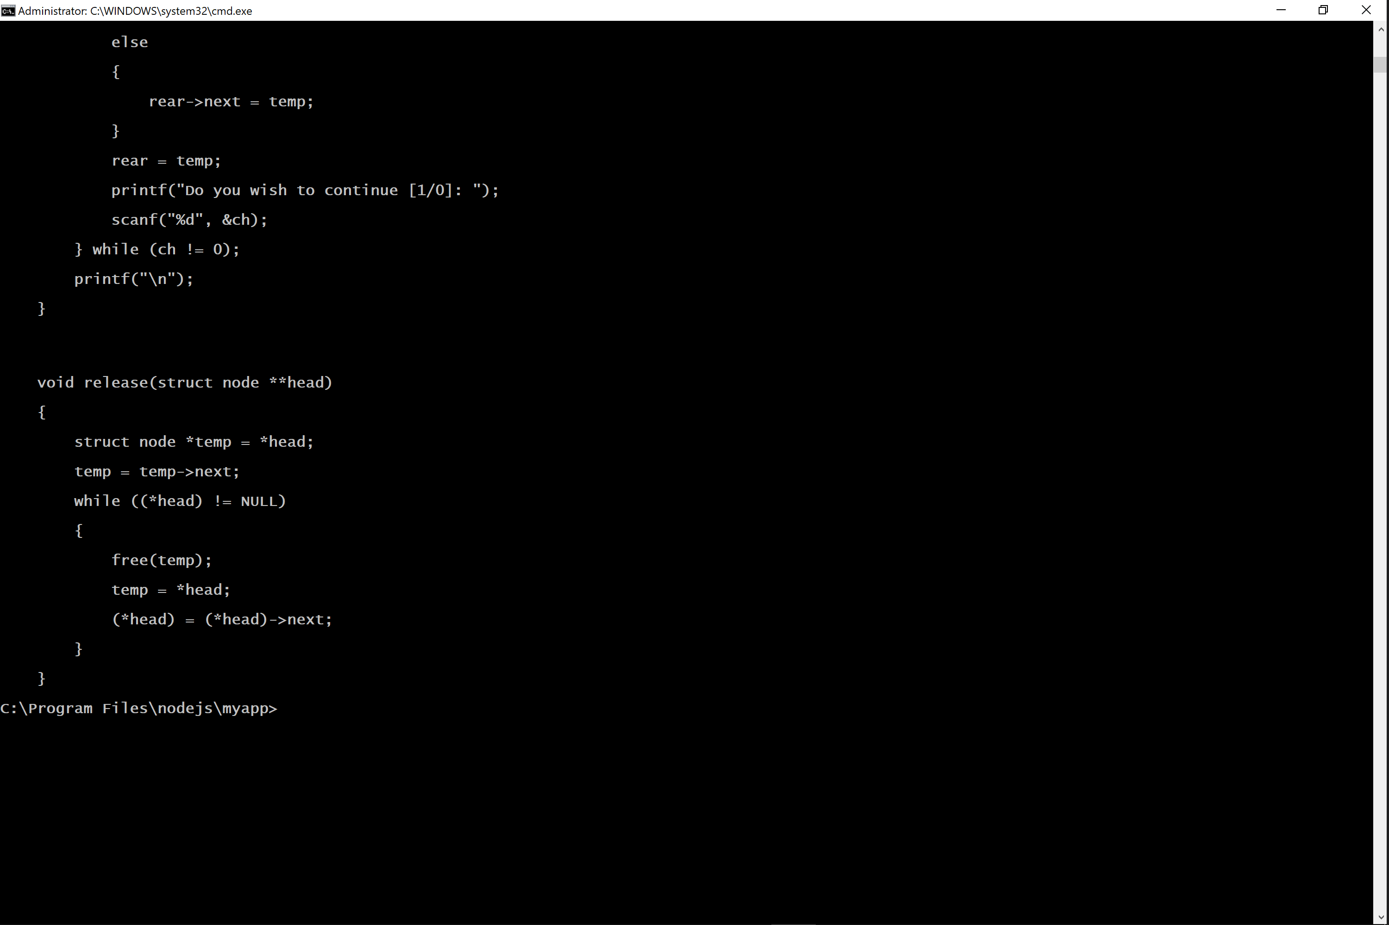

**Instructions to run PHP file.**

The file is not hard-coded hence it will run from any local-server.

**You can download XAMPP from the following link:**

[**https://www.apachefriends.org/download.html**](https://www.apachefriends.org/download.html)

**Installing XAMPP on a Mac**

1. [Download XAMPP for Mac OSX](https://www.apachefriends.org/download.html) - Be sure to select the proper version of PHP (5.6.40 / PHP 5.6.40 or any other version will work)
2. Open the downloaded file (the DMG-Image).
3. Drag and drop the XAMPP folder into your Applications folder.

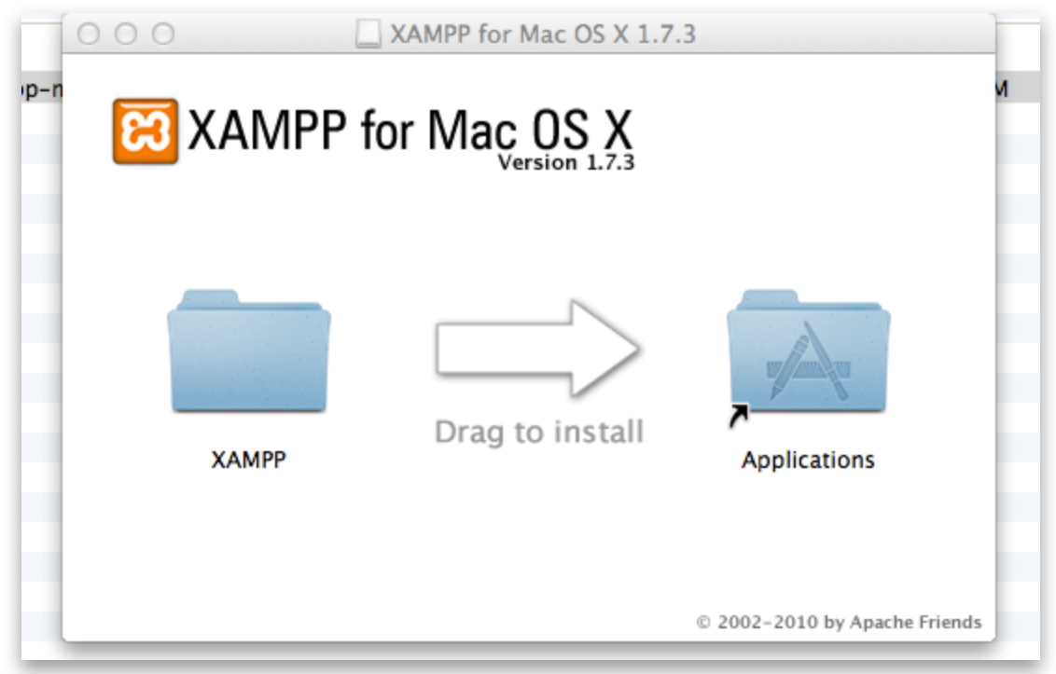

**Starting XAMPP on OSX**

1. To start XAMPP simply open **XAMPP Control** (by going to /Applications/XAMPP/manager-osx.app in **Finder**) and start Apache and MySQL on the **Manage Servers** tab.

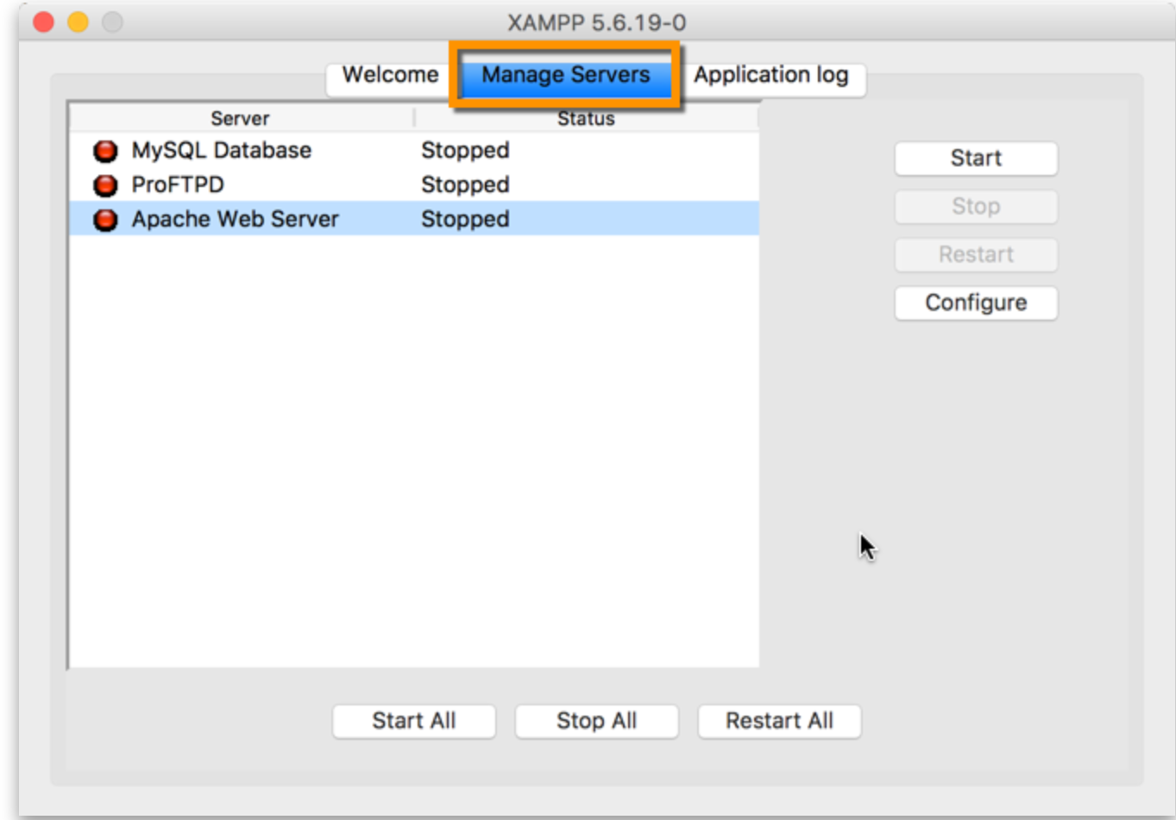

Place the file in any directory and just give the complete path of the file and the output will be displayed in a browser.

e.g: http://localhost:8080/test/strip.php

Following are the screenshots of successful execution of PHP program using XAMPP

