**ReadMe File**

For the given task we **have successfully implemented both Binary Search Tree traversal** using Iterator and also the **extra credit task of preorder, postorder and inorder traversal operations using recursion.**

* **The iterator’s code is using a dynamic Binary search tree class to create the tree and do the Inorder, Preorder and Postorder Traversals. Hence the code will work for any data.txt file given as a input to the program**

**Please make sure the data.txt file and the code files are in the same folder/directory.**

**Instructions to run the code for Iterator:**

1)Extract all the files from the zip folder.

2) Navigate to the folder/directory where the files are on the terminal i.e. change the directory to the folder where the files are.

3) Make sure that the data.txt file is in the same directory as the code is.

4) Run the file iterator.java using the following command

**javac iterator.java**

(This command will generate two class files, first iterator$Node.class and the second is iterator.class)

5) After generating the class files run the following command to get output on terminal,

**java iterator**

**Commands to run the code**



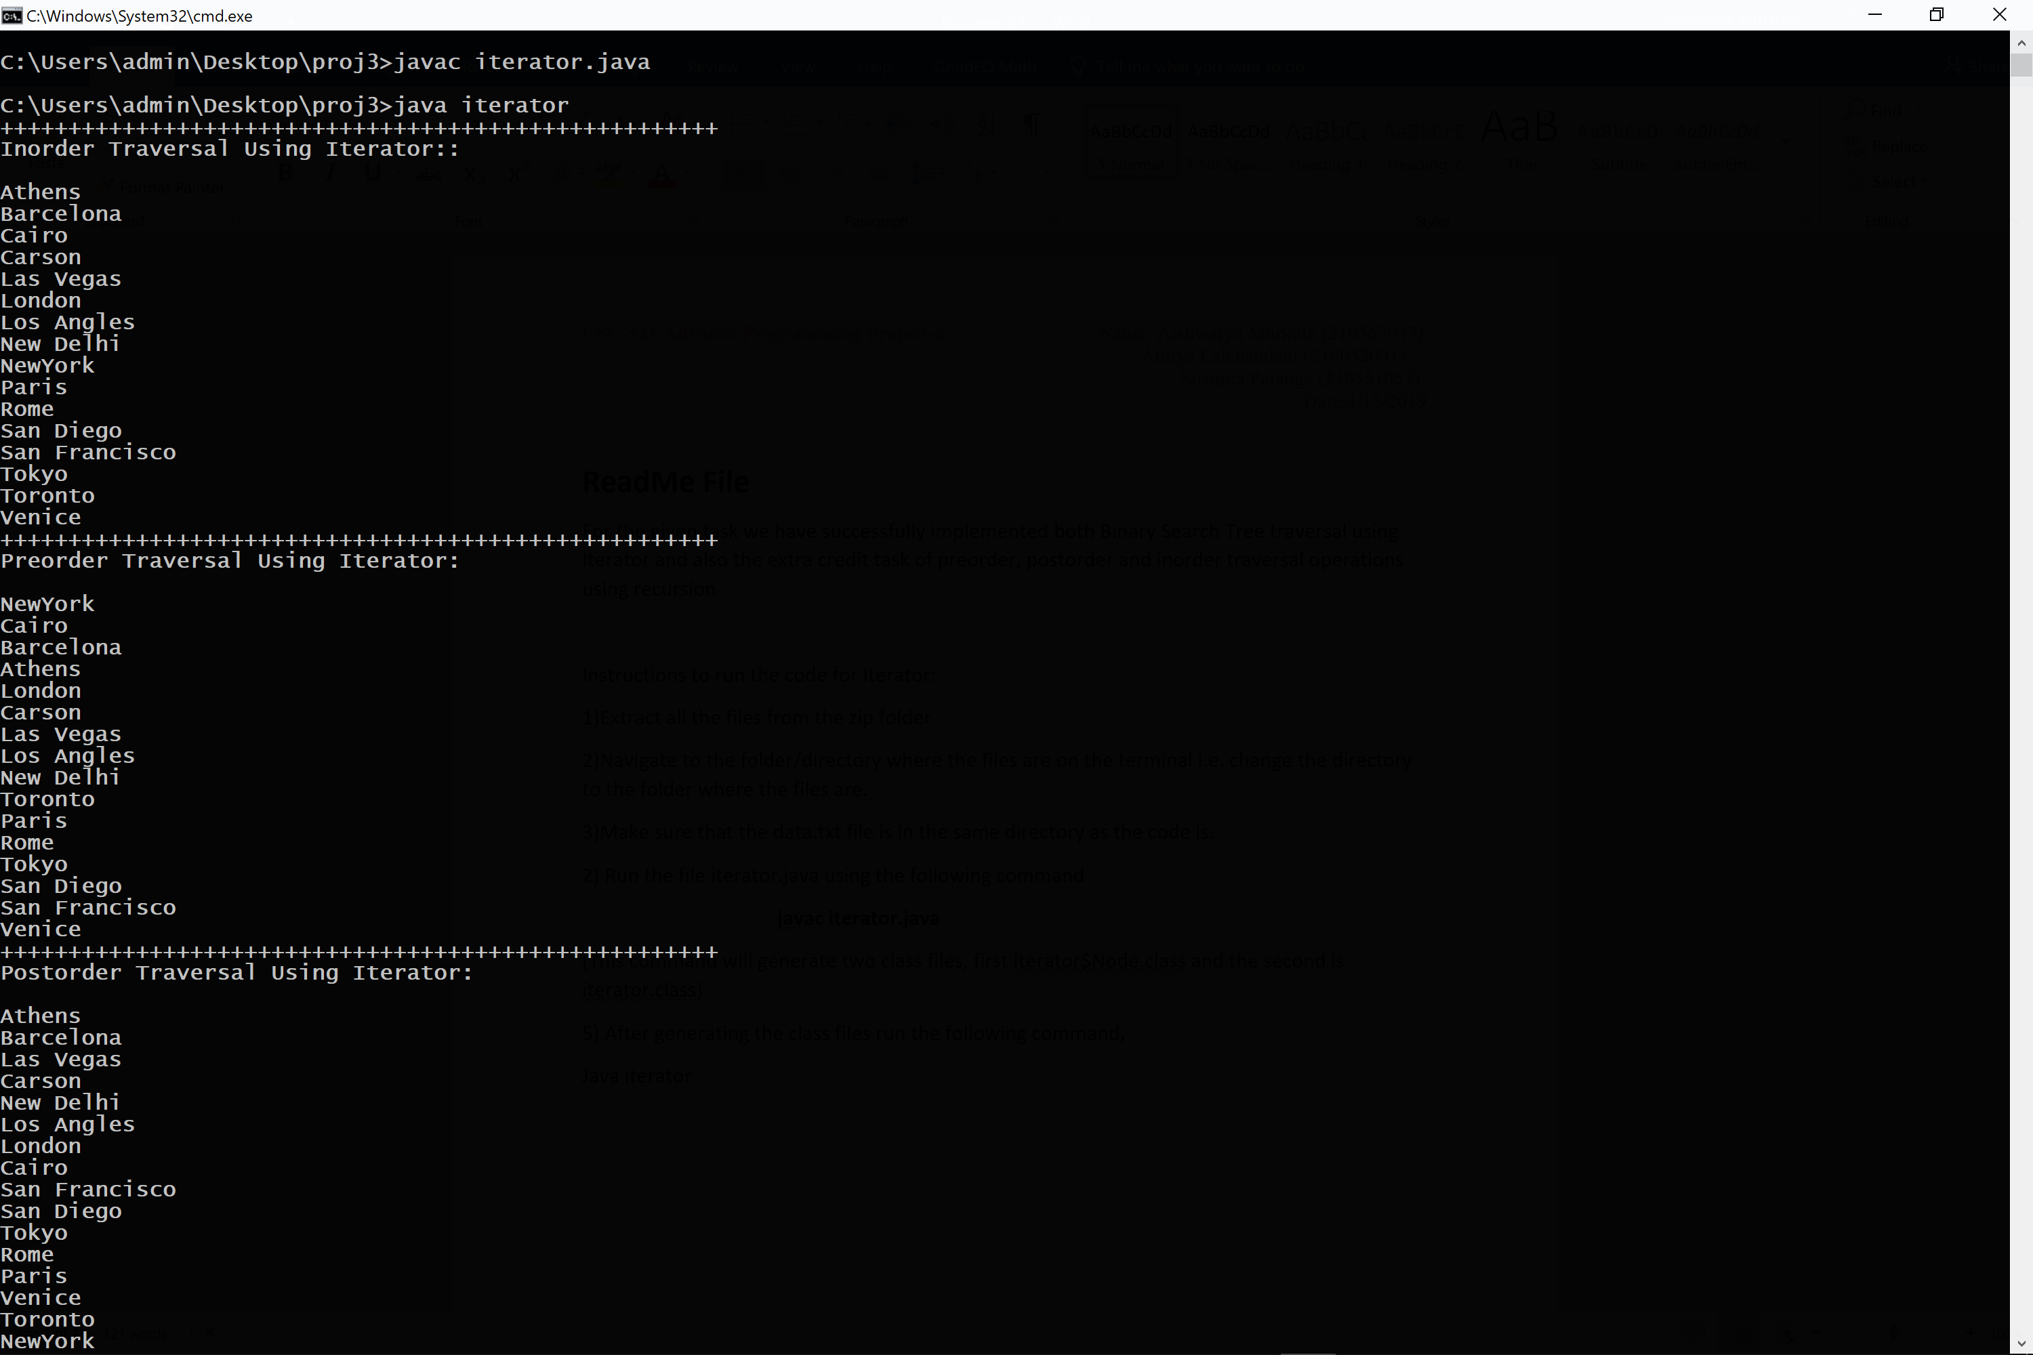

**Screenshot of output using Iterator**

**EXTRA CREDIT TASK**

* **The recursion code is using a Dynamic Binary search tree class to create the tree and do the Inorder, Preorder and Postorder Traversals. Hence the code will work for the any data.txt file as input to the program.**

**Please make sure the data.txt file and the code files are in the same folder/directory.**

**Instructions to run the code for recursion**:

1)Extract all the files from the zip folder

2)Navigate to the folder/directory where the files are on the terminal i.e. change the directory to the folder where the files are.

3)Make sure that the data.txt file is in the same directory as the code is.

4) Run the file recursive.java using the following command

**javac recursive.java**

(This command will generate two class files, first recursive.class and the second is recursive$node.class)

5) After generating the class files run the following command to get output on terminal,

**java recursive**

**Commands to run the code**



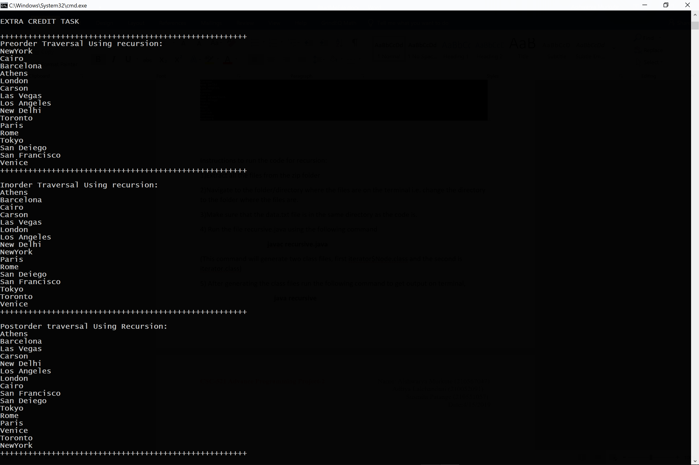

**Screenshot of output using Recursion**