BrightPay Ltd: Information Security Risk Assessment
Prepared by Aishwarya Shelar | Date: 1 November 2026 | Note: BrightPay is a fictional company created for this project.

1. Executive Summary
This assessment reviewed the information security risks at BrightPay Ltd, an online payments company with 50 employees. Seven risks were identified and scored using Likelihood × Impact on a 1 to 3 scale. Two risks are Critical, three are High, one is Medium and one is Low. The most urgent issue is cloud storage that is open to the public. Most risks can be reduced with a few basic controls: multi-factor authentication (MFA), regular patching and endpoint protection.

2. Scope
In scope: employee laptops, internal finance and HR systems, AWS cloud storage and the customer web application. Out of scope: physical building security and staff personal devices.

3. Method
The assessment followed five steps: (1) define the scope, (2) identify key assets, (3) identify threats and vulnerabilities, (4) score each risk as Likelihood × Impact, and (5) choose a treatment: Mitigate, Transfer, Avoid or Accept. Scores were rated Low (1-2), Medium (3-4), High (6) and Critical (9).

4. Risk Register
Seven risks, sorted from highest to lowest score.
Asset | Threat | Vulnerability | Likelihood | Impact | Score | Rating
Customer data | Data breach | Weak access controls, no MFA | 3 | 3 | 9 | Critical
AWS cloud storage | Files exposed to the public | Public S3 bucket | 3 | 3 | 9 | Critical
Customer web app | Hacker attacks the website | Outdated software not patched | 2 | 3 | 6 | High
Internal finance/HR systems | Ransomware | Unpatched systems | 2 | 3 | 6 | High
Employee email accounts | Phishing | No MFA, no phishing training | 3 | 2 | 6 | High
Employee laptops | Malware | No EDR protection software | 2 | 2 | 4 | Medium
Office printers | Misuse | Default settings | 1 | 1 | 1 | Low

5. Heat Map
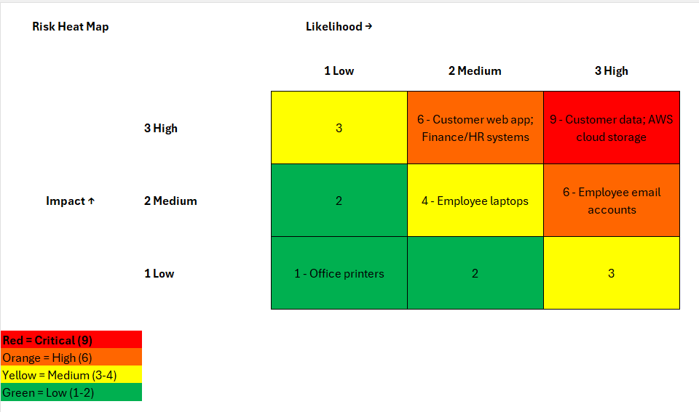

6. Key Findings
- Customer data (score 9): Weak access controls and no MFA make a data breach both likely and very damaging.
- AWS cloud storage (score 9): A public S3 bucket means files could be seen by anyone on the internet. It is the quickest critical risk to fix.
- Ransomware and phishing (score 6): Unpatched internal systems and a lack of staff training leave the finance systems and email accounts exposed.

7. Recommendations and Action Plan
Fix the risks in this order, starting with the quickest critical fix.
Asset | Treatment | Recommended action | Owner | Due
AWS cloud storage | Mitigate | Block public access on all S3 buckets and review settings weekly | Cloud Engineer | 7 days
Customer data | Mitigate | Turn on MFA for everyone, limit who can open customer files, encrypt the data | IT Security Lead | 30 days
Employee email accounts | Mitigate | Turn on MFA and run phishing training every quarter | IT Manager and HR | 30 days
Customer web app | Mitigate | Install updates monthly and run regular vulnerability scans | Development Lead | 45 days
Internal finance/HR systems | Mitigate + Transfer | Patch servers, keep offline backups, and buy cyber insurance | IT Manager and CFO | 60 days
Employee laptops | Mitigate | Install EDR protection software on all laptops | IT Manager | 60 days
Office printers | Accept | No action; change the default password when convenient | Office Manager | None

8. Conclusion
BrightPay's biggest risks come from a small number of simple weaknesses. Fixing the public storage setting, enforcing MFA and keeping systems patched would remove most of the high-scoring risks. The assessment should be repeated every 6 to 12 months or after any major change.

