System Requirements Statement (SRS) –

EduConnect

Doc. Ref. :

Version : 0.4

Status : Drafted

Created by : Aishwarya Badgujar, Sayali Mane, Nikita Shinde, Ashwini Dhumal, Nilima Jarad.

Date : 25-June-2024

1. Introduction 3

2. Functional Requirements 4

2.1 Admin Module 5

2.2 Teacher Module 8

2.3 Parent Module 10

2.4 Use Case Diagram..............................................................................................................................11

THIS DOCUMENT CONTAINS 15 NUMBERED PAGES

# Introduction

This document explains the system requirements and scope for developing EduConnect System.

EduConnect System can be divided into three main parts,Admin part, Teacher part, Parent part .

This document describes the system requirement of the Account part.

# Functional Requirements

The Account part of Edu-Connect System has four modules which are divided 21 processes described as below.

|  |  |  |
| --- | --- | --- |
| **No** | **BRS requirement ID** | **Description** |
| **2.1** | **Admin Module** | |
| **2.1.1** | **F1** | **Login Process** |
| **2.1.2** | **F2** | **Create Parent Account According to Student** |
| **2.1.3** | **F3** | **Teacher Account Creation Process** |
| **2.1.4** | **F4** | **Create Standards** |
| **2.1.5** | **F5** | **Assign Student to Standards** |
| **2.1.6** | **F6** | **Assign Teacher to Standards** |
| **2.1.7** | **F7** | **Create Subjects** |
| **2.1.8** | **F8** | **Assign Teacher to Subject** |
| **2.1.9** | **F9** | **Upload School Events** |
| **2.2** | **Teacher Module** | |
| **2.2.1** | **F10** | **Login Process** |
| **2.2.2** | **F11** | **View Assigned Classes** |
| **2.2.3** | **F12** | **Upload Homework** |
| **2.2.4** | **F13** | **Upload Marks** |
| **2.2.5** | **F14** | **Upload Activities** |
| **2.2.6** | **F15** | **View Performance** |
| **2.2.7** | **F16** | **Update Profile** |
| **2.3 Parent Module** | | |
| **2.3.1** | **F17** | **Login Process** |
| **2.3.2** | **F18** | **View Homework** |
| **2.3.3** | **F19** | **View Activities** |
| **2.3.4** | **F20** | **View Performance** |
| **2.3.5** | **F21** | **Update Profile** |

#### 2.1 Admin Module

* Administratorshould be responsible for following activities**,**

### 2.1.1 Login Process

* EduConnect System always compels user authentication before using itself.
* The user authentication demands UserID and Password. The UserID and the Password should be checked in three ways.
  + First, The UserID and the Password should be existed and correct.
* If The UserID and the Password are not equal to what the admin has registered, the Admin authentication cannot be provided.
  + Second, the User Type linked to the UserID should be "Admin".
* When the User Type is "Admin", user can be placed on “Admin Home”.
* The Admin account should alive for so long as the duration decided by Admin.
* Only when the two checks are successfully completed, Admin can be placed on respected page.
* The “Admin Home” provides the some items described as below.

1. A trigger to Create parent account according to student

2. A trigger to Create teacher account

3. A trigger to Create Standards

4. A trigger to Assign Students to Standards

5. A trigger to Assign Teacher to Standards

6. A trigger to Create Subject

7. A trigger to Assign Teacher to Subject

8. A trigger to Upload School Events

### Create Parent Account According to Student

* This menu is used to create an account for parent which include information about Student.

The Account creation process is described as below.

* + Admin will fill information about Students and parents on the basis of following points.

1. Student Name
2. Student Registration number
3. Standard
4. Division
5. Parent name
6. E-mail address
7. Contact details
8. Permanent address

* All items are compulsory demanded.
* Student Registration number should be unique.It should not be case sensitive and previously used.

### Teacher Account Creation Process

* This menu is used to create an account for Teacher which include information about Teacher.

The Account creation process is described as below.

* + Admin will fill information about Teachers on the basis of following points.

1. Teacher Name
2. Teacher Identity number
3. E-mail address
4. Contact details
5. Permanent address

* All items are compulsory demanded.
* Teacher Identity number should be unique.It should not be case sensitive and previously used.

### Create Divisions

* Admin will create list of standards.

### Assign Students to Standards

* Assigning students to standard typically refers to placing them into groups or categories based on predefined criteria .
* These criteria will include academic records,age etc.

### Assign Teacher to Standards0

* Assigning teacher to standards typically involves matching educators with specific role for class teacher.

### Create Subjects

* Admin will create list of subjects which are included in syllabus.

### Assign Teacher to Subjects

* Admin will assign teachers to specific subjects according to their qualification,subject expertise or any specialized training relevant to standards.

### Upload School Events

* School events involved are:
* Meetings
* Exam Schedule
* Annual Functions
* Seminars
* Group Activities
* Annual Sport Event
* Admin will fill event details such as name,date ,time,location,description,etc.
* Once all details are entered ,event will be published

## 2.3 Teacher Module

### 2.3.1 Login Process

### Entering Credentials: On the login page, teachers are required to enter their credentials. This typically includes:

* **Username**: The unique identifier assigned to the teacher by the system admin.
* **Password**: A secure password that the teacher has been assigned.

### View Assigned classes

* On the teacher dashboard, there will be classes section too view a list of classes teacher are assigned to teach.
* This view will include subject name along with schedule time, class name,etc.

### Upload homework

* Uploading homework assignments in a Teacher Module involves a straightforward process designed to upload homework task.
* Here teacher will provide description of assignments with some instructions and due time for when homework is expected.

### Upload marks

* Upload marks in the teacher module is the process where teacher will manage and upload student marks.
* Within the Marks section, teacher can find the specific subject, assignment or project for which he/she want to upload marks.
* Once marks are uploaded, parents can typically view them within the Marks section.

#### Upload Activities

* Uploading activities in the Teacher Module of EduConnect System involves adding and managing various educational tasks, exercises, or projects that students are required to complete.
* Activities section may include:
* **Activity Title**: Give the activity a descriptive title that indicates what students are expected to do.
* **Instructions**: Provide clear instructions for students on what they need to accomplish or submit.
* **Due Date and Time**: Set a due date and possibly a due time for when the activity is expected to be completed.
  + 1. **View Performance**
* Viewing performance in the Teacher Module allows teachers to monitor and analyze students' academic progress and achievements.
* **Understanding Student Performance:  
  Assessment:** Evaluate student work using predefined criteria such as learning standards.

**Data Analysis:** Analyze assessment results to identify strengths, weaknesses, and areas for improvement.

**Monitoring Progress**: Monitor student progress over time to assess the effectiveness of feedback.

### 2.2.7. Update Profile

Updating profile in the Teacher Module involves modifying personal information and preferences to ensure accurate communication and administrative management.

* **Edit Profile Information**: Within the Profile section, you should be able to edit various details such as:
* Name
* Contact Details
* E-mail address
* Permanent address

## 2.3 Parent Module

* Parent module will provide following features:

### 2.3.1 Login Process

* Parent is the user of system who requires login process for accessing the system.
* Admin will create account of parent and login credentials also will be provided by admin, so that using that credentials parent can access system.
* Login will include following fields
* User ID
* Password
* User ID and password will be provided by Admin after creation of account.
* During login credentials filled by parent should match already allocated login credentials, otherwise parent access will be denied.

**2.3.2 View Homework**

• The parent sees a list of all assigned homework, organized by date or subject.

**2.3.3 View activities**

* Activity List: The parent sees a list of all class activities, organized by date or subject.
* Activity Details: The parent can click on each activity to view more details, and see any relevant guidelines provided by the teacher.

**2.3.4 View Performance**

• After uploading the performance by the teacher, parent can view following contents.

* Marks
* Grades in activities
* Progress of projects
* Performance in other curriculum activities

### Update Profile

* EduConnect System should provide the function which makes the account updated for parent.
* The updatable items as described below.
* User Name
* User Phone No
* E-mail address
* Permanent address
* All items are compulsory demanded, but updating is optional.

#### 2.4 Use Case Diagram

**Admin:**

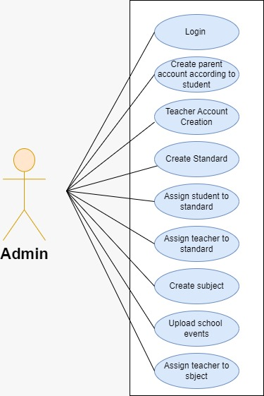

*Fig. Use case diagram for admin*

1. In Admin use case diagram, Admin is the Actor.
2. Admin can handle following use cases:
3. Login
4. Create parent account
5. Create Teacher Account
6. Create Standard List
7. Assign Student to Standard
8. Assign Teacher to Standard
9. Create Subject List
10. Assign Teacher to Subject
11. Upload School Event

**Teacher:**

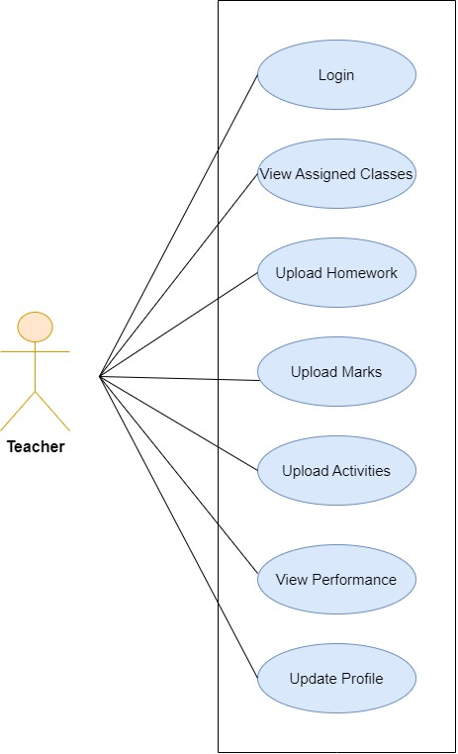

*Fig. Use case diagram for teacher*

1. In Teacher use case diagram, Teacher is the Actor.
2. Teacher can handle following use cases:
3. Login
4. View Assigned Classes
5. Upload Homework
6. Upload Marks
7. Upload Activities
8. View Performance
9. Update Profile

**Parent:**

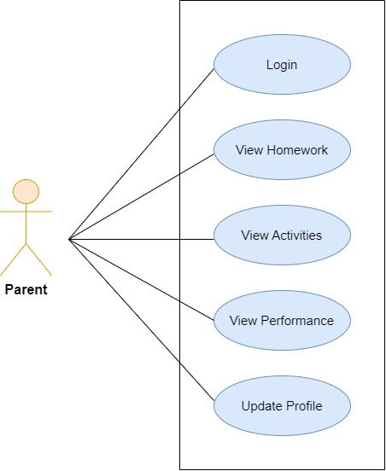

*Fig. Use case diagram for parent*

1. In Parent use case diagram Parent is the Actor.
2. Parent can handle following use cases:
3. Login process
4. View Homework
5. View Activities
6. View Performance
7. Update profile