**1.What are the two values of the Boolean data type? How do you write them?**

**ANSWER-**

*Boolean represents one of two values : ‘True’ and ‘False’.*

*When you compare two values the expression in python returns Boolean values.*

*bool() functions allow you to evaluate value and give you ‘true’ or ‘false’.*

**2. What are the three different types of Boolean operators?**

**ANSWER-**

*The three basin Boolean operators are AND, OR and NOT.*

**3. Make a list of each Boolean operator's truth tables (i.e. every possible combination of Boolean values for the operator and what it evaluate ).**

**ANSWER-**

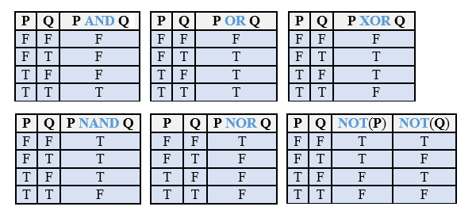

**4. What are the values of the following expressions?**

**(5 > 4) and (3 == 5)**

**not (5 > 4)**

**(5 > 4) or (3 == 5)**

**not ((5 > 4) or (3 == 5))**

**(True and True) and (True == False)**

**(not False) or (not True)**

**ANSWER-**

*1)false*

*2)false*

*3)true*

*4)false*

*5)false*

*6)true*

**5. What are the six comparison operators?**

**ANSWER-**

1. *greater than >*
2. *less than <*
3. *equal to ==*
4. *not equal to !=*
5. *greater than equal to >=*
6. *less than equal to <=*

**6. How do you tell the difference between the equal to and assignment operators?Describe a condition and when you would use one.**

**ANSWER-**

*First of all = is assignment operator and == is a comparison operator.*

*= operator is used to assign a value to a variable and*

*==operator is used to compare two variable and constant.*

**7. Identify the three blocks in this code:**

**spam = 0**

**if spam == 10:**

**print('eggs')**

**if spam > 5:**

**print('bacon')**

**else:**

**print('ham')**

**print('spam')**

**print('spam')**

**ANSWER-**

*The answer of above code is*

*‘ham spam spam’*

*In above code spam has assign a value which is zero and in conditional statements the given conditions comparison operator is used hence else block has been executed.*

**8. Write code that prints Hello if 1 is stored in spam, prints Howdy if 2 is stored in spam, and prints Greetings! if anything else is stored in spam.**

**ANSWER-**

*spam = 2*

*if spam == 1:*

*print("hello")*

*if spam ==2:*

*print("howdy")*

*else :*

*print('greeting!!!')*

**9.If your programme is stuck in an endless loop, what keys you’ll press?**

**ANSWER-**

*You can stop an infinite loop with CTRL + C*

**10. How can you tell the difference between break and continue?**

**ANSWER-**

*Break: A break statement in Python alters the flow of a loop by terminating it once a specified condition is met.*

*Continue: The continue statement in Python is used to skip the remaining code inside a loop for the current iteration only.*

**11. In a for loop, what is the difference between range(10), range(0, 10), and range(0, 10, 1)?**

**ANSWER-**

*Range(10) - generates the lists for values / sequence of length 10*

*Range(0,10)- it will print the numbers from 0 to 10.*

*Range(0, 10, 1)-it will print the number from 0 to 10 with the jump of 1.*

*NOTE-We are using the range function in which we are passing the starting and stopping points with the jump of the iterator.*

**12. Write a short program that prints the numbers 1 to 10 using a for loop. Then write an equivalent program that prints the numbers 1 to 10 using a while loop.**

**ANSWER-**

*1)For LOOP*

*for i in range(0, 10):*

*print(i)*

*print()*

*2)WHILE LOOP*

*i = 1*

*while(i<=10):*

*print(i)*

*i += 1*

**13. If you had a function named bacon() inside a module named spam, how would you call it after importing spam?**

**ANSWER-**

*To call the bacon() function from the spam****module****after importing it, you would use the syntax spam.bacon().*

*By prefixing the****function****name with the module name (spam), followed by a dot (.), you can reference and call the bacon() function using spam.bacon().*