Doctor Listing – Clone Project Work

Front end – Next Js
Backend- Node Js
Database – MongoDb (NoSql)

Run Backend ( node server.js)

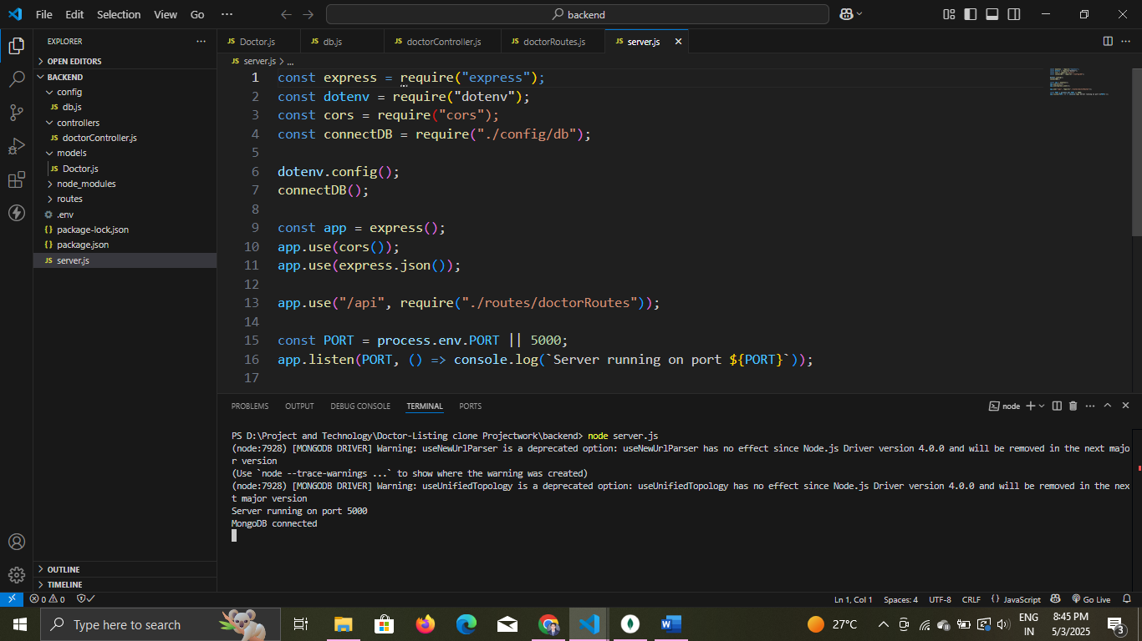

Run Frontend (npm run dev)

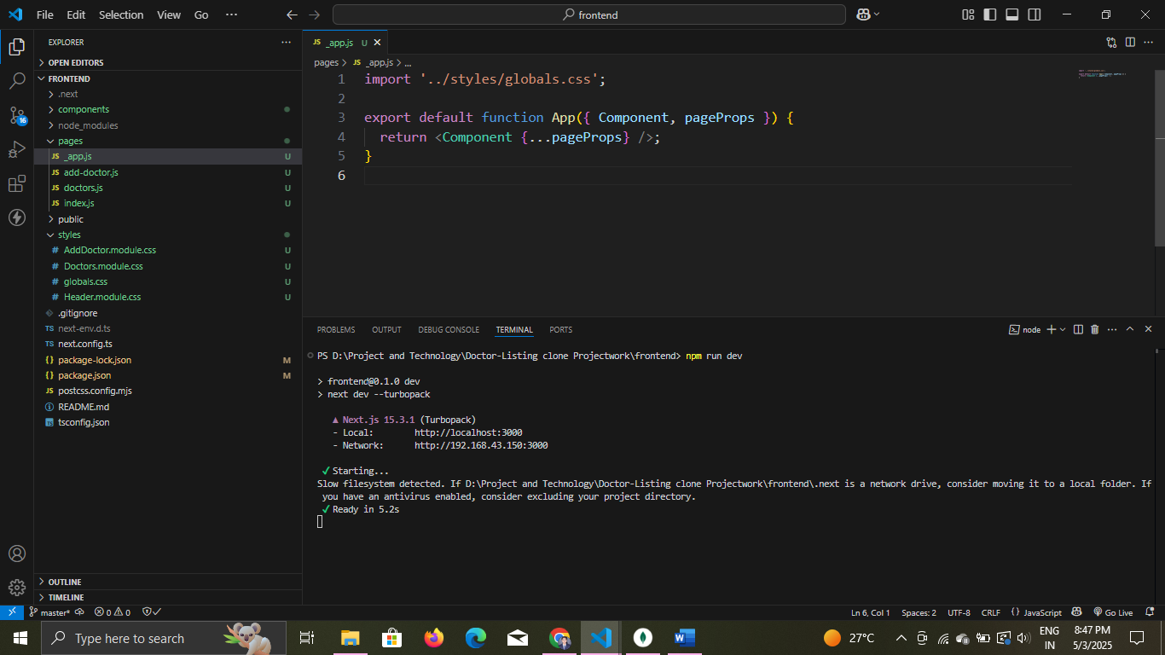
Run In (localhost:3000)

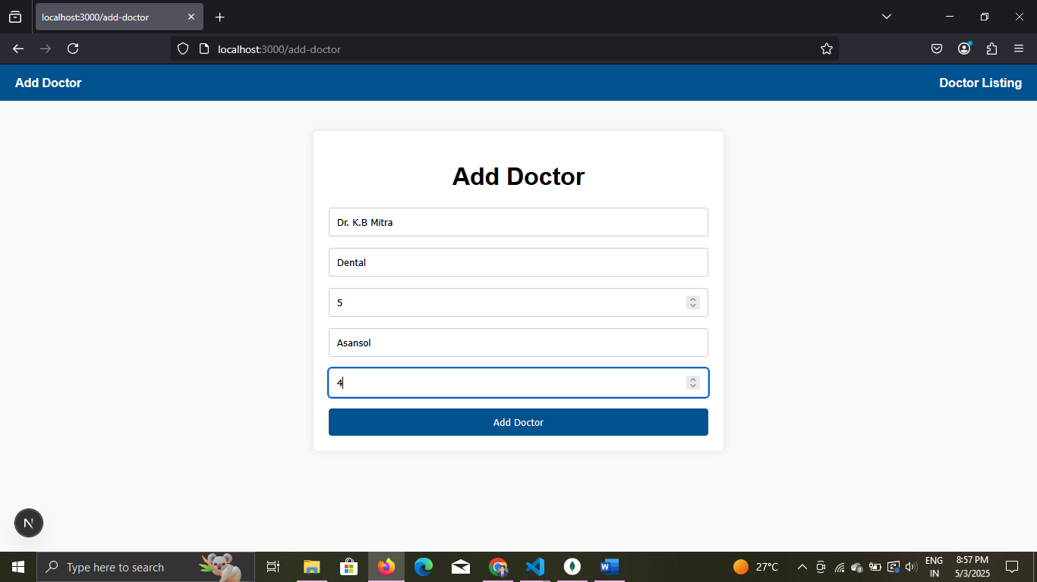

Fill up and Click on “Add Doctor”

All doctor list: You can filter using Name, Specialty or/and Place

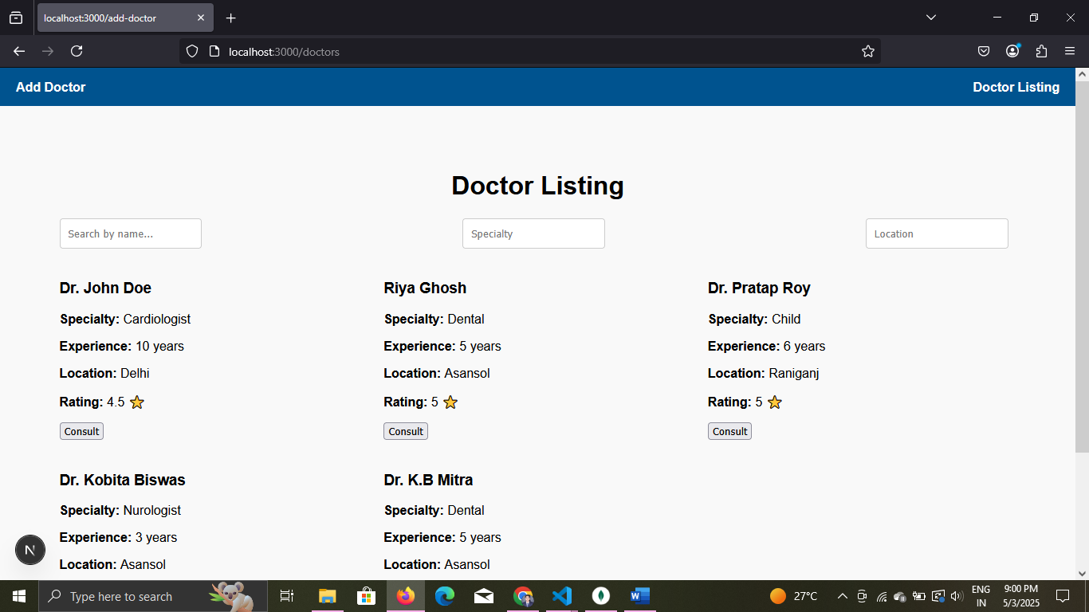

In Database:

