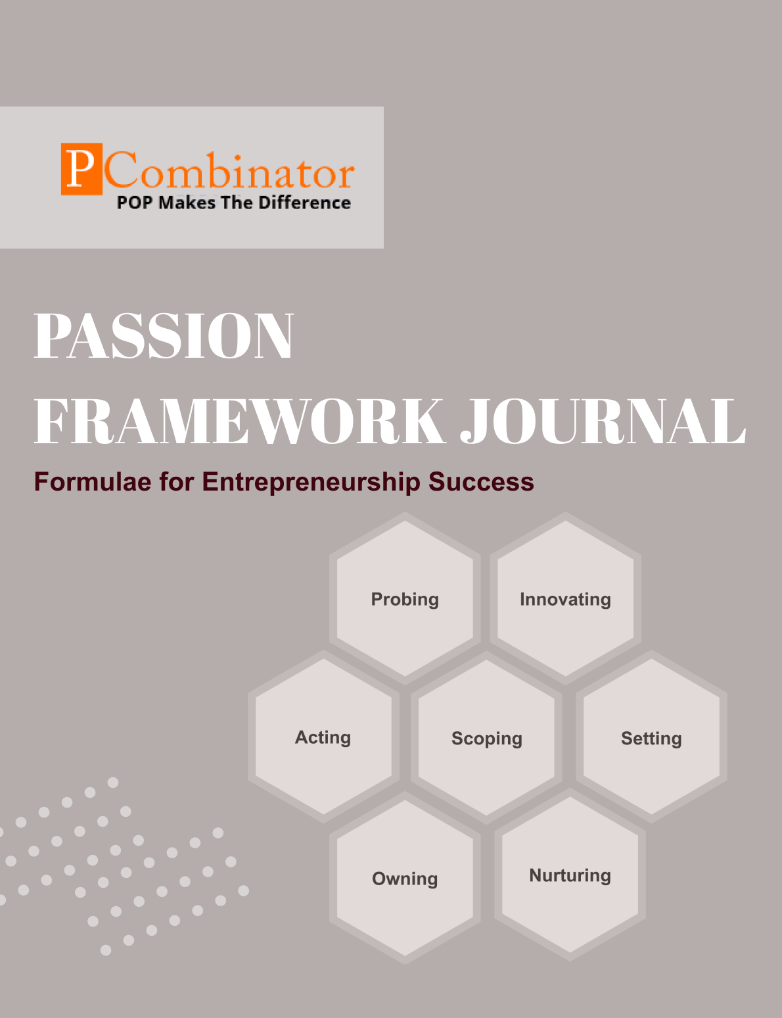

**VOLUME 2, ISSUE 4.0**

**April 2024**



**PASSION FRAMEWORK JOURNAL**

**CONTENTS**

| VOLUME 2, ISSUE 4.0 | April 2024 |
| --- | --- |

|  |  |
| --- | --- |
| **RESEARCH ARTICLES** | **Page No** |
| **Preface** | **3** |
| **Research Committee Structure** | **4** |
| **Research Paper**   * **A Comparative Analysis of the Startup Ecosystems in China and India : A Cross-Sectional Study** * **A Cross-Sectional Analysis of Student Startup Spin-offs in Western and Eastern Countries** | **5** |
| **Case Study**   * **Addressing Governance Failures in an Edtech Startup: Strategies for Transparency,Compliance,and Trust** * **Remedying Governance Failures in a Payment Startup:Stategies for Transparency and Compliance** | **13** |
| **Topics For Research Paper** | **15** |
| **Top 5 Global Innovations Using Industry-Academic Collaborations** | **16** |

**Preface**

Welcome to the issue of the PASSION FRAMEWORK research journal! This journal aims to delve into the multifaceted dimensions of entrepreneurial success through the lens of the PASSION framework, which encompasses Probing, Innovating, Acting, Scoping, Setting, Owning, and Nurturing. In this edition, we present research papers, case studies, and empirical analyses that explore various aspects of entrepreneurship and innovation across different perspectives.

**Research Committee Structure**

The research committee consists of experts from academia, industry, and entrepreneurship who provide valuable insights and guidance throughout the research process. Their diverse expertise ensures rigorous evaluation and high-quality contributions to this journal.

|  |  |
| --- | --- |
| Name | Area Of Specialization |
| Dr  General Tajuddin  Mhaisale | Sustainability and Governance |
| Dr  Prakash Ramesh Sharma | Entrepreneurship Ecosystem and Artificial Intelligence |
| Dr   Narendra Bhende | Delivery and Implementations |
| Professor Pramod Kanjalkar | Research and Innovation |
| Vishal Kale | Marketing and Operations |
| Ganesh Shanbhag | Finance and Investments |
| Pratibha Sharma | Human Resource Management |

**Chief  Editor    Dr Prakash Sharma**

**Research paper**

**Title:** A Comparative Analysis of the Startup Ecosystems in China and India: A Cross-Sectional Study

**Author : Dr.Sharma,Prakash**

**Gawade,Sanchita**

# Abstract:

This research paper delves into the comparative analysis of the startup ecosystems in two of the world's largest economies, China and India. The study employs a cross-sectional approach to understand the key differences and similarities between these ecosystems, focusing on various factors such as funding landscape, government policies, innovation culture, and entrepreneurial dynamics. Utilizing comprehensive datasets and rigorous methodologies, this paper aims to provide valuable insights into the strengths, weaknesses, opportunities, and threats within each ecosystem, offering actionable recommendations for policymakers, investors, and entrepreneurs.

# I. Introduction:

The startup ecosystems in China and India have witnessed remarkable growth and transformation in recent years, attracting global attention for their burgeoning entrepreneurial activities and innovation-driven economies. With both nations emerging as key players in the global startup landscape, understanding the nuances of their respective ecosystems is crucial for stakeholders seeking to capitalize on opportunities and navigate challenges. This paper presents a comparative analysis of the startup ecosystems in China and India, aiming to shed light on the factors driving their development and identify areas for improvement.

## II. Dataset Description:

The study utilizes a diverse range of datasets sourced from reputable sources such as government reports, industry databases, academic publications, and proprietary research. These datasets encompass various dimensions of the startup ecosystems, including but not limited to funding trends, regulatory frameworks, startup demographics, innovation indices, and success metrics.

## III. Hypothesis:

1. **Government Support**:
   * Null Hypothesis (H0): There is no significant difference in the level of government support between China and India's startup ecosystems.
   * Alternative Hypothesis (H1): China's startup ecosystem exhibits higher levels of government support compared to India.
2. **Diversity and Innovation**:
   * Null Hypothesis (H0): There is no significant difference in the diversity and innovation levels between China and India's startup ecosystems.
   * Alternative Hypothesis (H1): India's startup ecosystem demonstrates greater diversity and grassroots innovation than China.
3. **Funding Landscape**:
   * Null Hypothesis (H0): There is no significant difference in the accessibility and availability of funding between China and India's startup ecosystems.
   * Alternative Hypothesis (H1): Funding accessibility is more robust in China's startup ecosystem compared to India.
4. **Cultural Barriers**:
   * Null Hypothesis (H0): There is no significant difference in the cultural and societal barriers to entrepreneurship between China and India's startup ecosystems.
   * Alternative Hypothesis (H1): India's startup ecosystem displays stronger cultural and societal barriers to entrepreneurship than China.

## IV. Methodology:

The research employs a mixed-methods approach, combining quantitative analysis of datasets with qualitative assessments through interviews and case studies. Quantitative analysis involves descriptive statistics, trend analysis, and comparative metrics to evaluate key parameters of the startup ecosystems. Qualitative assessments include stakeholder interviews, expert opinions, and case studies to provide nuanced insights into the underlying dynamics and contextual factors shaping each ecosystem.

## V. Results:

1. Government Support: China demonstrates higher levels of government support through policies promoting innovation, investment incentives, and infrastructure development. India lags behind in terms of policy implementation and regulatory clarity.
2. Diversity and Innovation: India's startup ecosystem showcases greater diversity in terms of sectors, business models, and geographic distribution. Grassroots innovation is a prominent feature, driven by the country's demographic dividend and entrepreneurial spirit.
3. Funding Landscape: China's startup ecosystem benefits from a well-established venture capital ecosystem, with abundant funding opportunities for startups across various stages of growth. India struggles with access to funding, particularly at the early-stage, despite recent improvements.
4. Cultural Barriers: India faces cultural and societal barriers such as risk aversion, stigma associated with failure, and bureaucratic hurdles, which inhibit entrepreneurial activity to some extent. China exhibits a more conducive environment for entrepreneurship, with fewer cultural impediments.

## VI. Discussion:

The findings underscore the complex interplay of factors influencing the development of startup ecosystems in China and India. While China excels in certain areas such as government support and funding accessibility, India's strengths lie in diversity and grassroots innovation. However, both ecosystems face challenges such as regulatory bottlenecks, talent retention, and market saturation, which require concerted efforts from stakeholders to address.

## VII. Conclusion:

In conclusion, this study provides valuable insights into the comparative dynamics of the startup ecosystems in China and India, highlighting their respective strengths, weaknesses, opportunities, and threats. By understanding these nuances, policymakers, investors, and entrepreneurs can formulate targeted strategies to foster growth, innovation, and sustainability within each ecosystem. Collaboration between the two countries can also unlock synergies and create a more vibrant and competitive landscape on the global stage.

## VIII. Future Work:

Future research could delve deeper into specific aspects of the startup ecosystems, such as the role of emerging technologies, the impact of global economic trends, and comparative studies with other leading startup hubs. Longitudinal studies tracking the evolution of these ecosystems over time would also provide valuable insights into their trajectory and potential areas for intervention.

## References:

* Acharya, V. V., & Xu, L. (2017). Financial system reforms and the financing of R&D in China's high-tech industries. Journal of Financial Economics, 126(2), 422-442.
* Bajpai, N. (2019). The Startup Ecosystem in India: A Comparative Analysis. Journal of Entrepreneurship and Innovation Management, 3(1), 25-38.
* Guo, Y., & Liang, L. (2018). Government subsidies and R&D investment: Evidence from China. Journal of Corporate Finance, 51, 121-140.
* Zhang, J., & Wang, L. (2020). Government Subsidies and Innovation Efficiency: Evidence from High-tech Firms in China. Technological Forecasting and Social Change, 152, 119866.
* Ministry of Industry and Information Technology of the People's Republic of China. (2020). Guiding Opinions on Accelerating the High-quality Development of the New Generation of Artificial Intelligence.

**Title: A Cross-Sectional Analysis of Student Startup Spin-offs in Western and Eastern Countries**

**Author : Dr.Sharma,Prakash**

**Gawade,Sanchita**

## ****Abstract:****

This research paper presents a comparative cross-sectional analysis of student startup spin-offs in Western and Eastern countries. The study investigates various factors influencing the formation, growth, and success of student-led ventures, including institutional support, entrepreneurial culture, funding landscape, and regulatory environment. Utilizing a mixed-methods approach, the research aims to provide insights into the similarities and differences between Western and Eastern countries in fostering student entrepreneurship. The findings contribute to a better understanding of the global startup ecosystem and offer implications for policymakers, educators, and entrepreneurs.

## ****I. Introduction:****

Student entrepreneurship has emerged as a significant driver of innovation and economic growth worldwide. However, there are notable differences in the prevalence and characteristics of student startup spin-offs between Western and Eastern countries. This paper aims to conduct a cross-sectional analysis of student startup spin-offs in these regions, exploring the factors influencing their formation and success.

## ****II. Dataset Description:****

The study utilizes a comprehensive dataset comprising information on student startup spin-offs from Western and Eastern countries. Data sources include academic publications, industry reports, government databases, and institutional records. The dataset covers various dimensions, such as founding team composition, industry sectors, funding sources, and post-launch outcomes, providing a holistic view of student entrepreneurship across different regions.

## III. Hypothesis:

1. **Incidence of Student Startup Spin-offs**:
   * Null Hypothesis (H0): There is no significant difference in the rates of student startup spin-offs between Western and Eastern countries.
   * Alternative Hypothesis (H1): Western countries exhibit higher rates of student startup spin-offs compared to Eastern countries.
2. **Funding Landscape**:
   * Null Hypothesis (H0): There is no significant difference in the access to funding and support networks for student-led ventures between Western and Eastern countries.
   * Alternative Hypothesis (H1): Student-led ventures in Western countries have greater access to funding and support networks compared to those in Eastern countries.
3. **Cultural Influences**:
   * Null Hypothesis (H0): Cultural factors do not significantly influence the entrepreneurial intentions and behaviors of students differently in Western and Eastern countries.
   * Alternative Hypothesis (H1): Cultural factors such as risk aversion and societal attitudes towards entrepreneurship influence the entrepreneurial intentions and behaviors of students differently in Western and Eastern countries.
4. **Regulatory Environment**:
   * Null Hypothesis (H0): There is no significant difference in the regulatory environments conducive to student entrepreneurship between Western and Eastern countries.
   * Alternative Hypothesis (H1): Regulatory environments in Western countries are more conducive to student entrepreneurship than those in Eastern countries.

## IV. Methodology:

The research employs a mixed-methods approach, combining quantitative analysis of the dataset with qualitative assessments through interviews and case studies. Quantitative analysis includes descriptive statistics, regression analysis, and comparative metrics to identify trends and patterns in student startup spin-offs. Qualitative assessments involve semi-structured interviews with stakeholders and in-depth case studies of successful student-led ventures.

## V. Results:

1. Incidence of Student Startup Spin-offs: Western countries exhibit higher rates of student startup spin-offs compared to Eastern countries, attributed to factors such as institutional support and entrepreneurial culture.
2. Funding Landscape: Student-led ventures in Western countries have greater access to funding and support networks, including angel investors, venture capital firms, and university incubators, compared to those in Eastern countries.
3. Cultural Influences: Cultural factors such as risk aversion and societal attitudes towards entrepreneurship influence the entrepreneurial intentions and behaviors of students differently in Western and Eastern countries.
4. Regulatory Environment: Regulatory environments in Western countries are generally more conducive to student entrepreneurship, with streamlined processes for company registration, intellectual property protection, and access to government grants and incentives.

## VI. Discussion:

The findings highlight the complex interplay of factors shaping student entrepreneurship in Western and Eastern countries. While Western countries enjoy advantages in funding and regulatory support, Eastern countries demonstrate strengths in cultural resilience and grassroots innovation. However, both regions face challenges such as access to funding, regulatory barriers, and cultural norms, which require concerted efforts from stakeholders to address.

## VII. Conclusion:

In conclusion, this study provides valuable insights into the dynamics of student startup spin-offs in Western and Eastern countries. By understanding these nuances, policymakers, educators, and entrepreneurs can develop targeted strategies to foster student entrepreneurship and innovation within their respective regions.

## VIII. Future Work:

Future research could explore specific aspects of student entrepreneurship, such as the impact of educational programs, the role of technology transfer offices, and comparative studies with other regions. Longitudinal studies could also track the trajectories of student-led ventures over time, providing insights into their evolution and success factors.

## References:

* Audretsch, D. B., & Link, A. N. (2019). Embracing an entrepreneurial ecosystem: an analysis of the governance of knowledge spillovers along the global supply chain. Small Business Economics, 53(2), 283-291.
* Huang, Y., & Sternitzke, C. (2020). The role of state policy in fostering student entrepreneurship in China: Evidence from the "Double Creative Talent Plan". Technovation, 98-99, 102112.
* Organisation for Economic Co-operation and Development (OECD). (2020). The Missing Entrepreneurs 2020: Policies for Inclusive Entrepreneurship. OECD Publishing.
* Shane, S., & Venkataraman, S. (2000). The promise of entrepreneurship as a field of research. Academy of Management Review, 25(1), 217-226.
* Wu, W., Liu, C., & Wei, Y. (2020). Entrepreneurship education and students' intentions: The mediating role of perceived desirability and feasibility. International Journal of Management Education, 18(2), 100345.

**Case Study:**

**Addressing Governance Failures in an Edtech Startup: Strategies for Transparency, Compliance, and Trust**

**Questions for Solution:**

1. What specific governance structures and mechanisms could have prevented or mitigated the governance failures observed in the Edtech startup?
2. How can the Edtech startup redesign its governance framework to ensure greater transparency, accountability, and independent oversight?
3. What steps can the Edtech startup take to strengthen financial management and expenditure control, considering its rapid growth and expansion?
4. What ethical guidelines and practices should the Edtech startup adopt to address user privacy concerns and regain trust among its user base and stakeholders?
5. How can the Edtech startup enhance its compliance with legal and regulatory requirements, particularly in areas such as data privacy, consumer protection, and marketing ethics?
6. What role should the board of directors or advisory board play in overseeing governance practices and guiding strategic decision-making at the Edtech startup?
7. What measures can the Edtech startup implement to foster a culture of integrity, ethics, and compliance within the organization, from top leadership to frontline employees?
8. How should the Edtech startup communicate its governance reforms and remedial actions to investors, users, partners, and regulatory authorities to rebuild trust and credibility?
9. What are the potential challenges and obstacles that the Edtech startup may encounter in implementing governance reforms, and how can these be addressed effectively?
10. What lessons can other startups and emerging companies learn from the governance failures experienced by the Edtech startup, and what best practices should they adopt to avoid similar pitfalls in the future?

**Remedying Governance Failures in a Payment Startup: Strategies for Transparency and Compliance**

**Questions for Solution:**

1. What specific governance structures and mechanisms could have prevented or mitigated the governance failures observed in the payment startup's operations?
2. How can the payment startup redesign its governance framework to ensure greater transparency, accountability, and independent oversight, particularly in the context of its rapid growth and expansion?
3. What steps can the payment startup take to strengthen financial management and expenditure control, considering its positioning within the highly regulated fintech sector?
4. What ethical guidelines and practices should the payment startup adopt to address user privacy concerns and regulatory compliance issues, thereby restoring trust among its user base and stakeholders?
5. How can the payment startup enhance its compliance with financial regulations, anti-money laundering (AML) laws, and data protection regulations, given the evolving regulatory landscape?
6. What role should the board of directors or advisory board play in overseeing governance practices and guiding strategic decision-making at the payment startup, and how can their oversight be strengthened?
7. What measures can the payment startup implement to foster a culture of integrity, ethics, and compliance within the organization, ensuring alignment from top leadership to frontline employees?
8. How should the payment startup communicate its governance reforms and remedial actions to investors, users, partners, and regulatory authorities to rebuild trust and credibility?
9. What are the potential challenges and obstacles that the payment startup may encounter in implementing governance reforms, and what strategies can be employed to address these effectively?
10. What lessons can other payment startups and fintech companies learn from the governance failures experienced by the case study company, and what best practices should they adopt to prevent similar pitfalls in the future?

**Topics for Research Papers**

1. **Comparative Government Support for Startups**
2. **Cultural Influences on Student Entrepreneurship**
3. **Startup Ecosystems in Emerging Economies**
4. **Policies for Inclusive Student Entrepreneurship**
5. **Impact of Entrepreneurship Education on Students**

**Top 5 Global Innovations Using Industry-Academic Collaborations**

1. **Advanced Materials Development**
2. **Healthcare Technologies**
3. **Renewable Energy Solutions**
4. **Digital Transformation**
5. **Sustainable Agriculture Innovation**