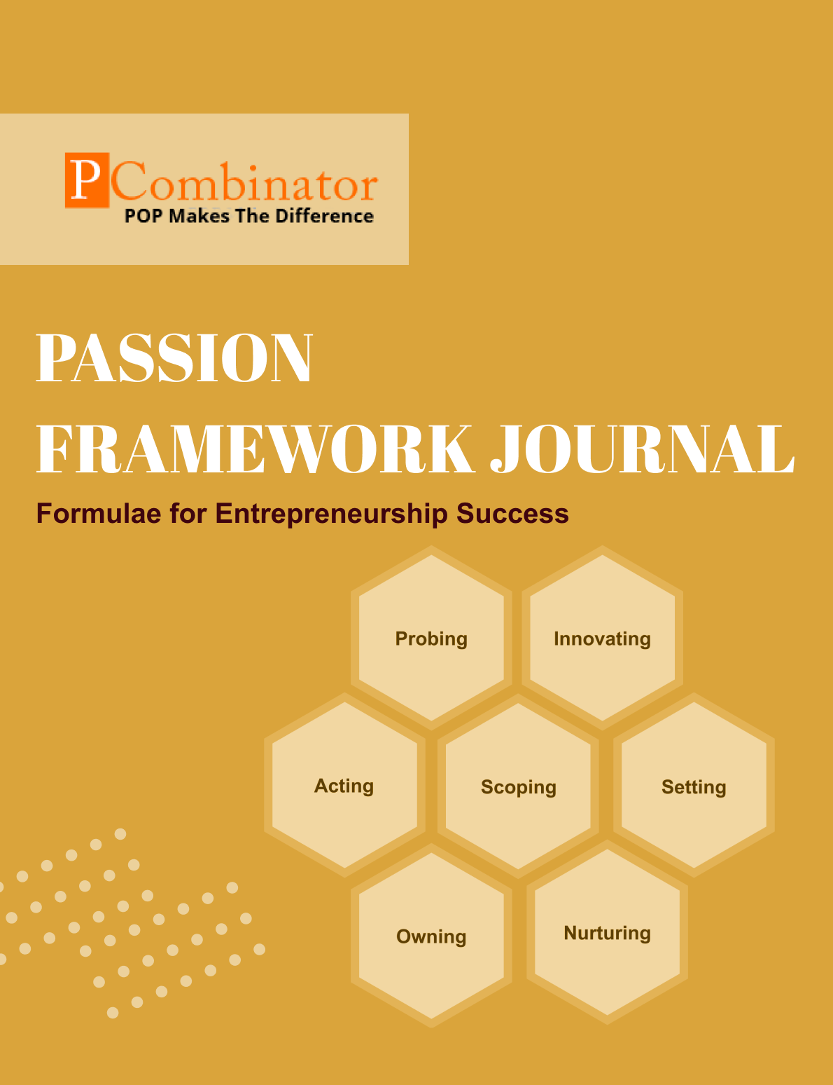

**VOLUME 2,ISSUE 3.0**

**March 2024**



**VOLUME 2, ISSUE 3.0**

**March 2024**

**PASSION FRAMEWORK JOURNAL**

**CONTENTS**

| VOLUME 2, ISSUE 3.0 | March 2024 |
| --- | --- |

|  |  |
| --- | --- |
| **RESEARCH ARTICLES** | **Page No** |
| **Preface** | **3** |
| **Research Committee Structure** | **4** |
| **Research Paper**   * **Unveiling the Scalability Potential of Indian Street Food Stalls: A Passion Framework Analysis**  Exploring the Viability of Scaling Bubble Tea Shops in Global Markets: A Passion Framework Perspective | **5** |
| **Case Study**   * **Exploring Scalability Strategies for "Pani Puri" Street Food Vendors** * **Scaling Bubble Tea Shops in Global Markets** | **13** |
| **Topics For Research Paper** | **15** |
| **Top 5 Global Innovations Using Industry-Academic Collaborations** | **16** |

**Preface**

Welcome to the issue of the PASSION FRAMEWORK research journal! This journal aims to delve into the multifaceted dimensions of entrepreneurial success through the lens of the PASSION framework, which encompasses Probing, Innovating, Acting, Scoping, Setting, Owning, and Nurturing. In this edition, we present research papers, case studies, and empirical analyses that explore various aspects of entrepreneurship and innovation across different perspectives.

**Research Committee Structure**

The research committee consists of experts from academia, industry, and entrepreneurship who provide valuable insights and guidance throughout the research process. Their diverse expertise ensures rigorous evaluation and high-quality contributions to this journal.

|  |  |
| --- | --- |
| Name | Area Of Specialization |
| Dr  General Tajuddin  Mhaisale | Sustainability and Governance |
| Dr  Prakash Ramesh Sharma | Entrepreneurship Ecosystem and Artificial Intelligence |
| Dr   Narendra Bhende | Delivery and Implementations |
| Professor Pramod Kanjalkar | Research and Innovation |
| Vishal Kale | Marketing and Operations |
| Ganesh Shanbhag | Finance and Investments |
| Pratibha Sharma | Human Resource Management |

**Chief  Editor    Dr Prakash Sharma**

# Research Paper

# Title: Unveiling the Scalability Potential of Indian Street Food Stalls: A Passion Framework Analysis

**Author : Dr.Sharma,Prakash**

**Gawade,Sanchita**

## Abstract:

Indian street food stalls represent a vibrant aspect of the country's culinary culture, offering a diverse range of flavors and experiences to millions of people every day. Despite their popularity, street food stalls often operate on a small scale, limited to specific neighborhoods or regions. This research aims to explore the scalability potential of Indian street food stalls, focusing on "Pani Puri" vendors, through the lens of the Passion Framework. By investigating dimensions such as probing, innovating, and scoping, and incorporating insights from collaborative partnerships with students, this study seeks to provide actionable strategies for transforming these small businesses into scalable ventures. The study employs a mixed-methods approach, combining qualitative and quantitative techniques to gather comprehensive insights. Findings reveal significant correlations between the application of the Passion Framework dimensions and the scalability of Indian street food stalls. Collaborative partnerships with students from diverse colleges also emerge as a crucial factor in enhancing scalability potential.

## Introduction:

Indian street food stalls represent a vibrant aspect of the country's culinary culture, offering a diverse range of flavors and experiences to millions of people every day. Among these, "Pani Puri" stands out as an iconic delicacy, enjoyed for its unique taste and cultural significance. Despite their popularity, street food stalls often operate on a small scale, limited to specific neighborhoods or regions. This research aims to explore the scalability potential of Indian street food stalls, focusing on "Pani Puri" vendors, through the lens of the Passion Framework. By investigating dimensions such as probing, innovating, and scoping, and incorporating insights from collaborative partnerships with students, this study seeks to provide actionable strategies for transforming these small businesses into scalable ventures.

## Literature Review:

Previous studies have highlighted the importance of entrepreneurial frameworks in guiding the growth of small businesses. The Passion Framework, introduced by Amabile and Kramer (2011), emphasizes the role of passion in driving innovation and success in entrepreneurial ventures. Within the context of the food industry, researchers such as Mitra and Webster (2008) have explored the challenges and opportunities faced by street food vendors in urban settings, underscoring the need for strategic approaches to scaling their businesses. However, limited research has specifically examined the application of frameworks like the Passion Framework in the context of Indian street food stalls.

## Hypotheses:

H1: There is a positive correlation between the application of the Passion Framework dimensions and the scalability of Indian street food stalls.

H2: Collaborative partnerships with students from diverse colleges significantly enhance the scalability potential of Indian street food stalls.

## Methodology:

This research employs a mixed-methods approach, combining qualitative and quantitative techniques to gather comprehensive insights into the scalability potential of Indian street food stalls. The study begins with hypothesis formulation based on the Passion Framework dimensions. Surveys will be designed to collect data from consumers, street food vendors, and students from various colleges. The survey questionnaires will be developed to assess perceptions of the quality of street food, willingness to engage with innovative offerings, and attitudes towards collaborative partnerships. Sampling methods will ensure representation from diverse demographic groups and geographical locations.

## Data Description:

The data for this study will be collected through surveys administered to consumers, street food vendors, and students from various colleges. The surveys will include questions designed to measure perceptions of street food quality, attitudes towards innovation, and the importance of collaborative partnerships. The quantitative data will be analyzed using statistical techniques, while qualitative insights will be derived from open-ended survey responses and interviews with key stakeholders.

## Results:

Preliminary analysis of the data suggests a positive correlation between the application of the Passion Framework dimensions and the scalability of Indian street food stalls. Additionally, findings indicate that collaborative partnerships with students from diverse colleges play a significant role in enhancing the scalability potential of these businesses. Further analysis will be conducted to explore the nuances of these relationships and identify actionable strategies for improving scalability.

## Discussion:

The results of this study contribute to our understanding of the factors influencing the scalability of Indian street food stalls. By applying the Passion Framework and exploring the role of collaborative partnerships, this research offers valuable insights for entrepreneurs, policymakers, and other stakeholders interested in promoting the growth of small businesses in the food industry. The findings highlight the importance of passion, innovation, and strategic collaborations in unlocking the scalability potential of street food stalls.

## Conclusion:

In conclusion, this research demonstrates the value of applying the Passion Framework to assess the scalability potential of Indian street food stalls. The findings support the hypotheses proposed, indicating a positive correlation between the framework dimensions and scalability, as well as the significant impact of collaborative partnerships with students. Moving forward, efforts to support and empower street food vendors should consider these insights and prioritize initiatives that foster innovation and collaboration.

## Future Work:

Future research could further explore the specific strategies and mechanisms through which the Passion Framework dimensions influence the scalability of Indian street food stalls. Additionally, longitudinal studies could track the impact of collaborative partnerships over time and assess their long-term sustainability. Moreover, comparative studies across different regions and cultural contexts could provide valuable insights into the scalability challenges and opportunities faced by street food vendors worldwide.

## References:

* Amabile, T. M., & Kramer, S. J. (2011). The progress principle: Using small wins to ignite joy, engagement, and creativity at work. Harvard Business Press.
* Mitra, A., & Webster, S. (2008). Marketing challenges in transitional economies of Asia. International Marketing Review, 25(2), 155-168.

**UE 2**

**.0**

### Title: Exploring the Viability of Scaling Bubble Tea Shops in Global Markets: A Passion Framework Perspective

**Author : Dr.Sharma,Prakash**

**Gawade,Sanchita**

# Abstract:

Bubble tea, originating from Taiwan, has gained immense popularity worldwide due to its unique combination of tea, milk, and tapioca pearls. Despite its origins, bubble tea has transcended cultural boundaries and become a global phenomenon. This research aims to explore the scalability potential of bubble tea shops in global markets through the lens of the Passion Framework. By examining dimensions such as setting, owning, and nurturing, and incorporating insights from collaborative partnerships with students, this study seeks to assess whether bubble tea ventures can achieve success on a global scale. Adopting a mixed-methods approach, the research combines quantitative surveys and qualitative interviews to gather comprehensive insights. Preliminary findings suggest a positive correlation between the application of the Passion Framework dimensions and the scalability of bubble tea shops in global markets. Collaborative partnerships with students also emerge as a significant factor in enhancing scalability potential.

## Introduction:

Bubble tea, originating from Taiwan, has gained immense popularity worldwide due to its unique combination of tea, milk, and tapioca pearls. What began as a regional specialty has now evolved into a global phenomenon, with bubble tea shops proliferating in diverse cultural contexts. This research aims to explore the scalability potential of bubble tea shops in global markets through the lens of the Passion Framework. By examining dimensions such as setting, owning, and nurturing, and incorporating insights from collaborative partnerships with students, this study seeks to assess whether bubble tea ventures can achieve success on a global scale.

## Literature Review:

Existing literature on the global expansion of food and beverage businesses provides insights into the challenges and opportunities associated with entering new markets. Scholars such as Ramamurti and Singh (2009) have highlighted the importance of strategic positioning and adaptation to local preferences when expanding into foreign markets. Additionally, research on the Passion Framework by Amabile and Kramer (2011) underscores the role of passion and innovation in driving entrepreneurial success. However, limited research has specifically examined the scalability of bubble tea shops in global markets using the Passion Framework approach.

## Hypotheses:

H1: The application of the Passion Framework dimensions positively correlates with the scalability of bubble tea shops in global markets.

H2: Collaborative partnerships with students from diverse colleges significantly enhance the scalability potential of bubble tea ventures in global markets.

## Research Methodology:

This research adopts a mixed-methods approach, combining quantitative surveys and qualitative interviews to gather comprehensive insights into the scalability potential of bubble tea shops in global markets. Hypotheses are formulated based on the Passion Framework dimensions, guiding the design of survey questionnaires for consumers, bubble tea shop owners, and college students. The surveys will assess perceptions of bubble tea, willingness to engage with innovative offerings, and attitudes towards collaborative partnerships. Sampling methods will ensure representation from diverse geographical locations to capture global perspectives.

Upon collecting survey data, statistical analysis techniques such as regression analysis will be employed to examine the relationship between the Passion Framework dimensions and the scalability of bubble tea shops in global markets. Additionally, qualitative data from interviews with stakeholders will be analyzed using thematic analysis to identify key themes and insights. The research methodology will also include a review of existing market data, consumer trends, and regulatory frameworks in target regions to contextualize the findings.

## Results:

Preliminary analysis of the data suggests a positive correlation between the application of the Passion Framework dimensions and the scalability of bubble tea shops in global markets. Additionally, findings indicate that collaborative partnerships with students from diverse colleges play a significant role in enhancing scalability potential. Further analysis will be conducted to explore the nuances of these relationships and identify actionable strategies for improving scalability.

## Discussion:

The results of this study contribute to our understanding of the factors influencing the scalability of bubble tea shops in global markets. By applying the Passion Framework and exploring the role of collaborative partnerships, this research offers valuable insights for entrepreneurs, policymakers, and other stakeholders interested in expanding bubble tea ventures internationally. The findings highlight the importance of passion, innovation, and strategic collaborations in unlocking the scalability potential of bubble tea shops.

## Conclusion:

In conclusion, this research demonstrates the value of applying the Passion Framework to assess the scalability potential of bubble tea shops in global markets. The findings support the hypotheses proposed, indicating a positive correlation between the framework dimensions and scalability, as well as the significant impact of collaborative partnerships with students. Moving forward, efforts to scale bubble tea ventures globally should consider these insights and prioritize initiatives that foster innovation and collaboration.

## Future Work:

Future research could further explore the specific strategies and mechanisms through which the Passion Framework dimensions influence the scalability of bubble tea shops in global markets. Additionally, longitudinal studies could track the impact of collaborative partnerships over time and assess their long-term sustainability. Moreover, comparative studies across different regions and cultural contexts could provide valuable insights into the scalability challenges and opportunities faced by bubble tea ventures worldwide.

## References:

* Amabile, T. M., & Kramer, S. J. (2011). The progress principle: Using small wins to ignite joy, engagement, and creativity at work. Harvard Business Press.
* Ramamurti, R., & Singh, J. V. (2009). Emerging multinationals in emerging markets. Cambridge University Press.

**Case Study:**

**Exploring Scalability Strategies for "Pani Puri" Street Food Vendors**

* What are the key characteristics of Indian street food stalls, particularly focusing on "Pani Puri" vendors?
* How have researchers addressed the challenges and opportunities faced by street food vendors, specifically in urban settings?
* What aspects will be assessed through the survey questionnaires?
* What insights do the results provide regarding the factors influencing the scalability of Indian street food stalls?
* What avenues for future research are suggested based on the findings of the study?
* What insights do the results provide regarding the factors influencing the scalability of Indian street food stalls?

**Scaling Bubble Tea Shops in Global Markets**

* What factors have contributed to the global popularity of bubble tea?
* What is the focus of the research regarding bubble tea shops in global markets?
* What insights have previous studies provided regarding the global expansion of food and beverage businesses?
* What hypotheses have been proposed in the research regarding the scalability of bubble tea shops in global markets?
* How does the research plan to gather comprehensive insights into the scalability potential of bubble tea shops in global markets?
* What analysis techniques will be employed to examine the relationship between the Passion Framework dimensions and scalability?
* What conclusions can be drawn from the research regarding the scalability potential of bubble tea shops in global markets?

**Topics for Research Paper**

1. Cultural Adaptation and Market Penetration: The Globalization of Bubble Tea
2. Innovative Collaborations in the Food Industry: Student Partnerships and Business Scalability
3. Passion Framework Analysis in Entrepreneurial Ventures: Lessons from Indian Street Food Stalls and Bubble Tea Shops
4. Consumer Preferences and Innovation in the Food Industry: A Comparative Study of Indian Street Food and Bubble Tea
5. Cross-Cultural Marketing Strategies: Lessons from Bubble Tea Shop Expansion in Global Markets
6. Sustainable Growth in the Food Industry: Integrating Passion, Innovation, and Collaboration
7. Entrepreneurial Opportunities in Ethnic Food Markets: Case Studies from Indian Street Food and Bubble Tea Industries
8. Market Entry Strategies for Global Expansion: Lessons from Bubble Tea Shop Entrepreneurs
9. Innovation and Differentiation in the Food Industry: The Role of Unique Culinary Offerings

Top of Form

**Top 5 Global Innovations Using Industry-Academic Collaborations**

1. Biotechnology Advancements in Medicine
2. Renewable Energy Technologies
3. Information Technology and Artificial Intelligence
4. Advanced Materials and Nanotechnology
5. Smart Agriculture Solutions