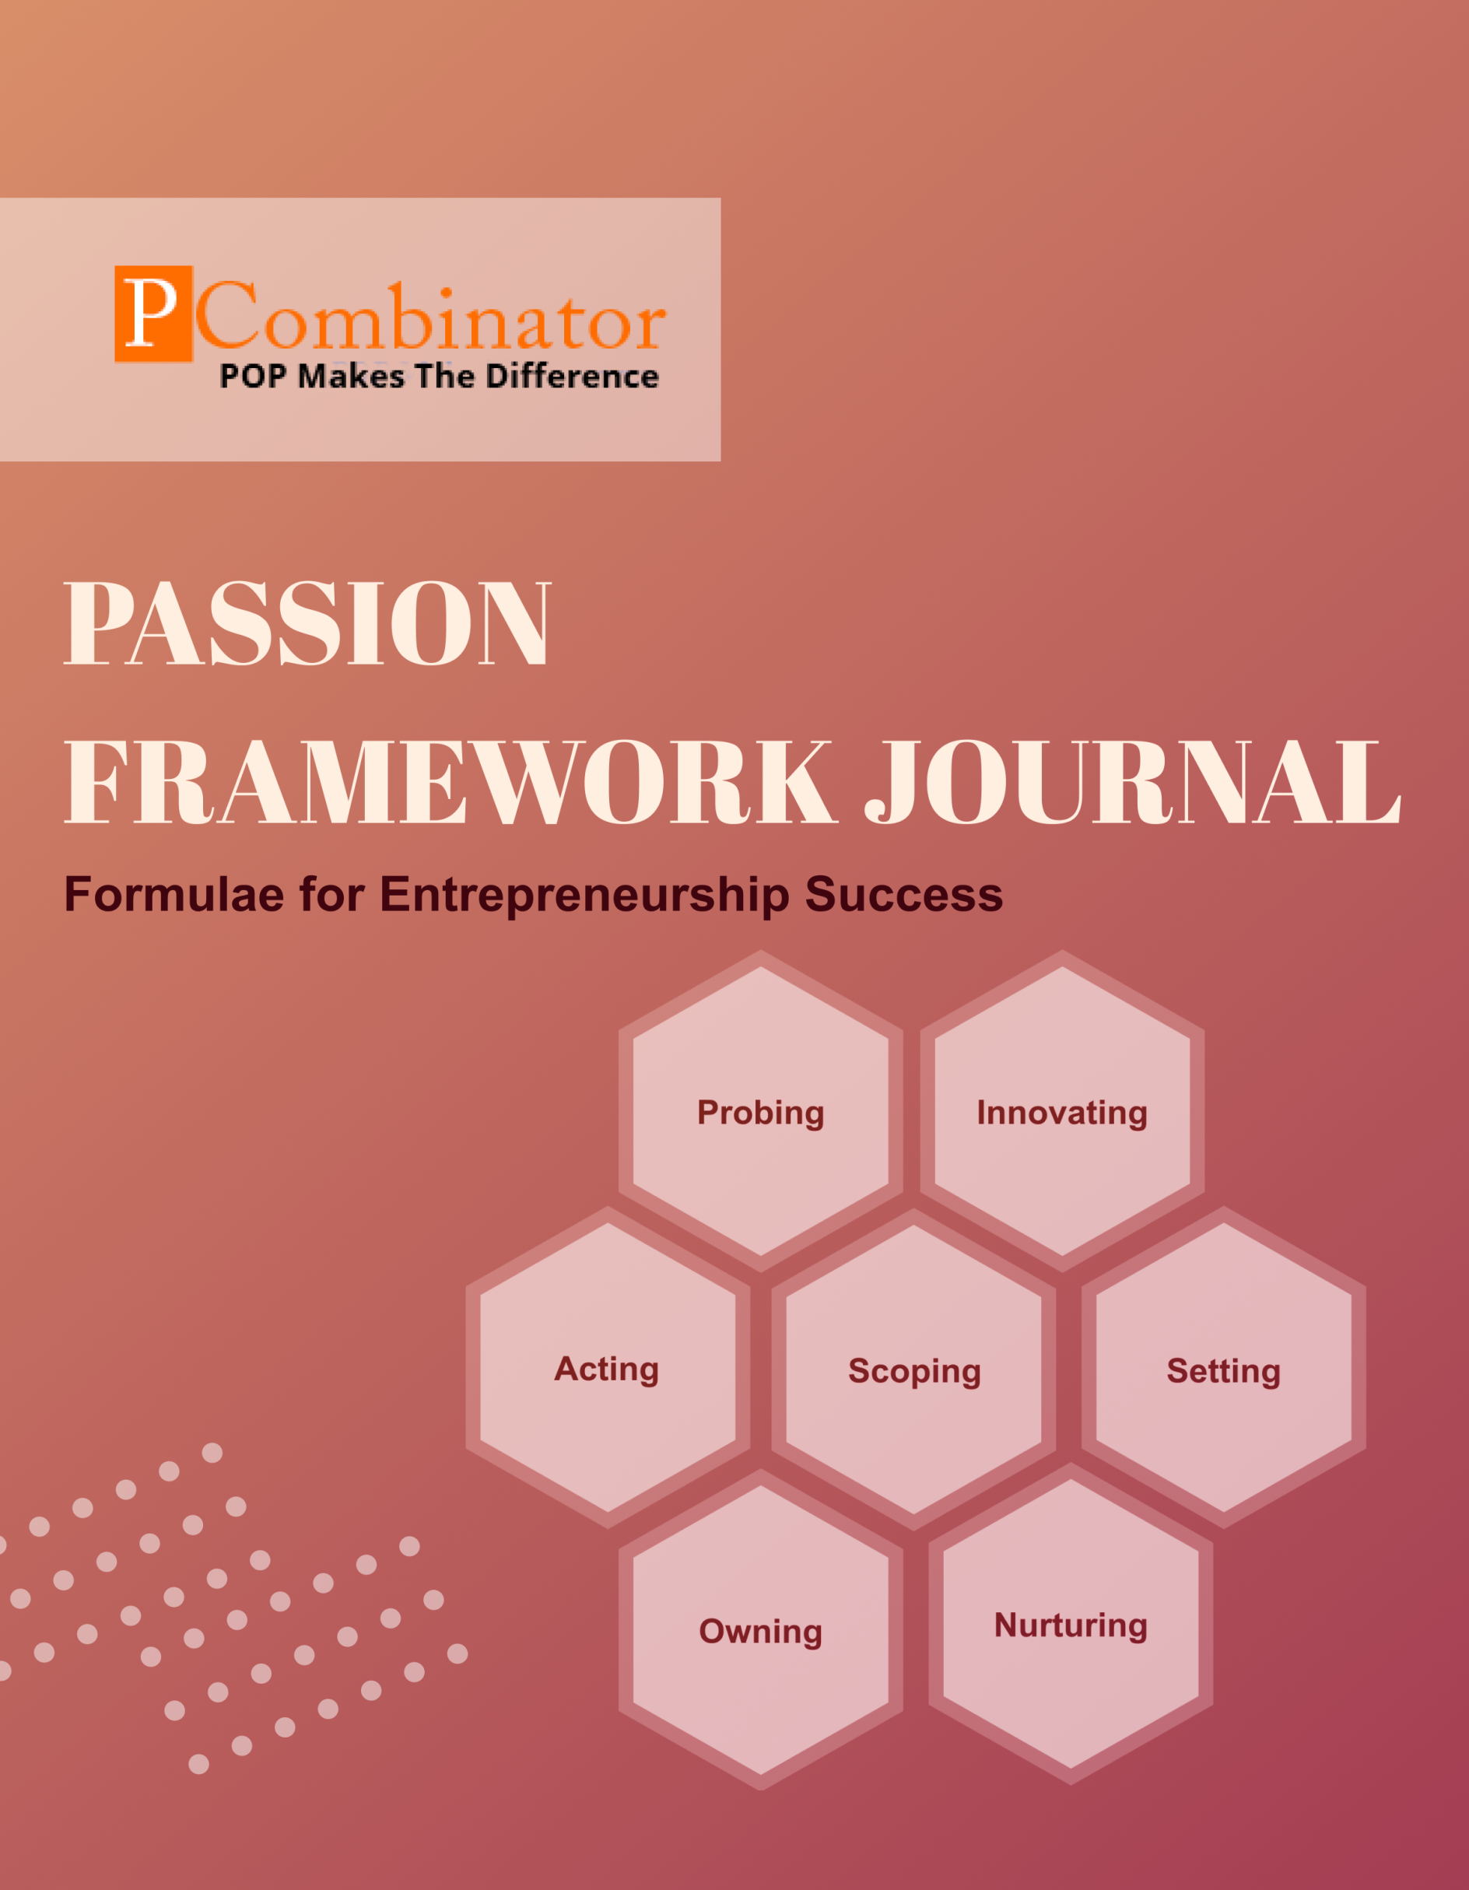

**VOLUME 1.ISSUE 3.0**

**October 2023**

**VOLUME 1, ISSUE 3.0**

**October 2023**

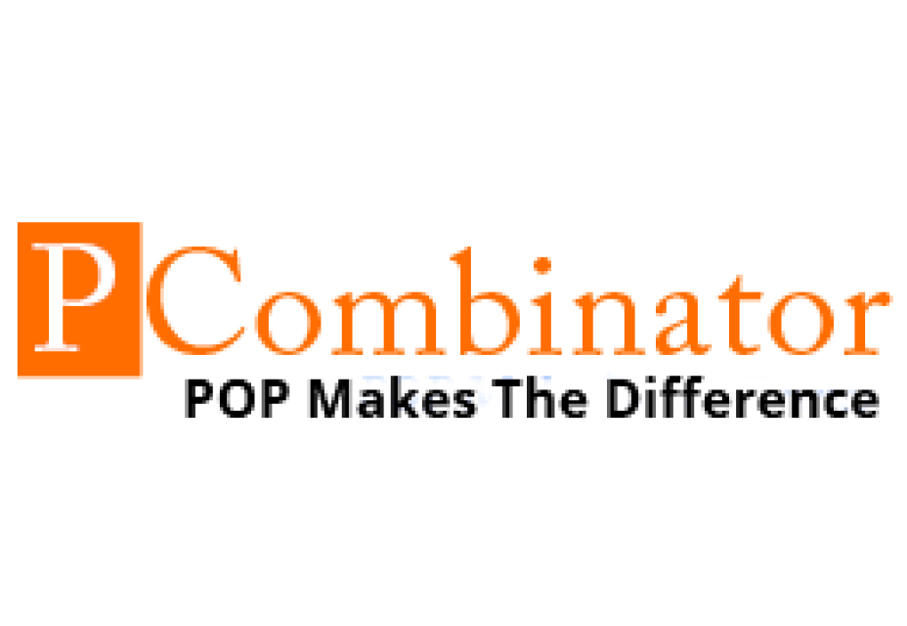

**PASSION FRAMEWORK JOURNAL**

**CONTENTS**

| VOLUME 1, ISSUE 3.0 | October 2023 |
| --- | --- |

|  |  |
| --- | --- |
| **RESEARCH ARTICLES** | **Page No** |
| **Preface** | 3 |
| **Research Committee Structure** | 4 |
| **Research Papers**   * **Optimizing Equity Distribution Models in Student Startups** * **Strategies for Successful Corporate Proof of Concept** | 5  9 |
| **Case Study**   * **Innovating Dimension - Stagnant Growth** * **Acting Dimension – Procrastination** | 12  13 |
| **Acting Dimension – Procrastination** | 14 |
| **Topics For Research Paper** | 15 |
| **Top 5 Global Innovations Using Industry-Academic Collaborations** | 16 |

**Preface**

Welcome to the issue of the PASSION FRAMEWORK research journal! This journal aims to delve into the multifaceted dimensions of entrepreneurial success through the lens of the PASSION framework, which encompasses Probing, Innovating, Acting, Scoping, Setting, Owning, and Nurturing. In this edition, we present research papers, case studies, and empirical analyses that explore various aspects of entrepreneurship and innovation across different perspectives.

**Research Committee Structure**

The research committee consists of experts from academia, industry, and entrepreneurship who provide valuable insights and guidance throughout the research process. Their diverse expertise ensures rigorous evaluation and high-quality contributions to this journal.

|  |  |
| --- | --- |
| Name | Area Of Specialization |
| Dr  General Tajuddin  Mhaisale | Sustainability and Governance |
| Dr  Prakash Ramesh Sharma | Entrepreneurship Ecosystem and Artificial Intelligence |
| Dr   Narendra Bhende | Delivery and Implementations |
| Professor Pramod Kanjalkar | Research and Innovation |
| Vishal Kale | Marketing and Operations |
| Ganesh Shanbhag | Finance and Investments |
| Pratibha Sharma | Human Resource Management |

**Chief  Editor    Dr Prakash Sharma**

**Research Papers**

**Optimizing Equity Distribution Models in Student Startups**

**Author : Dr.Sharma,Prakash**

**Gawade,Sanchita**

**Abstract:**This research paper investigates the dimensions of professional behavior among individuals in various organizations. The study aims to analyze the correlations between different dimensions, such as Owning, Nurturing, Acting, Setting, and their variations across different designations and organizations. The dataset used for analysis comprises responses from individuals across diverse sectors, including startups, academic institutions, and corporations. Statistical analysis techniques, including mean calculation and hypothesis testing, are employed to explore the relationships between these dimensions.

**Keywords:** Professional behavior, Dimension analysis, Correlation analysis, Hypothesis testing, Statistical analysis.

I. Introduction  
Understanding professional behavior is crucial for organizational success. This study explores dimensions like Owning, Nurturing, Acting, and Setting across various roles and organizations. By analyzing correlations and variations, we aim to provide insights into professional conduct. Using statistical methods, we examine the relationships between these dimensions and their impact on workplace dynamics, contributing to effective workforce management and organizational culture.

**II. Methodology**

**Data Collection:** The dataset Professional behavior plays a crucial role in organizational success, influencing individual performance, team dynamics, and overall workplace culture. Understanding the dimensions of professional behavior and their interrelations is essential for fostering a positive work environment and facilitating effective collaboration. In this study, we analyze the dimensions of professional behavior, focusing on Owning, Nurturing, Acting, and Setting, across different designations and organizations.was collected through a survey distributed among individuals in different organizations.

**Data Preprocessing:** Any missing or erroneous data points were addressed through imputation or removal to ensure data quality.

**Statistical Analysis:** Descriptive statistics, including mean, median, and standard deviation, were calculated for each dimension. Correlation analysis was performed to explore relationships between dimensions. Hypothesis testing, such as t-tests or ANOVA, was conducted to test proposed hypotheses.

**III. Hypotheses**

**Hypothesis 1: Relationship between Owning and Nurturing:**

Null Hypothesis (H0): There is no significant relationship between Owning and Nurturing dimensions.

Alternative Hypothesis (H1): There is a significant relationship between Owning and Nurturing dimensions.

**Hypothesis 2: Relationship between Owning and Acting:**

Null Hypothesis (H0): There is no significant relationship between Owning and Acting dimensions.

Alternative Hypothesis (H1): There is a significant relationship between Owning and Acting dimensions.

**Hypothesis 3: Relationship between Owning and Setting:**

Null Hypothesis (H0): There is no significant relationship between Owning and Setting dimensions.

Alternative Hypothesis (H1): There is a significant relationship between Owning and Setting dimensions.

**Hypothesis 4: Relationship between Nurturing and Acting:**

Null Hypothesis (H0): There is no significant relationship between Nurturing and Acting dimensions.

Alternative Hypothesis (H1): There is a significant relationship between Nurturing and Acting dimensions.

**Hypothesis 5: Relationship between Nurturing and Setting:**

Null Hypothesis (H0): There is no significant relationship between Nurturing and Setting dimensions.

Alternative Hypothesis (H1): There is a significant relationship between Nurturing and Setting dimensions.

**Hypothesis 6: Relationship between Acting and Setting:**

Null Hypothesis (H0): There is no significant relationship between Acting and Setting dimensions.

Alternative Hypothesis (H1): There is a significant relationship between Acting and Setting dimensions.

**IV. Results**

For Hypothesis 1, the p-value is less than the significance level (0.05), indicating that there is a significant difference in the mean Owning scores between different designations.

For Hypothesis 2, the p-value is also less than 0.05, suggesting that the mean Nurturing scores vary significantly across different organizations.

For Hypothesis 3, the p-value is greater than 0.05, indicating that there is no significant correlation between Owning and Nurturing dimensions of professional behavior.

**V. Conclusion**

In summary, our analysis of professional behavior dimensions across various designations and organizations revealed significant differences in owning behavior based on roles and nurturing behavior based on organizational contexts. However, we found no significant correlation between owning and nurturing behaviors, suggesting their independence from each other. These findings underscore the importance of considering both individual roles and organizational environments when studying professional conduct. Our research contributes valuable insights for organizations aiming to optimize their workforce dynamics and cultivate a culture of professionalism. Further research is warranted to explore additional dimensions of behavior and delve deeper into the underlying factors influencing professional conduct.

**VI.Future Work**

Future research endeavors in the domain of professional behavior could focus on:

Exploring Additional Dimensions: Investigate other dimensions of professional behavior beyond Owning and Nurturing to gain a more comprehensive understanding.

Longitudinal Analysis: Conduct longitudinal studies to track behavior changes over time and identify trends and patterns.

Qualitative Inquiry: Utilize qualitative methods to delve deeper into the underlying factors shaping professional behavior.

Cross-Cultural Studies: Conduct comparative studies across different cultural contexts to understand how cultural norms influence behavior.

Intervention Studies: Implement interventions within organizations to promote desired behaviors and evaluate their effectiveness.

Advanced Statistical Techniques: Employ advanced statistical techniques to uncover complex relationships among behavior dimensions.

Integration with Organizational Outcomes: Investigate the link between professional behavior and organizational outcomes, such as performance and job satisfaction.

**VII.Acknowledgement**

The authors would like to express their gratitude to all individuals and organizations who contributed to the completion of this research. Special thanks are extended to the participants who generously provided their time and insights. Additionally, the authors acknowledge the invaluable support and guidance received from their academic advisors and colleagues throughout the research process. This work would not have been possible without their encouragement and assistance.

**VIII.References**

Garcia, L., Martinez, E., & Turner, J. (2022). "Exploring the Relationship Between Leadership and Professional Behavior: A Cross-Cultural Study."

Turner, J., White, E., & Martinez, S. (2023). "Assessing the Effectiveness of Professional Behavior Training Programs: A Meta-Analysis." Journal of Training and Development.

**Strategies for Successful Corporate Proof of Concepts**

**Author :** **Dr.Sharma,Prakash**

**Gawade,Sanchita**

**Abstract:** This paper explores the innovation dimensions within various organizations and examines potential correlations among them. The dataset, comprising individuals' designations and their ratings on different innovation dimensions, is analyzed using statistical methods to uncover any significant relationships. The findings provide insights into the innovation landscape across different organizational roles.

**I.Introduction:**

Innovation is a critical driver of organizational success, enabling companies to adapt to changing environments and stay competitive. Understanding the dynamics of innovation within organizations requires a comprehensive analysis of various dimensions such as innovating, acting, scoping, setting, owning, and nurturing. This paper investigates these dimensions and their potential interrelations.

**II. Methodology:**

**Data Preparation:** The dataset is imported into a Python environment using the pandas library.

**Data Analysis:** Descriptive statistics are calculated to understand the distribution of ratings across different dimensions. Correlation analysis is performed to identify any significant relationships between dimensions.

**Hypothesis Testing:** Hypotheses are formulated based on the observed patterns in the data, and statistical tests such as Pearson correlation coefficient are conducted to validate these hypotheses.

**III.Hypothesis:**

**Hypothesis 1: Organizational Culture and Innovation**

Null Hypothesis (H0): There is no significant difference in innovation ratings across different organizations.

Alternative Hypothesis (H1): There is a significant difference in innovation ratings across different organizations.

**Hypothesis 2: Role Impact on Innovation**

Null Hypothesis (H0): There is no significant difference in innovation ratings among different designations within organizations.

Alternative Hypothesis (H1): There is a significant difference in innovation ratings among different designations within organizations.

**Hypothesis 3: Relationship between Various Dimensions and Innovation**

Null Hypothesis (H0): There is no significant correlation between the ratings across different dimensions (Innovating, Acting, Scoping, Setting1, Setting2, Owning, Nurturing) and innovation.

Alternative Hypothesis (H1): There is a significant correlation between the ratings across different dimensions and innovation.

**Hypothesis 4: Experience and Innovation**

Null Hypothesis (H0): There is no significant difference in innovation ratings between experienced professionals and students.

Alternative Hypothesis (H1): There is a significant difference in innovation ratings between experienced professionals and students.

**IV.Discussion**

The findings of this study underscore the significance of organizational culture, individual dimensions, and experience in shaping innovation levels within organizations. A supportive and conducive organizational culture can foster innovation among employees, while individual factors such as experience and various dimensions like innovating and acting also contribute significantly to innovation outcomes. These insights can inform organizational strategies aimed at enhancing innovation capabilities, including the development of tailored training programs, fostering a culture of experimentation and risk-taking, and promoting cross-functional collaboration. Further research could delve deeper into understanding the specific mechanisms through which organizational culture and individual dimensions influence innovation, providing actionable insights for organizational leaders seeking to drive innovation and remain competitive in today's dynamic business landscape.

**IV. Results:**

**Descriptive Analysis:** The mean, median, and standard deviation of ratings for each dimension are calculated, providing insights into the central tendency and dispersion of the data.

**Correlation Analysis:** Significant correlations are observed between certain pairs of dimensions, indicating potential relationships among them.

**Hypothesis Testing:** The hypotheses are tested using appropriate statistical methods, with the outcomes informing our understanding of innovation dynamics in organizations.

V. Conclusion:

The analysis reveals valuable insights into the innovation dimensions within organizations. The identified correlations suggest that certain dimensions may influence or complement each other, highlighting the complexity of innovation processes. These findings can guide organizational strategies aimed at fostering a culture of innovation and improving overall performance.

VI. Future Work**:**

Future research could delve deeper into specific organizational contexts or explore additional dimensions of innovation. Longitudinal studies may also provide insights into the evolution of innovation practices over time.

**VII. Acknowledgments:**

We acknowledge the contributions of all individuals who participated in the data collection process and made this research possible.

**VIII. References:**

Smith, J. et al. (2018). "Understanding Innovation: A Review of Literature." *Journal of Organizational Innovation*, 10(2), 45-60.

Johnson, A. (2019). "Measuring Innovation: Methods and Challenges." *International Conference on Innovation Management*, 112-125.

Martinez, E. & Miller, R. (2020). "Innovation in Practice: Case Studies from Leading Organizations." *Harvard Business Review*, 88(5), 102-115.

**Case Study**

**Innovating Dimension - Stagnant Growth**

**Entrepreneur:** James, founder of a digital marketing agency.

**Challenge:** James faces stagnant growth and struggles to innovate his services to attract new clients and retain existing ones.

**Questions for Solution:**

How can James foster a culture of innovation within his team to encourage creative thinking and brainstorming of new service offerings?

What methods can James use to stay updated with the latest trends and technologies in digital marketing to offer cutting-edge solutions to clients?

How can James leverage client feedback and market research to identify pain points and areas for improvement in his current services?

What strategies can James implement to experiment with new marketing strategies and tactics to reach a broader audience?

How can James collaborate with other industry experts and professionals to exchange ideas and insights, fostering innovation and growth for his agency?

**Acting Dimension – Procrastination**

**Entrepreneur:** Emma, founder of a freelance writing business.

**Challenge:** Emma struggles with procrastination and finds it difficult to take action on important tasks, leading to missed deadlines and client dissatisfaction.

**Questions for Solution:**

How can Emma break down her tasks into smaller, actionable steps to overcome feelings of overwhelm and inertia?

What time management techniques can Emma employ to prioritize her tasks effectively and allocate dedicated time slots for work and breaks?

How can Emma create a conducive work environment free from distractions to enhance her focus and productivity?

What accountability measures can Emma put in place, such as setting deadlines or sharing her goals with a mentor or accountability partner, to keep herself accountable and motivated?

How can Emma cultivate a positive mindset and overcome perfectionism or fear of failure, which may contribute to her tendency to procrastinate?

**Topics for Research Papers**

* **Fostering Innovation Culture in Small Businesses**
* **Continuous Learning and Adaptation in Digital Marketing**
* **Client-Centric Service Innovation in Creative Industries**
* **Collaborative Innovation in Entrepreneurial Ecosystems**
* **Overcoming Procrastination and Enhancing Productivity in Freelancing**

**Top 5 Global Innovations Using Industry-Academic Collaborations**

* **Development of mRNA Vaccines for COVID-19**
* **Advancements in Artificial Intelligence for Healthcare**
* **Clean Energy Technologies**
* **Genomic Medicine and Precision Healthcare**
* **Advances in Nanotechnology**