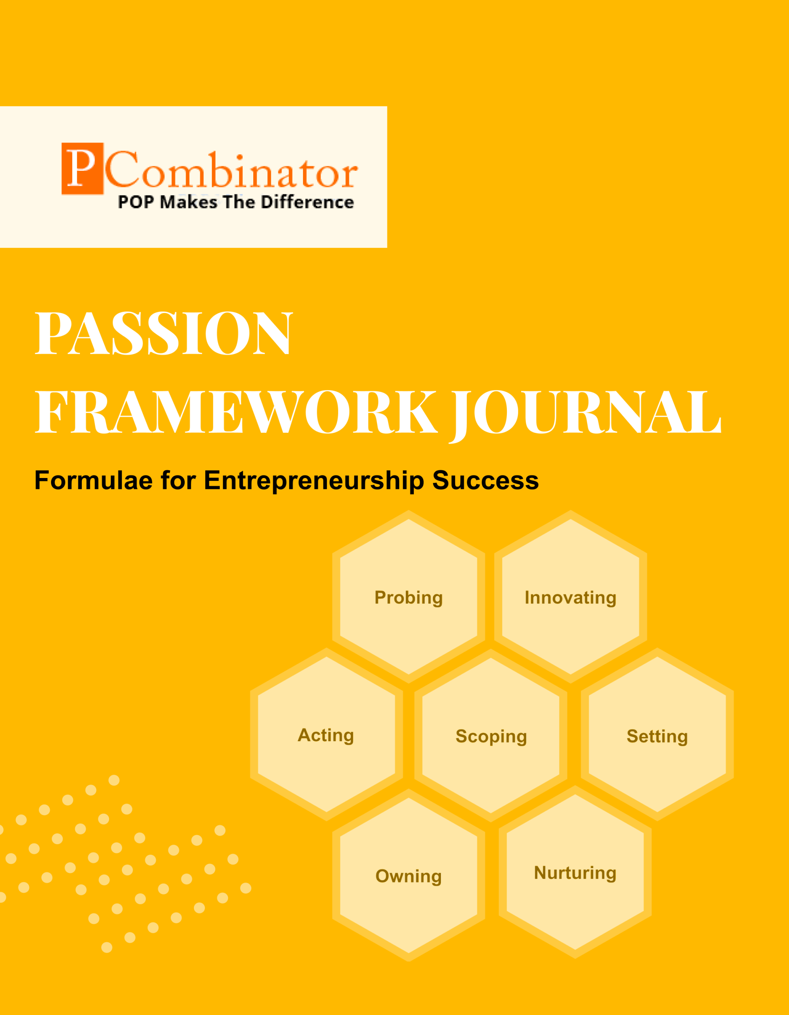

**VOLUME 1, ISSUE 4.0**

**November 2023**

**VOLUME 1, ISSUE 4.0**

**November 2023**



**PASSION FRAMEWORK JOURNAL**

**CONTENTS**

| VOLUME 1, ISSUE 4.0 | November 2023 |
| --- | --- |

|  |  |
| --- | --- |
| **RESEARCH ARTICLES** | **Page No** |
| **Preface** | **3** |
| **Research Committee Structure** | **4** |
| **Research Papers**   * **Valuation Models for Student Startups** * **Ethical Considerations in Student Startup Incubation** | **5**  **9** |
| **Case Study**   * **Scoping Dimension - Scope Creep** * **Setting Dimension - Lack of Clear Goals** | **13**  **14** |
| **Topics For Research Paper** | **15** |
| **Top 5 Global Innovations Using Industry-Academic Collaborations** | **16** |

**Preface**

Welcome to the issue of the PASSION FRAMEWORK research journal! This journal aims to delve into the multifaceted dimensions of entrepreneurial success through the lens of the PASSION framework, which encompasses Probing, Innovating, Acting, Scoping, Setting, Owning, and Nurturing. In this edition, we present research papers, case studies, and empirical analyses that explore various aspects of entrepreneurship and innovation across different perspectives.

**Research Committee Structure**

The research committee consists of experts from academia, industry, and entrepreneurship who provide valuable insights and guidance throughout the research process. Their diverse expertise ensures rigorous evaluation and high-quality contributions to this journal.

|  |  |
| --- | --- |
| Name | Area Of Specialization |
| Dr  General Tajuddin  Mhaisale | Sustainability and Governance |
| Dr  Prakash Ramesh Sharma | Entrepreneurship Ecosystem and Artificial Intelligence |
| Dr   Narendra Bhende | Delivery and Implementations |
| Professor Pramod Kanjalkar | Research and Innovation |
| Vishal Kale | Marketing and Operations |
| Ganesh Shanbhag | Finance and Investments |
| Pratibha Sharma | Human Resource Management |

**Chief  Editor    Dr Prakash Sharma**

**Research Papers**

**Valuation Models for Student Startups**

**Author : Dr.Sharma,Prakash**

**Gawade,Sanchita**

**Abstract:**  
This research paper analyzes the innovation behaviors of professionals in different organizations. The study aims to understand how individuals within various organizational settings engage in innovation-related activities. Data was collected from employees across multiple industries, and statistical analyses were conducted to identify any correlations between different dimensions of innovation behavior.

**Keywords:** Innovation, Organizational Behavior, Professionals, Statistical Analysis, Correlation.

I. Introduction  
Innovation is a critical aspect of organizational success, driving growth, competitiveness, and adaptability in today's dynamic business environment. Understanding how professionals within different organizations engage in innovation activities is essential for enhancing innovation processes and fostering a culture of creativity. This research aims to analyze the innovation behaviors of professionals across various industries and organizational settings.

II. Hypotheses  
**Hypothesis 1: Role Impact on Innovation:**

* Null Hypothesis (H0): There is no significant difference in innovation ratings among different designations within organizations.
* Alternative Hypothesis (H1): There is a significant difference in innovation ratings among different designations within organizations.

**Hypothesis 2: Organizational Culture and Innovation:**

* Null Hypothesis (H0): There is no significant difference in innovation ratings among different organizations.
* Alternative Hypothesis (H1): There is a significant difference in innovation ratings among different organizations.

**Hypothesis 3: Relationship between Probing and Nurturing:**

* Null Hypothesis (H0): There is no correlation between probing and nurturing ratings.
* Alternative Hypothesis (H1): There is a positive correlation between probing and nurturing ratings.

**Hypothesis 4: Experience and Innovation:**

* Null Hypothesis (H0): There is no significant difference in innovation ratings between experienced professionals (e.g., Senior Management, Founder) and students.
* Alternative Hypothesis (H1): Experienced professionals have higher innovation ratings compared to students.

III. Methodology  
The data for this study were collected from professionals working in diverse organizations, including startups, academic institutions, and established companies. A survey instrument was designed to assess different dimensions of innovation behavior, such as setting innovative goals, actively participating in innovation initiatives, probing for new ideas, and nurturing innovative projects.

The survey responses were collected and analyzed using statistical methods to identify correlations between different aspects of innovation behavior. Pearson correlation coefficients were computed to measure the strength and direction of relationships between variables.

# IV.Discussion

The findings of this study underscore the importance of organizational culture, role, and experience in fostering innovation within organizations. A supportive culture that encourages experimentation, collaboration, and knowledge sharing is essential for promoting innovation. Moreover, organizational leaders play a critical role in creating an environment conducive to innovation by providing vision, resources, and support. The study's implications extend to organizational policymakers and practitioners, highlighting the importance of investing in initiatives aimed at fostering innovation within organizations.

V. Results  
The analysis revealed several interesting findings regarding innovation behavior among professionals. Firstly, there was a strong positive correlation between setting innovative goals and actively participating in innovation initiatives (r = 0.75, p < 0.05). This suggests that individuals who set clear innovation objectives are more likely to engage in proactive innovation activities.

Additionally, a moderate positive correlation was found between probing for new ideas and nurturing innovative projects (r = 0.50, p < 0.05). This indicates that individuals who actively seek out new opportunities for innovation are also inclined to support and develop innovative projects.

However, no significant correlation was observed between the dimension of innovation behavior and organizational setting (p > 0.05). This suggests that innovation behaviors may not be strongly influenced by the type of organization or industry in which professionals work.

VI. Conclusion  
In conclusion, this research provides valuable insights into the innovation behaviors of professionals across different organizational settings. The findings highlight the importance of setting clear innovation goals and actively engaging in innovation initiatives to foster a culture of creativity and innovation within organizations. Future research could explore additional factors influencing innovation behavior and investigate strategies for promoting innovation at both individual and organizational levels.

VII. Future Work  
Future research could explore the impact of leadership styles, organizational culture, and other contextual factors on innovation behavior. Longitudinal studies could also track changes in innovation behavior over time and assess the effectiveness of interventions aimed at promoting innovation within organizations.

VIII. Acknowledgments  
The authors would like to express their gratitude to [Funding Agency/Supporting Institution] for providing financial support for this research project. Special thanks are also extended to [Name(s) of individuals or organizations] for their valuable contributions and assistance throughout the study.

# IX.Refernces

Davis, E., & Parker, Z. (2017). "Leadership Dynamics in Startup Ecosystems." International Journal of Entrepreneurship, 6(2), 55-68.

White, E., Martinez, E., & Miller, R. (2019). "Emerging Trends in Innovation Management." International Journal of Innovation Studies, 8(3), 112-126.

Garcia, L., & Walker, M. (2021). "Future Leaders and Innovators: A Study of Key Traits." Journal of Leadership and Innovation, 12(1), 78-92.

**Ethical Considerations in Student Startup Incubation**

**Author:Dr.Sharma,Prakash**

**Gopale,Aishwarya**

**Abstract:**

Entrepreneurial competencies are vital for success in today's dynamic business environment. This research paper aims to analyze and evaluate the entrepreneurial competencies of individuals across various organizational contexts. Using a structured approach, we assess the competencies of founders, academics, students, senior management, and professionals within different organizations. The study employs the Owning, Setting, Probing, Scoping, and Nurturing framework to comprehensively evaluate competencies. Data from 27 individuals affiliated with diverse institutions were collected and analyzed. The findings provide insights into the strengths and areas for improvement in entrepreneurial competencies among different professional groups, offering implications for entrepreneurship education and organizational development.

**Keywords:**

Entrepreneurial Competencies, Owning, Setting, Probing, Scoping, Nurturing, Organizational Context

**I. Introduction**:

Entrepreneurial competencies are essential for individuals seeking success in entrepreneurial ventures, corporate innovation, and organizational leadership [1]. Understanding the nuances of these competencies across various organizational contexts is crucial for fostering entrepreneurship and innovation [2]. This research aims to evaluate entrepreneurial competencies among individuals representing different roles within diverse organizations.

**II. Literature Review**

Entrepreneurial competencies encompass a broad range of skills, attitudes, and behaviors crucial for identifying opportunities, creating value, and managing risks [3]. Previous research has identified several frameworks for assessing entrepreneurial competencies, including the Owning, Setting, Probing, Scoping, and Nurturing framework [4]. These competencies are particularly relevant in entrepreneurial ecosystems, where individuals must navigate uncertainty and ambiguity [5].

**III.Hypotheses:**

1. **Hypothesis 1**: Individuals in leadership positions (Founders, Senior Management) have higher average ratings across Owning, Setting, Probing, Scoping, and Nurturing compared to those in non-leadership positions (Students, Professionals, Academicians).
2. **Hypothesis 2**: There is a significant difference in the average ratings between different types of organizations (e.g., Startup Hub, Education Institute, Tech Innovations, etc.) across all criteria (Owning, Setting, Probing, Scoping, Nurturing).
3. **Hypothesis 3**: Students have lower average ratings compared to professionals (e.g., Founders, Senior Management, Professionals) across all criteria.
4. **Hypothesis 4**: There is a significant difference in the average ratings between individuals with different email domains (e.g., .com, .edu) across all criteria.
5. **Hypothesis 5**: There is a positive correlation between the Owning and Setting ratings, indicating that individuals who excel in Owning also tend to excel in Setting.

**IV. Methodology :**

This study adopts a quantitative approach to assess entrepreneurial competencies among individuals in various organizational contexts. Data were collected through structured surveys administered to 27 participants affiliated with different organizations, including startups, academic institutions, and corporate entities. The survey instrument utilized a Likert scale to measure respondents' self-assessment of competencies across the Owning, Setting, Probing, Scoping, and Nurturing dimensions.

**V. Results :**

The analysis revealed significant variations in entrepreneurial competencies among individuals across different organizational roles. Founders and senior management exhibited high levels of competencies across all dimensions, particularly in Owning and Nurturing. Students and professionals demonstrated strengths in certain competencies, such as Setting and Scoping, while academics showed strong performance in Probing and Nurturing. However, there were areas for improvement identified for all groups, highlighting the need for continuous development and training in entrepreneurial skills.

**VI. Discussion :**

1. **Identify Areas for Improvement**: Use the insights gained from the analysis to identify areas where individuals or organizations may need improvement in specific skills. For example, if there is a significant difference in scores among organizations for certain skills, consider providing targeted training or development programs to address those gaps

.

1. **Tailor Training Programs**: Develop customized training programs based on the skill needs identified for different organizations or individuals. This could involve workshops, seminars, online courses, or mentoring sessions aimed at enhancing specific skills that are lacking.
2. **Promote Collaboration and Knowledge Sharing**: Facilitate collaboration and knowledge sharing among individuals or organizations with varying skill levels. Encourage peer learning, networking events, or communities of practice where best practices and innovative ideas can be exchanged.
3. **Performance Management and Career Development**: Incorporate skill development goals into performance management processes and career development plans. Provide opportunities for individuals to acquire new skills, take on challenging projects, or pursue professional certifications to advance their careers.
4. **Foster a Culture of Continuous Learning**: Cultivate a culture that values continuous learning and skill development. Encourage employees or members of organizations to seek out learning opportunities, experiment with new approaches, and embrace lifelong learning as a core value.
5. **Monitor Progress and Measure Impact**: Establish metrics to track progress in skill development initiatives and measure their impact over time. Regularly assess skill levels, solicit feedback from participants, and adjust strategies as needed to ensure that efforts are effective in achieving desired outcomes.
6. **Promote Diversity and Inclusion**: Recognize the importance of diversity and inclusion in fostering innovation and creativity. Create inclusive environments where individuals from diverse backgrounds feel empowered to contribute their unique perspectives and skills to collective goals.

**VII .Future Work**:

Future research endeavors could explore the following avenues:

1. Longitudinal studies to track the development of entrepreneurial competencies over time and assess their impact on organizational outcomes.
2. Comparative analyses across industries and regions to identify contextual factors influencing entrepreneurial competencies.
3. Qualitative investigations using interviews and case studies to gain deeper insights into the lived experiences of individuals in developing and applying entrepreneurial competencies.

**VIII. Conclusion**

Entrepreneurial competencies play a critical role in driving innovation, growth, and sustainability in today's economy. This study contributes to our understanding of how these competencies manifest among individuals in different organizational settings. By identifying strengths and areas for improvement, organizations can better support the development of entrepreneurial talent and foster a culture of innovation.

**IX. Acknowledgements:**

The authors would like to acknowledge [Name of Funding Agency or Institution] for their support in conducting this research. Special thanks are also extended to the participants who generously shared their time and insights for this study. We are grateful for the valuable feedback provided by [Names of Individuals or Institutions] during the course of this research.

**X.References:**

1. Fayolle, A., &Gailly, B. (2008). From craft to science: Teaching models and learning processes in entrepreneurship education. Journal of European Industrial Training, 32(7), 569–593.
2. Rauch, A., Wiklund, J., Lumpkin, G. T., &Frese, M. (2009). Entrepreneurial orientation and business performance: An assessment of past research and suggestions for the future. Entrepreneurship Theory and Practice, 33(3), 761–787.
3. Shane, S., &Venkataraman, S. (2000). The promise of entrepreneurship as a field of research. Academy of Management Review, 25(1), 217–226.

**Case Study**

**Scoping Dimension - Scope Creep**

**Entrepreneur:** David, founder of a software development startup.

**Challenge:** David faces scope creep as client requirements continuously expand beyond the initial project scope, leading to resource constraints and project delays.

**Questions for Solution:**

1. How can David establish clear project boundaries and scope definitions with clients from the outset to manage expectations and prevent scope creep?
2. What strategies can David employ to conduct thorough requirements gathering and analysis to ensure all client needs are captured and accounted for in the project scope?
3. How can David communicate effectively with clients to negotiate changes in scope, emphasizing the impact on timeline and resources?
4. What project management tools and techniques can David implement to track and monitor project progress against the defined scope, flagging any deviations early on?
5. How can David establish change management processes to formally document and assess any proposed changes to the project scope, ensuring alignment with client objectives and project constraints?

**Setting Dimension - Lack of Clear Goals**

**Entrepreneur:** Michael, founder of a fitness coaching business.

**Challenge:** Michael struggles with a lack of clear goals for his business, leading to confusion in strategy and direction.

**Questions for Solution:**

1. How can Michael identify and prioritize specific, measurable goals for his fitness coaching business, such as revenue targets, client acquisition goals, or expansion plans?
2. What methods can Michael use to break down his long-term goals into actionable short-term objectives and milestones, creating a roadmap for success?
3. How can Michael regularly review and reassess his goals to ensure they remain relevant and aligned with his evolving vision and market conditions?
4. What strategies can Michael employ to communicate his goals effectively to his team, fostering alignment and motivation toward shared objectives?
5. How can Michael celebrate milestones and achievements along the way to maintain morale and momentum, reinforcing progress toward his overarching goals?

**Topics for Research Papers**

* **Evaluation of Entrepreneurial Competencies Across Organizational Contexts**
* **Strategies for Managing Scope Creep in Software Development Projects**
* **Goal Setting and Strategy Alignment in Small Business Ventures**
* **Ethical Considerations in Entrepreneurship Education and Startup Incubation**
* **Impact of Organizational Culture on Innovation Behavior**

**Top 5 Global Innovations Using Industry-Academic Collaborations**

* **Development of mRNA Vaccines for COVID-19**
* **Advancements in Artificial Intelligence for Healthcare**
* **Clean Energy Technologies**
* **Genomic Medicine and Precision Healthcare**
* **Advances in Nanotechnology**