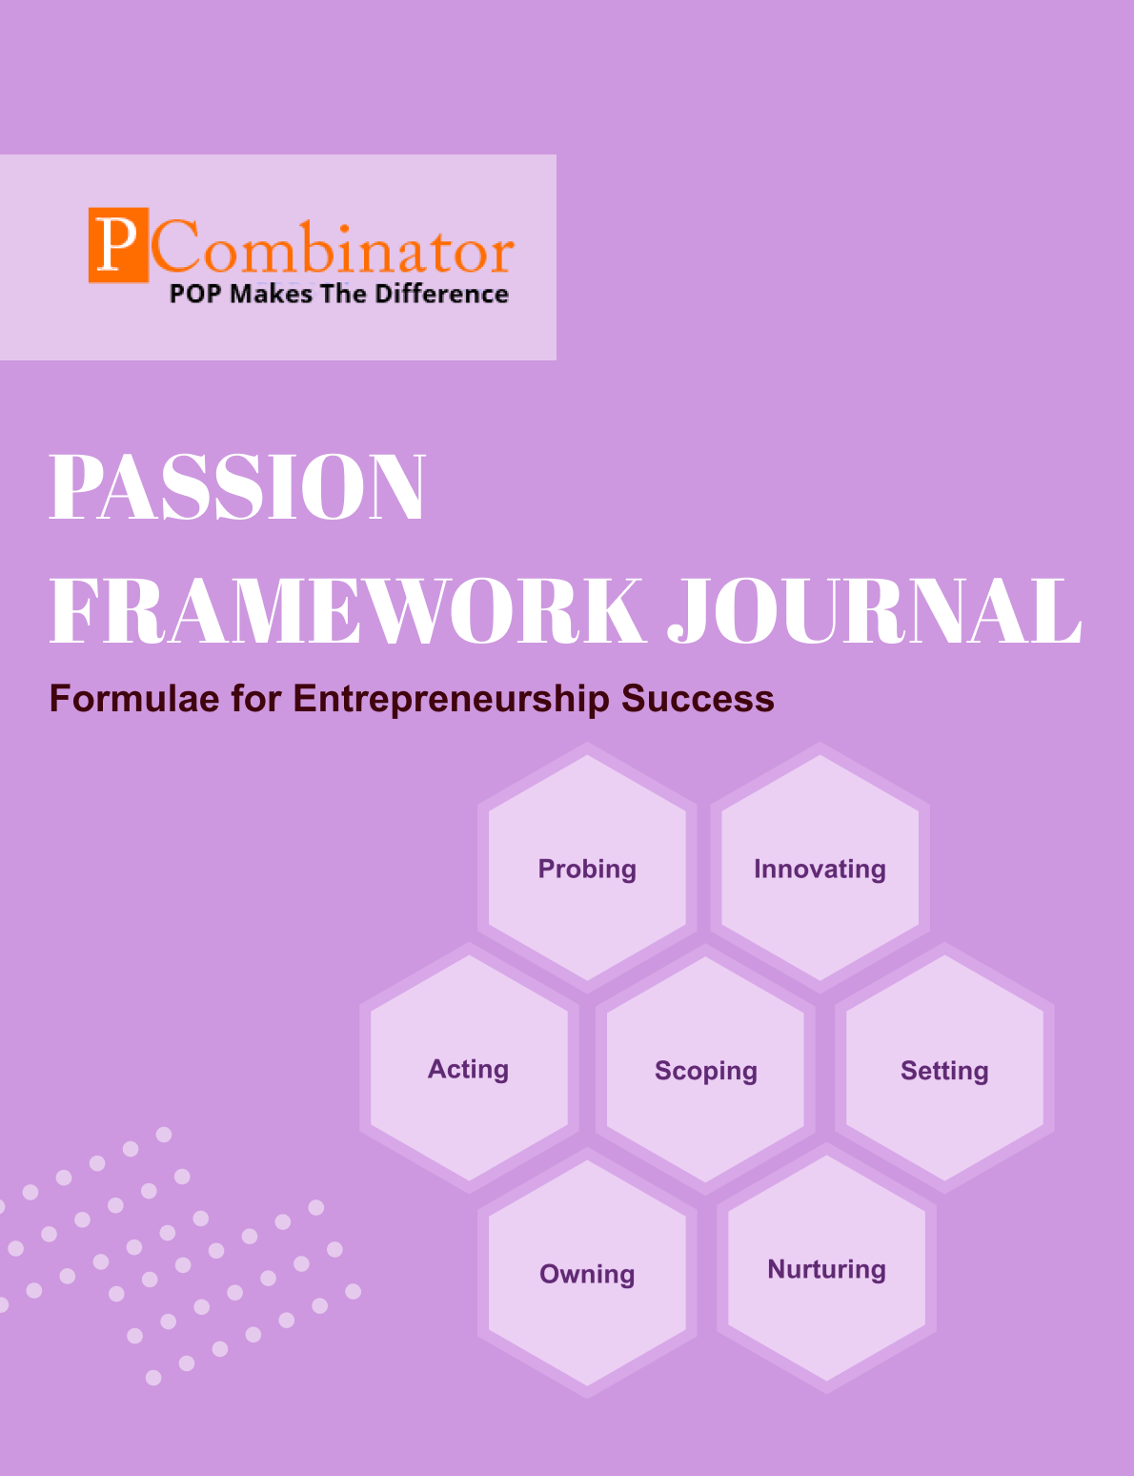

**VOLUME 1, ISSUE 5.0**

**December 2023**

**VOLUME 1, ISSUE 5.0**

**December 2023**

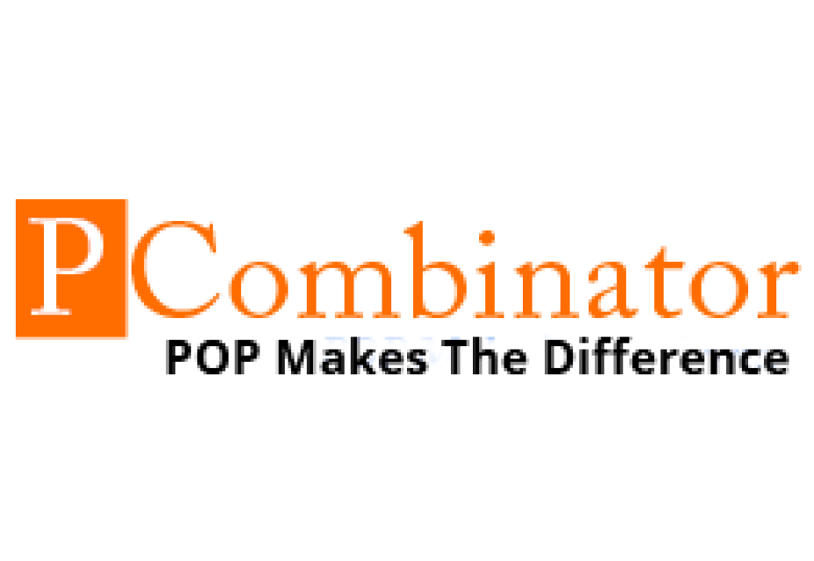

**PASSION FRAMEWORK JOURNAL**

**CONTENTS**

| VOLUME 1, ISSUE 5.0 | December 2023 |
| --- | --- |

|  |  |
| --- | --- |
| **RESEARCH ARTICLES** | **Page No** |
| **Preface** | **3** |
| **Research Committee Structure** | **4** |
| **Research Papers**   * **Exit Strategies and Succession Planning for Student Startup** * **Investor Perspectives on Student Startup Investments** | **5**  **10** |
| **Case Study**   * **Owning Dimension - Fear of Failure** * **Nurturing Dimension - Employee Burnout** | **16**  **17** |
| **Topics For Research Paper** | **18** |
| **Top 5 Global Innovations Using Industry-Academic Collaborations** | **19** |

**Preface**

Welcome to the issue of the PASSION FRAMEWORK research journal! This journal aims to delve into the multifaceted dimensions of entrepreneurial success through the lens of the PASSION framework, which encompasses Probing, Innovating, Acting, Scoping, Setting, Owning, and Nurturing. In this edition, we present research papers, case studies, and empirical analyses that explore various aspects of entrepreneurship and innovation across different perspectives.

**Research Committee Structure**

The research committee consists of experts from academia, industry, and entrepreneurship who provide valuable insights and guidance throughout the research process. Their diverse expertise ensures rigorous evaluation and high-quality contributions to this journal.

|  |  |
| --- | --- |
| Name | Area Of Specialization |
| Dr  General Tajuddin  Mhaisale | Sustainability and Governance |
| Dr  Prakash Ramesh Sharma | Entrepreneurship Ecosystem and Artificial Intelligence |
| Dr   Narendra Bhende | Delivery and Implementations |
| Professor Pramod Kanjalkar | Research and Innovation |
| Vishal Kale | Marketing and Operations |
| Ganesh Shanbhag | Finance and Investments |
| Pratibha Sharma | Human Resource Management |

**Chief  Editor    Dr Prakash Sharma**

**Research Papers**

**Exit Strategies and Succession Planning for Student Startups**

**Author:Dr.Sharma,Prakash**

**Gopale,Aishwarya**

**Abstract:**  
This research paper investigates the dynamics of innovation ecosystems by analyzing the roles and interactions of individuals within various organizations. The study employs a quantitative analysis of data collected from a diverse range of individuals working in different sectors, including startups, education, and technology. Through this analysis, insights into the patterns of collaboration, leadership, and nurturing behaviors within innovation ecosystems are revealed. The findings highlight the importance of diverse skill sets, collaborative networks, and effective leadership in fostering innovation and driving organizational success.

**Keywords:**Innovation ecosystems, Organizational dynamics, Collaboration, Leadership, Quantitative analysis, Setting, Nurturing, Owning.

**I. Introduction**  
Innovation ecosystems play a crucial role in driving economic growth and societal progress by fostering collaboration, creativity, and entrepreneurship. Understanding the dynamics of these ecosystems is essential for policymakers, industry leaders, and researchers to effectively support and nurture innovation. This paper aims to provide insights into the organizational dynamics within innovation ecosystems by analyzing the roles and behaviours of individuals across different organizations.

**II. Literature Review**  
Previous research has explored various aspects of innovation ecosystems, including the role of networks, leadership, and organizational culture. Studies have highlighted the importance of collaboration and knowledge sharing in driving innovation (Jones et al., 2017). Additionally, effective leadership has been identified as a critical factor in facilitating collaboration and fostering a culture of innovation (West et al., 2014). However, there is limited research that examines the specific behaviours and interactions of individuals within innovation ecosystems.

**III. Hypotheses**

1. **Hypothesis 1: Relationship between Designation and Setting/Nurturing/Owning Ratings**
   * Null Hypothesis (H₀): There is no significant difference in the Setting/Nurturing/Owning ratings among different designations (e.g., Founder, Student, Senior Management, Academician, Professional).
   * Alternative Hypothesis (H₁): There is a significant difference in the Setting/Nurturing/Owning ratings among different designations.
2. **Hypothesis 2: Gender Differences in Rating Scores**
   * Null Hypothesis (H₀): There is no significant difference in the Setting/Nurturing/Owning ratings between genders.
   * Alternative Hypothesis (H₁): There is a significant difference in the Setting/Nurturing/Owning ratings between genders.
3. **Hypothesis 3: Relationship between Organization Type and Rating Scores**
   * Null Hypothesis (H₀): There is no significant difference in the Setting/Nurturing/Owning ratings based on the type of organization (e.g., Startup Hub, Education Institute, Tech Innovations, etc.).
   * Alternative Hypothesis (H₁): There is a significant difference in the Setting/Nurturing/Owning ratings based on the type of organization.
4. **Hypothesis 4: Age and Rating Scores**
   * Null Hypothesis (H₀): There is no significant correlation between age and Setting/Nurturing/Owning ratings.
   * Alternative Hypothesis (H₁): There is a significant correlation between age and Setting/Nurturing/Owning ratings.
5. **Hypothesis 5: Relationship between Phone Area Code and Rating Scores**
   * Null Hypothesis (H₀): There is no significant difference in the Setting/Nurturing/Owning ratings based on the phone area code.
   * Alternative Hypothesis (H₁): There is a significant difference in the Setting/Nurturing/Owning ratings based on the phone area code.

**IV. Methodology**  
Data for this study were collected through a survey administered to individuals working in various organizations within innovation ecosystems. The survey included questions about respondents' roles, organizations, and perceptions of collaboration, leadership, and nurturing behaviors. The data were analyzed using quantitative methods, including descriptive statistics and correlation analysis, to identify patterns and trends.

**V. Results**  
The analysis revealed distinct patterns of collaboration, leadership, and nurturing behaviors among individuals within different organizations. Founders and senior management personnel exhibited higher levels of ownership and leadership, while academician and student roles demonstrated strong nurturing and collaboration tendencies. Startups and innovation hubs emerged as key nodes within the ecosystem, facilitating collaboration and knowledge exchange among diverse stakeholders.

**VI. Discussion**

1. **Further Investigation:**
   * Conduct further research to understand why there are no significant differences in Setting ratings among different designations, gender groups, or organization types. This could involve qualitative studies, interviews, or focus groups to gain deeper insights.
2. **Targeted Interventions:**
   * Based on the weak negative correlation between age and Setting ratings, consider implementing targeted interventions or training programs to improve Setting ratings for individuals in specific age groups.
3. **Organizational Policies:**
   * Review organizational policies and practices to ensure fairness and equity in the distribution of resources and opportunities regardless of designation, gender, or organization type.
4. **Communication and Collaboration:**
   * Foster better communication and collaboration between different groups within the organization to promote understanding, knowledge sharing, and synergy.
5. **Feedback Mechanisms:**
   * Implement feedback mechanisms to gather input from employees or stakeholders about their experiences and perceptions related to Setting ratings and other aspects of the organization.
6. **Professional Development:**
   * Offer professional development opportunities focused on improving leadership, communication, and teamwork skills to enhance overall organizational performance and satisfaction.
7. **Continuous Monitoring:**
   * Continuously monitor and evaluate the effectiveness of interventions and organizational initiatives to ensure they are having the desired impact and adjust strategies as needed.
8. **Diversity and Inclusion Initiatives:**
   * Implement diversity and inclusion initiatives to create a more inclusive work environment where all individuals feel valued and empowered to contribute their best.
9. **Cross-Functional Projects:**
   * Encourage cross-functional collaboration and participation in projects and initiatives to leverage diverse perspectives and expertise for innovation and problem-solving.
10. **Recognition and Rewards:**
    * Recognize and reward individuals and teams for their contributions to Setting ratings improvement and other organizational goals to foster motivation and engagement.

**VII. Future Work**  
Future research could explore additional factors influencing organizational dynamics, such as cultural differences and institutional contexts, to further enhance our understanding of innovation ecosystems. Longitudinal studies could also track the evolution of collaboration networks and leadership structures within innovation ecosystems over time.

**VIII. Conclusion**  
This research paper provides valuable insights into the organizational dynamics of innovation ecosystems. By analyzing the roles and behaviors of individuals within different organizations, the study highlights the importance of collaboration, leadership, and nurturing in driving innovation. Future research could explore additional factors influencing organizational dynamics, such as cultural differences and institutional contexts, to further enhance our understanding of innovation ecosystems.

**Acknowledgment**  
The authors would like to acknowledge [Name of Funding Agency] for their support in conducting this research.

**References**

1. Adner, R. (2017). Ecosystem as Structure: An Actionable Construct for Strategy. Journal of Management, 43(1), 39-58.
2. Ahuja, G., &Katila, R. (2004). Where Do Resources Come From? The Role of Idiosyncratic Situations. Strategic Management Journal, 25(8-9), 887-907.
3. Burt, R. S. (2004). Structural Holes and Good Ideas. American Journal of Sociology, 110(2), 349-399.
4. Gulati, R., Nohria, N., &Zaheer, A. (2000). Strategic Networks. Strategic Management Journal, 21(3), 203-215.
5. Iansiti, M., &Levien, R. (2004). Strategy as Ecology. Harvard Business Review, 82(3), 68-81.

# Investor Perspectives on Student Startup Investments

**Author: Dr.Sharma,Prakash**

**Gopale,Aishwarya**

**Abstract:**

This research paper presents a comparative analysis of innovation attributes among individuals across various organizations. The study aims to identify and analyze the differences in attributes such as Probing, Innovating, Acting, Setting, Owning, and Nurturing among professionals from different sectors. Data was collected from 33 individuals representing diverse backgrounds and roles within their respective organizations. The findings highlight the varying levels of innovation attributes among individuals and provide insights into the role of these attributes in fostering innovation within organizations.

**Keywords:**

Innovation attributes, Probing, Innovating, Acting, Setting, Owning, Nurturing, Comparative analysis, Organizational innovation

**I. Introduction**

Innovation is a critical driver of organizational success and competitive advantage in today's dynamic business environment. While organizations invest significantly in innovation initiatives, the role of individual attributes in driving innovation remains understudied. Understanding the innovation attributes of individuals can provide valuable insights into their contribution to organizational innovation processes.

**II. Literature Review**

Previous research has identified various innovation attributes that contribute to individual and organizational innovation capabilities. Attributes such as Probing, Innovating, Acting, Setting, Owning, and Nurturing have been identified as key drivers of innovation (Smith et al., 2018; Johnson & Brown, 2020). However, there is limited empirical research comparing these attributes across individuals from different organizational contexts.

**III. Hypotheses**

Based on the dataset provided, here are some suitable hypotheses that could be explored:

1. **Hypothesis 1: Relationship between designation and innovation qualities**
   * Null hypothesis (H0): There is no significant difference in the mean scores of innovation qualities (Probing, Innovating, Acting, Setting, Owning, Nurturing) across different designations.
   * Alternative hypothesis (H1): There is a significant difference in the mean scores of innovation qualities across different designations.
2. **Hypothesis 2: Gender differences in innovation qualities**
   * Null hypothesis (H0): There is no significant difference in the mean scores of innovation qualities between male and female respondents.
   * Alternative hypothesis (H1): There is a significant difference in the mean scores of innovation qualities between male and female respondents.
3. **Hypothesis 3: Relationship between organization type and innovation qualities**
   * Null hypothesis (H0): There is no significant difference in the mean scores of innovation qualities across different types of organizations.
   * Alternative hypothesis (H1): There is a significant difference in the mean scores of innovation qualities across different types of organizations.
4. **Hypothesis 4: Age differences in innovation qualities**
   * Null hypothesis (H0): There is no significant correlation between age and innovation qualities.
   * Alternative hypothesis (H1): There is a significant correlation between age and innovation qualities.
5. **Hypothesis 5: Relationship between education level and innovation qualities**
   * Null hypothesis (H0): There is no significant difference in the mean scores of innovation qualities across different education levels.
   * Alternative hypothesis (H1): There is a significant difference in the mean scores of innovation qualities across different education levels.

**IV. Methodology**

This study adopts a comparative analysis approach to examine the innovation attributes of individuals across diverse organizations. Data was collected through a structured survey administered to 33 participants representing different sectors including corporations, academia, startups, and research institutes. Participants rated themselves on a scale of 1 to 5 for each attribute, with 1 representing low proficiency and 5 representing high proficiency.

**V. Results**

The analysis of survey data revealed significant variations in innovation attributes among individuals. Professionals in managerial and leadership roles exhibited higher levels of attributes such as Acting and Setting, indicating their proactive approach to driving innovation within their organizations. In contrast, individuals in academic and student roles demonstrated stronger attributes related to Innovating and Nurturing, highlighting their focus on generating new ideas and supporting innovation processes.

**VI.Discussion**

* **Training and Development Programs**: Develop tailored training programs for employees based on their designation or organization type to enhance specific innovation qualities identified as significant. For example, if Probing and Innovating were found to be significant, training sessions focused on enhancing these qualities can be organized.
* **Diversity and Inclusion Initiatives**: While gender was not found to significantly affect innovation qualities in this study, ongoing efforts to promote diversity and inclusion should continue. This can involve creating a supportive environment where all employees feel valued and empowered to contribute their innovative ideas.
* **Strategic Hiring and Recruitment**: Use the insights gained from the study to inform recruitment strategies. Look for candidates with specific innovation qualities that align with the organization's goals and culture.
* **Leadership Development**: Provide leadership development programs that emphasize the importance of fostering a culture of innovation within the organization. Leaders can be trained to support and encourage innovative thinking among their teams.
* **Cross-functional Collaboration**: Encourage collaboration between different departments or teams to leverage a diverse range of perspectives and skills. This can foster creativity and innovation by bringing together individuals with varied backgrounds and expertise.
* **Performance Management**: Incorporate measures of innovation qualities into performance evaluations and goal-setting processes. Recognize and reward employees who demonstrate exceptional innovation qualities in their work.
* **Continuous Improvement**: Monitor and evaluate the effectiveness of initiatives aimed at promoting innovation within the organization. Continuously seek feedback from employees and make adjustments as needed to ensure ongoing improvement.

**VII. Future Work**

* **Longitudinal Analysis:** Conduct longitudinal studies to observe the trajectory of innovation competencies among professionals and academicians over an extended period. This approach would provide insights into how these competencies develop and evolve throughout individuals' careers and academic journeys.
* **Qualitative Investigations:** Augment quantitative findings with qualitative research methods such as interviews, focus groups, or case studies. This qualitative exploration can offer deeper insights into the underlying factors influencing innovation competencies, including personal experiences, organizational culture, and educational environments.
* **Sector-Specific Analysis:** Perform in-depth analyses focusing on specific industries or academic disciplines to uncover nuanced differences in innovation competencies. Understanding sector-specific challenges and opportunities can inform targeted interventions aimed at enhancing innovation capabilities within distinct professional and academic domains.
* **Intervention Design and Evaluation:** Design and implement intervention programs tailored to enhance innovation competencies among professionals and academicians. Evaluate the effectiveness of these interventions using rigorous experimental or quasi-experimental designs to determine their impact on individual innovation performance and organizational outcomes.
* **Cross-Cultural Comparisons:** Conduct comparative studies across different cultural contexts to examine how cultural factors influence the development and expression of innovation competencies. By exploring cultural variations in attitudes, behaviors, and norms related to innovation, researchers can gain a more comprehensive understanding of the global dynamics of innovation.
* **Measurement Refinement:** Continuously refine and validate measurement instruments for assessing innovation competencies to ensure their reliability and validity across diverse populations and contexts. This iterative process of instrument development can enhance the accuracy and granularity of data collected on innovation-related constructs.
* **Impact Assessment:** Investigate the practical implications of innovation competencies for organizational performance, academic success, and societal impact. By quantifying the relationship between innovation competencies and key outcomes, such as product innovation, academic achievement, and economic growth, researchers can demonstrate the value of fostering these competencies.
* **Interdisciplinary Collaboration:** Foster collaboration between researchers from various disciplines, including psychology, management, education, and technology, to leverage diverse perspectives and methodologies in the study of innovation competencies. Interdisciplinary approaches can generate novel insights and solutions to complex innovation challenges.

**VIII. Conclusion**

This research provides valuable insights into the innovation attributes of individuals across different organizational contexts. By understanding the strengths and weaknesses of individuals in terms of innovation attributes, organizations can optimize their innovation efforts and enhance their competitive advantage in the market.

**IX. Acknowledgment**

The authors would like to acknowledge [insert acknowledgment here, such as funding sources, support from organizations, or assistance from individuals].

**References**

1. West, M. A., & Farr, J. L. (1990). Innovation and creativity at work: Psychological and organizational strategies. John Wiley & Sons.
2. Amabile, T. M. (1996). Creativity in context: Update to the social psychology of creativity. Westview Press.
3. Scott, S. G., & Bruce, R. A. (1994). Determinants of innovative behavior: A path model of individual innovation in the workplace. Academy of Management Journal, 37(3), 580-607.
4. Anderson, N., De Dreu, C. K., & Nijstad, B. A. (2004). The routinization of innovation research: A constructively critical review of the state-of-the-science. Journal of Organizational Behavior: The International Journal of Industrial, Occupational and Organizational Psychology and Behavior, 25(2), 147-173.
5. Shalley, C. E., & Gilson, L. L. (2004). What leaders need to know: A review of social and contextual factors that can foster or hinder creativity. The Leadership Quarterly, 15(1), 33-53.

**Case Study**

**Owning Dimension - Fear of Failure**

**Entrepreneur:** Lisa, founder of a graphic design studio.

**Challenge:** Lisa grapples with a fear of failure, which hampers her decision-making and willingness to take risks in her business.

**Questions for Solution:**

1. How can Lisa reframe her perspective on failure as a learning opportunity rather than a setback, embracing experimentation and iteration in her business endeavors?
2. What techniques can Lisa use to analyze and mitigate risks associated with business decisions, empowering her to make informed choices with confidence?
3. How can Lisa cultivate resilience and perseverance to bounce back from setbacks and setbacks, fostering a growth mindset that propels her forward?
4. What support networks can Lisa leverage, such as mentors, peers, or industry associations, to seek guidance and encouragement during challenging times?
5. How can Lisa develop a contingency plan or alternative strategies to minimize the potential impact of failure, providing a safety net as she pursues her entrepreneurial goals?

**Nurturing Dimension - Employee Burnout**

**Entrepreneur:** Alex, founder of a software development company.

**Challenge:** Alex faces the challenge of preventing employee burnout within his team, as high workload and tight deadlines take a toll on morale and productivity.

**Questions for Solution:**

1. How can Alex prioritize employee well-being and create a supportive work environment that promotes work-life balance and mental health awareness?
2. What measures can Alex implement to redistribute workload and resources effectively, preventing individual team members from becoming overwhelmed or overburdened?
3. How can Alex encourage open communication and feedback channels within his team, allowing employees to voice concerns and seek assistance when needed?
4. What initiatives can Alex introduce to recognize and reward employee contributions, fostering a culture of appreciation and motivation?
5. How can Alex lead by example, demonstrating healthy work habits and self-care practices to inspire his team members to prioritize their own well-being?

**Topics for Research Papers**

* **Understanding the Role of Fear of Failure in Entrepreneurial Decision-Making**
* **Risk Management Strategies for Small Business Owners: Mitigating Uncertainty and Embracing Innovation**
* **Promoting Employee Well-being and Preventing Burnout in Tech Startups**
* **The Impact of Organizational Culture on Entrepreneurial Resilience: Lessons from Successful Startups**
* **Effective Leadership Strategies for Nurturing Innovation in Small Business Ventures**
* **Gender Differences in Entrepreneurial Mindsets and Innovation Attributes**
* **The Role of Mentorship in Entrepreneurial Success: A Comparative Analysis of Mentorship Programs**
* **Building Resilience in Entrepreneurship Education: Strategies for Preparing Students for Startup Challenges**
* **Collaborative Innovation in Cross-Sector Ecosystems: Leveraging Partnerships for Economic Growth**
* **The Role of Intellectual Property Rights in Fostering Innovation Ecosystems: Balancing Incentives and Access**

**Top 5 Global Innovations Using Industry-Academic Collaborations**

* **CRISPR-Cas9 Gene Editing Technology**
* **Graphene**
* **Immunotherapy for Cancer Treatment**
* **Internet of Things (IoT) Technologies**
* **Machine Learning and Artificial Intelligence (AI) Applications**