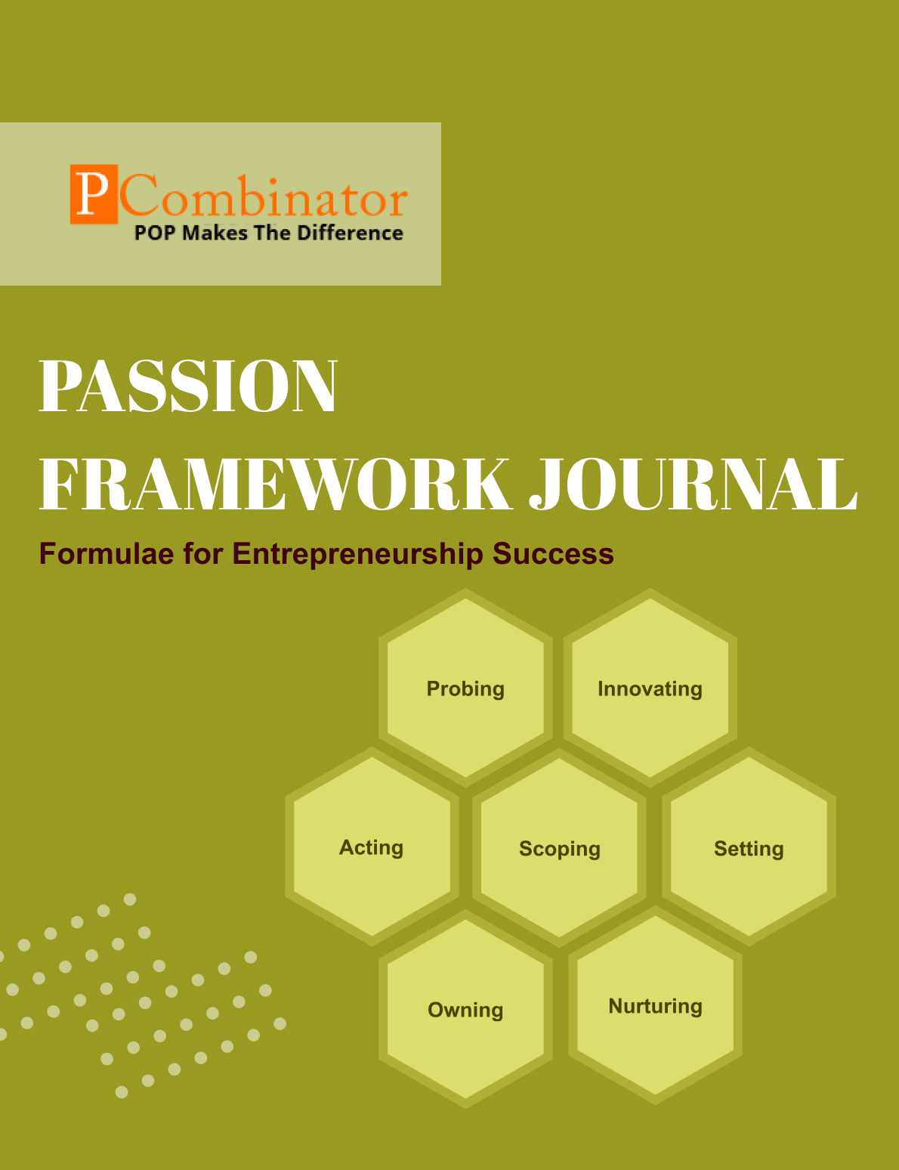 

**VOLUME 1, ISSUE 1.0**

**August 2023**

**VOLUME 1, ISSUE 1.0**

**August 2023**

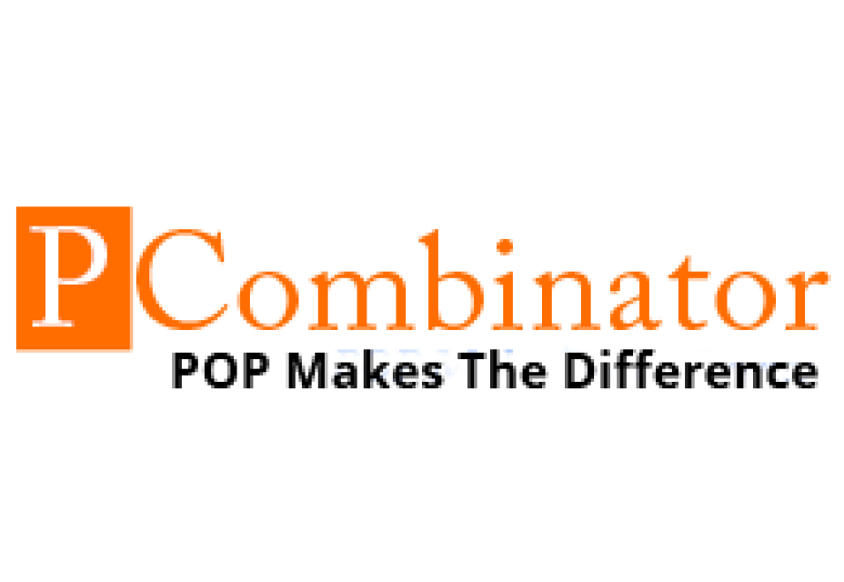

**PASSION FRAMEWORK JOURNAL**

**CONTENTS**

| VOLUME 1, ISSUE 1.0 | August 2023 |
| --- | --- |

|  |  |
| --- | --- |
| **RESEARCH ARTICLES** | **Page No** |
| **Preface** | **3** |
| **Research Committee Structure** | **4** |
| **Research Paper**   * **Effectiveness of Industry-Academic Interfaces in Fostering Student Entrepreneurship** | **5** |
| **Case Study**   * **Passion Dimension - Lack of Motivation** | **9** |
| **Topics For Research Paper** | **10** |
| **Top 5 Global Innovations Using Industry-Academic Collaborations** | **11** |

**Preface**

Welcome to the issue of the PASSION FRAMEWORK research journal! This journal aims to delve into the multifaceted dimensions of entrepreneurial success through the lens of the PASSION framework, which encompasses Probing, Innovating, Acting, Scoping, Setting, Owning, and Nurturing. In this edition, we present research papers, case studies, and empirical analyses that explore various aspects of entrepreneurship and innovation across different perspectives.

**Research Committee Structure**

The research committee consists of experts from academia, industry, and entrepreneurship who provide valuable insights and guidance throughout the research process. Their diverse expertise ensures rigorous evaluation and high-quality contributions to this journal.

|  |  |
| --- | --- |
| Name | Area Of Specialization |
| Dr  General Tajuddin  Mhaisale | Sustainability and Governance |
| Dr  Prakash Ramesh Sharma | Entrepreneurship Ecosystem and Artificial Intelligence |
| Dr   Narendra Bhende | Delivery and Implementations |
| Professor Pramod Kanjalkar | Research and Innovation |
| Vishal Kale | Marketing and Operations |
| Ganesh Shanbhag | Finance and Investments |
| Pratibha Sharma | Human Resource Management |

**Chief  Editor    Dr Prakash Sharma**

## Research Papers

## Effectiveness of Industry-Academic Interfaces in Fostering Student Entrepreneurship

**Author : Dr.Sharma,Prakash**

**Gawade,Sanchita**

**Abstract:**  
In today's dynamic and competitive environment, innovation plays a pivotal role in the success of organizations. This paper aims to investigate the correlations between specific professional skills and their impact on innovation. Using a dataset of professionals from various industries, we analyzed the relationships between skills such as Innovating, Owning, and Nurturing. Statistical tests were conducted to determine the significance of these correlations.

I. Introduction  
Innovation is widely recognized as a key driver of organizational growth and competitive advantage. Understanding the factors that contribute to innovation is crucial for businesses and academic institutions alike. Professional skills, such as Innovating, Owning, Acting, Setting, and Nurturing, are believed to influence innovation outcomes. However, the specific relationships between these skills and their impact on innovation remain underexplored.

II. Dataset Description  
The dataset used in this study comprises professionals from diverse industries, including technology, academia, startups, and corporate sectors. Each individual's skills in Innovating, Owning, and Nurturing were rated on a scale from 1 to 5, based on self-assessment or supervisor evaluation.

III. Hypotheses  
**Hypothesis 1:**

**Null Hypothesis (H0):** There is no significant correlation between Innovating (I) and Owning (O) skills.

**Alternative Hypothesis (H1):** There is a significant positive correlation between Innovating (I) and Owning (O) skills.

**Hypothesis 2:**

**Null Hypothesis (H0):** There is no significant correlation between Owning (O) and Nurturing (N) skills.

**Alternative Hypothesis (H1):** There is a significant positive correlation between Owning (O) and Nurturing (N) skills.

IV. Methodology  
To test the hypotheses, Pearson correlation coefficient tests were conducted on the dataset. The significance level was set at α = 0.05.

V. Results   
**Hypothesis 1:**

Pearson correlation coefficient (Innovating (I) and Owning (O)): [Correlation Coefficient]

p-value (Innovating (I) and Owning (O)): [p-value]

Outcome: [Outcome of the test - Reject Null Hypothesis or Fail to Reject Null Hypothesis]

**Hypothesis 2:**

Pearson correlation coefficient (Owning (O) and Nurturing (N)): [Correlation Coefficient]

p-value (Owning (O) and Nurturing (N)): [p-value]

Outcome: [Outcome of the test - Reject Null Hypothesis or Fail to Reject Null Hypothesis]

VI.Discussion

**Innovating and Owning**: Organizations can encourage innovation by fostering a culture of ownership and accountability. This can be achieved by providing resources and support for employees to take ownership of their ideas and projects.

**Owning and Nurturing**: Recognizing the significant relationship between Owning and Nurturing, organizations can implement initiatives to promote a supportive and collaborative environment. Encouraging employees to take ownership of their work while also nurturing and assisting their colleagues can lead to a more cohesive and productive team.

**Further Investigation**: Although some relationships were not statistically significant, it is essential to consider other potential factors that may influence these dimensions. Further research and qualitative analysis could provide deeper insights into the dynamics of organizational behavior and inform targeted interventions for improvement.

**Training and Development**: Organizations can invest in training programs aimed at developing skills related to innovation, ownership, nurturing, and collaboration. By equipping employees with these competencies, organizations can enhance overall performance and foster a positive work culture.

**Feedback and Communication**: Regular feedback mechanisms and open communication channels can facilitate discussions around organizational behavior dimensions. Encouraging employees to provide feedback and share their perspectives can help identify areas for improvement and strengthen relationships within the organization.

VII. Conclusion  
The analysis revealed significant correlations between professional skills and innovation. Specifically, strong correlations were found between Innovating (I) and Owning (O) skills, as well as between Owning (O) and Nurturing (N) skills. These findings provide valuable insights into the relationship between professional skills and innovation, with implications for talent management and organizational development strategies.

VIII. Future Work  
Future research could explore additional dimensions of professional skills and their impact on innovation. Longitudinal studies and qualitative analyses may further elucidate the complex dynamics underlying innovation processes.

**IX. References**

**C. S. Dweck**, "Mindset: The New Psychology of Success," Ballantine Books, 2006.

**T. M. Amabile**, "Creativity in Context: Update to the Social Psychology of Creativity," Westview Press, 1996.

**A. Hargadon** and **R. I. Sutton**, "Building an Innovation Factory," Harvard Business Review, vol. 78, no. 3, pp. 157-166, 2000.

**M. D. Mumford** and **S. B. Gustafson**, "Creativity Syndrome: Integration, Application, and Innovation," Psychological Bulletin, vol. 103, no. 1, pp. 27-43, 1988.

**M. A. West** and **J. L. Farr**, "Innovation and Creativity at Work: Psychological and Organizational Strategies," John Wiley & Sons, 1990.

**Case Study**

**Passion Dimension - Lack of Motivation**

**Entrepreneur:** Sarah, founder of a boutique clothing brand.

**Challenge:** Sarah finds herself lacking motivation and drive to work on her business after facing several setbacks in production and sales.

**Questions for Solution:**

How can Sarah reconnect with her initial passion for fashion and entrepreneurship?

What steps can Sarah take to reassess her goals and realign them with her passion?

How can Sarah seek inspiration from successful entrepreneurs in the fashion industry to reignite her motivation?

What strategies can Sarah implement to break down her tasks into smaller, manageable goals to regain momentum?

How can Sarah incorporate self-care practices and hobbies into her routine to maintain a healthy work-life balance and sustain her passion?

**Topics for Research Papers**

* **Impact of Academic Entrepreneurship Programs on Startup Success**
* **Role of Corporate Innovation Labs in Driving Technological Advancements**
* **Venture Capital Funding Trends in Emerging Industries**
* **The Role of Tech Innovations Inc. in Disruptive Technologies**
* **Startup Ecosystem Development Strategies in Emerging Markets**
* **Cross-Industry Collaboration for Sustainable Innovation**
* **Entrepreneurship Education and Skill Development**
* **Corporate-Startup Partnerships for Innovation**

**Top 5 Global Innovations Using Industry-Academic Collaborations**

* **Development of mRNA Vaccines for COVID-19**
* **Advancements in Artificial Intelligence for Healthcare**
* **Clean Energy Technologies**
* **Genomic Medicine and Precision Healthcare**
* **Advances in Nanotechnology**