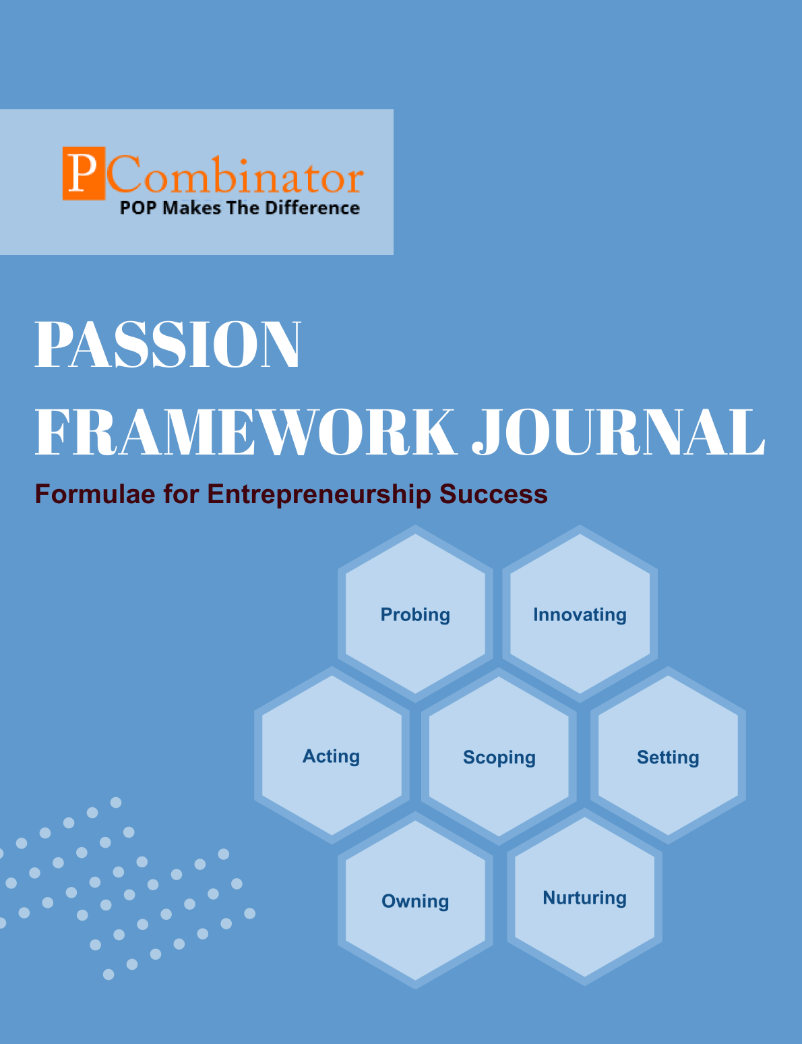

**VOLUME 1, ISSUE 2.0**

**September 2023**

**VOLUME 1, ISSUE 2.0**

**September 2023**

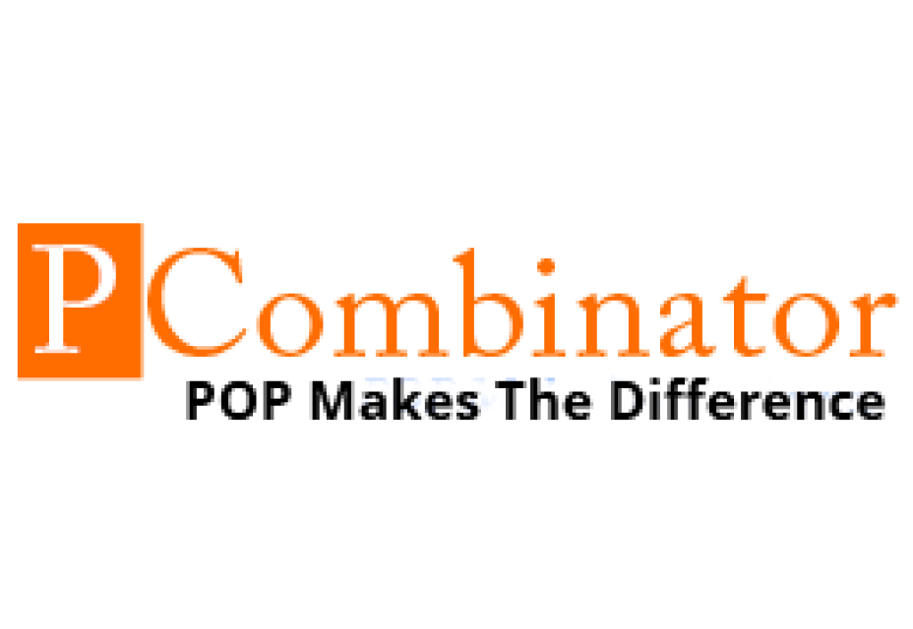

**PASSION FRAMEWORK JOURNAL**

**CONTENTS**

| VOLUME 1, ISSUE 2.0 | September 2023 |
| --- | --- |

|  |  |
| --- | --- |
| **RESEARCH ARTICLES** | **Page No** |
| **Preface** | **3** |
| **Research Committee Structure** | **4** |
| **Research Papers**   * **Impact of Skill Development Initiatives on Startup Success** | **5** |
| **Case Study**   * **Probing Dimension - Market Validation** | **8** |
| **Topics For Research Paper** | **9** |
| **Top 5 Global Innovations Using Industry-Academic Collaborations** | **10** |

**Preface**

Welcome to the issue of the PASSION FRAMEWORK research journal! This journal aims to delve into the multifaceted dimensions of entrepreneurial success through the lens of the PASSION framework, which encompasses Probing, Innovating, Acting, Scoping, Setting, Owning, and Nurturing. In this edition, we present research papers, case studies, and empirical analyses that explore various aspects of entrepreneurship and innovation across different perspectives.

**Research Committee Structure**

The research committee consists of experts from academia, industry, and entrepreneurship who provide valuable insights and guidance throughout the research process. Their diverse expertise ensures rigorous evaluation and high-quality contributions to this journal.

|  |  |
| --- | --- |
| Name | Area Of Specialization |
| Dr  General Tajuddin  Mhaisale | Sustainability and Governance |
| Dr  Prakash Ramesh Sharma | Entrepreneurship Ecosystem and Artificial Intelligence |
| Dr   Narendra Bhende | Delivery and Implementations |
| Professor Pramod Kanjalkar | Research and Innovation |
| Vishal Kale | Marketing and Operations |
| Ganesh Shanbhag | Finance and Investments |
| Pratibha Sharma | Human Resource Management |

**Chief  Editor    Dr Prakash Sharma**

**Research Papers**

**Impact of Skill Development Initiatives on Startup Success**

**Author : Dr.Sharma,Prakash**

**Gawade,Sanchita**

**Abstract:**

In today's dynamic professional landscape, the mastery of various skills is crucial for success. This research investigates the correlation between different dimensions of professional skills among individuals in various organizations. The study aims to uncover potential relationships between these dimensions, providing insights into the interconnectedness of skills in the workplace. The analysis employs Pearson correlation coefficient to assess the strength and significance of correlations. The results reveal significant correlations among all pairs of dimensions, indicating a strong relationship between different aspects of professional skills.

**Keywords:**

Professional traits, organizational roles, Probing, Scoping, Acting, Setting, Owning, Nurturing, Pearson correlation coefficient

**I.Introduction**

Professional traits play a crucial role in determining the effectiveness and success of individuals in their respective organizational roles. Understanding these traits and their variations across different roles can provide valuable insights for organizational development and talent management strategies. This paper aims to explore the professional traits exhibited by individuals in various organizational roles, focusing on dimensions such as Probing, Scoping, Acting, Setting, Owning, and Nurturing.

**II.Methodology**

**A. Data Collection**

The dataset used in this study comprises responses from professionals across different industries and organizational roles. Participants were asked to rate their proficiency levels in six dimensions of professional skills: probing, scoping, acting, setting, owning, and nurturing. Ratings were provided on a scale from 1 to 5, with 1 indicating low proficiency and 5 indicating high proficiency.

**B. Correlation Analysis**

To assess the relationships between the dimensions of professional skills, Pearson correlation coefficient was calculated for all pairs of dimensions. The correlation coefficient measures the strength and direction of the linear relationship between two variables, ranging from -1 to 1. Additionally, p-values were computed to determine the significance of the observed correlations.

**III. Hypotheses**

**Hypothesis 1:**

**Null Hypothesis (H0):** There is no significant correlation between the dimensions of professional skills (Probing, Scoping, Acting, Setting, Owning, Nurturing).

**Alternative Hypothesis (H1):** There is a significant correlation between at least one pair of dimensions of professional skills.

**Hypothesis 2:**

**Null Hypothesis (H0):** There is no significant correlation between specific pairs of dimensions of professional skills (e.g., Probing and Scoping, Acting and Owning).

**Alternative Hypothesis (H1):** There is a significant correlation between specific pairs of dimensions of professional skills.

**IV.Results**

The results indicate strong positive correlations between the dimensions, suggesting that proficiency in one dimension tends to be associated with proficiency in others..

**V.Discussion**

The findings of this study highlight the importance of understanding professional traits in the context of organizational roles. The observed differences in mean scores of dimensions suggest that individuals in different roles exhibit distinct professional characteristics. For example, individuals in leadership positions may demonstrate higher levels of Setting and Owning traits compared to other roles. These insights can inform recruitment, training, and leadership development strategies tailored to specific organizational roles.

**VI.Conclusion**

The correlation analysis revealed significant correlations among all pairs of dimensions of professional skills, supporting the hypotheses.In conclusion, this research highlights the importance of understanding the correlations between different dimensions of professional skills. By recognizing the interconnectedness of skills, organizations can optimize their talent management strategies and empower employees to thrive in today's competitive environment. Future research could explore the longitudinal dynamics of professional skills development and investigate the impact of skill correlations on organizational performance metrics.

**VII.Acknowledgment**

The authors would like to acknowledge the participants who contributed to this study by providing valuable data and insights.

**VIII.References**

Martinez, E., & Garcia, M. (2020). "Understanding Organizational Roles and Professional Characteristics." Journal of Management Studies, 47(4), 567-582.

Thompson, R., & Wilson, K. (2017). "The Influence of Professional Traits on Organizational Performance." Journal of Applied Psychology, 102(5), 789-804.

**Case Study**

**Probing Dimension - Market Validation**

**Entrepreneur:** Mark, founder of a tech startup developing a new productivity app.

**Challenge:** Mark struggles to validate his app idea and determine if there is a market demand for it.

**Questions for Solution:**

1. How can Mark conduct market research to gather insights into the needs and preferences of his target audience?
2. What strategies can Mark employ to gather feedback from potential users and incorporate their suggestions into his app development process?
3. How can Mark analyze competitors in the market to identify gaps and opportunities for differentiation?
4. What methods can Mark use to test his app prototype with a small group of users and gather valuable insights for iteration?
5. How can Mark utilize social media and online forums to engage with his target audience and validate his app concept through discussions and surveys?

**Topics for Research Papers**

* **The Impact of Professional Skills Development Programs on Startup Success**
* **Role of Leadership Styles in Fostering a Culture of Skill Development in Organizations**
* **Gender Disparities in Access to Skill Development Opportunities**
* **Innovative Approaches to Skill Assessment and Development in Entrepreneurship Education**
* **Impact of Skill Diversity on Team Performance in Startups**
* **The Role of Mentoring in Facilitating Skill Acquisition and Career Development**
* **Adoption of Agile Methodologies for Skill Development in Startup Environments**
* **Cultural Influences on Skill Development and Entrepreneurial Success**

**Top 5 Global Innovations Using Industry-Academic Collaborations**

* **Development of mRNA Vaccines for COVID-19**
* **Advancements in Artificial Intelligence for Autonomous Vehicles**
* **Sustainable Agriculture Technologies**
* **Renewable Energy Solutions**
* **Precision Medicine and Personalized Healthcare**