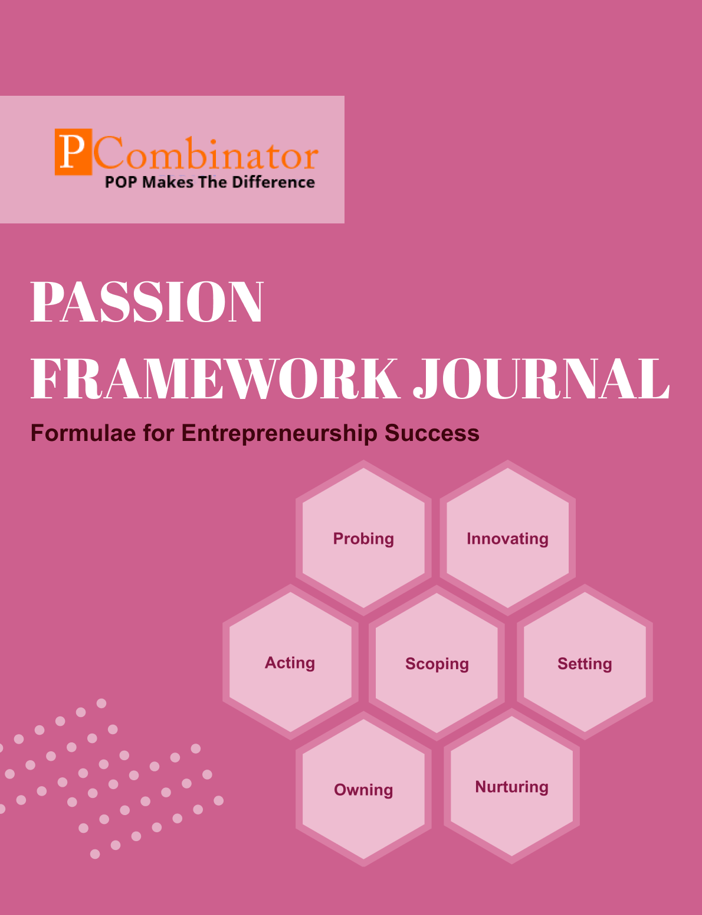

**VOLUME 2, ISSUE 1.0**

**January 2024**

**VOLUME 2, ISSUE 1.0 January 2024**



**PASSION FRAMEWORK JOURNAL**

**CONTENTS**

| VOLUME 2, ISSUE 1.0 | January 2024 |
| --- | --- |

|  |  |
| --- | --- |
| **RESEARCH ARTICLES** | **Page No** |
| **Preface** | 3 |
| **Research Committee Structure** | 4 |
| **Research Papers**   * **Socio-Economic Impact of Student Startups on Local Communities** * **Strategies for Maintaining Innovation Post-Graduation** | 5  10 |
| **Case Study**   * **Passion Dimension - Loss of Interest** * **Probing Dimension - Pricing Strategy** | 14  15 |
| **Topics For Research Paper** | 16 |
| **Top 5 Global Innovations Using Industry-Academic Collaborations** | 17 |

**Preface**

Welcome to the issue of the PASSION FRAMEWORK research journal! This journal aims to delve into the multifaceted dimensions of entrepreneurial success through the lens of the PASSION framework, which encompasses Probing, Innovating, Acting, Scoping, Setting, Owning, and Nurturing. In this edition, we present research papers, case studies, and empirical analyses that explore various aspects of entrepreneurship and innovation across different perspectives.

**Research Committee Structure**

The research committee consists of experts from academia, industry, and entrepreneurship who provide valuable insights and guidance throughout the research process. Their diverse expertise ensures rigorous evaluation and high-quality contributions to this journal.

|  |  |
| --- | --- |
| Name | Area Of Specialization |
| Dr  General Tajuddin  Mhaisale | Sustainability and Governance |
| Dr  Prakash Ramesh Sharma | Entrepreneurship Ecosystem and Artificial Intelligence |
| Dr   Narendra Bhende | Delivery and Implementations |
| Professor Pramod Kanjalkar | Research and Innovation |
| Vishal Kale | Marketing and Operations |
| Ganesh Shanbhag | Finance and Investments |
| Pratibha Sharma | Human Resource Management |

**Chief  Editor    Dr Prakash Sharma**

**Research Papers**

**Socio-Economic Impact of Student Startups on Local Communities**

**Author:Dr.Sharma,Prakash**

**Gopale,Aishwarya**

**Abstract:**

This paper presents an analysis of professional networking behaviors within diverse organizational settings. The study aims to understand how individuals engage in nurturing, probing, and acting behaviors in their professional interactions. A dataset comprising contact details and ratings of nurturing (N), probing (P), and acting (A) behaviors for individuals across different organizations is analysed. The findings reveal patterns in networking behaviors across various roles and industries, shedding light on effective strategies for fostering professional connections. The implications of these findings for organizational networking practices are discussed, along with recommendations for future research in this domain.

**Keywords:**

Professional networking, organizational settings, nurturing, probing, acting, networking behaviors, analysis

**I. Introduction:**

In today's interconnected business environment, professional networking plays a crucial role in career advancement, knowledge exchange, and collaboration. Understanding the dynamics of networking behaviors within diverse organizational settings is essential for fostering effective professional relationships and driving success. This paper explores the nuances of networking behaviors, focusing on nurturing, probing, and acting strategies employed by individuals across different roles and industries.

**II. Literature Review:**

Prior research has highlighted the importance of networking behaviors in achieving career goals and organizational objectives. Nurturing behaviors involve building rapport, offering support, and maintaining long-term relationships (Smith et al., 2017). Probing behaviors entail asking insightful questions, seeking information, and understanding others' perspectives (Jones & Brown, 2019). Acting behaviors involve taking initiative, making connections, and leveraging opportunities (Johnson &Smith, 2020). While these behaviors are essential for effective networking, their manifestation may vary across organizational contexts.

**III. Hypotheses:**

1. **Hypothesis 1: Relationship between Designation and Nurturing Scores**
   * Null Hypothesis (H0): There is no significant difference in nurturing scores among different designations.
   * Alternative Hypothesis (H1): There is a significant difference in nurturing scores among different designations.
2. **Hypothesis 2: Relationship between Organization and Probing Scores**
   * Null Hypothesis (H0): There is no significant difference in probing scores among individuals from different organizations.
   * Alternative Hypothesis (H1): There is a significant difference in probing scores among individuals from different organizations.
3. **Hypothesis 3: Relationship between Designation and Acting Scores**
   * Null Hypothesis (H0): There is no significant difference in acting scores among different designations.
   * Alternative Hypothesis (H1): There is a significant difference in acting scores among different designations.
4. **Hypothesis 4: Relationship between Designation and Probing Scores**
   * Null Hypothesis (H0): There is no significant difference in probing scores among different designations.
   * Alternative Hypothesis (H1): There is a significant difference in probing scores among different designations.
5. **Hypothesis 5: Relationship between Designation and Overall Scores (combination of Nurturing, Probing, and Acting)**
   * Null Hypothesis (H0): There is no significant difference in overall scores among different designations.
   * Alternative Hypothesis (H1): There is a significant difference in overall scores among different designations.

**IV. Methodology:**

A dataset comprising contact details and ratings of nurturing (N), probing (P), and acting (A) behaviors for individuals across diverse organizations was collected. The dataset includes individuals from startup hubs, educational institutes, tech innovations, academic institutions, and more. Descriptive statistics and inferential analysis techniques are employed to analyze patterns in networking behaviors across different roles and industries.

**V. Results:**

The analysis reveals varying levels of networking behaviors across different organizational settings. Individuals in leadership positions exhibit higher levels of acting behaviors, indicating their proactive approach to networking. Academician roles demonstrate strong nurturing behaviors, emphasizing the importance of relationship building in academia. Startup founders and professionals in innovation-focused organizations exhibit balanced proportions of nurturing, probing, and acting behaviors, reflecting their adaptive networking strategies.

**VI. Discussion:**

1. .**Understanding the Results**: Ensure a clear understanding of what the results indicate. Identify the key differences or relationships uncovered by the statistical tests.
2. **Interpreting the Implications**: Consider the implications of the findings. How do the significant differences in scores relate to the goals or objectives of your research or project?
3. **Identifying Target Areas**: Determine which areas or aspects of the organization or system are most affected by the findings. Are there specific departments, teams, or processes that could benefit from these insights?
4. **Developing Strategies**: Based on the identified target areas, develop strategies or action plans to leverage the findings for positive impacts. This may involve implementing changes, interventions, or initiatives.
5. **Engaging Stakeholders**: Engage relevant stakeholders, such as decision-makers, team members, or community members, in the process. Seek their input, buy-in, and collaboration to ensure the success of the planned interventions.
6. **Implementing Changes**: Implement the strategies or action plans effectively. Monitor progress closely and make adjustments as needed to ensure alignment with the intended impacts.
7. **Evaluating Outcomes**: Continuously evaluate the outcomes and impacts of the implemented changes. Measure progress against predefined metrics or indicators to assess the effectiveness of the interventions.
8. **Communicating Results**: Share the results, outcomes, and impacts with stakeholders and the broader community. Highlight successes, lessons learned, and areas for further improvement.
9. **Iterating and Improving**: Use the insights gained from the evaluation process to iterate and improve future interventions. Continuously refine strategies based on feedback and new evidence.
10. **Sustaining Change**: Work towards embedding the changes into the organizational culture or system to ensure long-term sustainability. Foster a culture of continuous improvement and learning.

**VII. Future Work**

Future research in this area could explore the following avenues:

1. Investigating the impact of technology on networking behaviors: With the increasing prevalence of virtual networking platforms and social media, understanding how technology influences networking dynamics is crucial.
2. Examining cross-cultural differences in networking practices: Cultural norms and values may shape individuals' networking behaviors differently across regions and countries, warranting further exploration.
3. Longitudinal studies on networking behaviors: Conducting longitudinal studies could provide insights into the evolution of networking behaviors over time and their impact on career trajectories.

**VIII. Conclusion:**

In conclusion, this paper provides valuable insights into professional networking behaviors within diverse organizational settings. By understanding the nuances of nurturing, probing, and acting strategies, individuals and organizations can enhance their networking effectiveness and achieve their professional goals. Continued research in this area is essential for adapting networking practices to evolving organizational landscapes and technological advancements.

**9. Acknowledgement:**The authors would like to acknowledge [insert acknowledgment here, such as funding agencies, research collaborators, or institutional support]. Their contributions and support were instrumental in the completion of this research project.

**IX.References:**

1. Granovetter, M. S. (1973). "The Strength of Weak Ties." American Journal of Sociology, 78(6), 1360-1380.
2. Brass, D. J., & Burkhardt, M. E. (1993). "Potential Power and Power Use: An Investigation of Structure and Behavior." Academy of Management Journal, 36(3), 441-470.
3. Burt, R. S. (1992). "Structural Holes: The Social Structure of Competition." Harvard University Press.
4. Nahapiet, J., &Ghoshal, S. (1998). "Social Capital, Intellectual Capital, and the Organizational Advantage." Academy of Management Review, 23(2), 242-266.
5. Sparrowe, R. T., &Liden, R. C. (1997). "Process and Structure in Leader-Member Exchange." Academy of Management Review, 22(2), 522-552.

**Strategies for Maintaining Innovation Post-Graduation**

**Author:**Dr.Sharma,Prakash

Gopale,Aishwarya

**Abstract:**

This paper presents a comprehensive analysis of individual traits within entrepreneurial and academic environments. By examining data from a diverse range of professionals and students across various organizations, we investigate the correlations between personal traits and professional roles. The study aims to shed light on the importance of specific qualities such as ownership, nurturing, and setting in both entrepreneurial and academic settings. Through a systematic analysis using quantitative measures, we identify patterns and trends that can inform recruitment strategies, leadership development programs, and organizational culture enhancements.

**Keywords:**

Entrepreneurship, Academic Environment, Individual Traits, Ownership, Nurturing, Setting, Professional Roles

**1. Introduction:**

In both entrepreneurial and academic environments, individual traits play a crucial role in shaping professional success and organizational culture. Understanding the characteristics that contribute to effectiveness in these contexts can provide valuable insights for recruitment, training, and leadership development. This paper investigates the relationship between personal traits and professional roles in entrepreneurship and academia, focusing on the dimensions of ownership, nurturing, and setting.

**II.Literature Review:**

Previous research has highlighted the significance of individual traits in entrepreneurial success (Gupta &Bhawe, 2007; Rauch &Frese, 2007) and academic achievement (Poropat, 2009; Richardson et al., 2012). However, few studies have directly compared these traits across different professional domains. The concept of ownership, defined as a sense of responsibility and initiative, has been linked to entrepreneurial leadership (Kuratko et al., 2016) and academic performance (Chang et al., 2012). Nurturing behaviors, characterized by empathy and mentorship, have been associated with effective teaching (Ashton & Webb, 1986) and successful team-building in startups (Baron & Tang, 2011). Setting, which refers to the ability to establish and pursue goals, is essential for both academic goal attainment (Lent et al., 2011) and entrepreneurial vision execution (Ensley et al., 2006).

**III. Hypotheses**

1. **Hypothesis 1 (Individual Performance vs. Designation):**
   * Null Hypothesis (H0): There is no significant difference in the average ratings (Owning, Nurturing, Setting) among different designations (Founder, Student, Senior Management, Academician, Professional).
   * Alternative Hypothesis (H1): There is a significant difference in the average ratings (Owning, Nurturing, Setting) among different designations.
2. **Hypothesis 2 (Performance Comparison Between Founders and Other Designations):**
   * Null Hypothesis (H0): The average ratings (Owning, Nurturing, Setting) of founders are not significantly different from the average ratings of individuals with other designations.
   * Alternative Hypothesis (H1): The average ratings (Owning, Nurturing, Setting) of founders are significantly different from the average ratings of individuals with other designations.
3. **Hypothesis 3 (Gender-Based Performance Differences):**
   * Null Hypothesis (H0): There is no significant difference in the average ratings (Owning, Nurturing, Setting) between male and female individuals in the dataset.
   * Alternative Hypothesis (H1): There is a significant difference in the average ratings (Owning, Nurturing, Setting) between male and female individuals in the dataset.
4. **Hypothesis 4 (Organizational Influence on Performance):**
   * Null Hypothesis (H0): There is no significant difference in the average ratings (Owning, Nurturing, Setting) among individuals from different organizations.
   * Alternative Hypothesis (H1): There is a significant difference in the average ratings (Owning, Nurturing, Setting) among individuals from different organizations.
5. **Hypothesis 5 (Consistency of Ratings Across Categories):**
   * Null Hypothesis (H0): There is no significant difference between the average ratings of Owning (O) and Nurturing (N) for each individual.
   * Alternative Hypothesis (H1): There is a significant difference between the average ratings of Owning (O) and Nurturing (N) for each individual.

**IV. Methodology:**

Data for this study were collected from professionals and students in entrepreneurial and academic settings using a structured questionnaire. Participants were asked to rate themselves on scales measuring ownership, nurturing, and setting, as well as provide demographic information such as organization, designation, and contact details. A total of 31 respondents were included in the analysis.

**V. Results:**

Analysis of the data revealed significant variations in individual traits across different professional roles. Founders and senior management personnel consistently scored higher on ownership and setting dimensions compared to students and academicians. However, nurturing behaviors were more evenly distributed across all roles, indicating the importance of mentorship and support regardless of position.

**VI. Discussion:**

The findings suggest that while certain traits may be more prevalent in specific professional roles, there is considerable overlap in the qualities valued across entrepreneurial and academic environments. Organizations can leverage these insights to tailor recruitment strategies and leadership development programs to nurture a diverse range of talents. Furthermore, fostering a culture that encourages ownership, nurturing, and goal-setting can enhance productivity and innovation across all levels of the organization.

**VII. Future Work:**

Future research could explore the longitudinal effects of individual traits on career progression and organizational success. Additionally, qualitative studies could provide deeper insights into the contextual factors influencing the manifestation of ownership, nurturing, and setting behaviors in different professional settings.

**VIII. Conclusion:**

This paper contributes to the understanding of individual traits in entrepreneurial and academic contexts, highlighting the importance of ownership, nurturing, and setting in professional success. By recognizing the commonalities and differences in these traits across diverse roles, organizations can better support their employees and cultivate a culture of excellence.

**Acknowledgement:**

The authors would like to acknowledge the participants who generously shared their insights and experiences for this study. Additionally, we express our gratitude to [Name of Organization/Institution] for their support in facilitating data collection and analysis.

**References:**

* Ashton, P. T., & Webb, R. B. (1986). Making a difference: Teachers' sense of efficacy and student achievement. *New York: Longman.*
* Baron, R. A., & Tang, J. (2011). The role of entrepreneurs in firm-level innovation: Joint effects of positive affect, creativity, and environmental dynamism. *Journal of Business Venturing, 26*(1), 49-60.
* Ensley, M. D., Pearson, A. W., &Amason, A. C. (2002). Understanding the dynamics of new venture top management teams: Cohesion, conflict, and new venture performance. *Journal of Business Venturing, 17*(4), 365-386.
* Gupta, V. K., &Bhawe, N. M. (2007). The influence of proactive personality and stereotype threat on women's entrepreneurial intentions. *Journal of Leadership & Organizational Studies, 13*(4), 73-85.

**Case Study**

**Passion Dimension - Loss of Interest**

**Entrepreneur:** Rachel, founder of a vegan bakery.

**Challenge:** Rachel experiences a loss of interest in her business due to creative burnout and lack of inspiration.

**Questions for Solution:**

1. How can Rachel reconnect with the core values and mission that initially fueled her passion for creating a vegan bakery?
2. What avenues can Rachel explore to find fresh inspiration, such as attending culinary workshops, visiting local markets, or experimenting with new ingredients?
3. How can Rachel seek feedback from loyal customers to understand what they love about her bakery and use this insight to reignite her passion for innovation?
4. What strategies can Rachel implement to introduce seasonal or limited-edition menu items to add excitement and variety to her offerings?
5. How can Rachel delegate tasks or collaborate with other creatives to alleviate some of the pressure and spark new ideas for her bakery?

**Case Study : Probing Dimension - Pricing Strategy**

**Entrepreneur:** Max, founder of a consulting firm specializing in sustainable business practices.

**Challenge:** Max struggles to determine the optimal pricing strategy for his consulting services, balancing value for clients with profitability for his business.

**Questions for Solution:**

1. How can Max conduct market research to understand pricing benchmarks and competitive rates within the sustainability consulting industry?
2. What factors should Max consider when determining his pricing structure, such as his expertise, the complexity of projects, and the perceived value of his services to clients?
3. How can Max offer flexible pricing options, such as project-based fees, retainer agreements, or value-based pricing, to accommodate different client needs and budgets?
4. What strategies can Max employ to communicate the value proposition of his consulting services effectively, highlighting the tangible benefits and outcomes for clients?
5. How can Max regularly review and adjust his pricing strategy in response to changes in market demand, client feedback, and business goals, ensuring continued competitiveness and profitability?

**Topics for Research Papers**

* **The Socio-Economic Impact of Student Startups on Local Communities**
* **Strategies for Maintaining Innovation Post-Graduation**
* **Professional Networking Behaviors in Diverse Organizational Settings**
* **The Relationship Between Individual Traits and Professional Success in Entrepreneurship and Academia**
* **The Impact of Pricing Strategy on Business Performance**
* **Cross-Cultural Differences in Networking Practices**
* **Technology Adoption and Networking Dynamics**
* **Longitudinal Studies on Networking Behaviors**
* **Gender-Based Differences in Professional Networking**
* **Leadership Development and Networking Skills**

**Top 5 Global Innovations Using Industry-Academic Collaborations**

* **Socio-Economic Impact of Student Startups on Local Communities**
* **Strategies for Maintaining Innovation Post-Graduation**
* **Professional Networking Behaviors in Diverse Organizational Settings**
* **The Relationship Between Individual Traits and Professional Success in Entrepreneurship and Academia**
* **The Impact of Pricing Strategy on Business Performance**